May 2025


Dear stockholders, customers, partners and friends,


In fiscal year 2025 (FY25), we returned to growth and delivered revenue and EPS well above our long-term value creation framework. I’m proud of our performance, our team and our customer innovation.

Generative artificial intelligence (GenAI) is driving global growth and advancing human progress, and Dell is positioned at the forefront of this technology revolution. By continuing to execute our strategy and operating model, we are expanding our leadership in AI, increasing eﬃciency, and positioning ourselves well for growth opportunities.

Financial Performance

- Delivered full-year revenue of $95.6B, up 8%

- Full-year operating income of $6.2B, up 15%, and non-GAAP operating income1 of $8.5B, up 8%

- Full-year diluted EPS of $6.38, up 39%, and record non-GAAP diluted EPS1 of $8.14, up 10%

- Returned $3.9B to shareholders through share repurchases and dividends

Infrastructure Solutions Group

We achieved record ISG revenue, showcasing strong growth and profitability. Data center modernization is creating tailwinds across our entire ISG business—from fast-growing AI environments, to accelerating traditional server consolidation, and a significant pivot to Dell IP storage. We are continuing to innovate across our portfolio to extend our leadership and capture new growth opportunities.

- Record revenue of $43.6B, up 29%

- AI server shipments of $9.8B, up from $1.5B in FY24

- Record operating income of $5.6B, up 30%

Client Solutions Group

We are excited about the future of PCs, the world’s leading productivity tool. We've extended our #1 position in Commercial AI PCs with the broadest portfolio of Copilot+ AI PCs. And we're optimistic about a broader PC refresh this year due to an aging installed base, the approaching Windows 10 end-of-life, and wider availability of AI PCs. Simplifying our branding, redesigning our PC portfolio, and broadening our silicon options position us well for the refresh and to focus on profitable segments.

- Revenue of $48.4B, down 1%

- Operating income of $3B, down 20%

- See Non-GAAP Financial Measures beginning on page 43 of the Annual Report on Form 10-K for the year ended January 31, 2025 for a reconciliation of these metrics, which are not calculated in accordance with generally accepted accounting principles in the United States of America (“GAAP”), to the most comparable GAAP measures.

Capital Return

We're excited about the future and remain confident in our ability to create meaningful long-term value for shareholders.

- Returned $10.8B to shareholders through $7.5B of share repurchases and $3.3B of dividends since initiating our capital allocation framework (more than 100% of our adjusted free cash flow to shareholders over the last three years)
- Raised our annual dividend by 18% from $1.78 to $2.10 per share, reflecting continued confidence in our long-term business model and ability to generate strong cash flow over time

- Increased share repurchase authorization by $10B

- Reached 1.2x core leverage ratio exiting the fiscal year

We also remain committed to returning 80% or more of our adjusted free cash flow to shareholders over the long term and targeting at least 10% dividend growth each year through fiscal year 2028.

Innovation

Driving innovation for our customers is an integral part of who we are. It was an exciting year for us with the limitless possibilities of GenAI, Data Center Modernization and Edge.

- We added five platforms to our AI-optimized portfolio, including Blackwell architectures

- We oﬀered the most GPU dense rack scale AI solutions

- We moved from AI server optimization to data center optimization for our largest customers

- We developed AI factories for enterprise customers and were the first in the world to ship NVIDIA’s NVL-72 GB200 solution

These are prime examples of the pace of innovation and engineering leadership evident across our entire portfolio.

Looking forward

We are extremely well positioned to capture growth across every segment of our business and extend AI from the largest at-scale cloud service providers into enterprise workloads and out to the edge with the PC. With IT spending expected to grow, we will leverage our pace of innovation and unique operating model that has driven value creation time and time again. We are confident that our opportunity is tremendous as we look ahead to FY26.

As always, we are grateful to our shareholders, customers and partners for their continued support.

Michael S. Dell

Chairman of the Board and Chief Executive Oﬃcer

UNITED STATES

SECURITIES AND EXCHANGE COMMISSION

Washington, D.C. 20549

Form 10-K

(Mark One)

- ANNUAL REPORT PURSUANT TO SECTION 13 OR 15(d) OF THE SECURITIES EXCHANGE ACT OF 1934

For the fiscal year ended January 31, 2025

or

- TRANSITION REPORT PURSUANT TO SECTION 13 OR 15(d) OF THE SECURITIES EXCHANGE ACT OF 1934

For the transition period from |  | to
Commission file number: 001-37867
Dell Technologies Inc.
(Exact name of registrant as specified in its charter)
Delaware | 80-0890963
(State or other jurisdiction of incorporation or organization) |  |  | (I.R.S. Employer Identification No.)

One Dell Way, Round Rock, Texas 78682

(Address of principal executive offices) (Zip Code)

1-800-289-3355

(Registrant’s telephone number, including area code)

Securities registered pursuant to Section 12(b) of the Act:

 | Title of each class |  | Trading Symbol(s) |  | Name of each exchange on which registered
Class C Common Stock, par value of $0.01 per share |  |  | DELL |  | New York Stock Exchange

Securities registered pursuant to Section 12(g) of the Act: None

Indicate by check mark if the registrant is a well-known seasoned issuer, as defined in Rule 405 of the Securities Act. Yes þ No ¨ Indicate by check mark if the registrant is not required to file reports pursuant to Section 13 or Section 15(d) of the Act. Yes ¨ No þ
Indicate by check mark whether the registrant (1) has filed all reports required to be filed by Section 13 or 15(d) of the Securities Exchange Act of 1934 during the preceding 12 months (or for such shorter period that the registrant was required to file such reports), and (2) has been subject to such filing requirements for the past 90 days. Yes þ No ¨

Indicate by check mark whether the registrant has submitted electronically every Interactive Data File required to be submitted pursuant to Rule 405 of Regulation S-T (§ 232.405 of this chapter) during the preceding 12 months (or for such shorter period that the registrant was required to submit such files). Yes þ No ¨

Indicate by check mark whether the registrant is a large accelerated filer, an accelerated filer, a non-accelerated filer, a smaller reporting company, or an emerging growth company. See the definitions of “large accelerated filer,” “accelerated filer,” “smaller reporting company” and “emerging growth company” in Rule 12b-2 of the Exchange Act.

Large accelerated filer | ☑ | Accelerated filer | ☐
Non-accelerated filer | ☐ | Smaller reporting company | ☐
 |  | Emerging growth company | ☐

If an emerging growth company, indicate by check mark if the registrant has elected not to use the extended transition period for complying with any new or revised financial accounting standards provided pursuant to Section 13(a) of the Exchange Act. ☐

Indicate by check mark whether the registrant has filed a report on and attestation to its management’s assessment of the effectiveness of its internal control over financial reporting under Section 404(b) of the Sarbanes-Oxley Act (15 U.S.C. 7262(b)) by the registered public
accounting firm that prepared or issued its audit report. ☑

If securities are registered pursuant to Section 12(b) of the Act, indicate by check mark whether the financial statements of the registrant included in the filing reflect the correction of an error to previously issued financial statements. ☑

1

Indicate by check mark whether any of those error corrections are restatements that required a recovery analysis of incentive-based compensation received by any of the registrant’s executive officers during the relevant recovery period pursuant to §240.10D-1(b). ☑

Indicate by check mark whether the registrant is a shell company (as defined in Rule 12b-2 of the Act). Yes ☐ No þ

As of August 2, 2024, the last business day of the registrant’s most recently completed second fiscal quarter, the aggregate market value of the shares of the registrant’s common stock held by non-affiliates was approximately $29.2 billion (based on the closing price of $102.29 per share of Class C Common Stock reported on the New York Stock Exchange on that date).

As of March 17, 2025, there were 697,840,821 shares of the registrant’s common stock outstanding, consisting of 358,710,357 outstanding shares of Class C Common Stock, 276,762,341 outstanding shares of Class A Common Stock, and 62,368,123 outstanding shares of Class B Common Stock.

DOCUMENTS INCORPORATED BY REFERENCE

The information required by Part III of this report, to the extent not set forth herein, is incorporated by reference from the registrant’s proxy statement relating to its annual meeting of stockholders to be held in 2025. The proxy statement will be filed with the Securities and Exchange Commission within 120 days after the end of the fiscal year to which this report relates.

2

CAUTIONARY NOTE REGARDING FORWARD-LOOKING STATEMENTS

This report contains “forward-looking statements” within the meaning of Section 27A of the Securities Act of 1933 and Section

21E of the Securities Exchange Act of 1934. The words “may,” “will,” “anticipate,” “estimate,” “expect,” “intend,” “plan,”

“aim,” “seek,” and similar expressions as they relate to us or our management are intended to identify these forward-looking

statements. All statements by us regarding our expected financial position, revenues, cash flows and other operating results,

business strategy, legal proceedings, and similar matters are forward-looking statements. Our expectations expressed or implied

in these forward-looking statements may not turn out to be correct. Our results could be materially different from our

expectations because of various risks, including the risks discussed in “Part I — Item 1A — Risk Factors” and in our other

periodic and current reports filed with the Securities and Exchange Commission (“SEC”). Any forward-looking statement

speaks only as of the date as of which such statement is made, and, except as required by law, we undertake no obligation to

update any forward-looking statement after the date as of which such statement was made, whether to reflect changes in

circumstances or our expectations, the occurrence of unanticipated events, or otherwise.

3

 | DELL TECHNOLOGIES INC.
 | TABLE OF CONTENTS
PART I |  | Page
Item 1. | Business | 5
Item 1A. | Risk Factors | 17
Item 1B. | Unresolved Staff Comments | 32
Item 1C. | Cybersecurity | 33
Item 2. | Properties | 35
Item 3. | Legal Proceedings | 35
Item 4. | Mine Safety Disclosures | 35
PART II
Item 5. | Market for Registrant’s Common Equity, Related Stockholder Matters and Issuer Purchases of | 36
 | Equity Securities
Item 6. | [Reserved] | 38
Item 7. | Management’s Discussion and Analysis of Financial Condition and Results of Operations | 39
Item 7A. | Quantitative and Qualitative Disclosures About Market Risk | 71
Item 8. | Financial Statements and Supplementary Data | 73
Item 9. | Changes in and Disagreements With Accountants on Accounting and Financial Disclosure | 151
Item 9A. | Controls and Procedures | 151
Item 9B. | Other Information | 153
Item 9C. | Disclosure Regarding Foreign Jurisdictions that Prevent Inspections | 153
PART III
Item 10. | Directors, Executive Officers and Corporate Governance | 153
Item 11. | Executive Compensation | 154
Item 12. | Security Ownership of Certain Beneficial Owners and Management and Related Stockholder | 154
 | Matters
Item 13. | Certain Relationships and Related Transactions, and Director Independence | 154
Item 14. | Principal Accountant Fees and Services | 154
PART IV
Item 15. | Exhibits and Financial Statement Schedules | 155
Item 16. | Form 10-K Summary | 162
Signatures |  | 163

4

PART I

Unless the context indicates otherwise, references in this report to “we,” “us,” “our,” the “Company,” and “Dell Technologies” mean Dell Technologies Inc. and its consolidated subsidiaries, references to “Dell” mean Dell Inc. and Dell Inc.’s consolidated subsidiaries, and references to “EMC” mean EMC Corporation and EMC Corporation’s consolidated subsidiaries.

Our fiscal year is the 52- or 53-week period ending on the Friday nearest January 31. We refer to our fiscal years ended January 31, 2025, February 2, 2024, and February 3, 2023 as “Fiscal 2025,” “Fiscal 2024,” and “Fiscal 2023,” respectively. Both Fiscal 2025 and Fiscal 2024 included 52 weeks, while Fiscal 2023 included 53 weeks.

ITEM 1 — BUSINESS

Company Overview

Dell Technologies is a leader in the global technology industry focused on providing broad and innovative technology solutions for the data and artificial intelligence (“AI”) era. These solutions range from client devices and peripherals to infrastructure solutions across servers, networking, and storage to meet the evolving needs of our customers and drive better business outcomes. With our extensive portfolio and our commitment to innovation, we offer secure, integrated solutions that extend from the edge to the core to the cloud, and we are at the forefront of AI, software-defined, and cloud native infrastructure solutions. Our differentiated and holistic information technology (“IT”) solutions enable us to provide value and capture growth as customer spending priorities evolve.

Dell Technologies operates globally in over 170 countries, supported by a world-class organization across key functional areas, including technology and product development, marketing, sales, services, and financing. We have a number of operational advantages that provide a critical foundation for our success. We provide leading end-to-end solutions across our portfolio of products and services. Our go-to-market operations include an extensive direct sales force, with the ability to build deep customer relationships, and a global network of channel partners. Our global services footprint consists of service and support professionals and vendor-managed service centers that support customers across the world. Our world-class supply chain operates at a significant scale with the ability to remain agile in a variety of environments.

We offer customers choice in how they acquire our solutions, including traditional purchasing and a portfolio of offerings that provide both payment and consumption solutions, including as-a-Service, subscription, utility, leases, and loans. These options allow our customers to pay over time and provide them with operational and financial flexibility.

Our Vision and Strategy

Our vision is to become the most essential technology partner. We help customers address their IT needs and digital transformation objectives as they embrace today’s changing technology landscape. We intend to realize our vision by executing our strategy of leveraging our strengths to extend our leadership positions and capture new growth.

We believe we are uniquely positioned in our industry and that our results will continue to benefit from our operational advantages, which position our Company for long-term growth and value creation while keeping our purpose at the forefront of our decision-making: to create technologies that drive human progress.

Technology is rapidly evolving with demand for simple and holistic solutions as companies navigate an increasingly complex IT environment. To meet our customers’ needs, we invest in research and development, sales, and other key areas of our business to deliver superior products and solutions capabilities and to drive sustainable long-term growth.

The impacts of technological advancement and data expansion continue to be a force for progress as artificial intelligence and generative AI have become the next wave of technological innovation. Through each wave of technological progress, we look to advance our capabilities to change the way we work and make decisions, improve business outcomes and the customer experience, and reduce costs by leveraging new technology to optimize business processes. We believe our unique operating advantages, our leadership, and our way of doing business provide a foundation to foster growth, drive efficiencies, and capitalize on each successive wave of innovation in a dynamic industry.

5

Products and Services

We design, develop, manufacture, market, sell, and support a wide range of comprehensive and integrated solutions, products, and services. We are organized into two business units which are also our reportable segments: Infrastructure Solutions Group and Client Solutions Group.

- Infrastructure Solutions Group (“ISG”) — ISG enables our customers’ digital transformations with solutions that address AI, machine learning, data analytics, and multicloud environments. ISG helps customers simplify, streamline, and automate IT operations. ISG solutions are built for multicloud environments and are optimized to run workloads in both public and private clouds, as well as on-premises. Our major product categories within ISG are our servers and networking offerings and storage offerings.

Our server portfolio includes high-performance general-purpose and AI-optimized servers able to run workloads across customers’ IT environments, on-premises, and in multicloud and edge environments. Our AI-optimized servers are designed to run high-value workloads, including AI model training, fine-tuning, and inferencing. Our networking portfolio helps our business customers transform and modernize their infrastructure, complementing our server and storage solutions. Our comprehensive storage portfolio includes modern and traditional storage solutions, including all-flash arrays, scale-out file, object platforms, hyper-converged infrastructure, and software-defined storage. ISG also offers software, peripherals, and services, including consulting, configuration, and support and deployment.

Approximately 60% of ISG revenue is generated by sales to customers in the Americas, with the remaining portion derived from sales to customers in the Europe, Middle East, and Africa region (“EMEA”) and the Asia-Pacific and Japan region (“APJ”).

- Client Solutions Group (“CSG”) — CSG offers branded PCs, including notebooks, desktops, and workstations and branded peripherals that include displays, docking stations, keyboards, mice, and webcam and audio devices, as well as third-party software and peripherals. CSG also includes services offerings, such as configuration, support and deployment, and extended warranties. Our major product categories within CSG are our commercial offerings and consumer offerings.

Our CSG offerings are designed to optimize performance, reliability, manageability, design, and security for our customers and include on-device AI for greater end-user creativity and productivity. Our commercial portfolio provides our customers with solutions centered on flexibility to address their complex needs such as IT modernization, hybrid work transformation, and other critical areas. Our consumer portfolio primarily focuses on high-end consumer and gaming offerings, providing our customers with powerful performance, processing, and end-user experiences.

Approximately 60% of CSG revenue is generated by sales to customers in the Americas, with the remaining portion derived from sales to customers in EMEA and APJ.

Our other businesses, described below, primarily consist of our resale of standalone offerings of VMware LLC (formerly VMware, Inc. and individually and together with its subsidiaries, “VMware”), referred to as “VMware Resale,” and offerings of SecureWorks Corp. (“Secureworks”). These businesses are divested businesses or their offerings are no longer actively sold, and are not classified as reportable segments, either individually or collectively. Their operating results are reported within Corporate and other.

- VMware Resale includes our sale of standalone VMware offerings. On November 22, 2023, VMware was acquired by Broadcom, and subsequently announced changes to its go-to-market approach for VMware offerings that impacted our commercial relationship with VMware. On March 25, 2024, we terminated our Commercial Framework Agreement with VMware, which provided the framework under which we and VMware continued our commercial relationship following our spin-off of VMware on November 1, 2021. We no longer act as a distributor of Broadcom’s VMware standalone products and services, although we will continue to support customers that have purchased resale offerings sold in prior periods.

We continue to integrate and embed certain VMware products and services with selected Dell Technologies’ offerings to end-users. The results of such offerings are reflected within CSG or ISG, depending upon the nature of the underlying offering sold. See Note 19 of the Notes to the Consolidated Financial Statements included in this report for more information regarding the impact of Broadcom’s acquisition of VMware.

6

- Secureworks (NASDAQ: SCWX) is a global cybersecurity provider of technology-driven security solutions singularly focused on protecting its customers by outpacing and outmaneuvering the adversary. The solutions offered by Secureworks enable organizations of varying size and complexity to prevent security breaches, detect malicious activity, respond rapidly when a security breach occurs, and identify emerging threats. On October 21, 2024, Secureworks announced that it had entered into a definitive agreement providing for its sale to Sophos Inc., an affiliate of Thoma Bravo, L.P., a private equity and growth capital firm. The transaction was completed on February 3, 2025, subsequent to the close of the Company’s fiscal year ended January 31, 2025, in an all-cash transaction for a purchase price of approximately $0.9 billion.

For further discussion regarding our current reportable segments, see “Part II — Item 7 — Management’s Discussion and Analysis of Financial Condition and Results of Operations — Results of Operations — Business Unit Results” and Note 18 of the Notes to the Consolidated Financial Statements included in this report.

Dell Payment Solutions

Our customers seek choice in how they acquire our solutions and look to remove cost and complexity, align offerings with their business needs, and provide consistent, high-quality operations throughout their IT enterprise. The Dell Payment Solutions portfolio offers a wide range of payment and consumption options to enable our customers globally to deploy the technology solutions they need now with predictability, flexibility, and choice.

We offer our customers choices that include as-a-Service, subscription, utility, leases, loans and immediate pay models designed to match customers’ consumption and financing preferences. We believe these options provide operational and financial flexibility and strengthen our customer relationships. Additionally, these offerings typically result in multiyear agreements which generate recurring revenue streams over the term of the arrangement. We expect that these offerings will provide a foundation for growth in recurring revenue. We define recurring revenue as revenue recognized that is primarily related to hardware and software maintenance as well as to subscription, as-a-Service, usage-based offerings, and operating leases.

To support financing solutions and services as part of the portfolio, Dell Financial Services and its affiliates (“DFS”) originate, collect, and service customer receivables primarily related to the purchase or use of our product, software, and services offerings. DFS funded $8.4 billion of originations in Fiscal 2025 and as of January 31, 2025 maintains an $11.2 billion global portfolio of financing receivables with a strong credit quality. The results of these operations are allocated to our segments based on the underlying product or service financed and may be impacted by, among other factors, changes in the interest rate environment and the translation of those changes to pricing. For additional information about our financing arrangements, see Note 5 of the Notes to the Consolidated Financial Statements included in this report.

Research and Development

We focus on developing innovative solutions that incorporate desirable features and capabilities at competitive prices. We employ a collaborative approach to design and development in which our engineers, with direct customer input, design solutions and work with a global network of technology partners to architect new system designs, influence the direction of future development, and integrate new technologies into our products and solutions. We strive to deliver new and relevant products to the market quickly and efficiently.

Our software engineers are focused on developing the next generation of innovative solutions. Our embedded software

simplifies the complex through automation, increasingly leveraging artificial intelligence and machine-learning technology. Most of our research and development (“R&D”) expenditures represent costs to develop the software that powers these solutions.

We manage our R&D expenses by concentrating on solutions that we believe are most valuable to our customers and by leveraging the capabilities of our strategic partnerships. We have a global R&D presence, with total R&D expenses of $3.1 billion for Fiscal 2025, and $2.8 billion for both Fiscal 2024 and Fiscal 2023. These investments reflect our commitment to innovation that aim to create the right solutions to help our customers build their digital future and transform their businesses.

7

Strategic Investments and Acquisitions

As part of our strategy, we will continue to evaluate opportunities for strategic investments through our venture capital investment arm, Dell Technologies Capital, with a focus on emerging technology areas that are relevant to our business and that will complement our existing portfolio of solutions. We target investments in areas such as storage, software-defined networking, management and orchestration, security, machine learning and AI, Big Data and analytics, cloud, edge computing, and software development operations. The technologies or products these companies have under development are typically in the early stages and may never have commercial value, which could result in a loss of a substantial part of our investment in the companies.

We held strategic investments in non-marketable securities of $1.5 billion and $1.3 billion as of January 31, 2025 and February 2, 2024, respectively. See Note 4 of the Notes to the Consolidated Financial Statements included in this report for additional information.

In addition to these investments, we may also make disciplined acquisitions of businesses that advance our strategic objectives and accelerate our innovation agenda.

Manufacturing and Materials

We own manufacturing facilities located in the United States, Malaysia, China, Brazil, India, Poland, and Ireland. See “Item 2

— Properties” for information about our manufacturing and distribution facilities.

We also utilize contract manufacturers throughout the world to manufacture or assemble our products under the Dell Technologies brand to provide operational flexibility, achieve cost efficiencies, deliver products faster, better serve our customers, and enhance our supply chain. When using contract manufacturers, we purchase components from suppliers and subsequently sell those components to the manufacturer. Our manufacturing process consists of assembly, software installation, functional testing, and quality control. We conduct operations utilizing a formal, documented quality management system to ensure that our products and services satisfy customer needs and expectations. Testing and quality control are also applied to components, parts, sub-assemblies, and systems obtained from third-party suppliers.

Our quality management system is maintained through the testing of components, sub-assemblies, software, and systems at various stages in the manufacturing process. Quality control procedures also include a burn-in period for completed units after assembly, ongoing production reliability audits, failure tracking for early identification of production and component problems, and processing of information from customers obtained through services and support programs. This system is certified to the ISO 9001 International Standard that includes our global sites and organizations that design, manufacture, and service our products.

Our order fulfillment, manufacturing, and test facilities are also certified to the ISO 9001 International Standard for quality management systems, the ISO 14001 International Standard for environmental management systems, the ISO 45001 International Standard for health and safety management systems, and the ISO 50001 International Standard for energy management systems. These internationally-recognized endorsements of ongoing quality, environmental, health and safety, and energy management are among the highest levels of certifications available. We also have implemented programs and methodologies to ensure that the quality of our designs, manufacturing, test processes, and supplier relationships are continually improved.

We maintain a Supplier Code of Conduct, actively manage recycling processes for our returned products, and are certified by the Environmental Protection Agency as a Smartway Transport Partner.

We purchase materials, supplies, product components, and products from a large number of qualified suppliers. In some cases, where multiple sources of supply are not available, we rely on a single source or a limited number of sources of supply if we believe it is advantageous to do so because of performance, quality, support, delivery, capacity, or price considerations. We believe that any disruption that may occur because of our dependence on single- or limited-source vendors would not disproportionately disadvantage us relative to our competitors. See “Item 1A — Risk Factors — Risks Relating to Our Business and Our Industry — Our use of single-source or limited-source suppliers may adversely affect the availability or timely delivery of some critical products or components.” for information about the risks associated with Dell Technologies’ use of single- or limited-source suppliers.

8

Product Backlog

Product backlog represents the value of unfulfilled manufacturing orders and is included as a component of remaining performance obligations to the extent we determine that the manufacturing orders are non-cancelable. Our business model generally gives us the flexibility to optimize product backlog including by expediting shipping or prioritizing customer orders for products that have shorter lead times. During Fiscal 2024, while our supply chain operated efficiently at standard lead times, demand for AI-optimized servers outpaced the supply of graphics processing units (“GPUs”), resulting in elevated backlog levels for such offerings as we exited the fiscal year. During Fiscal 2025, backlog levels for our AI-optimized servers remained elevated as we exited the fiscal year due to continued strong demand for these offerings.

Geographic Operations

Our corporate headquarters is located in Round Rock, Texas. We have operations and conduct business in many countries located in the Americas, Europe, the Middle East, Asia, and other geographic regions. We continue to view emerging markets outside of the United States, Western Europe, Canada, and Japan, which include the vast majority of the world’s population, as a long-term growth opportunity. Accordingly, we pursue the development of technology solutions that meet the needs of these markets. For information about the amount of net revenue we generated from our operations outside of the United States during the last three fiscal years, see Note 18 of the Notes to the Consolidated Financial Statements included in this report.

Seasonality

Our sales can be affected by seasonal trends. Within ISG, our storage sales are typically stronger in our fourth fiscal quarter. Our sales within the Americas are typically stronger in the second and fourth fiscal quarters, while our sales in EMEA are typically stronger during the fourth fiscal quarter. Historical seasonal patterns have been impacted by the changing macroeconomic environment and our mix of business, and may not continue in the future.

Competition

We operate in an industry in which there are rapid technological advances in hardware, software, and services offerings, including AI, cloud, and security-related offerings. We face ongoing product and price competition in all areas of our business from both branded and generic competitors, including companies that specialize in one or more of our product or service lines. We compete based on our ability to offer customers competitive, scalable, and integrated solutions that provide the most current and desired product and services features at a competitive price. We closely monitor market pricing, including the effect of foreign exchange rate movements, in an effort to provide the best value for our customers. We also closely monitor changing demand to keep pace with the demands of current and prospective customers. We believe that our strong relationships with our customers and channel partners allow us to respond quickly to changing customer needs and other macroeconomic factors.

We also face competition from non-traditional IT companies, including large Infrastructure-as-a-Service providers, that often buy their infrastructure directly from original design manufacturers. Competitive pressures could increase if customers choose to move existing workloads to these Infrastructure-as-a-Service providers.

The markets in which we compete span countries around the world with customers that range from the world’s largest corporations to small and medium-sized businesses to consumers and also include government and not-for-profit organizations. We believe that new businesses will continue to enter these markets and develop technologies that, if successfully commercialized, may compete with our products and services. Moreover, current competitors may enter into new strategic relationships with new or existing competitors, which may further increase competitive pressures. See “Item 1A — Risk Factors — Risks Relating to Our Business and Our Industry” for information about our competitive risks.

Sales and Marketing

Our sales and marketing efforts are organized around our customers. Our global sales and marketing team has created a go-to-market model that is collaborative and customer-focused. We generally organize our go-to-market operations with a focus on geographic and customer segments which encompass large global and national enterprises, governmental agencies and other public institutions, educational institutions, healthcare organizations, small and medium-sized businesses, and consumers.

9

Go-to-market strategy — We sell products and services directly to customers and through other sales channels, which include value-added resellers, system integrators, distributors, and retailers. We manage our direct sales team and channel partners to offer a unified customer experience.

We believe our direct sales channel is a significant competitive advantage and emphasizes direct communication with customers, allowing us to refine our products and marketing programs while providing insight to better navigate through supply chain challenges and complexity.

In addition to our direct sales channel, we use our network of channel partners to sell our products and services, enabling us to efficiently reach and serve a greater number of customers. The Dell Technologies partner program provides partners with appropriate incentives to encourage sales generation. We also facilitate access to third-party financing to help our channel partners manage their working capital. We believe that building long-term relationships with our channel partners enhances our ability to deliver a high-quality customer experience. During Fiscal 2025, our other sales channels generated approximately 50% of our net revenue.

Large enterprises and public institutions — We maintain a field sales force across the world to serve our largest customers, including large enterprises and public institutions. Dedicated account teams, which include technical sales specialists, form long-term relationships with and support our largest customers, develop tailored solutions to meet their needs, position the capabilities of Dell Technologies, and provide us with customer feedback. For these customers, we offer several programs designed to provide single points of contact and accountability with dedicated account managers, special pricing, and consistent service and support programs. We also maintain specific sales and marketing programs customized to the needs of each specific segment we serve.

Small and medium-sized business and consumers — We have a direct sales force of dedicated account teams for small and medium-sized businesses focused on delivering outcomes tailored to customers’ specific needs. For consumers, we offer robust online and channel engagement. We market our products and services to customers in these segments through various campaigns and advertising media, aligning with customer preferences. To react quickly to our customers’ needs, we track our Net Promoter Score, a customer loyalty metric that is widely used across various industries. Net Promoter Score is a trademark of Satmetrix Systems, Inc., Bain & Company, Inc., and Fred Reichheld. We also engage with customers through social media.

Patents, Trademarks, and Licenses

As of January 31, 2025, we held a worldwide portfolio of 24,351 granted patents and 8,424 pending patent applications. We continue to obtain new patents through our ongoing research and development activities. The inventions claimed in our patents and patent applications cover aspects of our current and possible future offerings, computer systems, software products, manufacturing processes, and related technologies. We also hold licenses to use numerous third-party patents. Although we use our patented inventions and license some of them to others, we are not substantially dependent on any single patent or group of related patents. Our product and process patents may establish barriers to entry, and we anticipate that our worldwide patent portfolio will continue to be of value in negotiating intellectual property rights with others in the industry.

We have used, registered, or applied to register certain trademarks and copyrights in the United States and in other countries. We believe that the Dell Technologies, DELL, and Alienware word marks and logo marks in the United States are material to our operations.

We have entered into software licensing agreements with other companies. We also license certain technologies and intellectual property from third parties for use in our offerings and processes, and license some of our technologies and intellectual property to third parties.

10

Government Regulation

Our business is subject to regulation by various U.S. federal and state governmental agencies and other governmental agencies. Such regulation includes the activities of the U.S. Federal Communications Commission; the anti-trust regulatory activities of the U.S. Federal Trade Commission, the U.S. Department of Justice, and the European Union; the consumer protection laws and financial services regulation of the U.S. Federal Trade Commission and various U.S. governmental agencies; the export regulatory activities of the U.S. Department of Commerce and the U.S. Department of the Treasury; the import regulatory activities of the U.S. Customs and Border Protection; the product safety regulatory activities of the U.S. Consumer Product Safety Commission and the U.S. Department of Transportation; the health information privacy and security requirements of the U.S. Department of Health and Human Services; and the environmental, employment and labor, and other regulatory activities of a variety of governmental authorities in each of the countries in which we conduct business.

Our operations are subject to a variety of environmental, performance, and safety regulations in all aspects of our operations. Product design and procurement operations must comply with requirements relating to materials composition, sourcing, radiated emissions, energy efficiency and collection, recycling, treatment, transportation, and disposal of electronics products, including restrictions on mercury, lead, cadmium, lithium metal, lithium ion, and other substances. Our operations may also become subject to new or emergent standards relating to climate change laws and regulations. The amount and timing of costs under environmental and safety laws are difficult to predict. We were not assessed any material environmental fines, nor did we have any material environmental remediation or other environmental costs, during Fiscal 2025.

We and our subsidiaries are subject to various anti-corruption laws that prohibit improper payments or offers of payments to foreign governments and their officials for the purpose of obtaining or retaining business, and are also subject to export controls, customs regulations, economic sanctions laws and embargoes imposed by the U.S. government. Violations of the U.S. Foreign Corrupt Practices Act or other anti-corruption laws or export controls, customs regulations, or economic sanctions laws may result in severe criminal or civil sanctions and penalties.

We are subject to provisions of the Dodd-Frank Wall Street Reform and Consumer Protection Act intended to improve transparency and accountability concerning the supply of minerals originating from the conflict zones of the Democratic Republic of the Congo or adjoining countries. We incur costs to comply with the disclosure requirements of this law and other costs relating to the sourcing and availability of minerals used in our products.

Sustainability and Environmental, Social, and Governance Activities

At Dell Technologies, we are committed to driving human progress by putting our technology and expertise to work where we believe it can do the most good for both people and the planet. We recognize that all of our stakeholders — shareholders, customers, suppliers, employees, and communities — are essential to our business.

Dell Technologies is committed to progressing towards the goals set forth in our plan for 2030 and beyond, which we refer to as our 2030 goals. We are using these goals to help build our business, promote long-term shareholder value creation, and guide our societal impact strategies over the next decade. Our environmental, social, and governance (“ESG”) commitments focus on six key areas:

- Circular Economy — We embed circularity principles throughout our value chain. By integrating sustainable practices with suppliers, customers, and stakeholders, we advance a circular economy that improves resource efficiency and environmental benefits, reinforcing our leadership in sustainability.

- Climate Action — We are committed to understanding the impact our business has on the environment. We are taking action to mitigate climate change, and we offer innovative products and solutions to customers to help them reduce their emissions, reach their reduction targets and operate more efficiently. We are actively addressing climate change by managing greenhouse gas emissions across our operations, supply chain, and product lifecycle, with a goal to achieve net zero emissions across scopes 1, 2, and 3 by 2050.

- Digital Inclusion — We endeavor to harness the power of technology, our scale, and our expertise to create a digital future that works for all. We are working to close the digital divide by providing access to connectivity and technology solutions that improve quality of life such as access to healthcare, education, and job opportunities.

11

- Human Rights — We respect the fundamental human rights of all people. This respect is core to our commitment to drive human progress. Dell endeavors to ensure we are not complicit in human rights violations, and we seek to hold our suppliers and other business partners to this same standard.

- Inclusive Workforce — We believe our people are key to our success. We are committed to creating an inclusive culture and fostering a strong pipeline of skilled talent. By focusing on equal opportunities, ethical practices, and integrity, we implement inclusive practices and policies that support diversity.

- Trust — We work to ensure that trust underpins all we do. We prioritize security, privacy, and ethics in all aspects of business. From the integrity of our products to transparency in our processes, we are dedicated to fostering trust with our stakeholders.

Dell Technologies continuously measures and shares updates on our progress in our annually released reports. For a more comprehensive view into our approach, commitments, and key initiatives, see our ESG annual report available on our website.

Human Capital Management

We are a diverse team with unique perspectives united in our purpose, strategy, and culture. Our goal is to ensure that all employees feel valued, engaged, and inspired to do their best work. We aim to attract, develop, and retain an inclusive workforce through our ongoing inclusion efforts, training and development offerings, and competitive and comprehensive benefits that include health and wellness resources. We believe the success of our commitment is demonstrated through our consistent market recognition as a best-in-class employer.

As of January 31, 2025, we had approximately 108,000 employees. Throughout Fiscal 2025, we remained committed to disciplined cost management in coordination with our ongoing business modernization initiatives and continued to take certain measures to reduce costs, including limitation of external hiring, employee reorganizations, and other actions to align our investments with our announced strategic and customer priorities. These actions resulted in a reduction in our overall headcount. Despite these difficult decisions, we continue focused efforts to empower our employees and attract, develop, and retain talent.

We seek to support our culture in four key focus areas:

Diversity and Inclusion — At Dell Technologies, we believe wide-ranging perspectives are powerful. Our pillar on cultivating inclusion highlights how our human capital resources are vital to serving our customer base, our societal impact, and long-term business success. We believe that a workforce diverse in experience and background drives innovation and growth — not only is it our competitive advantage, it is critical to meeting future business needs and ensuring that diverse perspectives reflect our global customer base.

We are committed to equal employment opportunity and continuing to implement inclusive policies that enable Dell Technologies to achieve these goals. Additional information on our aspirational 2030 goals and workforce demographics is included in our annual ESG report.

Achievement Through Learning, Development, and Competitive Compensation and Rewards — We have designed market competitive compensation programs to inspire employees to do their best work for our customers and the growth of our business. These merit, bonus, and long-term incentive programs help us foster our culture of high performance while attracting and retaining critical talent and skill sets. Through our comprehensive rewards programs, we are committed to equal pay. We believe people should be fairly compensated for the value they deliver to our customers and other stakeholders.

We provide centralized programs to support employees’ career growth and development. We offer formal training options, individualized development programs, tools for 360-degree feedback, mentoring, networking, stretch assignments, and growth opportunities. Our tools and resources are designed to empower and inspire employees to direct their own career paths and build a portfolio of transferable skills for success in the technology industry. Our internal Career Hub supports employee growth by providing personalized development suggestions, such as mentorship and internal opportunities, that align with their skills and development goals. We are committed to building a leadership pipeline with a broad spectrum of skills, including the ability to act with integrity and inspire others.

12

Balance and Wellness — We offer a competitive and comprehensive benefits package and strive to provide the best choice and value at the best cost. Through our benefits package, we support our employees’ overall health and well-being through a comprehensive approach which provides programs and resources focused on mental, physical, emotional and financial well-being, while reinforcing work-life balance. We strive to provide innovative and inclusive offerings, such as virtual live and on-demand educational sessions, counseling and support services, fitness and wellness challenges, voluntary progress tracking, and other incentives.

Connection and Engagement — We believe employee feedback is an important part of our culture and a key strategy to foster connection and engagement. For example, through our annual Tell Dell survey, employees can confidentially voice their perceptions of the Company and our leadership, culture, and inclusiveness so we can continue to improve the employee experience. We promote further employee connection and engagement through a variety of initiatives, including, among others, our broader team member listening strategy and our Employee Resource Groups (“ERGs”). We have 13 unique ERGs, which are open to all team members, that foster connection and design experiences focused on team member engagement, professional development, and community involvement.

Supply Chain Resources

We manage our responsible business practices in one of the world’s largest supply chains, which involves hundreds of thousands of people around the world. We seek to drive responsible manufacturing through robust assurance practices, including human rights due diligence and environmental stewardship. We recognize that looking after the well-being of people in our supply chain is important and have various objectives for our work in this area, including:

- providing healthy work environments;

- delivering future-ready skills development for employees in our supply chain; and

- continuing our engagement with the people who make our products.

We support workers in the value chain with training on key topics, including forced labor and health and safety, and we continue to work with suppliers to deliver training directly to employees via their mobile phones. Through this initiative, Dell Technologies covers the cost of developing training modules and shares training costs with suppliers who deliver them.

Dell Technologies works to ensure that we and our suppliers manufacture our products responsibly, in part through our social and environmental responsibility assurance program. Through risk assessments and audits conducted under this program, we seek to monitor factories’ adherence to the Responsible Business Alliance (“RBA”) Code of Conduct. Audits are conducted by third-party auditors that have been trained and certified by the RBA. The audits cover topics across five areas: labor, including risks of forced labor and weekly working hours; employee health and safety; environment; ethics; and management systems. Through our audit program, we aim to identify and solve concerns in our supply chain, and seek continual improvements to address issues and enable suppliers to build their own in-house capabilities. We supplement our audits with targeted assessments of suppliers when we identify opportunities to drive further improvements.

Information about our supply chain sustainability progress is available through annual reporting on our website. Human Rights

At Dell Technologies, upholding and advancing respect for the fundamental human rights of all people is core to our business strategy, purpose, and commitment to drive human progress and create a positive and lasting societal impact. We believe everyone deserves to be treated fairly with dignity and respect, and we are committed to responsible, ethical, inclusive, and sustainable business practices. Our policies and practices are grounded in expectations set out in the United Nations Guiding Principles on Business and Human Rights and the OECD Guidelines on Responsible Business Conduct. We endeavor to ensure that we are not complicit in human rights violations, and we seek to hold our suppliers and other business partners to this same standard. We believe in winning with integrity, and we use training and technology to assist our team members in applying the principles of integrity and compliance as part of everyday business transactions, activities, and decisions.

13

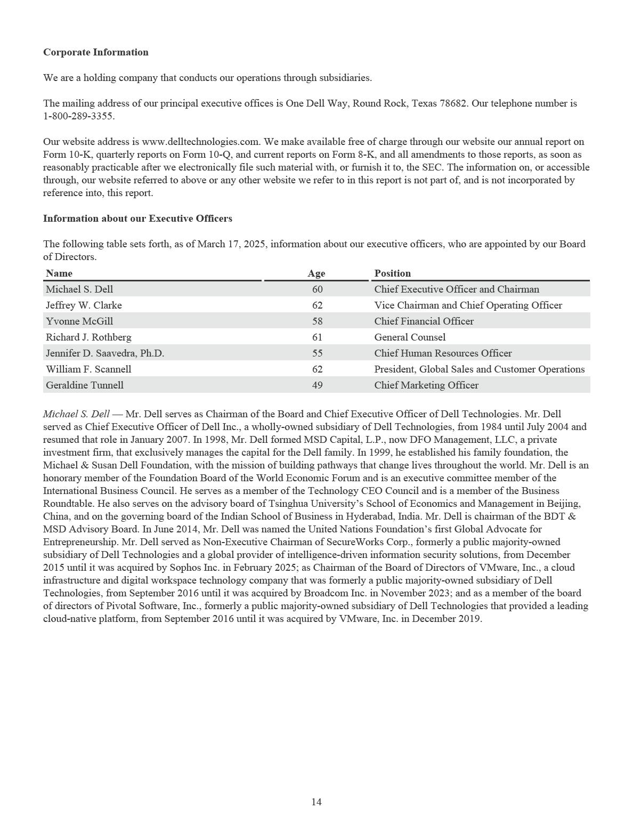

Jeffrey W. Clarke — Mr. Clarke serves as Vice Chairman and Chief Operating Officer of Dell Technologies, responsible for running day-to-day business operations, shaping the Company’s strategic agenda, and setting priorities across the Dell Technologies executive leadership team. Mr. Clarke directs the Infrastructure Solutions Group and the Client Solutions Group and manages Global Operations, including manufacturing, procurement, and supply chain. He is also responsible for setting the long-term strategy and leads planning for emerging technology areas such as Cloud, Edge, Telecom, and as-a-Service. Mr. Clarke served as Chief Operating Officer from December 2019 to August 2021 before resuming that role in August 2023 and as Co-Chief Operating Officer from August 2021 until August 2023, and has served as Vice Chairman since September 2017, before which he served as Vice Chairman and President, Operations and Client Solutions with Dell Technologies and, previously, Dell, since January 2009. From January 2003 until January 2009, Mr. Clarke served as Senior Vice President, Business Product Group. From November 2001 to January 2003, Mr. Clarke served as Vice President and General Manager, Relationship Product Group. In 1995, Mr. Clarke became the director of desktop development. Mr. Clarke joined Dell in 1987 as a quality engineer and has served in a variety of other engineering and management roles. Before joining Dell, Mr. Clarke served as a reliability and product engineer at Motorola, Inc, a global technology company.

Yvonne McGill — Ms. McGill serves as Chief Financial Officer of Dell Technologies. In this role, in which she has served since August 2023, she is responsible for all aspects of the Company’s finance function, including accounting, financial planning and analysis, tax, treasury, and investor relations, as well as corporate development, global business operations and Dell Financial Services. She also partners closely with the office of the CEO to develop and execute a long-term strategy that creates value for Dell Technologies stakeholders. From August 2015 to August 2023, Ms. McGill served in a variety of finance leadership roles at Dell, including Corporate Controller, where she had responsibility for accounting, tax, treasury, and investor relations, Chief Financial Officer and Senior Vice President, Infrastructure Solutions Group, and Senior Vice President, Global Financial Planning and Analysis. Since joining Dell in 1997, Ms. McGill has served in various other finance leadership roles, including Chief Financial Officer for the Company’s Asia-Pacific, Japan and China region and Chief Accounting Officer. Before beginning her service with Dell, Ms. McGill worked at ManTech International Corporation, a company providing technology solutions and services to U.S. intelligence, defense and federal civilian agencies, and Price Waterhouse LLP (now PricewaterhouseCoopers LLP), a firm specializing in accounting, assurance, tax, and consulting services. Ms. McGill serves on the board of directors of Applied Materials, Inc., an international materials engineering company.

Richard J. Rothberg — Mr. Rothberg serves as General Counsel and Secretary for Dell Technologies. In this role, in which he has served since November 2013, Mr. Rothberg oversees the global legal department and manages government affairs, compliance, and ethics. He is also responsible for global security. Mr. Rothberg joined Dell in 1999 and has served in critical leadership roles throughout the legal department. He served as Vice President of Legal, supporting Dell’s businesses in the Europe, Middle East, and Africa region before moving to Singapore in 2008 as Vice President of Legal for the Asia-Pacific and Japan region. Mr. Rothberg returned to the United States in 2010 to serve as Vice President of Legal for the North America and Latin America regions. In this role, he was lead counsel for sales and operations in the Americas and for the enterprise solutions, software, and end-user computing business units. He also led the government affairs organization worldwide. Before joining Dell, Mr. Rothberg served nearly eight years at Caterpillar Inc., an equipment manufacturing company, in senior legal roles in Nashville, Tennessee and Geneva, Switzerland. Mr. Rothberg was also an attorney for IBM Credit Corporation and at Rogers & Wells, a law firm.

Jennifer D. Saavedra, Ph.D. — Dr. Saavedra is Dell Technologies' Chief Human Resources Officer. In this role, Dr. Saavedra leads Dell’s Global Human Resources and Facilities function and accelerates the performance and growth of the Company through its culture and its people. Dr. Saavedra previously served as Dell Technologies’ Senior Vice President, Human Resources – Sales from December 2019 to March 2021 and as its Senior Vice President, Human Resources – Talent and Culture from November 2017 to December 2019. Dr. Saavedra joined Dell in 2005 and has served in many key leadership roles throughout the Human Resources organization, including talent development and culture, business partner, strategy, and learning and development. Before joining Dell in 2005, Dr. Saavedra served as a Human Resources consultant to private and public companies.

15

William F. Scannell — Mr. Scannell serves as President, Global Sales and Customer Operations for Dell Technologies, overseeing Sales, Presales, Specialty Sales, OEM and the Global Alliances and Channel operations. In this role, in which he has served since February 2020, Mr. Scannell is responsible for go-to-market strategy and driving global growth by delivering Dell Technologies’ solutions to organizations in established and new markets globally. Mr. Scannell previously served as President, Global Enterprise Sales and Customer Operations for Dell Technologies from September 2017 to January 2020, leading the sales teams to deliver innovative and practical technology solutions to large enterprises and public institutions worldwide. Prior to joining Dell Technologies, Mr. Scannell served as President, Global Sales and Customer Operations at EMC until EMC was acquired by Dell Technologies in September 2016. In this role, to which he was appointed in July 2012 after overseeing customer operations in the Americas and EMEA, Mr. Scannell focused on driving coordination and teamwork among EMC’s business unit sales forces, as well as building and maintaining relationships with EMC’s largest global accounts, global alliance partners, and global channel partners. Mr. Scannell began his career as an EMC sales representative in 1986, becoming country manager of Canada in 1988. Shortly thereafter, his responsibilities expanded to include the United States and Latin America. In 1999, Mr. Scannell moved to London to oversee EMC’s business across all of Europe, Middle East, and Africa. He then managed worldwide sales in 2001 and 2002 before being appointed Executive Vice President in 2007. Mr. Scannell serves on the board of directors of IonQ, Inc., a quantum computing company.

Geraldine Tunnell — Ms. Tunnell serves as the Chief Marketing Officer for Dell Technologies. In this role, which she has held since March 2024, she is directly responsible for the global marketing organization strategy and all aspects of Dell Technologies’ marketing efforts, which include brand, creative, media, product and field marketing, corporate communications and environmental, social, and governance initiatives. Since joining Dell in 2005, Ms. Tunnell has been instrumental in driving transformation and customer-focused strategies across all of Dell Technologies’ businesses and product lines in various marketing capacities. Ms. Tunnell previously served as Senior Vice President of Global Field and Partner Marketing from 2018 to March 2024. Prior to joining Dell, Ms. Tunnell was a management consultant at CapGemini Ernst & Young, a multinational IT services and consulting company, and worked in Silicon Valley at a start-up enterprise focused on supply chain management.

16

ITEM 1A — RISK FACTORS

Our business, operating results, financial condition, and prospects are subject to a variety of significant risks, many of which are beyond our control. The following is a description of material risk factors that may cause our actual results in future periods to differ substantially from those we currently expect or seek. The risks described below are not the only risks we face. There are additional risks and uncertainties not currently known to us or that we currently deem to be immaterial that also may materially adversely affect our business, operating results, financial condition, or prospects.

Risks Relating to Our Business and Our Industry

Adverse global economic conditions may harm our business and result in reduced net revenue and profitability.

As a global company with customers operating in a broad range of businesses and industries, our performance is affected by global and regional economic conditions and the demand for technology products and services in international markets. Adverse economic conditions may negatively affect customer demand, and could result in postponed or decreased spending amid customer concerns over elevated inflation and interest rates or slowing demand for their products, reduced asset values, volatile energy costs, the availability and cost of credit, and the stability of financial institutions, financial markets, businesses, local and state governments, and sovereign nations. In Fiscal 2025, global economic uncertainty adversely affected the demand for our products and services as some of our larger customers exhibited caution in their IT spending.

Factors contributing to weak or unstable global or regional economic conditions, including those attributable to geopolitical volatility (such as ongoing military conflicts and terrorism), extreme weather events (such as wildfires or flooding), international trade protection measures and disputes, or public health issues also could harm our business by contributing to product shortages or delays, supply chain disruptions, insolvency of key suppliers, customers and counterparties, increased product costs and associated price increases, reduced global sales, and other adverse effects on our operations. Any such effects could have a negative impact on our net revenue and profitability.

Trade policies and disputes could result in increased tariffs and other trade restrictions and protectionist measures, which could increase our manufacturing costs, increase prices of and reduce demand for our products, limit our ability to sell to certain customers, hamper our procurement of components or raw materials, or impede or slow the movement of our goods across borders.

Competitive pressures may adversely affect our industry unit share position, revenue, and profitability.

We operate in an industry in which there are rapid technological advances in hardware, software, and services offerings, including AI, cloud, and security-related offerings. Our ability to respond to such advances and to develop new or improved offerings is critical to our continued success. We face aggressive competition from a variety of competitors in all areas of our business, including companies that specialize in one or more of our product or service lines. Our competitors may provide offerings that are less costly, perform better, or include additional features. Further, our offering portfolios may quickly become outdated or our market share may quickly erode. Our efforts to balance the mix of products and services to optimize profitability, liquidity, and growth may put pressure on our industry position. If we do not successfully adapt to industry developments and changing demand, and evolve our business to keep pace with the demands of current and prospective customers, we may be unable to develop and maintain a competitive advantage, which would adversely affect our unit share position, revenue, and profitability.

In addition, companies with which we have strategic alliances may become competitors in other product areas, or current competitors may enter into new strategic relationships with new or existing competitors, all of which may further increase competitive pressures.

17

The operating results of our business units may be adversely affected if we fail to successfully execute our strategy and related initiatives.

We pursue a strategy of providing broad and innovative technology solutions for the data and artificial intelligence era and being at the forefront of AI, software-defined, and cloud native infrastructure solutions. To successfully execute our strategy, we must continue to improve cost structures, optimize sales coverage, improve channel execution, manage the increasingly difficult tasks of inventory management and demand forecasting, and strengthen our capabilities in our areas of strategic focus, while continuing to achieve product innovation that builds on our strategic capabilities in areas such as edge computing, hybrid cloud, artificial intelligence, data center networking, network security, and high-performance computing. The operating results of our business units may be adversely affected if we fail to successfully execute our strategy and related initiatives.

We are organized into two business units consisting of ISG and CSG that are each important components of our strategy. ISG offers a portfolio of storage, server, and networking solutions, including AI-optimized technologies, and faces intense competition from existing on-premises competitors and increasing competitive pressures from Infrastructure-as-a-Service providers. Accordingly, we expect we will be required to make additional investments to address such competitive pressures and drive future growth. Such pressures could result in the erosion of revenue and operating income and negatively affect ISG’s results of operations. To address industry trends, we have developed and continue to develop traditional, converged, and hyper-converged infrastructure solutions as well as AI-optimized products and solutions. ISG’s results of operations could be adversely affected if such products and solutions are not adopted by our customers or potential customers, or if customers move rapidly to adopt public cloud solutions.

CSG largely relies on sales of notebooks, desktops, and workstations. Revenue from CSG absorbs our overhead costs and provides for scaled procurement. CSG faces risks and uncertainties from fundamental changes in the personal computer market, including a decline in worldwide revenues for notebooks, desktops, and workstations, and lower shipment forecasts for these products due to a general lengthening of the replacement cycle. Reduced demand for PC products or a significant increase in competition could cause our operating income to fluctuate and adversely impact CSG’s results of operations.

Our relationships with our product and component vendors could harm our business by adversely affecting product availability, delivery, reliability, and cost.

Our reliance on vendors subjects us to a greater risk of shortages and reduced control over delivery schedules of components and products, as well as a greater risk of increases in product and component costs.

We obtain many products and all of our components from third-party vendors, many of which are located outside of the United States. In addition, significant portions of our products are assembled by contract manufacturers, primarily in various locations in Asia. A significant concentration of such outsourced manufacturing is performed by only a few contract manufacturers, often in single locations. We sell components to these contract manufacturers and generate large non-trade accounts receivables, an arrangement that would present a risk of uncollectibility if the financial condition of a contract manufacturer should deteriorate.

We may experience additional supply shortages and price increases caused by changes to raw material availability, manufacturing capacity, labor shortages, public health issues, tariffs, trade disputes and protectionist measures, extreme weather events or effects of climate change, and significant changes in the financial condition of our suppliers. Because we generally maintain minimal levels of component and product inventories, a disruption in component or product availability could harm our ability to fill customer orders on a timely basis and at an acceptable price. The impact of supply constraints on our operations may be more acute during periods of rapid growth in demand for new products and services, such as the current demand for AI-optimized solutions. We are also subject to risks associated with our receipt from vendors of defective parts and products, which could require the replacement of such parts and products and expose us to reputational harm.

Our profitability is affected by our ability to achieve favorable pricing from vendors and contract manufacturers, including through negotiations for vendor rebates, marketing funds, and other vendor funding received in the normal course of business. Because these supplier negotiations are continual and reflect the evolving competitive environment, the variability in timing and amount of incremental vendor discounts and rebates can affect our profitability. The vendor programs may change periodically, and changes in our business may result in increased reliance of vendors with less favorable pricing terms, potentially resulting in adverse profitability trends if we cannot adjust pricing or variable costs. An inability to establish a cost and product advantage, or determine alternative means to deliver value to customers, may adversely affect our revenue and profitability.

18

Our use of single-source or limited-source suppliers may adversely affect the availability or timely delivery of some critical products or components.

We maintain several single-source or limited-source supplier relationships, including relationships with third-party software providers, either because multiple sources are not readily available or because the relationships are advantageous due to performance, quality, support, delivery, capacity, or price considerations. A delay in the supply of a critical single- or limited-source product or component may prevent the timely shipment of the related product in desired quantities or configurations. In addition, we may not be able to replace the functionality provided by third-party software currently offered with our products if that software becomes obsolete, defective, or incompatible with future product versions or is not adequately maintained or updated. Even where multiple sources of supply are available, qualification of the alternative suppliers and establishment of reliable supplies could result in delays and a possible loss of sales, which could harm our operating results.

The nature of the demand for AI solutions may have adverse effects on our operating performance.

While we expect the buyer base for our AI solutions to continue to expand, to date our AI solutions have been purchased primarily by a small number of larger customers and cloud service providers. If we are not successful in continuing to expand sales to a broader base of customers, our ability to maintain growth in this area may be limited. Sales of AI to large customers may also cause fluctuations in our results of operations, as such large orders may occur in some periods and not others and are generally subject to intense competition and pricing pressure, which can have an impact on our margin and results of operations. Larger orders may also require greater commitments of working capital, such as for purchases of key components, which could adversely affect our cash flow and expose us to the risk of holding excess and obsolete inventory due to delays or cancellations. These transactions may also involve larger amounts of credit or longer payment terms than have been typical for our business, increasing our risks in the event customers do not pay or make timely payment, particularly where our payment terms with major suppliers of underlying components differ from the payment terms of our customers. In addition, the accelerated rate of innovation of components from our suppliers may result in higher defects or failure of our offerings to perform, which could cause us to incur increased warranty costs, inventory provisions or impairments and could impact future sales.

Risks associated with management of our AI solutions and use of AI in our internal functions and operations could result in reputational harm, legal liability, and other adverse effects on our business.

The use of AI in our products and services presents ethical and legal risks to our business, financial condition, and results of operations. If our use of AI becomes controversial, we may experience loss of user trust, as well as brand or reputational harm, competitive injury, or legal liability. The use of AI technologies also could expose us to an increased risk of cybersecurity threats and incidents and claims or other adverse effects from infringements or violations of intellectual property, including claims related to AI technologies considered to have similarities to other AI technologies. Our use of such technologies could increase the risk of exposure of our or other parties’ proprietary confidential information, or other confidential or sensitive information, to unauthorized recipients, including inadvertent disclosure of confidential or sensitive information into publicly available third-party training sets, and may affect our ability to realize the benefit of, or adequately maintain, protect and enforce, our intellectual property or confidential information. Such risks related to the use of AI could, whether directly or indirectly, harm our results of operations, competitive position, and business.

AI is the subject of evolving review by various domestic and international governmental and regulatory agencies, including the SEC and the U.S. Federal Trade Commission, and laws, rules, directives and regulations governing the use of AI, such as the EU Artificial Intelligence Act, are changing and evolving rapidly. We may not always be able to anticipate how to respond to these legal frameworks for AI use and we may have to expend resources to adjust or audit our products and services in certain jurisdictions, especially if the legal frameworks are not consistent across jurisdictions. In particular, use of personal data in foundational models and intellectual property ownership and license rights, including copyright, of generative and other AI output, have not been fully interpreted by courts or regulations. Any failure or perceived failure by us to comply with laws, rules, directives, and regulations governing the use of AI could have an adverse impact on our business, and we may not be able to claim intellectual property ownership and license rights on content or source code that we create using AI.

19

Failure to deliver high-quality products, software, and services, or to manage solutions and product and services transitions in an effective manner, could reduce demand and negatively affect the profitability of our operations.

We must identify and address quality issues associated with our products, software, and services, many of which include third-party components. Although quality testing is performed regularly to detect quality problems and implement required solutions, failure to identify and correct significant product quality issues before the sale of such products to customers could result in lower sales, increased warranty or replacement expenses, and reduced customer confidence, which could harm our operating results.

In addition, continuing improvements in technology, and the development of new technology, result in the frequent introduction of new solutions, products, and services, improvements in product performance characteristics, and short product life cycles. If we fail to effectively manage transitions to new solutions and offerings, the products and services associated with such offerings and customer demand for our solutions, products, and services could diminish, and our profitability could suffer.

We frequently source new products and transition existing products through our contract manufacturers and manufacturing outsourcing relationships to generate cost efficiencies and better serve our customers. The success of product transitions depends on various factors that include the availability of sufficient quantities of components at an acceptable cost. Product transitions also present execution uncertainties and risks, including the risk that new or upgraded products may have quality problems or other defects.

Failure to successfully implement our cost efficiency plans may negatively affect our future results.

We continue to make significant changes to modernize the way we work and make decisions, improve business outcomes and the customer experience, and reduce costs by leveraging new technology and optimizing business processes. We are pursuing disciplined cost management in coordination with our ongoing business modernization initiatives and will continue to take certain measures to reduce costs, including limitation of external hiring, employee reorganizations, and other actions to align our investments with our strategic priorities and customer needs. As a result of these actions, we may experience a loss of continuity, loss of accumulated knowledge, diminished employee productivity, disruptions to our operations, and operational inefficiencies during transitional periods. These actions could also negatively impact employee retention. We may experience delays or unanticipated costs in implementing our cost efficiency plans, which could prevent the timely or full achievement of expected cost efficiencies and adversely affect our competitive position and results of operations.

Strategic acquisitions and dispositions we pursue may require us to incur costs and expose us to liabilities that could harm our business and adversely affect our financial performance.

We may make additional strategic acquisitions of other companies as part of our growth strategy. These transactions may fail to generate a financial return sufficient to offset acquisition costs. We could experience unforeseen operating difficulties in integrating the businesses, technologies, services, products, personnel, or operations of acquired companies, especially if we are unable to retain the key personnel of an acquired company. Acquisitions may result in a delay or reduction of sales because of customer uncertainty and may disrupt our existing business by diverting resources and management attention. Acquisitions also may negatively affect our relationships with strategic partners if they view the transactions as bringing us into competition. To complete an acquisition, we may be required to use substantial amounts of cash, engage in equity or debt financings, or enter into credit agreements to secure additional funds. Such debt financings could involve financial or restrictive covenants that might limit our capital-raising activities and operating flexibility. Further, an acquisition may expose us to unexpected liabilities, require the incurrence of charges and substantial indebtedness or other liabilities, have adverse tax consequences, result in acquired in-process research and development expenses, or require the amortization, write-down, or impairment of amounts related to deferred compensation, goodwill, and other intangible assets.

In addition, we periodically divest businesses, including businesses that are no longer a part of our strategic plan. These divestitures require significant investment of time and resources, may disrupt our business and distract management from other responsibilities, and may result in losses on disposition or continued financial involvement in the divested business, including through indemnification or other financial arrangements, which could adversely affect our financial results.

20

Security incidents, including cyber-attacks, could disrupt our operations and result in the compromise of networks, systems, and assets, and the breach or loss of proprietary, personal, or confidential information of our company or of our workforce, customers, partners, or third parties.

We routinely receive, collect, manage, store, transmit, and process large amounts of proprietary information and confidential data, including personally identifiable and other sensitive information, relating to our operations, products, partners, and customers. We face numerous sophisticated and evolving cyber threats of significant scale, volume, severity, and complexity, including threats specifically designed for or directly targeted at us, making it increasingly difficult to defend against security incidents successfully or to implement adequate preventative measures.

Our cybersecurity program may not always successfully manage or mitigate the effects of these risks. Future cyber-attacks or incidents, such as some of those we have experienced in the past, could persist undetected in our environments for a period of time. Despite our cybersecurity governance and investment in controls and security measures, threat actors, including nation states and state-sponsored organizations, pose a significant risk of penetrating or bypassing our security defenses, including by utilizing insider threat tactics or utilizing AI tools against our defenses, breaching our information technology systems, and misappropriating or compromising confidential and proprietary information of our company, our partners, or our customers, causing system disruptions and shutdowns, introducing ransomware, malware, or vulnerabilities into our products, systems, and networks or those of our customers and partners, or accessing systems and networks of our customers or partners through connectivity to or credentials taken from our network. In some cases these incidents, which are common in our industry for companies of our size, have resulted in successful attacks on our IT environments.

We are targeted by criminal and other threat actors that conduct cyber-attacks of our systems and networks on an ongoing basis. We have experienced cyber-attacks that leveraged compromised credentials of our partners, employees, and customers to gain unauthorized access to Dell Technologies, partner, and vendor systems and confidential information, including information about our customers, employees, and partners. These incidents have caused, and may in the future cause, disruption to parts of our business operations and could result in regulatory, investigative, recovery, remediation, and litigation expenses. We anticipate that our systems and networks will continue to be targeted by criminal and other threat actors with increasing frequency and potential harm. In particular, we expect that attacks by nation state actors and their agents may intensify during periods of geopolitical conflict.

The costs to address cybersecurity risks, both before and after a security incident, could be significant, regardless of whether incidents result from an attack on us directly, on customers we service, or on partners or third-party vendors upon which we rely. The costs associated with cybersecurity tools and infrastructure and competition for scarce cybersecurity and IT resources have at times limited, and may in the future limit, our ability to identify, eliminate, or remediate cybersecurity or other security vulnerabilities or problems or enact changes to minimize the attack surface of our network.

Our customers, partners, and third-party vendors continue to experience security incidents of varying severity and differing attack methods. These parties possess or transmit our proprietary information and confidential data, including personal data, personally identifiable information, and other sensitive information, which may be exfiltrated if they are affected by a security incident. Targeted cyber-attacks or those that result from a security incident directed at a partner or third-party vendor create a risk of compromise to our internal systems, products, services, and offerings, as well as the systems of our customers, which could result in interruptions, delays, or cessation of service that could disrupt business operations for us and our customers. Our proactive measures and remediation efforts may not always be successful or timely. In addition, compromises of our security measures, including through the use and the unapproved dissemination of proprietary information or sensitive or confidential data about us, our customers, partners or other third parties, could impair our intellectual property rights and expose us, our customers, partners, or such other third parties to a risk of loss or misuse of such information or data. Any such incidents could subject us to government investigations and regulatory enforcement actions, litigation, potential liability, and damage to our brand and reputation, or otherwise harm our business and operations.

21

Hardware, software, and applications that we produce or procure from third parties may contain defects in design or manufacture or other deficiencies, including security vulnerabilities that could interfere with the operation or security of our products, services, and offerings. In the event of a security vulnerability or other flaws in third-party components or software code, we may have to rely on multiple third parties to mitigate vulnerabilities. The mitigation techniques they deploy may be ineffective or result in adverse performance, system instability, or data loss, and may not always be available, or available on a timely basis. Further, our use of AI technologies, including generative AI, may make us susceptible to unanticipated security threats from adversaries as we incorporate such technologies into our internal systems, customer-facing services and products, while our understanding of AI-related security risks and protection methods continues to develop.

Any actual or perceived security vulnerabilities in our products or services, or those of third-party products we sell or in the open-source software we utilize, could lead to loss of existing or potential customers, and may impede our sales, manufacturing, distribution, outsourcing services, information technology solutions, and other critical functions and offerings. Failure to comply with internal security policies and standards, including secure development lifecycle practices, or to prevent or promptly mitigate security vulnerabilities in our products and offerings may adversely affect our brand and reputation, impact our ability to sell products in certain jurisdictions, and subject us to government investigations, regulatory enforcement actions, litigation, and potential liability resulting from our inability to fulfill our contractual obligations to our customers and partners.

As a global enterprise, we face compliance risks under a significant and increasing number of laws and regulations in the United States, the European Union, China, and numerous other jurisdictions relating to cybersecurity, product security, software supply chain security and AI, and the collection, use, residency, transfer, and protection of data. Such laws and regulations continue to evolve, may be applied differently in different jurisdictions, and could result in increased costs in the event of a significant disruption of our operations, data or privacy breach, loss, or other compromise of proprietary or confidential information as a result of a cyber-attack or insider activity. It is likely that in some cases, we will fail to comply with such requirements, and any such non-compliance could adversely affect our ability to conduct business or sell our products or offerings in a specific jurisdiction or result in fines or penalties that could negatively affect our financial results.

Our ability to generate substantial non-U.S. net revenue is subject to additional risks and uncertainties.

Sales outside the United States accounted for approximately half of our consolidated net revenue for Fiscal 2025. Our future growth rates and success are substantially dependent on the continued growth of our business outside of the United States. Our international operations face many risks and uncertainties, including varied local economic and labor conditions; political instability; public health issues; changes in the U.S. and international regulatory environments; the impacts of trade protection measures, including increases in tariffs and trade barriers, and other changes in international trade arrangements that could adversely affect our ability to conduct business in non-U.S. markets; changes in tax laws; potential theft or other compromise, and limited or unfavorable protection, of our technology, data, or intellectual property; copyright levies; and volatility in foreign currency exchange rates. We could incur additional operating costs, or sustain supply chain disruptions, due to any such changes. Any of these factors could negatively affect our international business results and growth prospects.

Our profitability may be adversely affected by changes in the mix of products and services, customers, or geographic sales, and by seasonal sales trends.

Our overall profitability for any period may be adversely affected by changes in the mix of products and services, customers, or geographic markets reflected in sales for that period, and by seasonal trends. Profit margins vary among products, services, customers, and geographic markets. In addition, parts of our business are subject to seasonal sales trends. Within ISG, our storage sales are typically stronger in our fourth fiscal quarter. Our sales within the Americas are typically stronger in the second and fourth fiscal quarters, while our sales in EMEA are typically stronger during the fourth fiscal quarter. Seasonality in our business may change over time.

22

We may lose revenue opportunities and experience gross margin pressure if sales channel participants fail to perform as expected.

We rely on value-added resellers, system integrators, distributors, and retailers as sales channels to complement our direct sales organization. Our future operating results depend on the performance of sales channel participants and on our success in maintaining and developing these relationships. Our revenue and gross margins could be negatively affected if the financial condition or operations of channel participants weaken as a result of adverse economic conditions or other business challenges, or if uncertainty regarding the demand for our products causes channel participants to reduce their orders for these products. Further, channel participants may consider our direct sales initiatives to conflict with their business interests, which could lead them to reduce their investment in the distribution and sale of such products, or to cease all sales of our products.

Our financial performance is dependent on access to the capital markets by us or some of our customers.

We may access debt and capital sources to provide financing for customers and to obtain funds for general corporate purposes, including working capital, acquisitions, capital expenditures, and funding of customer receivables. The debt and capital markets may experience extreme volatility and disruption from time to time, which could result in higher credit spreads in such markets and higher funding costs for us.

In addition, we maintain customer financing relationships with some companies that rely on access to the debt and capital markets to meet significant funding needs. Any inability of these companies to access such markets could compel us to self-fund transactions with such companies or to forgo customer financing opportunities, which could harm our financial performance.

Deterioration in our business performance, a credit rating downgrade, volatility in the capital markets, changes in financial services regulation, or adverse changes in the economy could lead to reductions in the availability of debt financing. In addition, these events could limit our ability to continue asset securitizations or other forms of financing from debt or capital sources, reduce the amount of financing receivables that we originate, or negatively affect the costs or terms on which we may be able to obtain capital. Any of these developments could adversely affect our net revenue, profitability, and cash flows.

Weak economic conditions, changing customer mix, and additional regulation could harm our financial services activities.

Our financial services activities, conducted primarily through Dell Financial Services, can be negatively affected by adverse economic conditions that contribute to loan delinquencies and defaults. An increase in loan delinquencies and defaults would result in greater net credit losses, which may require us to increase our reserves for customer receivables.

In addition, the implementation of new financial services regulation, or the application of existing financial services regulation, in countries where we conduct our financial services and related supporting activities, could unfavorably affect the profitability and cash flows of our consumer financing activities.

We are subject to counterparty default risks.

We have numerous arrangements with financial institutions that include cash and investment deposits, interest rate swap contracts, foreign currency option contracts, and forward contracts. As a result, we are subject to the risk that the counterparty to one or more of these arrangements will default, either voluntarily or involuntarily, on its performance under the terms of the arrangement. In times of market distress, a counterparty may default rapidly and without notice, and we may be unable to take action to cover its exposure, either because of lack of contractual ability to do so or because market conditions make it difficult to take effective action. If one of our counterparties becomes insolvent or files for bankruptcy, our ability eventually to recover any losses suffered as a result of that counterparty’s default may be limited by the impaired liquidity of the counterparty or the applicable legal regime governing the bankruptcy proceeding. In the event of such a default, we could incur significant losses, which could harm our business and adversely affect our results of operations and financial condition.

23

If the value of our goodwill or intangible assets is materially impaired, our results of operations and financial condition could be materially and adversely affected.

As of January 31, 2025, our goodwill and intangible assets, net had a combined carrying value of $24.1 billion, representing approximately 30% of our total consolidated assets. We periodically evaluate goodwill and intangible assets, net to determine whether all or a portion of their carrying values may be impaired, in which case an impairment charge may be necessary. The value of goodwill may be materially and adversely affected if businesses that we acquire perform in a manner that is inconsistent with our assumptions at the time of acquisition. In addition, from time to time we divest businesses, and any such divestiture could result in significant asset impairment and disposition charges, including those related to goodwill and intangible assets, net. Any future evaluations resulting in an impairment of goodwill or intangible assets, net could materially and adversely affect our results of operations and financial condition in the period in which the impairment is recognized.

Our performance and business could suffer if our contracts for ISG services and solutions fail to produce revenue at expected levels due to exercise of customer rights under the contracts, inaccurate estimation of costs, or customer defaults in payment.

We offer our ISG customers a range of consumption models for our services and solutions, including as-a-Service, utility, lease, or immediate pay models, designed to match customers’ consumption preferences. These solutions generally are multiyear agreements that typically result in recurring revenue streams over the term of the arrangement. Our financial results and growth depend, in part, on customers continuing to purchase our services and solutions over the contract life on the agreed terms. The contracts allow customers to take actions that may adversely affect our recurring revenue and profitability. These actions may include terminating a contract if our performance does not meet specified services levels, requesting rate reductions, reducing the use of our services and solutions or terminating a contract early upon payment of agreed fees. In addition, we estimate the costs of delivering the services and solutions at the outset of the contract. If we fail to estimate such costs accurately and actual costs significantly exceed estimates, we may incur losses on the contracts. We also are subject to the risk of loss under the contracts as a result of a default, voluntarily or involuntarily, in payment by the customer, whether because of financial weakness or other reasons.

Loss of government contracts could harm our business.

Our contracts with U.S. federal, state, and local governments and with foreign governments represent a significant source of business and are subject to future funding that may affect the extension or termination of programs and to the right of such governments to terminate contracts for convenience or non-appropriation. In addition, there is pressure to reduce spending on governments, both domestically and internationally, notably in recent periods on U.S. federal government agencies. Funding reductions, uncertainties or delays could adversely affect public sector demand for our products and services. In addition, if we violate legal or regulatory requirements, the applicable government could suspend or disbar us as a contractor, which would unfavorably affect our net revenue and profitability.

Our business could suffer if we do not develop and protect our proprietary intellectual property or obtain or protect licenses to intellectual property developed by others on commercially reasonable and competitive terms.

If we or our suppliers are unable to develop or protect desirable technology or obtain technology licenses, we may be prevented from marketing products, may have to market products without desirable features, or may incur substantial costs to redesign products. We also may have to defend or enforce legal actions or pay damages and comply with injunctions in jurisdictions throughout the world if we are found to have violated patents, including standard essential patents, or other intellectual property rights of other parties. Although our suppliers might be contractually obligated to obtain or protect such licenses and indemnify us against related expenses and injunctions, those suppliers could be unable to meet their obligations. We invest in research and development and obtain additional intellectual property through acquisitions, but those activities do not guarantee that we will develop or obtain intellectual property necessary for profitable operations. Costs involved in developing and protecting rights in intellectual property may have a negative impact on our business. In addition, our operating costs could increase because of copyright levies or similar fees by rights holders and collection agencies in European and other countries. New regulations, legislation and executive orders may also create uncertainty for our ability to develop or protect desirable technology or obtain technology licenses.

24

Infrastructure disruptions could harm our business.

We depend on our information technology and manufacturing infrastructure to achieve our business objectives. Natural disasters, manufacturing failures, telecommunications system failures, or defective or improperly installed new or upgraded business management systems could lead to disruptions in this infrastructure. Portions of our IT infrastructure, including those provided by third parties, also may experience interruptions, delays, or cessations of service, or produce errors in connection with systems integration or migration work. Such disruptions may adversely affect our ability to receive or process orders, manufacture and ship products in a timely manner, or otherwise conduct business in the normal course. Further, portions of our business involve the processing, storage, and transmission of data, which also would be negatively affected by such an event. Disruptions in our infrastructure could lead to loss of customers and revenue, particularly during a period of heavy demand for our products and services. We also could incur significant expense in repairing system damage and taking other remedial measures.

Failure to hedge effectively our exposure to fluctuations in foreign currency exchange rates and interest rates could adversely affect our financial condition and results of operations.

We utilize derivative instruments to hedge our exposure to fluctuations in foreign currency exchange rates and interest rates. Some of these instruments and contracts may involve elements of market and credit risk in excess of the amounts recognized in our financial statements. Global economic events, including trade disputes, economic sanctions and emerging market volatility, and associated uncertainty could cause currencies to fluctuate, which may contribute to variations in our sales of products and services in various jurisdictions. If we are not successful in monitoring our foreign exchange exposures and conducting an effective hedging program, our foreign currency hedging activities may not offset the impact of fluctuations in currency exchange rates on our results of operations and financial position.

Adverse legislative or regulatory tax changes, the expiration of tax holidays or favorable tax rate structures, or unfavorable outcomes in tax audits and other tax compliance matters could result in an increase in our tax expense or our effective income tax rate.

Changes in tax laws could adversely affect our operations and profitability. In recent years, numerous legislative, judicial, and administrative changes have been made to tax laws applicable to us and similar companies. The Organisation for Economic Co-operation and Development (the “OECD”) is continuing discussions regarding fundamental changes in the allocation of profits among tax jurisdictions in which companies do business, as well as the implementation of a global minimum tax, referred to as the “Pillar One” and “Pillar Two” proposals. Many countries, including countries in which we have tax holidays, have enacted or are in the process of enacting laws based on the Pillar Two proposal. Our effective tax rate and cash tax payments could

increase in future years as a result of these changes.

Portions of our operations are subject to a reduced tax rate under various tax holidays that expire in whole or in part from time to time. Many of these holidays may be extended when certain conditions are met, or may be terminated if certain conditions are not met or as a result of changes in tax legislation. If the tax holidays are not extended, if tax legislation changes, or if we fail to satisfy the conditions of the reduced tax rate, our effective tax rate would be affected. Our effective tax rate also could be impacted if our geographic distribution of earnings changes. In addition, any actions by us to repatriate non-U.S. earnings for which we have not previously provided for U.S. taxes may affect the effective tax rate.

We are continually under audit in various tax jurisdictions, including the United States. We may not be successful in resolving potential tax claims that arise from these audits. A final determination of tax audits or disputes may differ from what is reflected in our historical income tax provisions or benefits and accruals. An unfavorable outcome in certain of these matters could result in a substantial increase in our tax expense. Further, our provision for income taxes could be adversely affected by changes in the valuation of deferred tax assets.

25

Our profitability could suffer from declines in fair value or impairment of our portfolio investments.

We invest a portion of our available funds in a portfolio consisting of both equity and debt securities of various types and maturities pending the deployment of these funds in our business. Our equity investments consist of strategic investments in both marketable and non-marketable securities. Investments in marketable securities are measured at fair value on a recurring basis. We have elected to apply the measurement alternative for non-marketable securities. Under the alternative, we measure investments without readily determinable fair values at cost, less impairment, adjusted by observable price changes. Our debt securities generally are classified as held to maturity and are recorded in our financial statements at amortized cost. Our earnings performance could suffer from declines in fair value or impairment of our investments.

Unfavorable results of legal proceedings could harm our business and result in substantial costs.

We are involved in various claims, suits, investigations, and legal proceedings that arise from time to time in the ordinary course of business or otherwise. Additional legal claims or regulatory matters affecting us and our subsidiaries may arise in the future and could involve stockholder, consumer, regulatory, compliance, intellectual property, antitrust, tax, trade, privacy, and other issues on a global basis. Litigation is inherently unpredictable. Regardless of the merits of a claim, litigation may be both time-consuming and disruptive to our business. We could incur judgments or enter into settlements of claims that could adversely affect our operating results or cash flows in a particular period. Even if we are not named a party to a particular suit, we may be subject to indemnification obligations to the named parties, including our directors and executive officers as well as other third parties, that could subject us to liability for damages or other amounts payable as a result of such judgments or settlements. In addition, our business, operating results, and financial condition could be adversely affected if any infringement or other intellectual property claim made against us by any third party is successful, resulting in damages being assessed and injunctions granted, or if we fail to develop non-infringing technology or license the proprietary rights on commercially reasonable terms and conditions.

Evolving and varied stakeholder expectations and regulatory requirements with respect to sustainability and ESG activities could harm our reputation, adversely affect our business, and expose us to regulatory proceedings and litigation.

Many stakeholders are increasingly focused on ESG considerations with evolving and varied expectations that could expose us to heightened scrutiny and various financial, legal, reputational, operational, compliance, and other risks. We make statements about sustainability and ESG goals and initiatives through our SEC filings, our annual ESG report, our other non-financial reports, information provided on our website, press statements and other communications. Responding to these considerations and successful implementation of these goals and initiatives involves risks and uncertainties, is not guaranteed, and is subject to numerous conditions, as well as standards, processes, regulations, and methodologies that continue to evolve. Any failure, or perceived failure, by us to achieve our sustainability and ESG goals, further our initiatives, adhere to our public statements, comply with federal, state, or international ESG laws and regulations, or meet evolving and varied stakeholder expectations could harm our reputation, adversely affect our business, financial condition or results of operations, and expose us to liabilities under regulatory proceedings or litigation instituted in the United States or in other countries.

In recent periods, regulators in various jurisdictions have increasingly expressed or pursued opposing views, legislation, and expectations with respect to sustainability initiatives. Conflicting regulations and a lack of harmonization of ESG legal and regulatory environments across the jurisdictions in which we operate may create enhanced compliance risks and costs.

Global climate change, and legal, regulatory, or market measures related to climate change, may negatively affect our business, operations, and financial results.

We are subject to risks associated with the long-term effects of climate change on the global economy and on the IT industry in particular. The physical risks associated with climate change include the adverse effects of carbon dioxide and other greenhouse gases on global temperatures, weather patterns, and the frequency and severity of natural disasters. Extreme weather and natural disasters within or outside the United States could make it more difficult and costly for us to manufacture and deliver our products to our customers, obtain production materials from our suppliers, or perform other critical corporate functions.

26

Concern over climate change could also result in transition risks such as shifting customer preferences or regulatory changes. Changing customer preferences may result in increased demands regarding our solutions, products, and services, including the use of packaging materials and other components in our products and their environmental impact on sustainability. These demands may cause us to incur additional costs or make other changes to other operations to respond to such demands, which could adversely affect our financial results.

Concern over climate change could result in new legal requirements for us to reduce greenhouse gas emissions and other environmental impacts of our operations, improve our energy efficiency, or undertake sustainability measures that exceed those we currently pursue. Any such regulatory requirements could cause disruptions in the manufacture of our products and result in increased procurement, production, and distribution costs.

Our compliance with current or future environmental and safety laws could have an adverse effect on our business.

Our operations are subject to environmental and safety regulations in all areas in which we conduct business. Product design and procurement operations must comply with new and future requirements relating to climate change laws and regulations, materials composition, sourcing, energy efficiency and collection, recycling, treatment, transportation, and disposal of electronics products, including restrictions on mercury, lead, cadmium, lithium metal, lithium ion, and other substances. If we fail to comply with applicable rules and regulations regarding the transportation, source, use, and sale of such regulated substances, we could be subject to liability. The costs and timing of costs under environmental and safety laws are difficult to predict, but could have an adverse impact on our business.

Compliance requirements of anti-corruption laws, economic sanctions and other trade laws, human rights laws and other laws regulating our international operations may expose us to potential liability, increase our operating costs and otherwise harm our business.

We and our subsidiaries are subject to various anti-corruption laws that prohibit improper payments or offers of payments to foreign governments and their officials for the purpose of obtaining or retaining business, and are also subject to export controls, country and product specific tariffs, customs, economic sanctions laws, and embargoes imposed by the U.S. government. Violations of the U.S. Foreign Corrupt Practices Act or other anti-corruption laws or export control, customs, trade, or economic sanctions laws may result in severe criminal or civil sanctions and penalties, and we and our subsidiaries may be subject to other liabilities that could have a material adverse effect on our business, results of operations, and financial condition.

We are subject to various human rights laws, including provisions of the EU Forced Labor Regulations, US Uniform Forced Labor Protection Act, and the Dodd-Frank Wall Street Reform and Consumer Protection Act intended to improve transparency and accountability concerning the supply of minerals originating from the conflict zones of the Democratic Republic of the Congo or adjoining countries. We incur costs to comply with the disclosure requirements of this law and other costs relating to the sourcing and availability of minerals used in our products. Further, we may face reputational harm if our customers or other stakeholders conclude that we are unable to sufficiently verify the origins of the minerals used in our products.

We are highly dependent on the services of Michael S. Dell, our Chief Executive Officer, and our loss of, or our inability to continue to attract, retain, and motivate, executive talent and other employees in this highly competitive market could harm our business.

We are highly dependent on the services of Michael S. Dell, our founder, Chief Executive Officer, and largest stockholder. Further, we rely on key personnel, including Jeff Clarke and other members of our executive leadership team, to support our business and increasingly complex product and services offerings. Our experienced executives are supported by employees in our U.S. and international operations who are highly skilled in product development, manufacturing, sales, and other functions critical to our future growth and profitability. If we lose the services of Mr. Dell or other key personnel, we may not be able to locate suitable or qualified replacements, and we may incur additional expenses to recruit replacements, which could severely disrupt our business and growth. We face intensive competition, both within and outside of our industry, in retaining and hiring individuals with the requisite expertise. As a result of this competition, we may be unable to continue to attract, retain, and motivate suitably qualified individuals at acceptable compensation levels who have the managerial, operational, and technical knowledge and experience to meet our needs. Failure by us to do so could adversely affect our competitive position and results of operations.

27

We have outstanding indebtedness and may incur additional debt in the future, which could adversely affect our financial condition.

As of January 31, 2025, we and our subsidiaries had approximately $24.6 billion of indebtedness. As of the same date, we and our subsidiaries may incur up to $5.0 billion of short-term indebtedness under our commercial paper program and up to $6.0 billion of additional indebtedness under our revolving credit facility, which acts as a backstop to provide liquidity for the commercial paper program. Although continued debt paydown is part of our overall capital allocation strategy, a substantial portion of our cash flow from operations is used to make interest and other debt service payments, which reduces funds available to us for other purposes such as working capital, capital expenditures, other general corporate purposes, and potential acquisitions. Our indebtedness could also reduce our flexibility in responding to current and changing industry and financial market conditions. We may be able to incur significant additional secured and unsecured indebtedness under the terms of our existing debt, which generally do not restrict our ability to incur additional unsecured debt and contain significant exceptions to the covenant restricting our ability to incur additional secured debt.

Risks Relating to Ownership of Our Class C Common Stock

Our multi-class common stock structure with different voting rights may adversely affect the trading price of the Class C Common Stock.

Each share of our Class A Common Stock and each share of our Class B Common Stock has ten votes, while each share of our Class C Common Stock has one vote. Because of these disparate voting rights, Michael Dell and the Susan Lieberman Dell Separate Property Trust (the “MD stockholders”) and certain investment funds affiliated with Silver Lake Partners (the “SLP stockholders”) collectively held common stock representing approximately 91.4% of the total voting power of our outstanding common stock as of March 17, 2025. The limited ability of unaffiliated holders of the Class C Common Stock to influence matters requiring stockholder approval may adversely affect the trading price of the Class C Common Stock.

Because of our multi-class share structure, we have in the past been, and may in the future be, excluded from certain stock indices. Previously, the FTSE Russell and S&P Dow Jones had excluded companies with multiple share classes, such as Dell Technologies, from its indices. We cannot be sure that the policies of the FTSE Russell or S&P Dow Jones or the policies of other sponsors of indices will not change and make us ineligible for inclusion in their indices in the future. It is unclear what effect, if any, exclusion from any indices has on the valuations of the affected publicly-traded companies. It is possible that such policies may depress the valuations of public companies excluded from such indices compared to valuations of companies that are included.

Future sales, or the perception of future sales, of a substantial amount of shares of the Class C Common Stock could depress the trading price of the Class C Common Stock.

Sales of a substantial number of shares of the Class C Common Stock in the public market, or the perception that these sales may occur, could adversely affect the market price of the Class C Common Stock, which could make it more difficult for investors to sell their shares of Class C Common Stock at a time and price that they consider appropriate. These sales, or the possibility that these sales may occur, also could impair our ability to sell equity securities in the future at a time and at a price we deem appropriate, and our ability to use Class C Common Stock as consideration for acquisitions of other businesses, investments, or other corporate purposes. As of March 17, 2025, we had a total of approximately 359 million shares of Class C Common Stock outstanding.

As of March 17, 2025, the 277 million outstanding shares of Class A Common Stock held by the MD stockholders and the 62 million outstanding shares of Class B Common Stock held by the SLP stockholders are convertible into shares of Class C Common Stock at any time on a one-to-one basis. Such shares, upon any conversion into shares of Class C Common Stock, will be eligible for resale in the public market pursuant to Rule 144 under the Securities Act of 1933 (the “Securities Act”), subject to compliance with conditions of Rule 144.

28

We have entered into a registration rights agreement with holders of substantially all outstanding shares of Class A Common Stock (which are convertible into the same number of shares of Class C Common Stock), holders of all outstanding shares of Class B Common Stock (which are convertible into the same number of shares of Class C Common Stock), and, as of March 17, 2025, holders of approximately 38 million outstanding shares of Class C Common Stock, pursuant to which we granted such holders and their permitted transferees shelf, demand and/or piggyback registration rights with respect to such shares (including the shares of Class C Common Stock into which the Class A Common Stock and the Class B Common Stock may be converted). Registration of those shares under the Securities Act would permit such holders to sell the shares into the public market.

As of January 31, 2025, 26 million shares of Class C Common Stock that were issuable upon the exercise, vesting, or settlement of outstanding stock options, restricted stock units, or deferred stock units under our stock incentive plan, all of which would have been, upon issuance, eligible for sale in the public market, subject where applicable to compliance with Rule 144, and an additional 54 million shares of Class C Common Stock were authorized and reserved for issuance pursuant to potential future awards under the stock incentive plan. We also may issue additional stock options in the future that may be exercised for additional shares of Class C Common Stock and additional restricted stock units or deferred stock units that may vest. We expect that all shares of Class C Common Stock issuable with respect to such awards will be registered under one or more registration statements on Form S-8 under the Securities Act and available for sale in the open market.

We are controlled by the MD stockholders, who, together with the SLP stockholders, collectively own a substantial majority of our common stock and are able to effectively control our actions, including approval of mergers and other significant corporate transactions.

By reason of their ownership of Class A Common Stock possessing a majority of the aggregate votes entitled to be cast by holders of all outstanding shares of our common stock voting together as a single class, the MD stockholders have the ability to approve any matter submitted to the vote of holders of all of the outstanding shares of the common stock voting together as a single class. Through their control, the MD stockholders are able to control our actions, including actions related to the election of our directors and directors of our subsidiaries, amendments to our organizational documents, and the approval of significant corporate transactions, including mergers and sales of substantially all of our assets that our stockholders may deem advantageous. For example, although our bylaws provide that the number of directors will be fixed by resolution of the Board of Directors, our stockholders may adopt, amend, or repeal the bylaws in accordance with the Delaware General Corporation Law. Through their control, the MD stockholders therefore may amend our bylaws to change the number of directors (within the limits of the certificate of incorporation), notwithstanding any determination by the Board of Directors regarding board size.

Further, as of March 17, 2025, the MD stockholders together with the SLP stockholders collectively beneficially owned 54.0% of our outstanding common stock. This concentration of ownership together with the disparate voting rights of our common stock may delay or deter possible changes in control of Dell Technologies, which may reduce the value of an investment in the Class C Common Stock. So long as the MD stockholders and the SLP stockholders continue to own common stock representing a significant amount of the combined voting power of our outstanding common stock, even if such amount is, individually or in the aggregate, less than 50%, such stockholders will continue to be able to strongly influence our decisions.

In addition, the MD stockholders and the SLP stockholders, respectively, have the right to nominate a number of individuals for election as Group I Directors (who constitute all but one of our directors), which is equal to the percentage of the total voting power for the regular election of directors beneficially owned by the MD stockholders or by the SLP stockholders multiplied by the number of directors then on the Board of Directors who are not members of the audit committee, rounded up to the nearest whole number. Further, so long as the MD stockholders or the SLP stockholders each beneficially own at least 5% of all outstanding shares of the common stock entitled to vote generally in the election of directors, each of the MD stockholders or the SLP stockholders, as applicable, are entitled to nominate at least one individual for election as a Group I Director.

29

The MD stockholders, the MSD Partners stockholders, and the SLP stockholders and their respective affiliates may have interests that conflict with the interests of other stockholders or those of Dell Technologies.

In the ordinary course of their business activities, the MD stockholders, certain investment funds affiliated with an investment firm formed by principals of the firm that manages the capital of Michael Dell and his family (the “MSD Partners stockholders”), and the SLP stockholders and their respective affiliates may engage in activities in which their interests conflict with our interests or those of other stockholders. Our certificate of incorporation provides that none of the MD stockholders, the MSD Partners stockholders, the SLP stockholders, nor any of their respective affiliates or any director or officer of the Company who is also a director, officer, employee, managing director, or other affiliate (other than Michael Dell) have any duty to refrain from engaging, directly or indirectly, in the same business activities or similar business activities or lines of business in which we operate. The MD stockholders, the MSD Partners stockholders, and the SLP stockholders also may pursue acquisition opportunities that may be complementary to our business and, as a result, those acquisition opportunities may not be available to us. In addition, such stockholders may have an interest in pursuing acquisitions, divestitures, and other transactions that, in their judgment, could enhance the value of their investment in Dell Technologies, even though such transactions might involve risks to other stockholders.

Because we are a “controlled company” within the meaning of the rules of the New York Stock Exchange and, as a result, qualify for exemptions from certain corporate governance requirements, holders of Class C Common Stock do not have the same protections afforded to stockholders of companies that are subject to such requirements.

We are a “controlled company” within the meaning of the rules of the New York Stock Exchange (the “NYSE”) because the MD stockholders hold common stock representing more than 50% of the voting power in the election of directors. As a result, holders of Class C Common Stock do not have the same protections afforded to stockholders of companies that are subject to all of the NYSE’s corporate governance requirements. Because we are a controlled company, we may elect not to comply with certain corporate governance requirements under NYSE rules, including the requirements that we have a board composed of a majority of “independent directors,” as defined under NYSE rules, and that we have a compensation committee and a nominating/corporate governance committee each composed entirely of independent directors. Although we currently maintain a board composed of a majority of independent directors and three standing committees of the board composed entirely of independent directors, we may decide in the future to change our board membership and committee composition so that the board is not composed of a majority of independent directors or one or more committees are not composed entirely of independent directors.

Our certificate of incorporation designates a state court of the State of Delaware and the U.S. federal district courts as the sole and exclusive forum for certain types of legal actions and proceedings that may be initiated by our stockholders, which could limit the ability of the holders of Class C Common Stock to obtain a favorable judicial forum for disputes with us or with our directors, officers, or controlling stockholders.

Our certificate of incorporation contains provisions requiring an exclusive forum for specified types of legal actions and proceedings. These provisions could limit the ability of the holders of the Class C Common Stock to obtain a favorable judicial forum for disputes with us or with our directors, officers, or controlling stockholders, which may discourage such lawsuits against us and our directors, officers, and stockholders.

Under our certificate of incorporation, unless we consent in writing to the selection of an alternative forum, the sole and exclusive forum will be, to the fullest extent permitted by law, a state court located within the State of Delaware (or, if no state court located within the State of Delaware has jurisdiction, the federal district court for the District of Delaware) for:

- any derivative action or proceeding brought on our behalf;

- any action asserting a claim of breach of a fiduciary duty owed by any director or officer or stockholder of Dell Technologies to us or our stockholders;

- any action asserting a claim against Dell Technologies or any director or officer or stockholder of Dell Technologies arising pursuant to any provision of the Delaware General Corporation Law or of our certificate of incorporation or bylaws; or

30

- any action asserting a claim against us or any director or officer or stockholder of Dell Technologies governed by our internal affairs doctrine.

The foregoing Delaware exclusive forum provision does not apply to suits brought to enforce any liability or duty created by the Exchange Act or the rules or regulations thereunder, or any other claim over which the federal district courts of the United States have exclusive jurisdiction.

In addition to the Delaware exclusive forum provision, our certification of incorporation contains a provision stating that, unless we consent in writing to the selection of an alternative forum, the federal courts of the United States shall be the exclusive forum for the resolution of any complaint asserting a cause of action arising under the Securities Act.

If a court were to find these provisions inapplicable to, or unenforceable in respect of, one or more of the specified types of actions or proceedings, we may incur additional costs associated with resolving such matters in other jurisdictions, which could adversely affect our business, financial condition, and results of operations.

We may not continue to pay cash dividends or to pay cash dividends at the same rate as announced in February 2025.

Our payment of cash dividends, as well as the rate at which we pay dividends, is solely at the discretion of our Board of Directors. Further, dividend payments, if any, are subject to our financial results and the availability of statutory surplus to pay dividends. These factors could result in a change to our current dividend policy.

31

ITEM 1B — UNRESOLVED STAFF COMMENTS

None.

32

ITEM 1C — CYBERSECURITY

We face numerous cybersecurity threats that range from cyber-attacks common to most industries to attacks from more advanced and persistent threat actors that target large information technology companies with products and services operating in strategic sectors. We could be adversely affected by cybersecurity incidents affecting our systems or the systems of our suppliers and other third-party service providers. To address these threats, we expend considerable resources on cybersecurity risk management, strategy, and governance.

We assess, identify, and manage material cybersecurity risks in a number of ways. Our global security and resiliency organization, under the leadership of our Chief Security Officer (“CSO”), has established an internal governance structure to identify, assess, rate, and manage cybersecurity risks across the Company in an integrated manner. The security and resiliency organization advises each business unit and functional area on addressing cybersecurity risks and monitors initiatives to mitigate and manage such risks over time. Each business unit or functional area is responsible for managing risks and ensuring that security and resiliency policies and standards are implemented within the respective business unit or function. Compliance with our internal security and resiliency policies and standards is assessed by our internal audit team, which has a dedicated cybersecurity audit function.

Our security and resiliency organization includes a dedicated cybersecurity function led by our Chief Information Security Officer (“CISO”). As part of our cybersecurity function, the cybersecurity and intelligence response team (“CSIRT”) administers a program to monitor, detect, investigate, respond to, and escalate management of internal and external cybersecurity threats and incidents. The CSIRT provides threat intelligence information to our CSO, broader security and resiliency organization, and relevant business units and functional areas.

We also engage third parties in connection with our cybersecurity risk management processes, including cybersecurity consultants and auditors, to conduct evaluations of our security controls and provide certifications for industry-standard security frameworks, such as ISO27001 and SOC, Type 2.

In addition to monitoring risks from threats to our own assets, we administer a third-party risk management program that helps identify and manage risks from cybersecurity threats arising from attacks against our suppliers and other service provider organizations. This program seeks to combine a methodology for risk ratings with targeted cybersecurity assessments, security-focused contractual requirements, and monitoring activities based on the risk profile of covered suppliers and service providers.

Our CSO reports to our General Counsel and has principal executive responsibility and oversight for the Company’s strategy, planning, and operations on the management of both physical security and cybersecurity risk. Our CSO has extensive cybersecurity and program management experience and previously served in relevant leadership positions at another large multinational corporation and the U.S. Department of Defense. He is supported by our CISO, who has extensive cybersecurity experience in both the private and public sectors, and a team of cybersecurity professionals with relevant and expansive educational and industry experience.

Cybersecurity risk management has been integrated into the Company’s overall enterprise risk management program (“ERM”) through the Company’s enterprise risk governing bodies, which are the Global Risk and Compliance Council (“GRCC”) and the Enterprise Risk Steering Committee (“ERSC”). Our CSO reports on cybersecurity risk to the GRCC and ERSC and also serves as a member of the ERSC. The CSO regularly meets with members of our executive leadership team to discuss cybersecurity risks, as well as related mitigation and remediation activities. In addition, information on cybersecurity risks is further integrated into our overall ERM through our central internal audit function, which incorporates such information in regular audits of our cybersecurity and data protection controls and processes.

Our Board of Directors oversees significant cybersecurity risks to the Company directly and through its Audit Committee. The Board of Directors meets with our CSO or his delegate annually to review significant cybersecurity risks as well as cybersecurity priorities and focus areas for the upcoming fiscal year. The Audit Committee meets with our CSO or his delegate quarterly to review significant cybersecurity incidents and risks, programmatic security modifications and enhancements, and progress made towards key cybersecurity initiatives and matters. The CSO may provide more frequent updates to the Board of Directors and Audit Committee if necessitated by a security incident or other developments. The Audit Committee reports regularly to our Board of Directors regarding the committee’s oversight of cybersecurity risk matters.

33

To date, no risks from cybersecurity threats, including as a result of any previous cybersecurity incident, have materially affected our business strategy, results of operations, or financial condition. Notwithstanding our investment in cybersecurity, we may not be successful in identifying a cybersecurity risk or preventing or mitigating a cybersecurity incident or product security vulnerability that could have a material adverse effect on our business, results of operations, or financial condition. For a discussion of cybersecurity risks affecting our business, see “Item 1A—Risk Factors—Risks Relating to Our Business and Our Industry.” Although we maintain cybersecurity insurance, the costs related to cybersecurity incidents may not be fully insured.

34

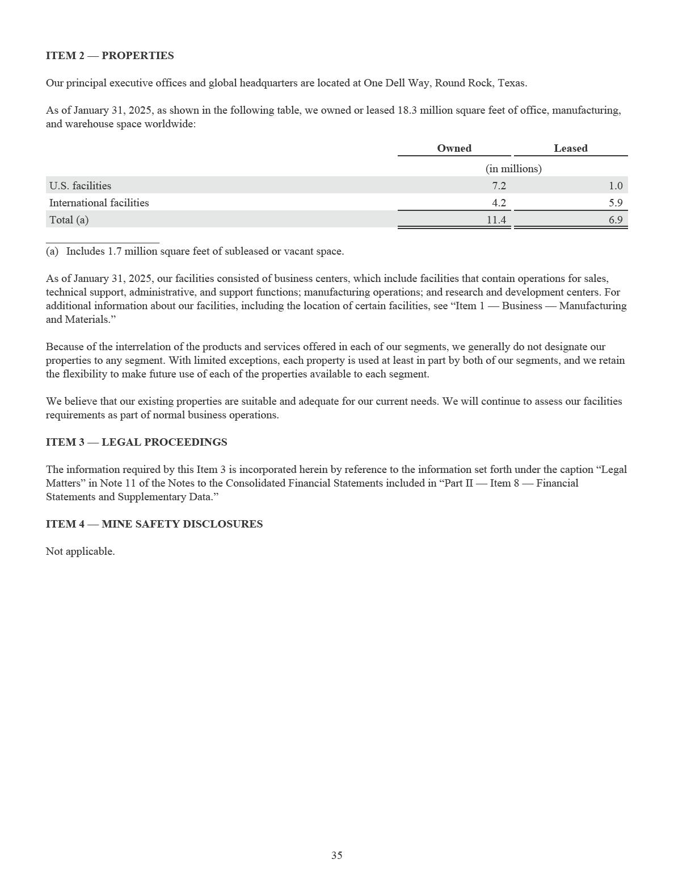

PART II — OTHER INFORMATION

ITEM 5 — MARKET FOR REGISTRANT’S COMMON EQUITY, RELATED STOCKHOLDER MATTERS AND ISSUER PURCHASES OF EQUITY SECURITIES

Market for Class C Common Stock

Our Class C Common Stock is listed and traded on the New York Stock Exchange under the symbol “DELL.”

There is no public market for our Class A Common Stock or Class B Common Stock. No shares of our Class D Common Stock were outstanding as of January 31, 2025.

Holders

As of March 17, 2025, there were 3,714 holders of record of our Class C Common Stock, six holders of record of our Class A Common Stock, and five holders of record of our Class B Common Stock. The number of record holders does not include individuals or entities that beneficially own shares of any class of our common stock, but whose shares are held of record by a broker, bank, or other nominee.

Dividends

During Fiscal 2025, we paid the following quarterly dividends:

Declaration Date |  | Record Date |  | Payment Date |  |  | Dividend per Share |  |  | Amount
Declaration Date |  | Record Date |  | Payment Date |  |  | Dividend per Share |  |  | (in millions)
February 29, 2024 |  | April 23, 2024 |  | May 3, 2024 | $ |  | 0.445 | $ |  | 316
June 11, 2024 |  | July 23, 2024 |  | August 2, 2024 | $ |  | 0.445 | $ |  | 314
September 18, 2024 |  | October 22, 2024 |  | November 1, 2024 | $ |  | 0.445 | $ |  | 312
December 3, 2024 |  | January 22, 2025 |  | January 31, 2025 | $ |  | 0.445 | $ |  | 310

During the fiscal year ended January 31, 2025, we also paid an immaterial amount of dividend equivalents on eligible vested equity awards which are not included above.

On February 27, 2025, we announced that the Board of Directors approved an 18% increase in the dividend rate to $0.525 per share per fiscal quarter beginning in the first quarter of the fiscal year ending January 30, 2026.

The dividend policy and the declaration and payment of each quarterly cash dividend will be subject to the continuing determination by the Board of Directors that the policy and the declaration of dividends thereunder are in the best interests of our stockholders and are in compliance with applicable law. The Board of Directors retains the power to modify, suspend, or cancel the dividend policy in any manner and at any time that it may deem necessary or appropriate.

36

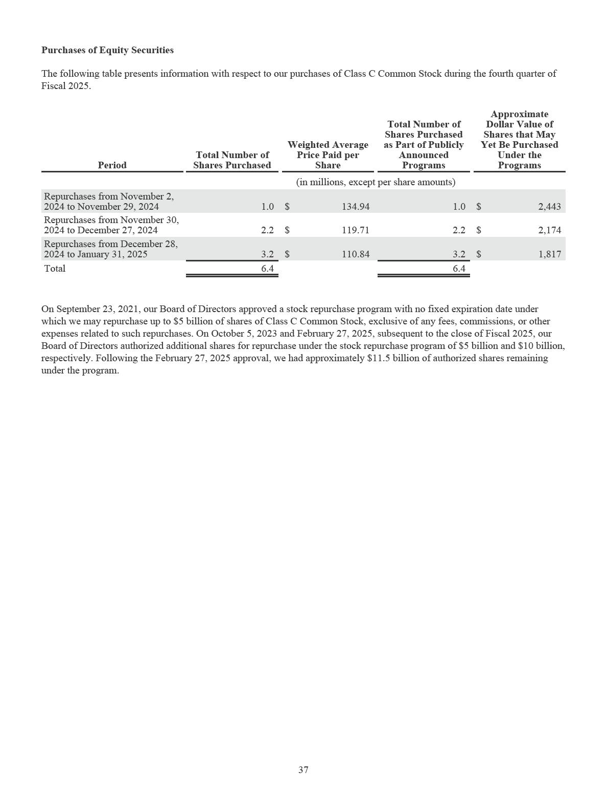

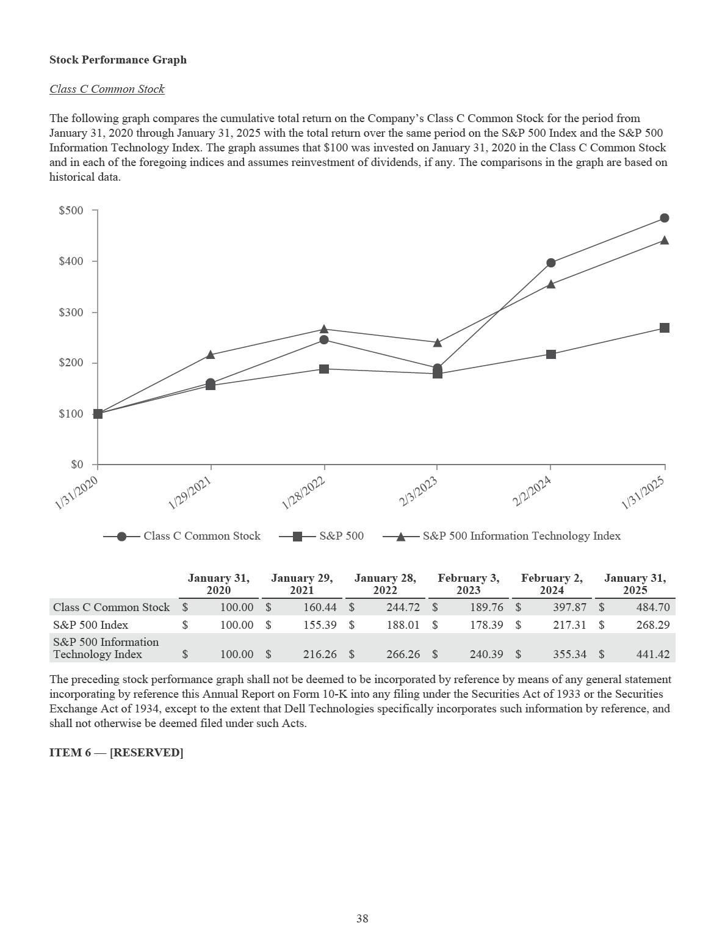

ITEM 7 — MANAGEMENT’S DISCUSSION AND ANALYSIS OF FINANCIAL CONDITION AND RESULTS OF OPERATIONS

This management’s discussion and analysis should be read in conjunction with the audited Consolidated Financial Statements and accompanying Notes included in this Annual Report on Form 10-K. This section of this Annual Report on Form 10-K generally discusses Fiscal 2025 and Fiscal 2024 items. This section also discusses Fiscal 2024 and Fiscal 2023 results, as the Company revised its Fiscal 2024 items to correct for a misstatement in its financial statements discovered during the fourth quarter of Fiscal 2025. The revisions ensure comparability across all periods reflected herein. For additional information, see Note 1 and Note 22 of the Notes to the Consolidated Financial Statements included in this report.

In addition to historical financial information, the following discussion contains forward-looking statements that reflect our plans, estimates, and beliefs, and that are subject to numerous risks and uncertainties. Our actual results may differ materially from those expressed or implied in any forward-looking statements.

Unless otherwise indicated, all results presented are prepared in a manner that complies, in all material respects, with generally accepted accounting principles in the United States of America (“GAAP”). Unless otherwise indicated, all changes identified for the current-period results represent comparisons to results for the prior corresponding fiscal period.

Unless the context indicates otherwise, references in this report to “we,” “us,” “our,” the “Company,” and “Dell Technologies” mean Dell Technologies Inc. and its consolidated subsidiaries, references to “Dell” mean Dell Inc. and Dell Inc.’s consolidated subsidiaries, and references to “EMC” mean EMC Corporation and EMC Corporation’s consolidated subsidiaries.

Our fiscal year is the 52- or 53-week period ending on the Friday nearest January 31. We refer to our fiscal years ended January 31, 2025, February 2, 2024, and February 3, 2023 as “Fiscal 2025,” “Fiscal 2024,” and “Fiscal 2023,” respectively. Both Fiscal 2025 and Fiscal 2024 included 52 weeks, while Fiscal 2023 included 53 weeks.

INTRODUCTION

Company Overview

Dell Technologies is a leader in the global technology industry focused on providing broad and innovative technology solutions for the data and artificial intelligence (“AI”) era. We build and offer solutions ranging from client devices and peripherals to infrastructure solutions across servers, networking, and storage to meet the evolving needs of our customers and drive better business outcomes. With our extensive portfolio and our commitment to innovation, we offer secure, integrated solutions that extend from the edge to the core to the cloud, and we are at the forefront of AI, software-defined, and cloud native infrastructure solutions. Our vision is to become the most essential technology partner. We intend to realize our vision by executing our strategy of leveraging our strengths to extend our leadership positions and capture new growth.

We are organized into two business units which are also our reportable segments: Infrastructure Solutions Group and Client Solutions Group.

- Infrastructure Solutions Group (“ISG”) — ISG includes our servers and networking offerings and our storage offerings. Our server portfolio includes high-performance general-purpose and AI-optimized servers. Our networking portfolio includes wide area network infrastructure, data center and edge networking switches, and cables and optics. Our comprehensive storage portfolio includes modern and traditional storage solutions, including all-flash arrays, scale-out file, object platforms, hyper-converged infrastructure, and software-defined storage. ISG also offers software, peripherals, and services, including consulting and support and deployment.

- Client Solutions Group (“CSG”) — CSG includes offerings designed for commercial and consumer customers. Our CSG portfolio includes branded PCs, including notebooks, desktops, and workstations, branded peripherals, and third-party software and peripherals. CSG also includes services offerings, such as configuration, support and deployment, and extended warranties.

39

Our other businesses primarily consist of our resale of standalone offerings of VMware LLC (formerly VMware, Inc. and individually and together with its subsidiaries, “VMware”), referred to as “VMware Resale,” and offerings of SecureWorks Corp. (“Secureworks”). These businesses are divested businesses or their offerings are no longer actively sold, and are not classified as reportable segments, either individually or collectively. Their operating results are reported within Corporate and other. On October 21, 2024, Secureworks announced that it had entered into a definitive agreement providing for its sale to Sophos Inc., an affiliate of Thoma Bravo, L.P., a private equity and growth capital firm. The transaction was completed on February 3, 2025, subsequent to the close of the Company’s fiscal year ended January 31, 2025, in an all-cash transaction for a purchase price of approximately $0.9 billion.

For further discussion regarding our current reportable segments, see “Results of Operations — Business Unit Results” and Note 18 of the Notes to the Consolidated Financial Statements included in this report.

We offer customers choice in how they acquire our solutions, including traditional purchasing and offerings under the Dell Payment Solutions portfolio. These offerings provide both payment and consumption solutions, including as-a-Service, subscription, utility, leases, and loans, which allow our customers to pay over time and provide them with operational and financial flexibility. Dell Financial Services and its affiliates (“DFS”) support financing solutions and services as part of the portfolio. For additional information about our financing arrangements, see Note 5 of the Notes to the Consolidated Financial Statements included in this report.

Business Trends and Challenges

Fiscal 2025 Significant Developments — During Fiscal 2025, we executed our strategy with strong operating results, generating net revenue and operating income growth. The following trends and conditions affected the environment in which we operated:

- Macroeconomic environment: The demand environment was strong for our servers and networking offerings, which contributed to overall net revenue growth. Additionally, we saw modest demand improvement in our commercial offerings within CSG. Given the demand dynamics for the year, we experienced a shift in the mix of the business towards our ISG offerings.

- Demand for AI-optimized solutions: Our ISG business continued to benefit from increased demand for AI-optimized solutions as customers continue to adopt and further integrate AI into their operations. As a result of the continued strong demand for our AI-optimized servers, backlog levels for such offerings remained elevated as we exited the fiscal year.

- Supply chain: Notwithstanding the increased demand for AI-optimized solutions, our supply chain continued to operate efficiently. We experienced a modest increase in input costs, primarily driven by both component and logistics costs.

- Broadcom’s acquisition of VMware: On November 22, 2023, Broadcom Inc. (“Broadcom”) completed its acquisition of VMware, leading to changes to our relationship with VMware as described below.

We expect demand growth across our servers and networking offerings and, to a lesser extent, our storage offerings, which we expect will result in ISG net revenue growth in Fiscal 2026. We expect modest CSG net revenue growth for the full fiscal year, driven in part by the anticipated PC refresh cycle in the latter part of Fiscal 2026. Additionally, we expect a continued reduction of our Corporate and other net revenue as we no longer act as a distributor of VMware’s standalone products and services.

We expect a modest decline in input costs during the first half of Fiscal 2026. Input cost trends are dependent on the strength or weakness of actual end-user demand and supply dynamics, which will continue to fluctuate and ultimately impact our costs, pricing, and operating results.

We remain focused on executing our key strategic priorities, building long-term value creation for our stakeholders, and addressing our customers’ needs while continuing to make prudent decisions in response to the environment. We expect margin rate pressure resulting from a continuing shift in mix towards our AI-optimized servers and a competitive environment. We look to balance profitability and growth while maintaining disciplined pricing as we navigate through competitive pricing pressures.

40

We continue to advance our own capabilities to change the way we work and make decisions, improve business outcomes and the customer experience, and reduce costs by leveraging new technology and optimizing business processes. We remain committed to disciplined cost management in coordination with our ongoing business modernization initiatives and expect continued reductions in operating expenses as we take certain measures to reduce costs, including limitation of external hiring, employee reorganizations, and other actions to align our investments with our strategic priorities and customer needs. We anticipate these actions will result in additional reductions in our overall headcount. We believe our unique operating advantages provide a foundation to foster growth, drive efficiencies, and continue to position us for long-term success.

Relationship with VMware — On November 22, 2023, VMware was acquired by Broadcom, and subsequently announced changes to its go-to-market approach for VMware offerings that impacted our commercial relationship with VMware. On March 25, 2024, we terminated our Commercial Framework Agreement with VMware, which provided the framework under which we and VMware continued our commercial relationship following our spin-off of VMware on November 1, 2021. We no longer act as a distributor of Broadcom’s VMware standalone products and services, although we will continue to support customers that have purchased resale offerings sold in prior periods. We continue to integrate and embed certain VMware products and services with selected Dell Technologies’ offerings to end-users, such as through our VxRail solution. The results of such offerings are reflected within CSG or ISG, depending upon the nature of the underlying offering sold.

VMware was a related party until the date of its acquisition by Broadcom. The acquisition terminated the preexisting related party relationship with VMware such that no related party relationship exists with either Broadcom or VMware effective as of November 22, 2023. For more information regarding the impact of the Broadcom acquisition of VMware and our prior related party transactions with VMware, see Note 19 of the Notes to the Consolidated Financial Statements included in this report.

ISG — We expect ISG will continue to be impacted by the evolving nature of the IT infrastructure market and competitive environment. With our scale and market-leading solutions portfolio, we believe we are well-positioned to address the ongoing competitive dynamics and trends in technology and customer needs. Through our collaborative, customer-focused approach to innovation, we strive to deliver new and relevant solutions and software to our customers quickly and efficiently. We continue to focus on customer base expansion and the lifetime value of customer relationships.

We anticipate ISG will continue to benefit from technology advancements and interest in AI as customers continue to adopt and integrate AI into their operations. The timing of customer purchases reflects the varying stages of adoption of AI by different customer segments and drives variability in our revenue. To meet the growing demand and increasing complexity of our AI-optimized offerings, we have increased our purchases of certain components with suppliers, which has resulted in increased inventory levels, higher purchase obligations, and new working capital dynamics. Additionally, frequent component part updates or transitions create additional challenges in managing demand and supply levels. While we have seen lead times shorten, we anticipate the next-generation of these components will be subject to supply constraints as demand for these components remains high.

We expect that growth in data will continue to generate long-term demand for our storage solutions and services. Cloud native applications are expected to continue to be a key trend in the infrastructure market. We continue to expand our offerings in external storage arrays, which incorporate flexible, cloud-based functionality. We benefit from offering solutions that address software-defined storage, hyper-converged infrastructure, and modular solutions based on server-centric architectures. Our storage business is subject to seasonal trends, which may continue to impact ISG results.

CSG — We participate in all segments of the PC market with a focus on commercial and high-end consumer computing devices, which we believe represent the most stable and profitable markets. We anticipate that CSG will benefit from advances in AI over the long-term as customers will require PCs with the ability to run their complex AI workloads.

Competitive dynamics remain an important factor in our CSG business and continue to impact pricing and operating results. We are committed to our long-term CSG strategy and will continue to make investments to innovate across the portfolio. We expect that the CSG demand environment will be subject to seasonal trends and influenced by the timing and scale of the anticipated PC refresh cycle.

Recurring Revenue and Consumption Models — We expect that our flexible consumption models will further strengthen our customer relationships and provide a foundation for growth in recurring revenue. We define recurring revenue as revenue recognized that is primarily related to hardware and software maintenance, as well as operating leases, subscription, as-a-Service, and usage-based offerings.

41

Strategic Investments and Acquisitions — As part of our strategy, we will continue to evaluate opportunities for strategic investments through our venture capital investment arm, Dell Technologies Capital, with a focus on emerging technology areas that are relevant to our business and that will complement our existing portfolio of solutions. The technologies or products these companies have under development are typically in the early stages and may never have commercial value, which could result in a loss of a substantial part of our investment in the companies. In addition to these investments, we may also make targeted acquisitions of businesses that advance our strategic objectives and accelerate our innovation agenda.

Foreign Currency Exposure — We manage our business on a U.S. Dollar basis. However, we have a large global presence, generating approximately half of our net revenue from sales to customers outside of the United States during Fiscal 2025 and Fiscal 2024. As a result, our operating results can be, and particularly in recent periods have been, impacted by fluctuations in foreign currency exchange rates. We utilize a comprehensive hedging strategy intended to mitigate the impact of foreign currency volatility over time, and we adjust pricing when possible to further minimize foreign currency impacts.

Other Macroeconomic Risks and Uncertainties — The impacts of trade protection measures, including increases in tariffs and trade barriers, changes in government policies and international trade arrangements, geopolitical volatility, and global macroeconomic conditions (including those in China) may affect our ability to conduct business in some non-U.S. markets. We monitor and seek to mitigate these risks with adjustments to our manufacturing, supply chain, and distribution networks.

42

NON-GAAP FINANCIAL MEASURES

In this management’s discussion and analysis, we use supplemental measures of our performance which are derived from our consolidated financial information but which are not presented in our consolidated financial statements prepared in accordance with GAAP. These non-GAAP financial measures include non-GAAP product gross margin; non-GAAP services gross margin; non-GAAP gross margin; non-GAAP operating expenses; non-GAAP operating income; non-GAAP net income; non-GAAP earnings per share attributable to Dell Technologies Inc. - diluted; free cash flow; and adjusted free cash flow. These non-GAAP financial measures are not meant to be considered as indicators of performance or liquidity in isolation from or as a substitute for gross margin, operating expenses, operating income, net income, diluted earnings per share, or cash flows from operating activities prepared in accordance with GAAP, and should be read only in conjunction with financial information presented on a GAAP basis.

We use non-GAAP financial measures to supplement financial information presented on a GAAP basis. Management uses these non-GAAP measures in financial planning and forecasting and when evaluating our financial results and operating trends and performance. We believe, when used supplementally with GAAP financial measures, these non-GAAP financial measures provide our investors with useful and transparent information to help them evaluate our results by facilitating an enhanced understanding of our results of operations and enabling them to make period to period comparisons. There are limitations to the use of the non-GAAP financial measures presented in this report. Our non-GAAP financial measures may not be comparable to similarly titled measures of other companies. Other companies, including companies in our industry, may calculate non-GAAP financial measures differently than we do, limiting the usefulness of those measures for comparative purposes.

Non-GAAP product gross margin, non-GAAP services gross margin, non-GAAP gross margin, non-GAAP operating expenses, non-GAAP operating income, non-GAAP net income, and non-GAAP earnings per share attributable to Dell Technologies Inc.

- diluted, as defined by us, exclude amortization of intangible assets, stock-based compensation expense, other corporate expenses and, for non-GAAP net income and non-GAAP earnings per share attributable to Dell Technologies Inc. - diluted, fair value adjustments on equity investments and an aggregate adjustment for income taxes. As the excluded items may have a material impact on our financial results, our management compensates for this limitation by relying primarily on our GAAP results and using non-GAAP financial measures supplementally or for projections when comparable GAAP financial measures are not available.

Reconciliations of each non-GAAP financial measure to its most directly comparable GAAP financial measure are presented below. We encourage you to review the reconciliations in conjunction with the presentation of the non-GAAP financial measures for each of the periods presented. The discussion below includes information on each of the excluded items as well as our reasons for excluding them from our non-GAAP results. In future fiscal periods, we may exclude such items and may incur income and expenses similar to these excluded items. Accordingly, the exclusion of these items and other similar items in our non-GAAP presentation should not be interpreted as implying that these items are non-recurring, infrequent, or unusual.

The following is a summary of the items excluded from the most comparable GAAP financial measures to calculate our non-GAAP financial measures.

- Amortization of Intangible Assets — Amortization of intangible assets primarily consists of the amortization of customer relationships, developed technology, and trade names. In connection with our acquisition by merger of EMC, referred to as the “EMC merger transaction,” and the acquisition of Dell by Dell Technologies Inc., referred to as the “going-private transaction,” all of the tangible and intangible assets and liabilities of EMC and Dell, respectively, were accounted for and recognized at fair value on the transaction dates. We exclude amortization charges for the amortization of intangible assets as they do not reflect our current operating performance and charges are significantly impacted by the timing and magnitude of our acquisitions and, as a result, may vary in amount from period to period.

- Stock-based Compensation Expense — Stock-based compensation expense consists of equity awards granted based on the estimated fair value of those awards at grant date. To estimate the fair value of performance-based awards containing a market condition, we use the Monte Carlo valuation model. For other share-based awards, the fair value is generally based on the closing price of the Class C Common Stock as reported on the New York Stock Exchange on the date of

grant. Although stock-based compensation is an important aspect of the compensation of our employees and executives, we exclude such expense because the fair value of the stock-based awards may fluctuate based on factors unrelated to the operating performance of the business and may bear little resemblance to the actual value realized upon the vesting or future exercise of the related stock-based awards.

43

- Other Corporate Expenses — Other corporate expenses consist primarily of severance expenses, payroll taxes associated with stock-based compensation, incentive charges related to equity investments, facility action costs, transaction-related expenses, and impairment charges. Severance costs are primarily related to severance and benefits for employees terminated pursuant to cost management initiatives. During Fiscal 2025, Fiscal 2024, and Fiscal 2023, we recognized $0.7 billion, $0.6 billion, and $0.5 billion, respectively, of severance expense related to workforce reduction activities. During Fiscal 2023, other corporate expenses also included $0.9 billion of net expense recognized within interest and other, net, in connection with an agreement to settle the Class V transaction litigation. See Note 11 of the Notes to the Consolidated Financial Statements included in this report for information about this matter. Transaction-related expenses typically consist of acquisition, integration, and divestitures related costs, primarily representing costs for legal, banking, consulting, and advisory services, and are expensed as incurred. Although we may incur these types of expenses in the future, we exclude other corporate expenses as they can vary from period to period, are significantly impacted by the timing and nature of these events, and are not used by management in assessing operating performance of the business.

- Fair Value Adjustments on Equity Investments — Fair value adjustments on equity investments primarily consist of the gain (loss) on strategic investments, which includes recurring fair value adjustments of investments in publicly-traded companies, as well as those in privately-held companies, which are adjusted for observable price changes and any potential impairments. See Note 4 of the Notes to the Consolidated Financial Statements included in this report for additional information on our strategic investment activity. We exclude fair value adjustments on equity investments given the volatility in ongoing adjustments to the valuation of these strategic investments and because such adjustments are unrelated to the operating performance of our business.

- Aggregate Adjustment for Income Taxes — The aggregate adjustment for income taxes is the estimated combined income tax effect for the adjustments described above and determined based on the tax jurisdictions where those adjustments were incurred, as well as an adjustment for discrete tax items. During Fiscal 2025, the aggregate adjustment for income taxes included discrete tax benefits of $0.4 billion related to changes in uncertain tax benefits resulting from the expiration of certain U.S. statutes of limitations and $0.2 billion related to stock-based compensation. We exclude these benefits or charges for purposes of calculating non-GAAP net income due to the variability in recognition of discrete tax items from period to period. The tax effects are determined based on the tax jurisdictions where the above items were incurred. See Note 12 of the Notes to the Consolidated Financial Statements included in this report for additional information about our income taxes. Beginning in Fiscal 2025, our non-GAAP income tax was calculated using a fixed estimated annual tax rate that is determined based on historical trends and projections for the current fiscal year. We may adjust our estimated annual tax rate during the fiscal year to take into account events that would significantly impact our income tax expense, including significant changes resulting from tax legislation, material changes in geographic mix of revenue and expenses, changes to our corporate structure, and other significant events.

44

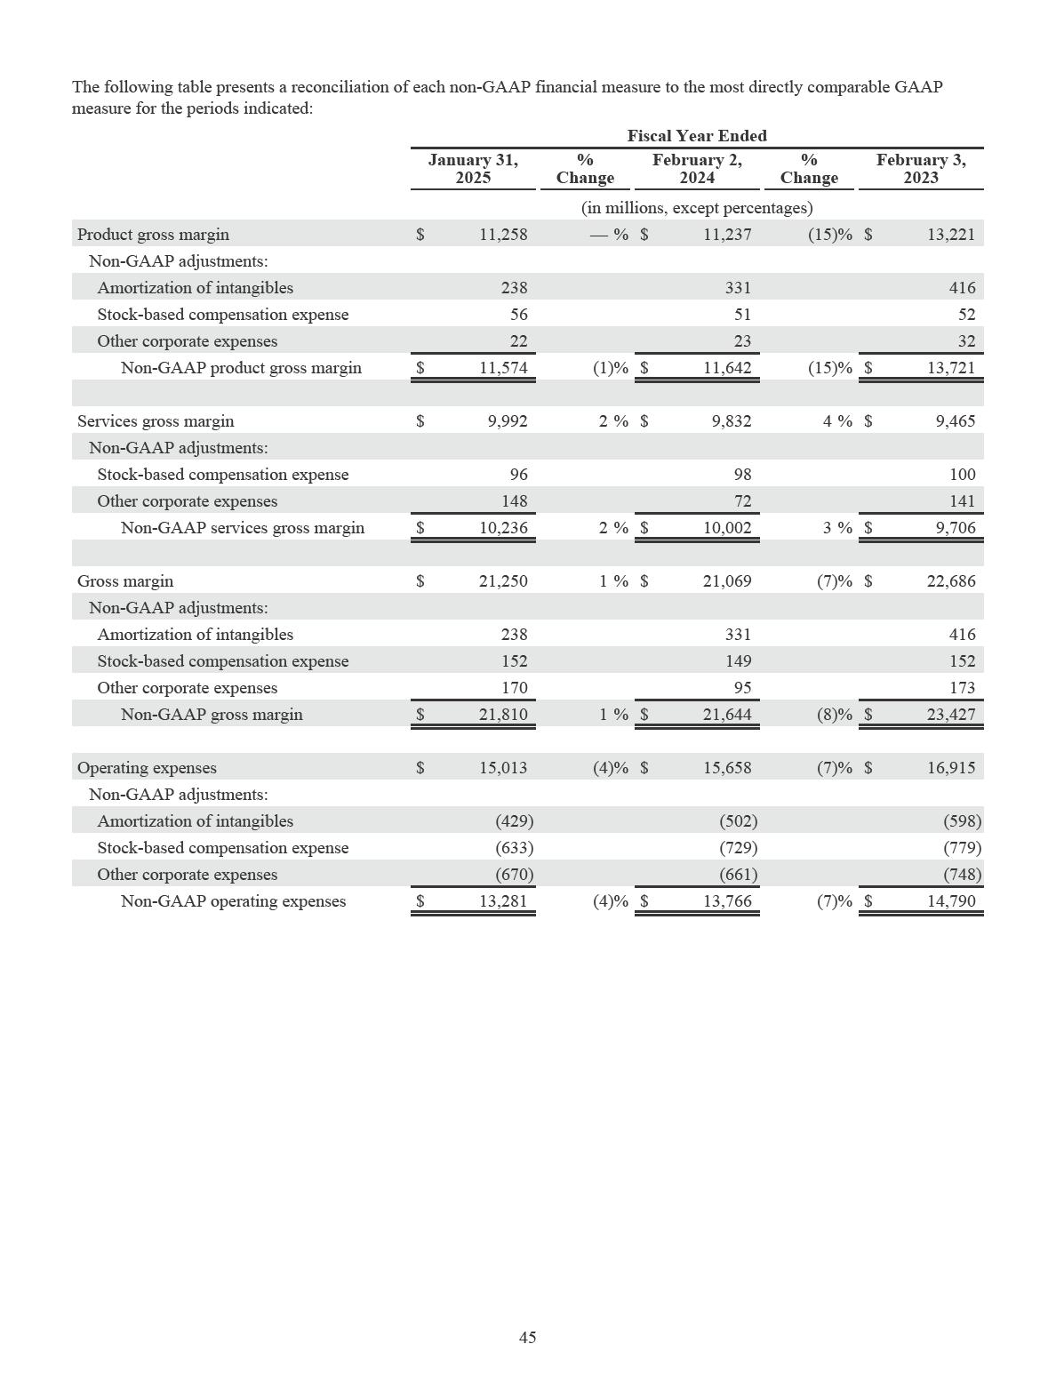

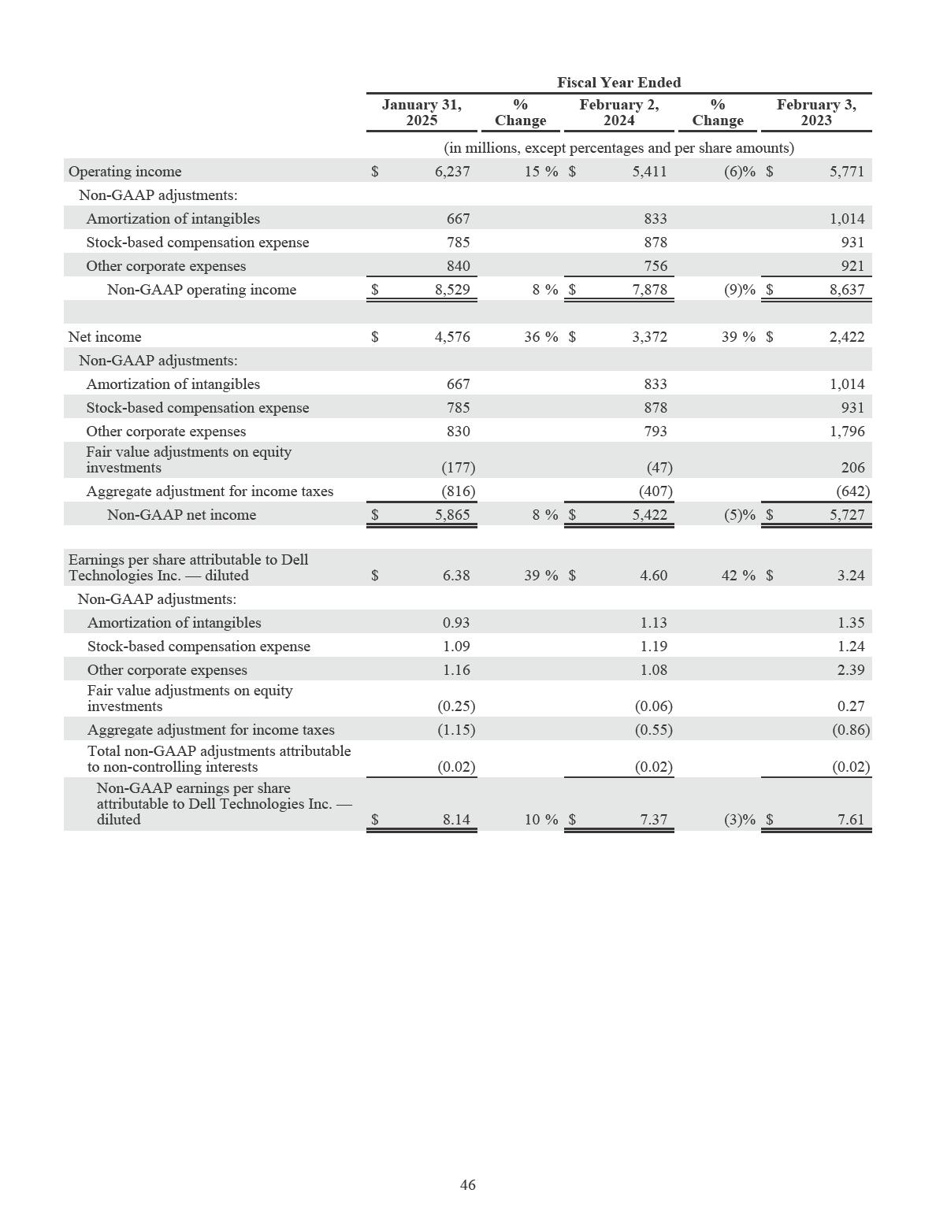

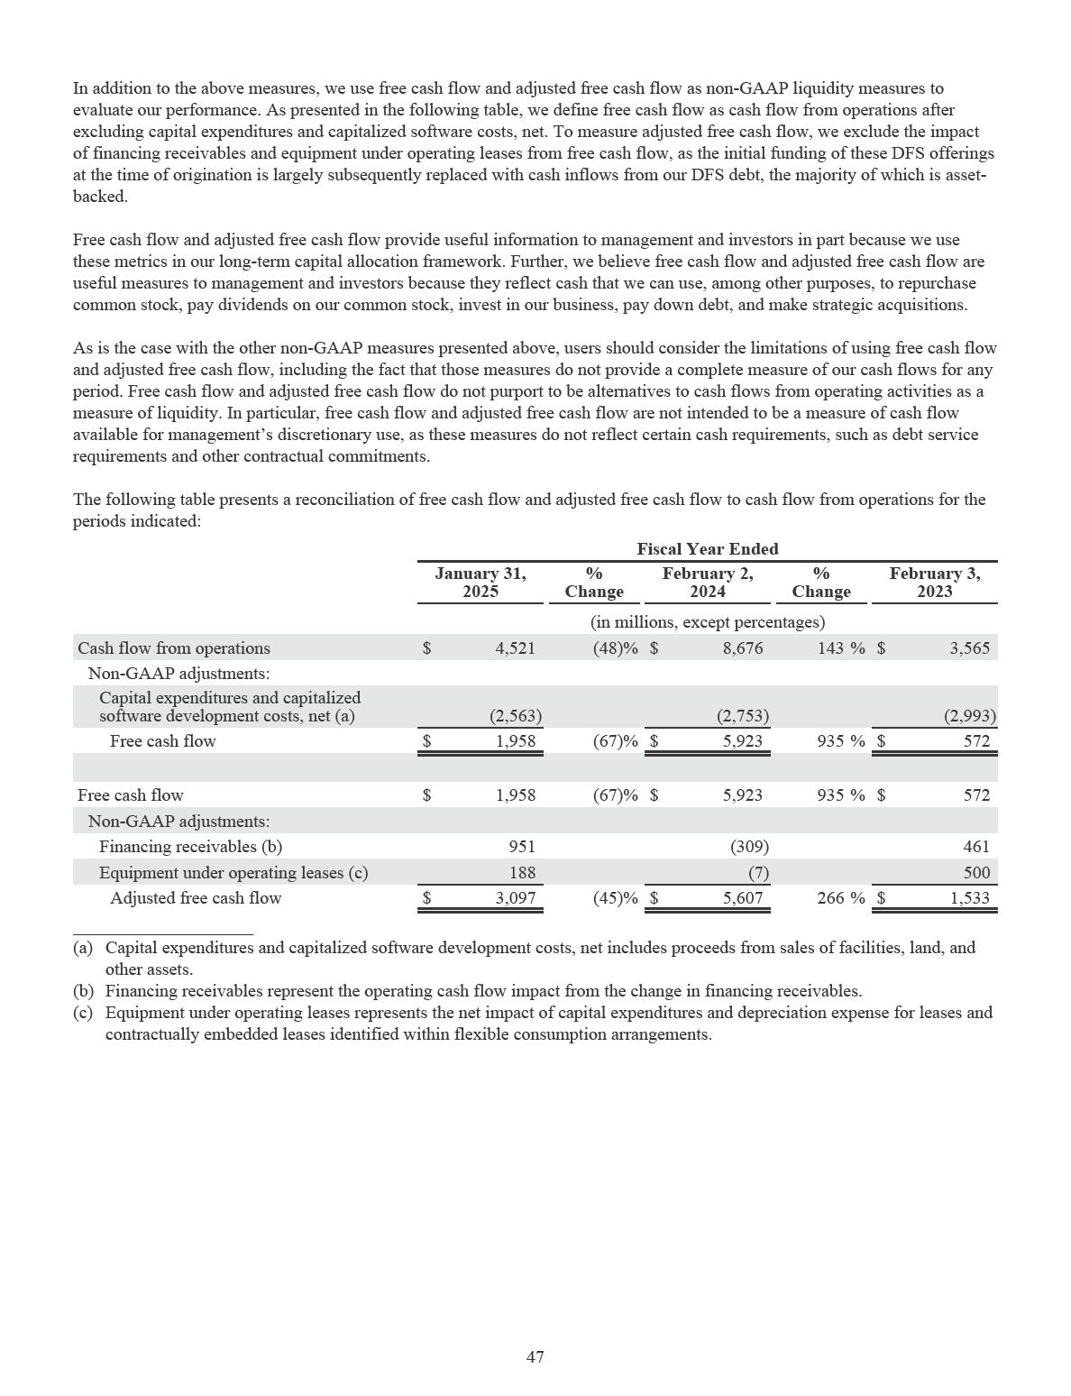

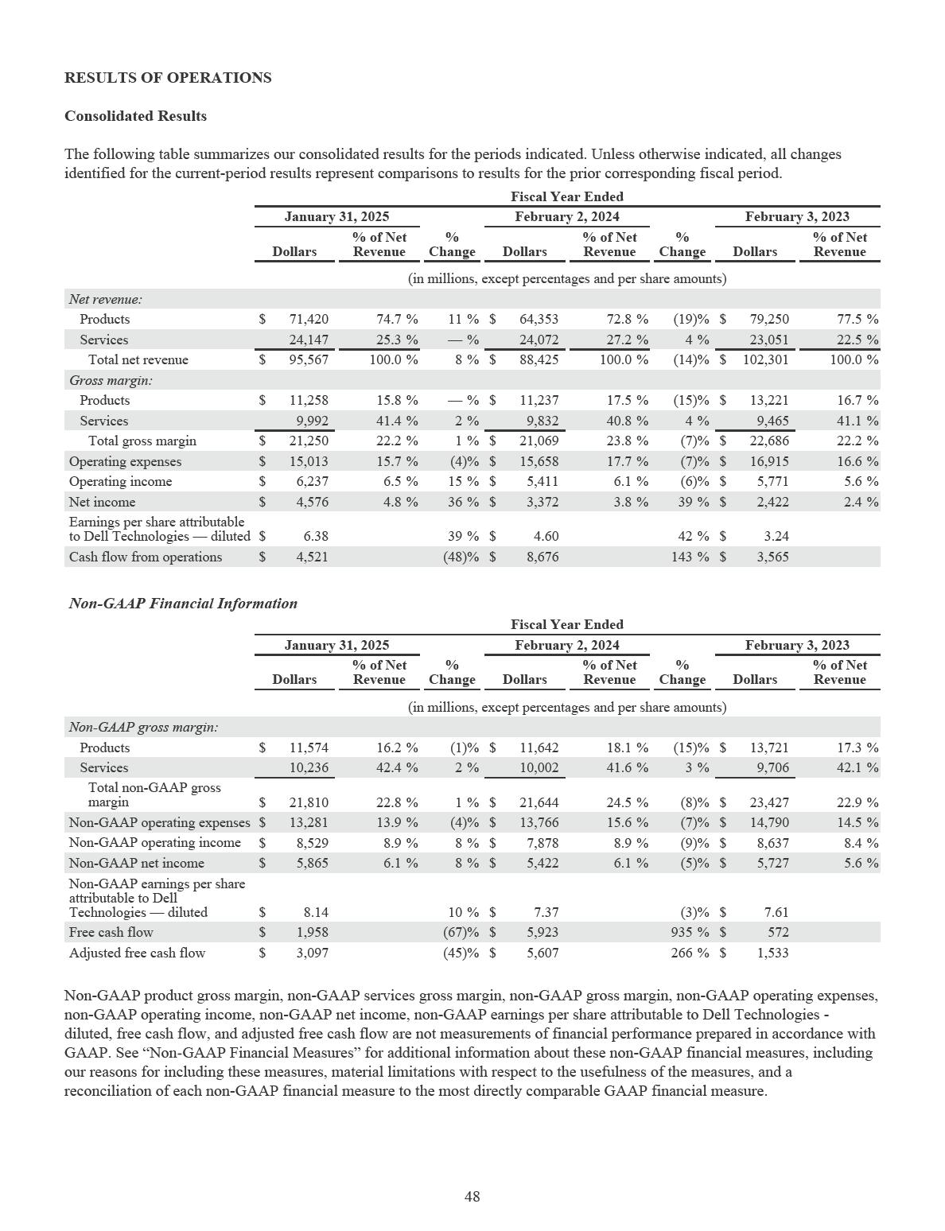

Overview

During Fiscal 2025, net revenue increased by 8%, driven by an increase in ISG net revenue that was partially offset by a decrease in Corporate and other net revenue and, to a lesser extent, CSG net revenue. The increase in ISG net revenue was driven by growth in our servers and networking offerings. Corporate and other net revenue declined primarily due to a decrease in VMware Resale revenue as we no longer act as a distributor of standalone VMware offerings. The decline in CSG net revenue was attributable to a decrease in sales of our consumer offerings.

During Fiscal 2025, operating income and non-GAAP operating income increased by 15% to $6.2 billion and 8% to $8.5 billion, respectively. During Fiscal 2025, the increases in operating income and non-GAAP operating income were primarily attributable to an increase in ISG operating income that was driven by our servers and networking offerings and, to a lesser extent, our storage offerings, which was partially offset by a decrease in CSG operating income.

During Fiscal 2025, operating income and non-GAAP operating income as a percentage of net revenue increased 40 basis points to 6.5% and remained flat at 8.9%, respectively. The operating income and non-GAAP operating income rates during the current year were affected by the favorable impact of a decrease in operating expense rate that was driven by strong ISG net revenue growth coupled with continued disciplined cost management. The favorable impact of a decrease in operating expense rate was offset by a decline in gross margin as a percentage of net revenue due to a shift in mix towards AI-optimized server offerings and a competitive CSG pricing environment.

Cash provided by operating activities was $4.5 billion during Fiscal 2025, and was driven by profitability, partially offset by working capital dynamics. Working capital was primarily impacted by AI, which led to higher inventory, accounts receivable, and accounts payable levels. During Fiscal 2024, cash provided by operating activities was $8.7 billion, which was primarily driven by profitability coupled with strong inventory management and cash collections performance. Cash provided by operating activities during Fiscal 2024 also reflected the impact of the $0.9 billion net payment to settle the Class V transaction litigation and $0.4 billion in proceeds from the sale of our U.S. consumer revolving customer receivables portfolio. See “Liquidity, Cash Requirements, and Market Conditions” for additional information about our cash flow metrics.

We continue to see opportunities to create value and grow as we respond to long-term demand for our IT solutions driven by a data- and AI-enabled world. We have demonstrated our ability to adjust to changing market conditions with complementary solutions and innovation across both segments of our business, an agile workforce, and the strength of our global supply chain. As we continue to innovate and modernize our offerings, we believe that Dell Technologies is well-positioned for long-term profitable growth.

Net Revenue

Fiscal 2025 compared to Fiscal 2024

During Fiscal 2025, net revenue increased 8%, primarily driven by an increase in ISG net revenue that was partially offset by a decrease in Corporate and other net revenue and, to a lesser extent, CSG net revenue. See “Business Unit Results” for further information.

- Product Net Revenue — Product net revenue includes revenue from the sale of hardware products and software licenses. During Fiscal 2025, product net revenue increased 11% due to an increase in ISG product net revenue driven by growth in our servers and networking offerings. The increase was partially offset by a decrease in CSG product net revenue as a result of a decrease in the average selling prices of our CSG offerings and, to a lesser extent, a decline in units sold within our consumer offerings, as well as a decline in Corporate and other product net revenue as we no longer act as a distributor of standalone VMware offerings.

- Services Net Revenue — Services net revenue includes revenue from our services offerings and support services related to hardware products and software licenses. During Fiscal 2025, services net revenue was flat as the growth within CSG services net revenue and, to a lesser extent, ISG services net revenue was offset by a decline in Corporate and other services net revenue. The increase in CSG services net revenue was primarily due to CSG third-party software support and maintenance as well as support and maintenance associated with products sold in prior periods. The increase in ISG services net revenue was primarily due to support and maintenance associated with products sold in prior periods. Corporate and other services net revenue declined as we no longer act as a distributor of standalone VMware offerings.

49

A substantial portion of services net revenue is derived from offerings that have been deferred over a period of time, and, as a result, reported growth rates for services net revenue will be different than reported growth rates for product net revenue.

From a geographical perspective, net revenue increased during Fiscal 2025 in the Americas and, to a lesser extent, APJ and remained flat in EMEA.

Fiscal 2024 compared to Fiscal 2023

During Fiscal 2024, net revenue decreased 14%, primarily driven by declines in CSG net revenue and, to a lesser extent, ISG net revenue. See “Business Unit Results” for further information.

- Product Net Revenue — During Fiscal 2024, product net revenue decreased 19% due to declines in CSG product net revenue and, to a lesser extent, ISG product net revenue. CSG product net revenue decreased primarily as a result of a decline in units sold, which impacted both our commercial and consumer offerings. The decline in ISG product net revenue was primarily attributable to a decrease in product net revenue attributable to our servers and networking offerings that was driven by a decrease in units sold and, to a lesser extent, a decline in our product net revenue attributable to storage offerings.

- Services Net Revenue — During Fiscal 2024, services net revenue increased 4%, driven primarily by growth within services net revenue attributable to CSG and Corporate and other. The increase in services net revenue attributable to CSG was driven primarily by third-party software support and maintenance and hardware support and maintenance. The increase in services net revenue attributable to Corporate and other was driven primarily by VMware software maintenance arrangements. See “Introduction” for additional information about the impact of Broadcom’s acquisition of VMware on our relationship with VMware.

From a geographical perspective, net revenue decreased in the Americas, EMEA, and APJ during Fiscal 2024, most notably within APJ.

Gross Margin

Fiscal 2025 compared to Fiscal 2024

During Fiscal 2025, both gross margin and non-GAAP gross margin increased 1%, to $21.3 billion and $21.8 billion, respectively, driven by an increase in ISG gross margin that was largely offset by a decrease in CSG gross margin. The increase in ISG gross margin was primarily attributable to growth in our AI-optimized server offerings and, to a lesser extent, our storage offerings. The decrease in CSG gross margin was primarily attributable to a competitive pricing environment.

During Fiscal 2025, gross margin and non-GAAP gross margin percentage decreased 160 basis points to 22.2% and 170 basis points to 22.8%, respectively. The decreases in gross margin percentage and non-GAAP gross margin percentage were primarily driven by a shift in mix towards AI-optimized server offerings and a competitive CSG pricing environment.

- Product Gross Margin — During Fiscal 2025, product gross margin and non-GAAP product gross margin remained flat at $11.3 billion and decreased 1% to $11.6 billion, respectively, as the decrease in CSG product gross margin was largely offset by an increase in ISG product gross margin. The decline in CSG product gross margin was primarily attributable to a competitive pricing environment. The increase in ISG product gross margin was primarily due to growth in our AI-optimized server offerings and, to a lesser extent, our storage offerings.

During Fiscal 2025, product gross margin percentage and non-GAAP product gross margin percentage decreased 170 basis points to 15.8% and 190 basis points to 16.2%, respectively. The declines were primarily attributable to a shift in mix towards our AI-optimized server offerings and a competitive CSG pricing environment.

50

- Services Gross Margin — During Fiscal 2025, both services gross margin and non-GAAP services gross margin increased 2%, to $10.0 billion and $10.2 billion, respectively. Services gross margin and non-GAAP services gross margin benefited from an increase in support and maintenance associated with products sold in prior periods within both ISG and CSG and, to a lesser extent, an increase in CSG third-party software support and maintenance.

During Fiscal 2025, services gross margin percentage and non-GAAP services gross margin percentage increased 60 basis points to 41.4% and 80 basis points to 42.4%, respectively. The increases in services gross margin percentage and non-GAAP services gross margin percentage were primarily driven by a shift in mix as we no longer act as a distributor of standalone VMware offerings.

Fiscal 2024 compared to Fiscal 2023

During Fiscal 2024, gross margin and non-GAAP gross margin decreased 7% to $21.1 billion and 8% to $21.6 billion, respectively. The declines were driven by decreases in both ISG and CSG gross margin that were primarily attributable to a decrease in net revenue, the effect of which was partially offset by lower input costs.

Both gross margin and non-GAAP gross margin percentage increased 160 basis points, to 23.8% and 24.5%, respectively, during Fiscal 2024. The increases were primarily attributable to the impacts of an overall decline in input costs coupled with an increase in average selling prices across many of our offerings as we continued to exercise disciplined pricing in an increasingly competitive environment.

- Product Gross Margin — During Fiscal 2024, product gross margin and non-GAAP product gross margin both decreased 15%, to $11.2 billion and $11.6 billion, respectively. The decreases were primarily driven by declines in both ISG and CSG product gross margin, which were largely attributable to declines in product net revenue, partially offset by lower input costs.

During Fiscal 2024, product gross margin percentage and non-GAAP product gross margin percentage both increased 80 basis points, to 17.5% and 18.1%, respectively, primarily due to an increase in CSG product gross margin percentage. CSG product gross margin percentage increased primarily as a result of the impacts of an overall decline in input costs coupled with an increase in average selling prices across many of our product offerings.

- Services Gross Margin — During Fiscal 2024, services gross margin and non-GAAP services gross margin increased 4% to $9.8 billion and 3% to $10.0 billion, respectively. The increases were primarily attributable to growth within ISG services gross margin and, to a lesser extent, CSG services gross margin that were driven by support and maintenance associated with products sold in prior periods.

During Fiscal 2024, services gross margin percentage decreased 30 basis points to 40.8% and non-GAAP services gross margin percentage decreased 50 basis points to 41.6%. The decreases were driven primarily by a shift in mix of services delivered.

Vendor Programs

Our gross margin is affected by our ability to achieve competitive pricing with our vendors and contract manufacturers, including through our negotiation of a variety of vendor rebate programs to achieve lower net costs for the various components we include in our products. Under these programs, vendors provide us with rebates or other discounts from the list prices for the components, which are generally elements of their pricing strategy. We account for vendor rebates and other discounts as a reduction in cost of net revenue. We manage our costs on a total net cost basis, which includes supplier list prices reduced by vendor rebates and other discounts.

The terms and conditions of our vendor rebate programs are largely based on product volumes and are generally negotiated either at the beginning of the annual or quarterly period, depending on the program. The timing and amount of vendor rebates and other discounts we receive under the programs may vary from period to period, reflecting changes in the competitive environment. We monitor our component costs and seek to address the effects of any changes to terms that might arise under our vendor rebate programs. Our gross margins for Fiscal 2025 and Fiscal 2024 were not materially affected by any changes to the terms of our vendor rebate programs, as the amounts we received under these programs were generally stable relative to our total net cost. We are not aware of any significant changes to our vendor rebate programs that will materially impact our results in the near term.

51

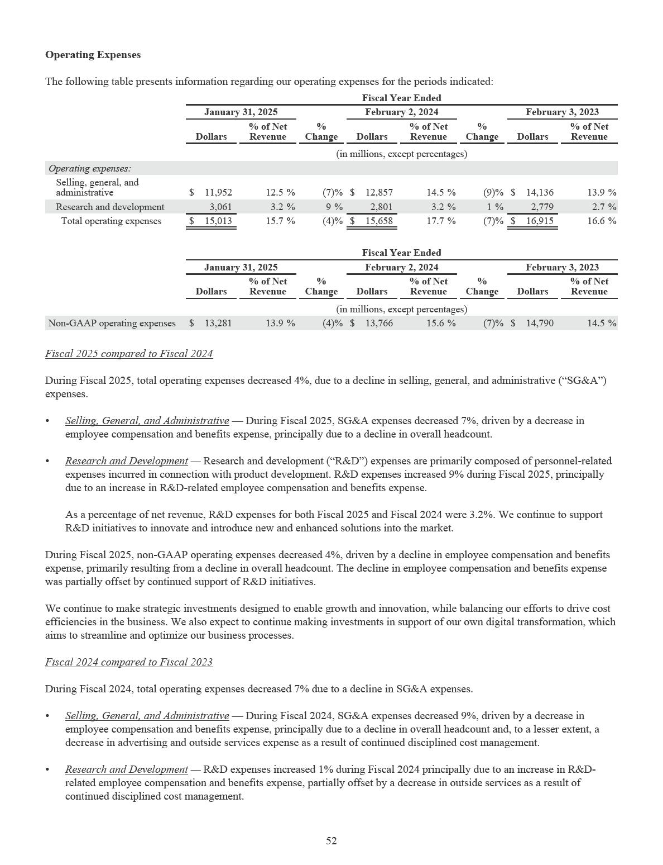

As a percentage of net revenue, R&D expenses for Fiscal 2024 and Fiscal 2023 were 3.2% and 2.7%, respectively. The increases in R&D expenses as a percentage of net revenue were attributable to continued R&D investments as we support R&D initiatives to innovate and introduce new and enhanced solutions into the market.

During Fiscal 2024, non-GAAP operating expenses decreased 7% principally due to continued disciplined cost management, which resulted in a decline in employee compensation and benefits, outside services, and advertising expenses, among other items.

Operating Income

Fiscal 2025 compared to Fiscal 2024

During Fiscal 2025, operating income and non-GAAP operating income increased by 15% to $6.2 billion and 8% to $8.5 billion, respectively. During Fiscal 2025, the increases in operating income and non-GAAP operating income were primarily attributable to an increase in ISG operating income that was driven by our servers and networking offerings and, to a lesser extent, our storage offerings, which was partially offset by a decrease in CSG operating income.

During Fiscal 2025, operating income and non-GAAP operating income as a percentage of net revenue increased 40 basis points to 6.5% and remained flat at 8.9%, respectively. The operating income and non-GAAP operating income rates during the current year were affected by the favorable impact of a decrease in operating expense rate that was driven by strong ISG net revenue growth coupled with continued disciplined cost management. The favorable impact of a decrease in operating expense rate was offset by a decline in gross margin as a percentage of net revenue due to a shift in mix towards AI-optimized server offerings and a competitive CSG pricing environment.

Fiscal 2024 compared to Fiscal 2023

Operating income and non-GAAP operating income decreased by 6% to $5.4 billion and 9% to $7.9 billion, respectively, during Fiscal 2024. The decreases were driven by a decrease in ISG operating income, which declined primarily as a result of a decrease in net revenue that outpaced the favorable impacts of a decline in input costs and cost management measures. The decline in ISG operating income was primarily attributable to decreases in our servers and networking offerings and, to a lesser extent, our storage offerings. The decline in operating income was partially offset by decreases in other corporate expenses and amortization of intangibles.

During Fiscal 2024, both operating income and non-GAAP operating income as a percentage of net revenue increased 50 basis points, to 6.1% and 8.9%, respectively. The increases were due to an increase in gross margin as a percentage of net revenue, which was principally driven by a decline in input costs. The increase in operating income and non-GAAP operating income as a percentage of net revenue was offset by an increase in operating expense rate, principally within ISG, that was attributable to a decrease in net revenue which outpaced the impact of continued cost management measures.

53

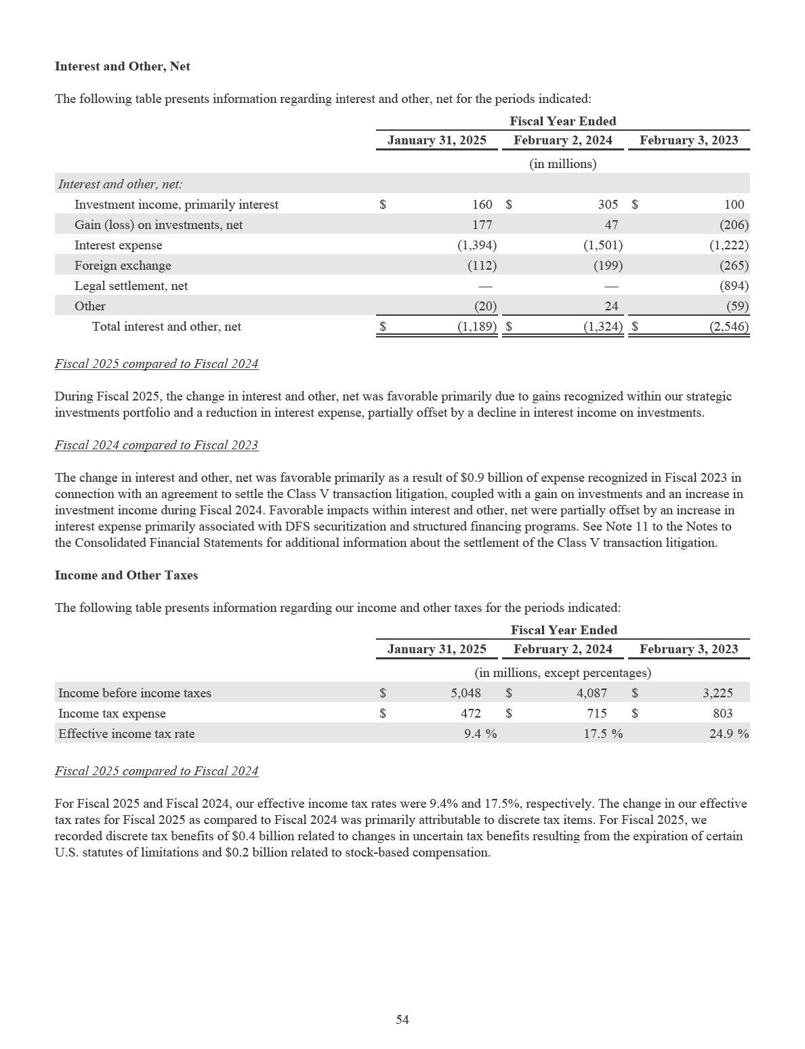

Our effective income tax rate can fluctuate depending on the geographic distribution of our worldwide earnings, as our foreign earnings are generally taxed at lower rates than in the United States. The differences between our effective income tax rates and the U.S. federal statutory rate of 21% principally result from the geographical distribution of income, differences between the book and tax treatment of certain items, and discrete tax items. In certain jurisdictions, our tax rate is significantly less than the applicable statutory rate as a result of tax holidays. The majority of our foreign income subject to these tax holidays is attributable to Singapore and China. A significant portion of these income tax benefits relates to a tax holiday that will be effective until January 31, 2029. Most of our other tax holidays will expire in whole or in part during Fiscal 2030 and Fiscal 2031. Many of these tax holidays and reduced tax rates may be extended when certain conditions are met or may be terminated early if certain conditions are not met or as a result of changes in tax legislation. As of January 31, 2025, we were not aware of any matters of non-compliance. Our income tax benefits attributable to tax holidays and incentives of the affected subsidiaries were immaterial to our provision for income taxes and earnings per share for Fiscal 2025 and Fiscal 2024.

Many countries, including Singapore, a country in which we have a tax holiday, have enacted or are in the process of enacting laws based on the Pillar Two proposal relating to a global minimum tax issued by the Organisation for Economic Co-operation and Development (“OECD”). While we expect our effective income tax rate and cash income tax payments may increase in future years as a result of the global minimum tax, the tax did not have a material impact on our Fiscal 2025 consolidated results of operations and we do not expect a material impact for Fiscal 2026. Our assessment could be affected by legislative guidance and future enactment of additional provisions within the Pillar Two framework.

For further discussion regarding tax matters, including the status of income tax audits, see Note 12 of the Notes to the Consolidated Financial Statements included in this report.

Fiscal 2024 compared to Fiscal 2023

For Fiscal 2024 and Fiscal 2023, our effective income tax rates were 17.5% and 24.9%, respectively. The change related to our effective income tax rates for Fiscal 2024 as compared to Fiscal 2023 was primarily attributable to the tax impact of foreign operations and benefits from U.S. research and development tax credits. In addition, our effective tax rate for Fiscal 2023 included the impact of an expense recognized in connection with the agreement to settle the Class V transaction litigation described in Note 11 of the Notes to the Consolidated Financial Statements included in this report.

Net Income

Fiscal 2025 compared to Fiscal 2024

During Fiscal 2025, net income and non-GAAP net income increased 36% to $4.6 billion and 8% to $5.9 billion, respectively.

Net income increased primarily due to an increase in operating income and, to a lesser extent, lower income tax expense. Non-

GAAP net income increased primarily due to an increase in operating income.

Fiscal 2024 compared to Fiscal 2023

During Fiscal 2024, net income increased 39% to $3.4 billion, driven primarily by a favorable change in interest and other, net, partially offset by a decline in operating income. During Fiscal 2024, non-GAAP net income decreased 5% to $5.4 billion, driven by a decline in operating income, partially offset by a decline in income tax expense.

55

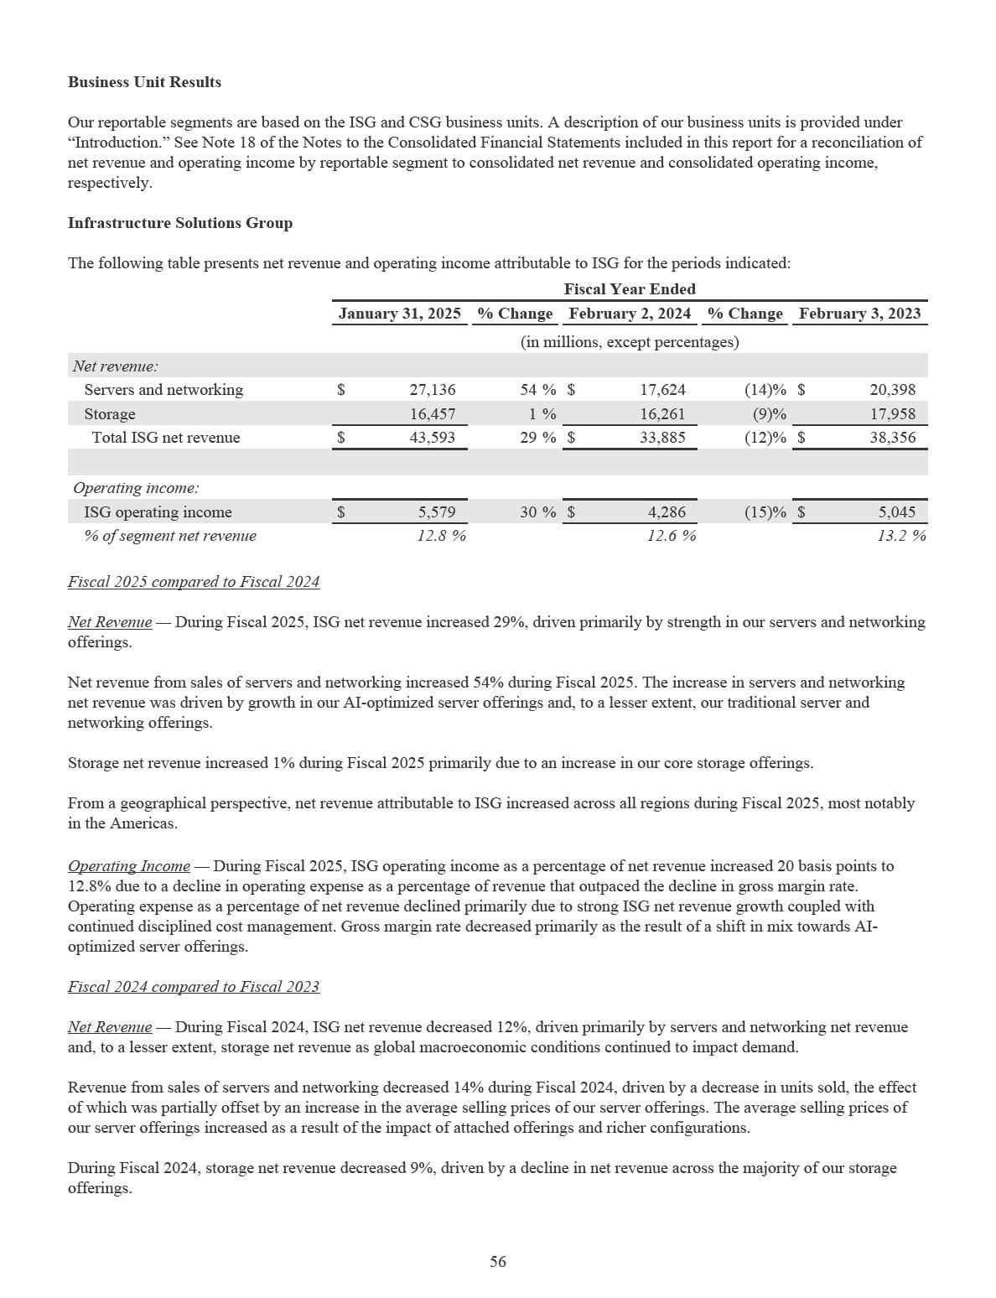

From a geographical perspective, net revenue attributable to ISG decreased in the Americas, EMEA, and APJ during Fiscal 2024.

Operating Income — During Fiscal 2024, ISG operating income as a percentage of net revenue decreased 60 basis points to 12.6% principally due to an increase in operating expenses as a percentage of net revenue. Operating expenses as a percentage of net revenue increased as a result of a decline in revenue that outpaced the impact of continued cost management measures coupled with continued investment in research and development. The impact of an increase in operating expenses as a percentage of net revenue was partially offset by an overall decline in input costs coupled with an increase in average selling prices.

57

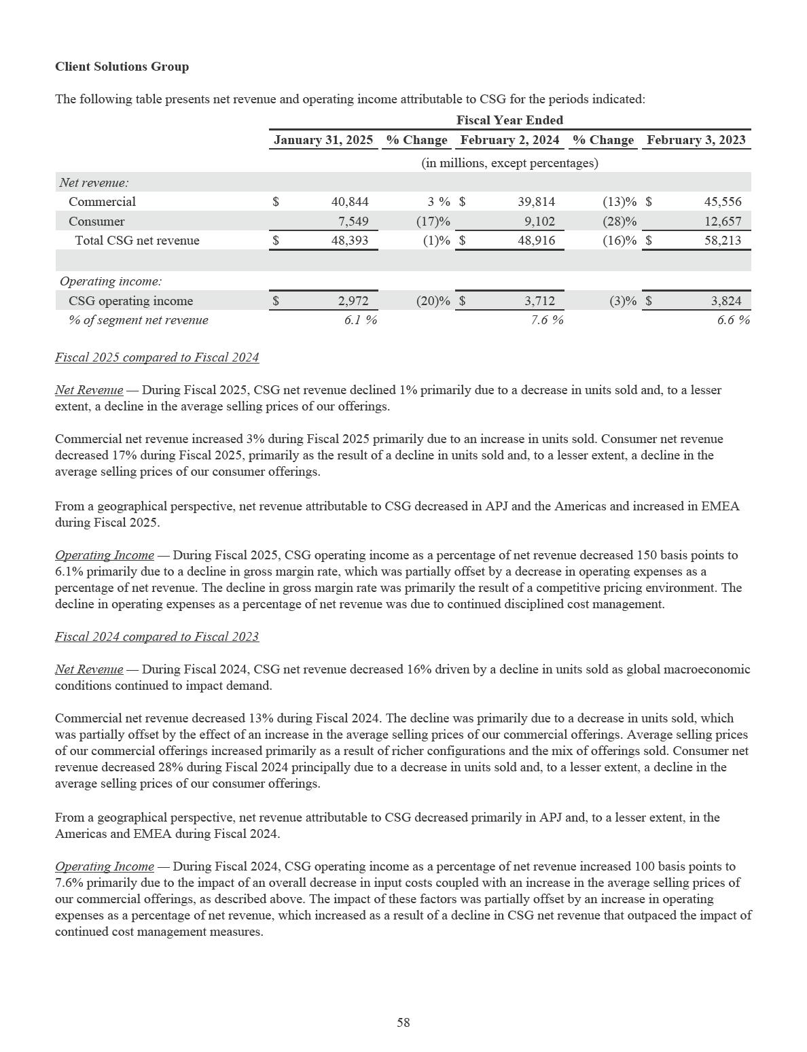

OTHER BALANCE SHEET ITEMS

Accounts Receivable

We sell products and services directly to customers and through a variety of sales channels, including retail distribution. Our accounts receivable, net was $10.3 billion and $9.3 billion as of January 31, 2025 and February 2, 2024, respectively. Accounts receivable, net was up due to growth in our AI-optimized server offerings and the timing of cash receipts. We maintain an allowance for expected credit losses to cover receivables that may be deemed uncollectible. The allowance for expected credit losses is an estimate based on an analysis of historical loss experience, current receivables aging, and management’s assessment of current conditions and its reasonable and supportable expectation of future conditions, as well as specific identifiable customer accounts that are deemed at risk. As of January 31, 2025 and February 2, 2024, the allowance for expected credit losses was $63 million and $71 million, respectively. Based on our assessment, we believe that we are adequately reserved for expected credit losses.

Dell Financial Services and Financing Receivables

We offer or arrange a portfolio of payment and consumption solutions and services for our customers globally, including as-a-Service, subscription, utility, leases, and loans designed to match customers' consumption and financing preferences. We believe these options provide operational and financial flexibility and strengthen our customer relationships. To support financing solutions and services as part of the portfolio, DFS originates, collects, and services customer receivables primarily related to the purchase of our product and services solutions. New financing originations were $8.4 billion for both Fiscal 2025 and Fiscal 2024 and $9.7 billion for Fiscal 2023.

Our leases are generally classified as sales-type leases or operating leases. On commencement of sales-type leases, we recognize profit up-front, and recognize amounts due from the customer under the lease contract as financing receivables. Interest income is recognized as net product revenue over the term of the lease. Upon origination of operating leases, we record equipment under operating leases, classified as property, plant, and equipment, net. We recognize product revenue and depreciation expense, classified as cost of net revenue, over the contract term.

As of January 31, 2025 and February 2, 2024, our financing receivables, net were $11.2 billion and $10.5 billion, respectively. We maintain an allowance to cover expected financing receivables credit losses and evaluate credit loss expectations based on our total portfolio. The principal charge-off rate for our financing receivables portfolio was 0.6% for Fiscal 2025 and 0.5% for both Fiscal 2024 and Fiscal 2023. The credit quality of our financing receivables remains strong due to the mix of high-quality commercial accounts in our portfolio. We continue to monitor broader economic indicators and their potential impact on future credit loss performance. We have an extensive process to manage our exposure to customer credit risk that includes active management of credit lines and collection activities. We also sell selected fixed-term financing receivables without recourse to unrelated third parties on a periodic basis, primarily to manage certain concentrations of customer credit exposure. Based on our assessment of the customer financing receivables, we believe that we are adequately reserved.

We retain a residual interest in equipment leased under our lease programs. As of January 31, 2025 and February 2, 2024, the residual interest recorded as part of financing receivables was $168 million and $157 million, respectively. The amount of the residual interest is established at the inception of the lease based upon estimates of the value of the equipment at the end of the lease term using historical studies, industry data, and future value-at-risk demand valuation methods. On a quarterly basis, we assess the carrying amount of our recorded residual values for expected losses. Generally, expected losses as a result of residual value risk on equipment under lease are not considered to be significant primarily because of the existence of a secondary market with respect to the equipment. Further, the lease agreement defines applicable return conditions and remedies for non-compliance to ensure that the leased equipment will be in good operating condition upon return. No expected losses were recorded related to residual assets during Fiscal 2025 and Fiscal 2024.

As of both January 31, 2025 and February 2, 2024, equipment under operating leases, net was $2.2 billion. We assess the carrying amount of the equipment under operating leases for impairment whenever events or circumstances may indicate that an impairment has occurred. No material impairment losses were recorded related to such equipment during Fiscal 2025, Fiscal 2024, and Fiscal 2023.

59

DFS offerings are initially funded through cash on hand at the time of origination, most of which is subsequently replaced with asset-backed financing. For offerings that qualify as sales-type leases, the initial funding of financing receivables is reflected as an impact to cash flows from operations and is largely subsequently offset by cash proceeds from financing. For offerings that qualify as operating leases, the initial funding is classified as a capital expenditure and reflected as an impact to cash flows used in investing activities.

See Note 5 of the Notes to the Consolidated Financial Statements included in this report for additional information about our financing receivables and the associated allowances, and equipment under operating leases.

60

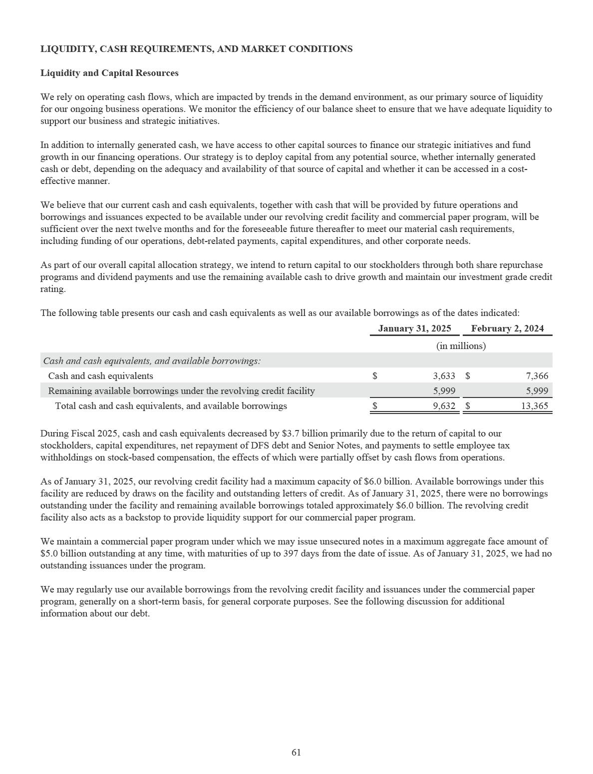

Debt
The following table presents our outstanding debt as of the dates indicated:
 |  |  | January 31, 2025 |  |  | Change |  |  | February 2, 2024
 |  |  |  |  |  | (in millions)
Core debt
Senior Notes |  | $ | 15,073 | $ |  | (534) | $ |  | 15,607
Legacy Notes |  |  | 952 |  |  | — |  |  | 952
DFS allocated debt |  |  | (3,028) |  |  | (1,388) |  |  | (1,640)
Total core debt |  |  | 12,997 |  |  | (1,922) |  |  | 14,919
DFS related debt
DFS debt |  |  | 8,711 |  |  | (781) |  |  | 9,492
DFS allocated debt |  |  | 3,028 |  |  | 1,388 |  |  | 1,640
Total DFS related debt |  |  | 11,739 |  |  | 607 |  |  | 11,132
Other |  |  | 52 |  |  | (119) |  |  | 171
 | Total debt, principal amount |  | 24,788 |  |  | (1,434) |  |  | 26,222
 | Carrying value adjustments |  | (221) |  |  | 7 |  |  | (228)
 | Total debt, carrying value | $ | 24,567 | $ |  | (1,427) | $ |  | 25,994

The outstanding principal amount of our debt decreased $1.4 billion to $24.8 billion as of January 31, 2025, driven primarily by net repayments of our DFS debt and Senior Notes.

We define core debt as the total principal amount of our debt, less DFS related debt and other debt. Our core debt was $13.0 billion and $14.9 billion as of January 31, 2025 and February 2, 2024, respectively. See Note 7 of the Notes to the Consolidated Financial Statements included in this report for additional information about our debt.

DFS related debt primarily represents debt from our securitization and structured financing programs. Our risk of loss under these programs is limited to transferred lease and loan payments and associated equipment, as the credit holders have no recourse to Dell Technologies.

To fund the expansion of our DFS business, we balance the use of the securitization and structured financing programs with other sources of liquidity. We approximate the amount of our core debt used to fund the DFS business by applying a 7:1 debt-to-equity ratio to the sum of our financing receivables balance and equipment under operating leases, net, also referred to as DFS owned assets. The debt-to-equity ratio is based on the underlying credit quality of the assets. See Note 5 of the Notes to the Consolidated Financial Statements included in this report for additional information about our DFS debt.

The following table presents DFS owned assets as of the dates indicated:
 |  | January 31, 2025 |  |  | February 2, 2024
 |  | (in millions)
Financing receivables, net | $ | 11,231 | $ |  | 10,520
Equipment under operating leases, net |  | 2,185 |  |  | 2,202
DFS owned assets | $ | 13,416 | $ |  | 12,722

We believe we will continue to be able to make our debt principal and interest payments, including payment of short-term maturities, from existing and expected sources of cash, primarily from operating cash flows. Cash used for debt principal and interest payments may include short-term borrowings under our commercial paper program, our revolving credit facility, or other borrowings. Under our variable-rate debt, we could experience variations in our future interest expense from potential fluctuations in applicable reference rates, or from possible fluctuations in the level of DFS debt required to meet future demand for customer financing.

62

At our sole discretion, we may purchase, redeem, prepay, refinance, or otherwise retire any amount of our outstanding indebtedness under the terms of such indebtedness at any time and from time to time, in open market or negotiated transactions with the holders of such indebtedness or otherwise, as we consider appropriate in light of market conditions and other relevant factors.

Cash Flows

The following table presents a summary of our Consolidated Statements of Cash Flows for the periods indicated:

 |  |  |  | Fiscal Year Ended
 |  | January 31, 2025 |  |  | February 2, 2024 |  |  | February 3, 2023
 |  |  |  |  | (in millions)
Net change in cash from:
Operating activities | $ | 4,521 | $ |  | 8,676 | $ |  | 3,565
Investing activities |  | (2,215) |  |  | (2,783) |  |  | (3,024)
Financing activities |  | (5,815) |  |  | (7,094) |  |  | (1,625)
Effect of exchange rate changes on cash, cash |  | (179) |  |  | (186) |  |  | (104)
equivalents, and restricted cash |  | (179) |  |  | (186) |  |  | (104)
Change in cash, cash equivalents, and restricted cash | $ | (3,688) | $ |  | (1,387) | $ |  | (1,188)

Operating Activities — Cash provided by operating activities was $4.5 billion during Fiscal 2025 and was driven by profitability, partially offset by working capital dynamics. Working capital was primarily impacted by AI, which led to higher inventory, accounts receivable, and accounts payable levels. During Fiscal 2024, cash provided by operating activities was $8.7 billion, which was primarily driven by profitability coupled with strong inventory management and cash collections performance. Cash provided by operating activities during Fiscal 2024 also reflected the impact of the $0.9 billion net payment to settle the Class V transaction litigation and $0.4 billion in proceeds from the sale of our U.S. consumer revolving customer receivables portfolio.

Investing Activities — Investing activities primarily consist of cash used to fund capital expenditures for property, plant, and equipment inclusive of equipment under operating leases and equipment used to support our as-a-Service offerings, which we refer to collectively as assets in a customer contract. Additional activities may include capitalized software development costs, the maturities, sales, and purchases of investments, and acquisitions and divestitures. Cash used in investing activities was $2.2 billion and $2.8 billion during Fiscal 2025 and Fiscal 2024, respectively, and was primarily applied to capital expenditures.

Financing Activities — Financing activities primarily consist of the proceeds and repayments of debt and return of capital to our stockholders. Cash used in financing activities was $5.8 billion during Fiscal 2025 and primarily consisted of repurchases of common stock, inclusive of payments to settle employee tax withholdings on stock-based compensation, net repayments of our DFS debt and Senior Notes, and the payment of quarterly dividends. During Fiscal 2024, cash used in financing activities was $7.1 billion and primarily consisted of principal repayments of our Senior Notes, repurchases of common stock, inclusive of payments to settle employee tax withholdings on stock-based compensation, and the payment of quarterly dividends.

DFS Cash Flow Impacts — DFS offerings are initially funded through cash on hand at the time of origination, most of which is subsequently replaced with asset-backed financing. For offerings that qualify as sales-type leases, the initial funding of financing receivables is reflected as an impact to cash flows from operations and is largely subsequently offset by cash proceeds from financing. For offerings that qualify as operating leases, the initial funding is classified as a capital expenditure and reflected as cash flows used in investing activities. DFS new financing originations were $8.4 billion during both Fiscal 2025 and Fiscal 2024 and $9.7 billion during Fiscal 2023. As of January 31, 2025, we had $11.2 billion of total net financing receivables and $2.2 billion of equipment under operating leases, net.

63

Supply Chain Finance Program — We maintain a Supply Chain Finance Program (the “SCF Program”) that enables eligible suppliers to sell receivables due from us to a third-party financial institution at the suppliers’ sole discretion. The SCF Program does not impact our liquidity, as payments by us to participating suppliers are remitted to the financial institution on the original invoice due date. Further, we negotiate payment terms with our suppliers regardless of their decision to participate in the SCF Program. Payments made under the SCF Program are included in cash flows from operating activities on the Consolidated Statements of Cash Flows. See Note 20 of the Notes to the Consolidated Financial Statements included in this report for more information regarding the SCF Program.

Material Capital Commitments and Cash Requirements

The Company’s material capital commitments include the following:

Capital Expenditures — We spent $2.7 billion and $2.8 billion during Fiscal 2025 and Fiscal 2024, respectively, on property, plant, and equipment and capitalized software development costs. Of total expenditures incurred, funding of assets in a customer contract totaled $1.3 billion and $1.2 billion during Fiscal 2025 and Fiscal 2024, respectively. Product demand, product mix, the use of contract manufacturers, and ongoing investments in operating and information technology infrastructure influence the level and prioritization of our capital expenditures.

Repurchases of Common Stock — On September 23, 2021, our Board of Directors approved a stock repurchase program with no fixed expiration date under which we may repurchase up to $5 billion of shares of Class C Common Stock, exclusive of any fees, commissions, or other expenses related to such repurchases. On October 5, 2023 and February 27, 2025, subsequent to the close of Fiscal 2025, our Board of Directors authorized additional shares for repurchase under the stock repurchase program of $5 billion and $10 billion, respectively. Following the February 27, 2025 approval, we had approximately $11.5 billion of authorized shares remaining under the program.

During Fiscal 2025, we repurchased approximately 22 million shares of Class C Common Stock for a total purchase price of approximately $2.6 billion. During Fiscal 2024, we repurchased approximately 34 million shares of Class C Common Stock for a total purchase price of approximately $2.1 billion.

Dividend Payments — During Fiscal 2025 and Fiscal 2024, the Company paid $1.3 billion and $1.1 billion in dividends and dividend equivalents at a rate of $0.445 and $0.37 per share per fiscal quarter, respectively.

On February 27, 2025, we announced that the Board of Directors approved an 18% increase in the dividend rate to $0.525 per share per fiscal quarter beginning in the first quarter of Fiscal 2026.

Additionally, the Company’s material cash requirements include the following contractual obligations:

Debt — Our expected principal cash payments on borrowings are exclusive of discounts and premiums. As of January 31, 2025, the Company had outstanding debt for an aggregate principal amount of $24.8 billion, with $5.2 billion payable within 12 months. Included within the aggregate principal amount was $16.1 billion of corporate and other debt with varying maturities, with an immaterial amount payable within 12 months, and $8.7 billion of DFS debt, with $5.2 billion payable within 12 months.

As of January 31, 2025, future interest payments associated with outstanding debt were $7.4 billion, with $1.2 billion payable within 12 months. Included within total future interest payments is $6.9 billion of payments related to corporate and other debt, with $0.9 billion payable within 12 months, and $0.5 billion of payments related to DFS debt, with $0.3 billion payable within 12 months.

Purchase Obligations — Purchase obligations are defined as contractual obligations to purchase goods or services that are enforceable and legally binding on us. These obligations specify all significant terms, including fixed or minimum quantities to be purchased; fixed, minimum, or variable price provisions; and the approximate timing of the transaction. Purchase obligations do not include contracts that may be canceled without penalty.

64

We utilize several suppliers to manufacture sub-assemblies for our products. Our efficient supply chain management allows us to enter into flexible and mutually beneficial purchase arrangements with our suppliers in order to minimize inventory risk. Consistent with industry practice, we acquire raw materials or other goods and services, including product components, by issuing to suppliers authorizations to purchase based on our projected demand and manufacturing needs. Additionally, to meet the growing demand and increasing complexity of our AI-optimized offerings, we have increased our purchases of certain components with suppliers, which has resulted in increased purchase obligations. These purchase orders are typically fulfilled within 30 days and are entered into during the ordinary course of business in order to establish best pricing and continuity of supply for our production. Purchase orders are not included in purchase obligations, as they typically represent our authorization to purchase rather than binding purchase obligations.

As of January 31, 2025, the Company had purchase obligations of $6.5 billion, of which $5.0 billion was payable within 12 months.

Operating Leases — We lease property and equipment, manufacturing facilities, and office space under non-cancelable leases. Certain of these leases obligate us to pay taxes, maintenance, and repair costs. As of January 31, 2025, the Company had operating lease obligations of $0.8 billion, with $0.2 billion payable within 12 months. See Note 6 of the Notes to the Consolidated Financial Statements included in this report for additional information about our leasing transactions in which we are the lessee.

Tax Obligations — Tax obligations represent a one-time mandatory deemed repatriation tax on undistributed earnings of foreign subsidiaries. As of January 31, 2025, the balance of tax obligations was $60 million, with the full amount payable within 12 months. Excluded from the amounts above are $0.9 billion in additional liabilities associated with uncertain tax positions as of January 31, 2025. We are unable to reliably estimate the expected payment dates for any liabilities for uncertain tax positions. See Note 12 of the Notes to the Consolidated Financial Statements included in this report for more information regarding these tax matters.

Market Conditions

We regularly monitor economic conditions and associated impacts on the financial markets and our business. We consistently evaluate the financial health of our supplier base, carefully manage customer credit, diversify counterparty risk, and monitor the concentration risk of our cash and cash equivalents balances globally. We routinely monitor our financial exposure to borrowers and counterparties.

We monitor credit risk associated with our financial counterparties using various market credit risk indicators such as credit ratings issued by nationally recognized credit rating agencies and changes in market credit default swap levels. Our AI solutions to date have been purchased primarily by a small number of larger customers and cloud service providers. Such purchases generally involve larger amounts of credit, and could impact overall credit risk in trade and financing receivables. We perform periodic evaluations of our positions with counterparties and may limit exposure to any one counterparty in accordance with our policies. We monitor and manage our positions based on current and expected market developments.

We use derivative instruments to hedge certain foreign currency exposures. We use forward contracts and purchased options designated as cash flow hedges to protect against the foreign currency exchange rate risks inherent in our forecasted transactions denominated in currencies other than the U.S. dollar. In addition, we primarily use forward contracts and may use purchased options to hedge monetary assets and liabilities denominated in a foreign currency. See Note 8 of the Notes to the Consolidated Financial Statements included in this report for additional information about our use of derivative instruments.

We are exposed to interest rate risk related to our variable-rate debt portfolio. In the normal course of business we follow established policies and procedures to manage this risk, including monitoring of our asset and liability mix and the use of derivative instruments. As a result, we do not anticipate any material losses from interest rate risk.

65

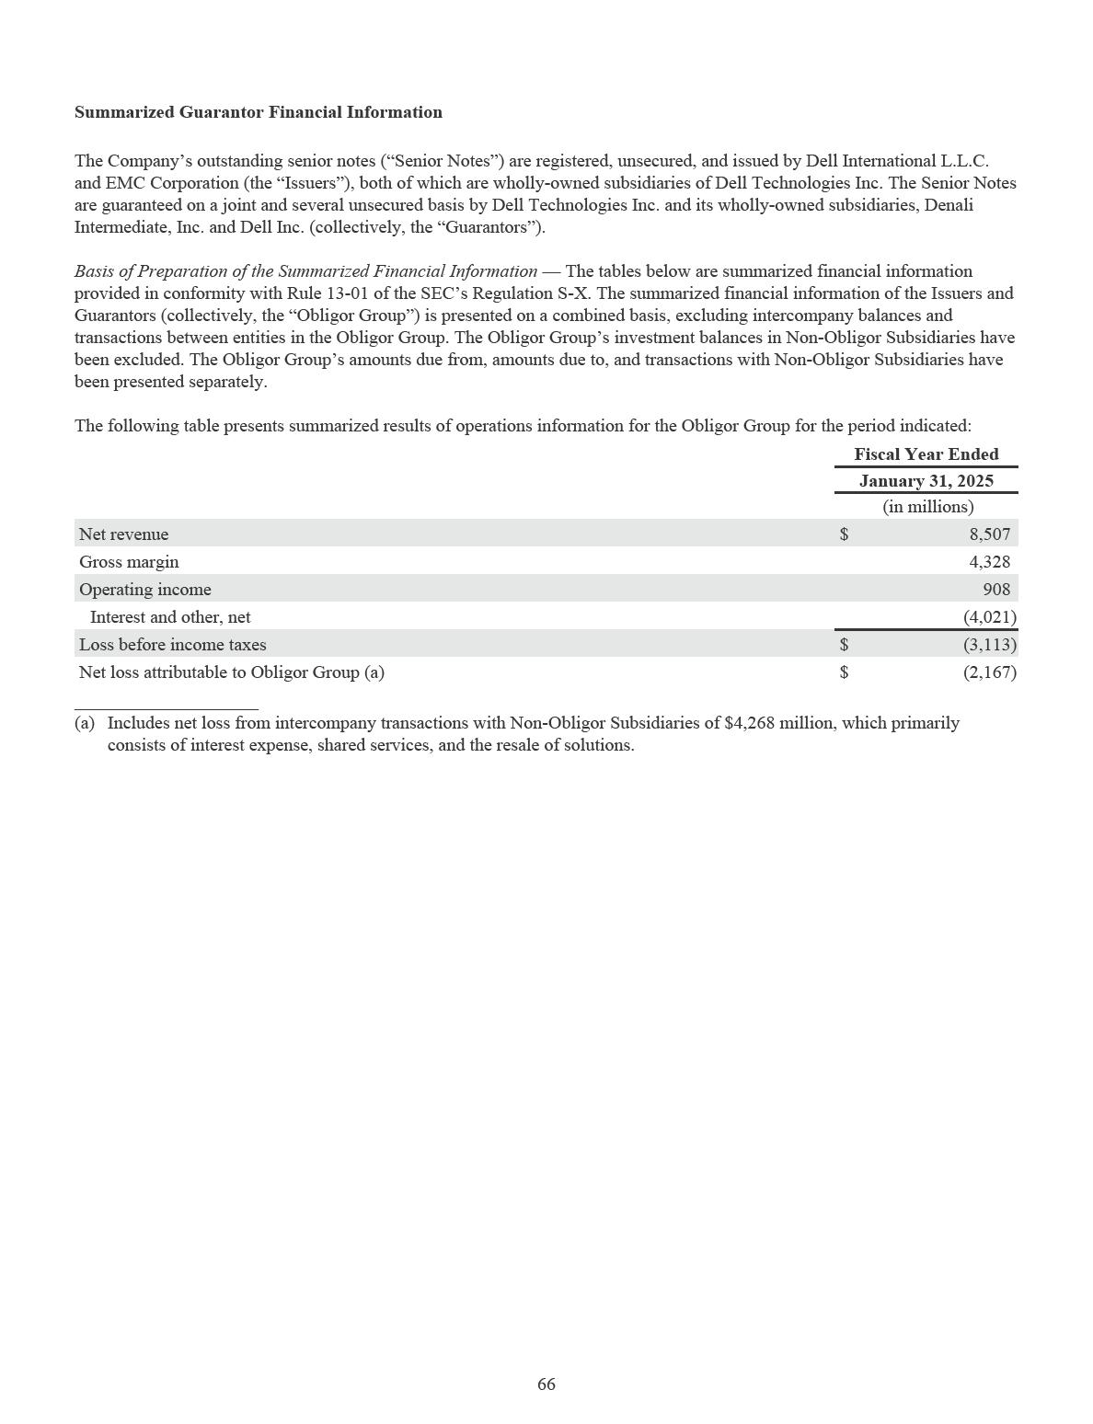

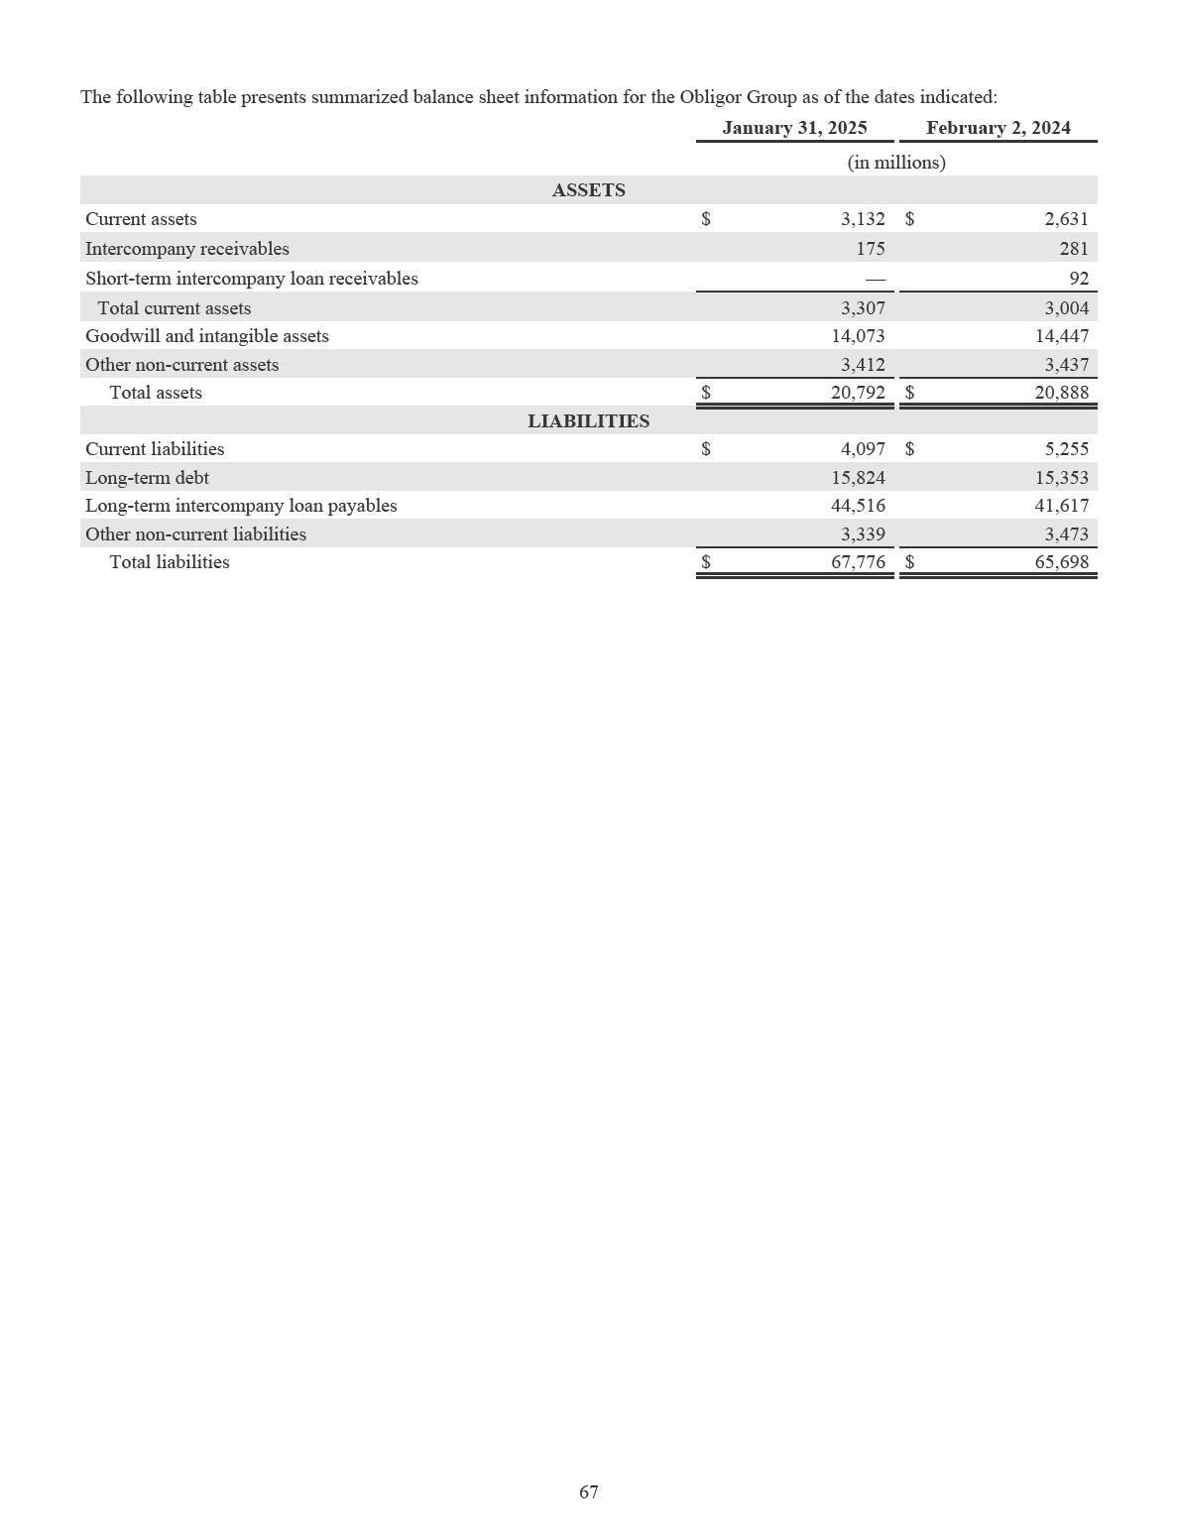

Critical Accounting Estimates

We prepare our financial statements in conformity with GAAP, which requires certain estimates, assumptions, and judgments to be made that may affect our Consolidated Statements of Financial Position and Consolidated Statements of Income. Accounting policies that have a significant impact on our Consolidated Financial Statements are described in Note 2 of the Notes to the Consolidated Financial Statements included in this report. The accounting estimates and assumptions discussed in this section are those that we consider to be the most critical. We consider an accounting policy to be critical if the nature of the estimate or assumption is subject to a material level of judgment and if changes in those estimates or assumptions are reasonably likely to materially impact our Consolidated Financial Statements. We have discussed the development, selection, and disclosure of our critical accounting policies with the Audit Committee of our Board of Directors.

Revenue Recognition — We sell a wide portfolio of products and services offerings to our customers. Our agreements have varying terms and conditions depending on the goods and services being sold, the rights and obligations conveyed, and the legal jurisdiction of the arrangement. While most of our agreements have standard terms and conditions, more complex agreements may contain nonstandard terms and conditions. There are significant judgments in interpreting agreements to determine the appropriate accounting for nonstandard terms and conditions.

Our contracts with customers often include multiple performance obligations for various distinct goods and services such as hardware, software licenses, support and maintenance agreements, and other service offerings and solutions. We use significant judgment to assess whether these promises are distinct performance obligations that should be accounted for separately. In certain hardware solutions, the hardware is highly interdependent on, and interrelated with, the embedded software. In these offerings, the hardware and software licenses are accounted for as a single performance obligation.

The transaction price reflects the amount of consideration to which we expect to be entitled in exchange for transferring goods or services to the customer. If the consideration promised in a contract includes a variable amount, we estimate the amount to which we expect to be entitled using either the expected value or most likely amount method. Estimates are updated each reporting period as the variability is resolved or if additional information becomes available. Generally, volume discounts, rebates, and sales returns reduce the transaction price. When we determine the transaction price, we only include amounts that are not subject to significant future reversal.

When a contract includes multiple performance obligations, the transaction price is allocated to each performance obligation in proportion to the standalone selling price (“SSP”) of each performance obligation.

Judgment is required when determining the SSP of our performance obligations. If the observable price is available, we utilize that price for the SSP. If the observable price is not available, the SSP must be estimated. We estimate SSP by considering multiple factors, including, but not limited to, pricing practices, internal costs, and profit objectives as well as overall market conditions, which include geographic or regional specific factors, competitive positioning, and competitor actions. Our SSP estimates rely, in part, on company pricing trends. Market conditions could impact the selling price in the current period which may not be reflective of trends, and could lead to revenue timing, classification, and segment differences when compared to similar contracts in other periods. SSP for our performance obligations is periodically reassessed.

For transactions that involve a third party, the Company evaluates whether it is acting as the principal or the agent in the transaction. This determination requires significant judgment and impacts the amount and timing of revenue recognized. If the Company determines that it controls a good or service before it is transferred to the customer, the Company is acting as the principal and recognizes revenue at the gross amount of consideration it is entitled to from the customer. Indicators that the Company controls a good or service before transferring to a customer include, but are not limited to, the Company being the primary obligor to the customer, establishing its own pricing, and having inventory and credit risks.

Goodwill and Indefinite-Lived Intangible Assets Impairment Assessments — Goodwill and indefinite-lived intangible assets are tested for impairment annually during the third fiscal quarter and whenever events or circumstances may indicate that an impairment has occurred.

To determine whether goodwill is impaired, we first assess certain qualitative factors. Qualitative factors that may be assessed include, but are not limited to, macroeconomic conditions, industry and market considerations, cost factors, overall financial performance, or other relevant company-specific events. Based on this assessment, if it is determined to be more likely than not that the fair value of a goodwill reporting unit is less than its carrying amount, we perform a quantitative analysis of the goodwill impairment test. Alternatively, we may bypass the qualitative assessment and perform a quantitative impairment test.

68

Significant judgment is exercised in the identification of goodwill reporting units, assignment of assets and liabilities to goodwill reporting units, assignment of goodwill to reporting units, and determination of the fair value of each goodwill reporting unit. The fair value of each of our goodwill reporting units is generally estimated using a combination of public company multiples and discounted cash flow methodologies, which is then compared to the carrying value of each goodwill reporting unit. The discounted cash flow and public company multiples methodologies require significant judgment, including estimation of future revenues, gross margins, and operating expenses, which are dependent on internal forecasts, current and anticipated economic conditions and trends, selection of market multiples through assessment of the reporting unit’s performance relative to peer competitors, the estimation of the long-term revenue growth rate and discount rate of our business, and the determination of our weighted average cost of capital. Changes in these estimates and assumptions could materially affect the fair value of the goodwill reporting unit, potentially resulting in a non-cash impairment charge.

The fair value of the indefinite-lived intangible assets is generally estimated using discounted cash flow methodologies. The discounted cash flow methodologies require significant judgment, including estimation of future revenue, the estimation of the long-term revenue growth rate of our business, and the determination of the weighted average cost of capital and royalty rates. Changes in these estimates and assumptions could materially affect the fair value of the indefinite-lived intangible assets, potentially resulting in a non-cash impairment charge.

For our annual impairment test during the third fiscal quarter of Fiscal 2025, during which the Company elected to quantitatively test the Infrastructure Solutions Group and Client Solutions Group reporting units, we determined that the fair value of each of these reporting units substantially exceeded its carrying amount. For more information about our goodwill and intangible assets, see Note 9 of the Notes to the Consolidated Financial Statements included in this report.

Income Taxes — We are subject to income tax in the United States and numerous foreign jurisdictions. Significant judgments are required in determining the consolidated provision for income taxes. We calculate a provision for income taxes using the asset and liability method, under which deferred tax assets and liabilities are recognized by identifying the temporary differences arising from the different treatment of items for tax and accounting purposes. We account for the tax impact of including Global Intangible Low-Taxed Income (GILTI) in U.S. taxable income as a period cost. We provide related valuation allowances for deferred tax assets, where appropriate. Significant judgment is required in determining any valuation allowance against deferred tax assets. In assessing the need for a valuation allowance, we consider all available evidence for each jurisdiction, including past operating results, estimates of future taxable income, and the feasibility of ongoing tax planning strategies. In the event we determine that all or part of the net deferred tax assets are not realizable in the future, we will make an adjustment to the valuation allowance that would be charged to earnings in the period such determination is made.

Significant judgment is also required in evaluating our uncertain tax positions. Although we believe our tax return positions are sustainable, we recognize tax benefits from uncertain tax positions in the financial statements only when it is more likely than not that the positions will be sustained upon examination, including resolution of any related appeals or litigation processes, based on the technical merits and a consideration of the relevant taxing authority’s administrative practices and precedents. To the extent that the final tax outcome of these matters is different from the amounts recorded, such differences will impact the provision for income taxes in the period in which such determination is made. The provision for income taxes includes the impact of reserve provisions and changes to reserves that are considered appropriate, as well as the related net interest and penalties. We believe we have provided adequate reserves for all uncertain tax positions.

Legal and Other Contingencies — The outcomes of legal proceedings and claims brought against us are subject to significant uncertainty. An estimated loss from a loss contingency such as a legal proceeding or claim is accrued by a charge to income if it is probable that an asset has been impaired or a liability has been incurred and the amount of the loss can be reasonably estimated. In determining whether a loss should be accrued, we evaluate, among other factors, the degree of probability of an unfavorable outcome and the ability to make a reasonable estimate of the amount of loss. Significant judgment is required in determining whether a loss should be accrued, and changes in these factors could materially impact our Consolidated Financial Statements.

69

Inventories — We state our inventory at the lower of cost or net realizable value. We record a write-down for inventories of components and products, including third-party products held for resale, which have become obsolete or are in excess of anticipated demand or net realizable value. We perform a detailed review of inventory each fiscal quarter that considers multiple factors, including demand forecasts, product life cycle status, product development plans, current sales levels, product pricing, and component cost trends. The industries in which we compete are subject to demand changes. If future demand or market conditions for our products are less favorable than forecasted, or if unforeseen technological changes negatively impact the utility of component inventory, we may be required to record additional write-downs, which would adversely affect our gross margin.

Recently Issued Accounting Pronouncements

See Note 2 of the Notes to the Consolidated Financial Statements included in this report for a summary of recently issued accounting pronouncements that are applicable to our Consolidated Financial Statements.

70

ITEM 7A — QUANTITATIVE AND QUALITATIVE DISCLOSURES ABOUT MARKET RISK

Dell Technologies is exposed to a variety of market risks, including risks associated with foreign currency exchange rate fluctuations, interest rate changes affecting its variable-rate debt, and changes in the market value of equity investments. In the normal course of business, Dell Technologies employs established policies and procedures to manage these risks.

Foreign Currency Risk

During Fiscal 2025, the principal foreign currencies in which Dell Technologies transacted business were the Euro, Indian Rupee, Japanese Yen, British Pound, Canadian Dollar, and Australian Dollar. The objective of Dell Technologies in managing its exposures to foreign currency exchange rate fluctuations is to reduce the impact of adverse fluctuations associated with foreign currency exchange rate changes on earnings and cash flows. Accordingly, Dell Technologies utilizes foreign currency option contracts and forward contracts to hedge its exposure on forecasted transactions and firm commitments for certain currencies. Dell Technologies monitors its foreign currency exchange exposures to ensure the overall effectiveness of its foreign currency hedge positions. However, there can be no assurance that the foreign currency hedging activities will continue to substantially offset the impact of fluctuations in currency exchange rates on Dell Technologies’ results of operations and financial position in the future.

Based on the outstanding foreign currency hedge instruments of Dell Technologies, which include designated and non-designated instruments, there was a maximum potential one-day loss in fair value at a 95% confidence level of approximately $9 million as of January 31, 2025 and $15 million as of February 2, 2024, using a Value-at-Risk (“VAR”) model. By using market implied rates and incorporating volatility and correlation among the currencies of a portfolio, the VAR model simulates 10,000 randomly generated market prices and calculates the difference between the fifth percentile and the average as the Value-at-Risk. The VAR model is a risk estimation tool and is not intended to represent actual losses in fair value that could be incurred. Additionally, as Dell Technologies utilizes foreign currency instruments for hedging forecasted and firmly committed transactions, a loss in fair value for those instruments is generally offset by increases in the value of the underlying exposure.

Interest Rate Risk

Dell Technologies is primarily exposed to interest rate risk related to its variable-rate debt portfolio and fixed-rate debt which has been converted to variable-rate debt through the use of derivative instruments. As of January 31, 2025, interest rate risk exposure is related to DFS borrowings.

DFS debt represents borrowings under securitization programs and structured financing programs that facilitate the funding of leases, loans, and other alternative payment structures. Amounts outstanding under these facilities generally bear interest at variable rates equal to applicable margins plus specified base rates. Interest expense on such borrowings is recognized within interest and other, net whereas interest income on the underlying assets is recognized to net revenue over time. The Company uses interest rate swaps to hedge the variability in cash flows related to the interest rate payments on such borrowings. These contracts are not designated for hedge accounting and mark-to-market adjustments are recognized immediately within interest and other, net.

Dell Technologies’ interest rate risk exposure is limited to fluctuations in interest rates on unhedged borrowings where we do not mitigate the interest rate risk through the use of interest rate swaps.

As of January 31, 2025, borrowings exposed to interest rate fluctuations were $2.6 billion relative to total borrowings of $24.6 billion, and accrued interest at an annual rate between 3.65% and 6.53%. Based on this debt outstanding as of January 31, 2025, a 100 basis point increase in interest rates would have resulted in an increase of approximately $26 million in annual interest expense.

By comparison, as of February 2, 2024, borrowings exposed to interest rate fluctuations were $3.3 billion, relative to total borrowings of $26.0 billion, and accrued interest at an annual rate between 2.45% and 6.88%. Based on this debt outstanding as of February 2, 2024, a 100 basis point increase in interest rates would have resulted in an increase of approximately $33 million in annual interest expense.

For more information about our debt and use of derivative instruments, see Note 5, Note 7, and Note 8 of the Notes to the Consolidated Financial Statements included in this report.

71

Equity Price Risk

Strategic Investments — Our strategic investments include primarily early-stage, privately-held companies that are considered to be in the start-up or development stages and are inherently risky. The technologies or products these companies have under development are typically in the early stages and may never materialize, which could result in a loss of a substantial part of our initial investment in the companies. We record these investments at cost, less impairment, adjusted for observable price changes. The evaluation is based on information provided by these companies, which are not subject to the same disclosure obligations as U.S. publicly-traded companies, and, accordingly, the basis for these evaluations is subject to the timing and accuracy of the data provided. As of January 31, 2025 and February 2, 2024, we held strategic investments in non-marketable securities of $1.5 billion and $1.3 billion, respectively.

See Note 4 of the Notes to the Consolidated Financial Statements included in this report for additional information.

72

ITEM 8 — FINANCIAL STATEMENTS
Index
 | Page
Report of Independent Registered Public Accounting Firm (Public Company Accounting Oversight Board ID: 238) | 74
Consolidated Statements of Financial Position as of January 31, 2025 and February 2, 2024 | 76
Consolidated Statements of Income for the fiscal years ended January 31, 2025, February 2, 2024, and February 3, | 77
2023 | 77
Consolidated Statements of Comprehensive Income for the fiscal years ended January 31, 2025, February 2, 2024, | 78
and February 3, 2023 | 78
Consolidated Statements of Cash Flows for the fiscal years ended January 31,2025, February 2, 2024, and February | 79
3,2023 | 79
Consolidated Statements of Stockholders’ Equity (Deficit) for the fiscal years ended January 31, 2025, February 2, | 80
2024, and February 3, 2023 | 80
Notes to the Consolidated Financial Statements | 83
Note 1 — Overview and Basis of Presentation | 83
Note 2 — Summary of Significant Accounting Policies | 86
Note 3 — Fair Value Measurements | 96
Note 4 — Investments | 98
Note 5 — Financial Services | 100
Note 6 — Leases | 107
Note 7 — Debt | 109
Note 8 — Derivative Instruments and Hedging Activities | 111
Note 9 — Goodwill and Intangible Assets | 115
Note 10 — Deferred Revenue | 117
Note 11 — Commitments and Contingencies | 118
Note 12 — Income and Other Taxes | 121
Note 13 — Accumulated Other Comprehensive Income (Loss) | 126
Note 14 — Capitalization | 128
Note 15 — Earnings Per Share | 130
Note 16 — Stock-Based Compensation | 131
Note 17 — Retirement Plan Benefits | 134
Note 18 — Segment Information | 136
Note 19 — Related Party Transactions | 140
Note 20 — Supplemental Consolidated Financial Information | 142
Note 21 — Government Assistance | 145
Note 22 — Quarterly Results (Unaudited) | 146
Note 23 — Subsequent Events | 150

73

Report of Independent Registered Public Accounting Firm

To the Board of Directors and Stockholders of Dell Technologies Inc.

Opinions on the Financial Statements and Internal Control over Financial Reporting

We have audited the accompanying consolidated statements of financial position of Dell Technologies Inc. and its subsidiaries (the “Company”) as of January 31, 2025 and February 2, 2024, and the related consolidated statements of income, of comprehensive income, of stockholders’ equity (deficit) and of cash flows for each of the three years in the period ended January 31, 2025, including the related notes (collectively referred to as the “consolidated financial statements”). We also have audited the Company's internal control over financial reporting as of January 31, 2025, based on criteria established in Internal Control - Integrated Framework (2013) issued by the Committee of Sponsoring Organizations of the Treadway Commission (COSO).

In our opinion, the consolidated financial statements referred to above present fairly, in all material respects, the financial position of the Company as of January 31, 2025 and February 2, 2024, and the results of its operations and its cash flows for each of the three years in the period ended January 31, 2025 in conformity with accounting principles generally accepted in the United States of America. Also in our opinion, the Company did not maintain, in all material respects, effective internal control over financial reporting as of January 31, 2025, based on criteria established in Internal Control - Integrated Framework (2013) issued by the COSO because a material weakness in internal control over financial reporting existed as of that date as the Company did not design and maintain effective controls over non-recurring credits from certain suppliers that related to cost of net revenue.

A material weakness is a deficiency, or a combination of deficiencies, in internal control over financial reporting, such that there is a reasonable possibility that a material misstatement of the annual or interim financial statements will not be prevented or detected on a timely basis. The material weakness referred to above is described in Management’s Annual Report on Internal Control over Financial Reporting appearing under Item 9A. We considered this material weakness in determining the nature, timing, and extent of audit tests applied in our audit of the 2025 consolidated financial statements, and our opinion regarding the effectiveness of the Company’s internal control over financial reporting does not affect our opinion on those consolidated financial statements.

Basis for Opinions

The Company's management is responsible for these consolidated financial statements, for maintaining effective internal control over financial reporting, and for its assessment of the effectiveness of internal control over financial reporting, included in management’s report referred to above. Our responsibility is to express opinions on the Company’s consolidated financial statements and on the Company's internal control over financial reporting based on our audits. We are a public accounting firm registered with the Public Company Accounting Oversight Board (United States) (PCAOB) and are required to be independent with respect to the Company in accordance with the U.S. federal securities laws and the applicable rules and regulations of the Securities and Exchange Commission and the PCAOB.

We conducted our audits in accordance with the standards of the PCAOB. Those standards require that we plan and perform the audits to obtain reasonable assurance about whether the consolidated financial statements are free of material misstatement, whether due to error or fraud, and whether effective internal control over financial reporting was maintained in all material respects.

Our audits of the consolidated financial statements included performing procedures to assess the risks of material misstatement of the consolidated financial statements, whether due to error or fraud, and performing procedures that respond to those risks. Such procedures included examining, on a test basis, evidence regarding the amounts and disclosures in the consolidated financial statements. Our audits also included evaluating the accounting principles used and significant estimates made by management, as well as evaluating the overall presentation of the consolidated financial statements. Our audit of internal control over financial reporting included obtaining an understanding of internal control over financial reporting, assessing the risk that a material weakness exists, and testing and evaluating the design and operating effectiveness of internal control based on the assessed risk. Our audits also included performing such other procedures as we considered necessary in the circumstances. We believe that our audits provide a reasonable basis for our opinions.

74

Definition and Limitations of Internal Control over Financial Reporting

A company’s internal control over financial reporting is a process designed to provide reasonable assurance regarding the reliability of financial reporting and the preparation of financial statements for external purposes in accordance with generally accepted accounting principles. A company’s internal control over financial reporting includes those policies and procedures that (i) pertain to the maintenance of records that, in reasonable detail, accurately and fairly reflect the transactions and dispositions of the assets of the company; (ii) provide reasonable assurance that transactions are recorded as necessary to permit preparation of financial statements in accordance with generally accepted accounting principles, and that receipts and expenditures of the company are being made only in accordance with authorizations of management and directors of the company; and (iii) provide reasonable assurance regarding prevention or timely detection of unauthorized acquisition, use, or disposition of the company’s assets that could have a material effect on the financial statements.

Because of its inherent limitations, internal control over financial reporting may not prevent or detect misstatements. Also, projections of any evaluation of effectiveness to future periods are subject to the risk that controls may become inadequate because of changes in conditions, or that the degree of compliance with the policies or procedures may deteriorate.

Critical Audit Matters

The critical audit matter communicated below is a matter arising from the current period audit of the consolidated financial statements that was communicated or required to be communicated to the audit committee and that (i) relates to accounts or disclosures that are material to the consolidated financial statements and (ii) involved our especially challenging, subjective, or complex judgments. The communication of critical audit matters does not alter in any way our opinion on the consolidated financial statements, taken as a whole, and we are not, by communicating the critical audit matter below, providing a separate opinion on the critical audit matter or on the accounts or disclosures to which it relates.

Revenue Recognition — Identification of Performance Obligations in Revenue Contracts

As described in Notes 2 and 18 to the consolidated financial statements, the Company’s contracts with customers often include the promise to transfer multiple goods and services to a customer. Distinct promises within a contract are referred to as performance obligations and are accounted for as separate units of account. Management assesses whether each promised good or service is distinct for the purpose of identifying the performance obligations in the contract. This assessment involves subjective determinations and requires management to make judgments about the individual promised goods or services and whether such goods or services are separable from the other aspects of the contractual relationship. The Company’s performance obligations include various distinct goods and services such as hardware, software licenses, support and maintenance agreements, and other service offerings and solutions. For the year ended January 31, 2025, a significant portion of the $43.6 billion Infrastructure Solutions Group (“ISG”) reportable segment net revenues relate to contracts with multiple performance obligations.

The principal considerations for our determination that performing procedures relating to the identification of performance obligations in revenue contracts is a critical audit matter are (i) the significant judgment by management in identifying performance obligations in revenue contracts and (ii) a high degree of auditor judgment, subjectivity and effort in performing procedures and evaluating audit evidence related to whether performance obligations in revenue contracts were appropriately identified by management.

Addressing the matter involved performing procedures and evaluating audit evidence in connection with forming our overall opinion on the consolidated financial statements. These procedures included testing the effectiveness of controls relating to the revenue recognition process, including controls related to the proper identification of performance obligations in revenue contracts. These procedures also included, among others, testing the completeness and accuracy of management’s identification of performance obligations by examining revenue contracts on a test basis.

/s/ PricewaterhouseCoopers LLP

Austin, Texas
March 25, 2025

We have served as the Company’s auditor since 1986.

75

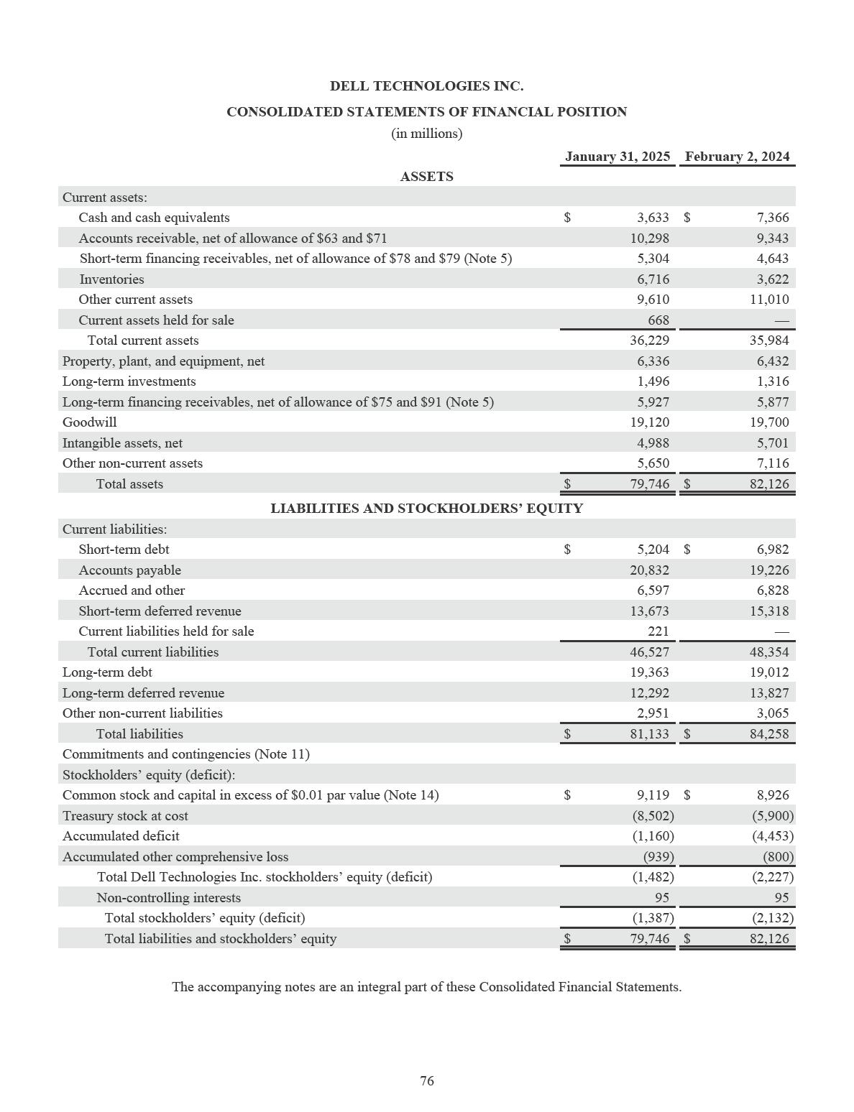

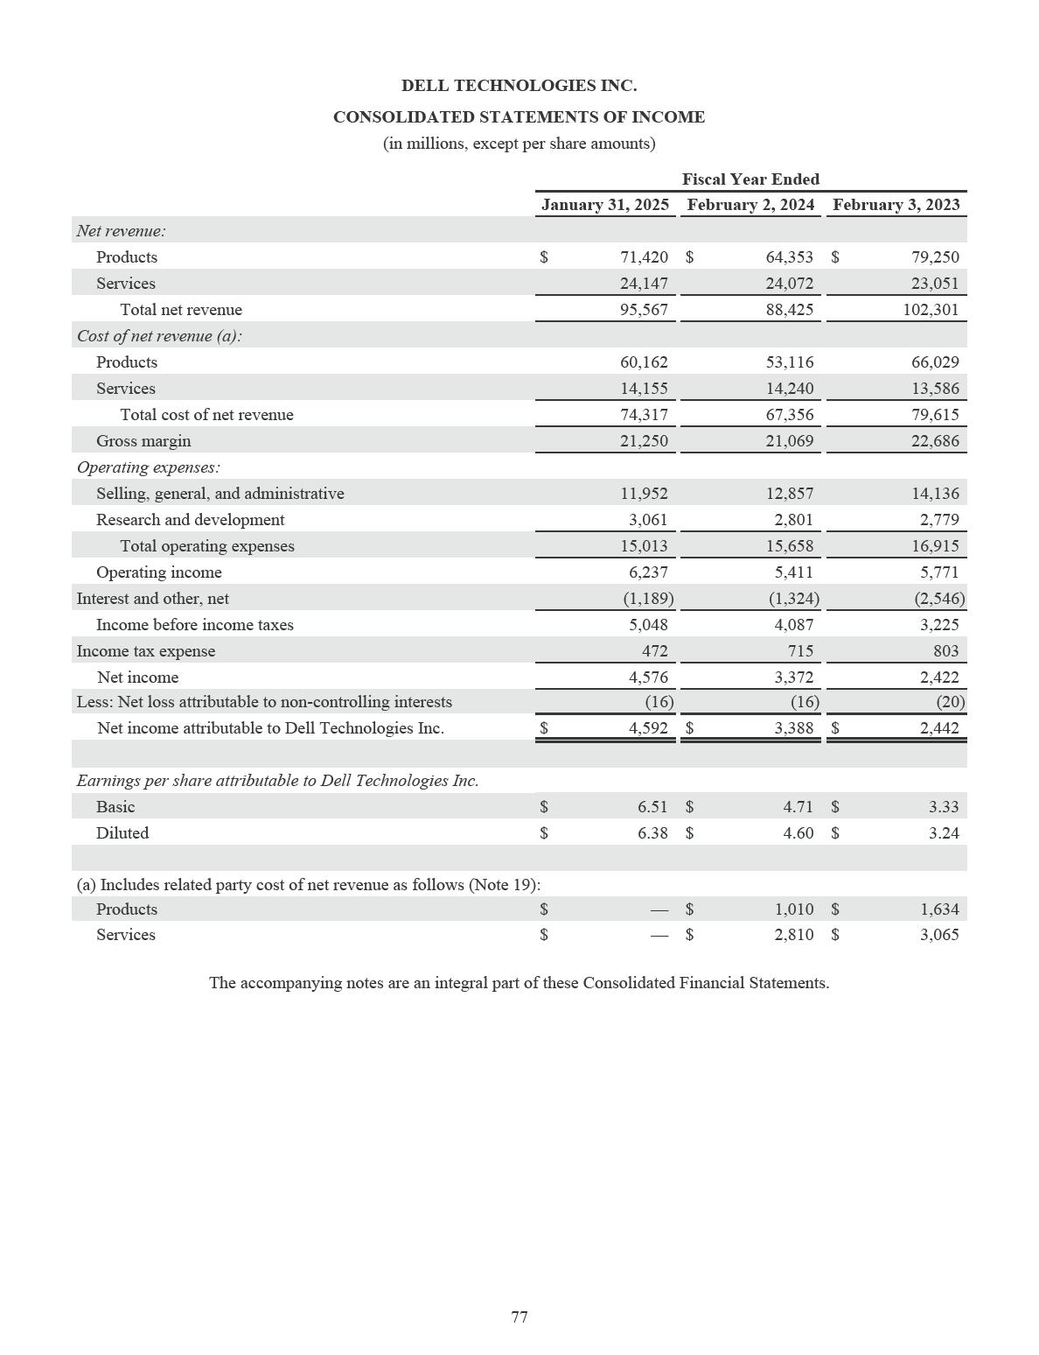

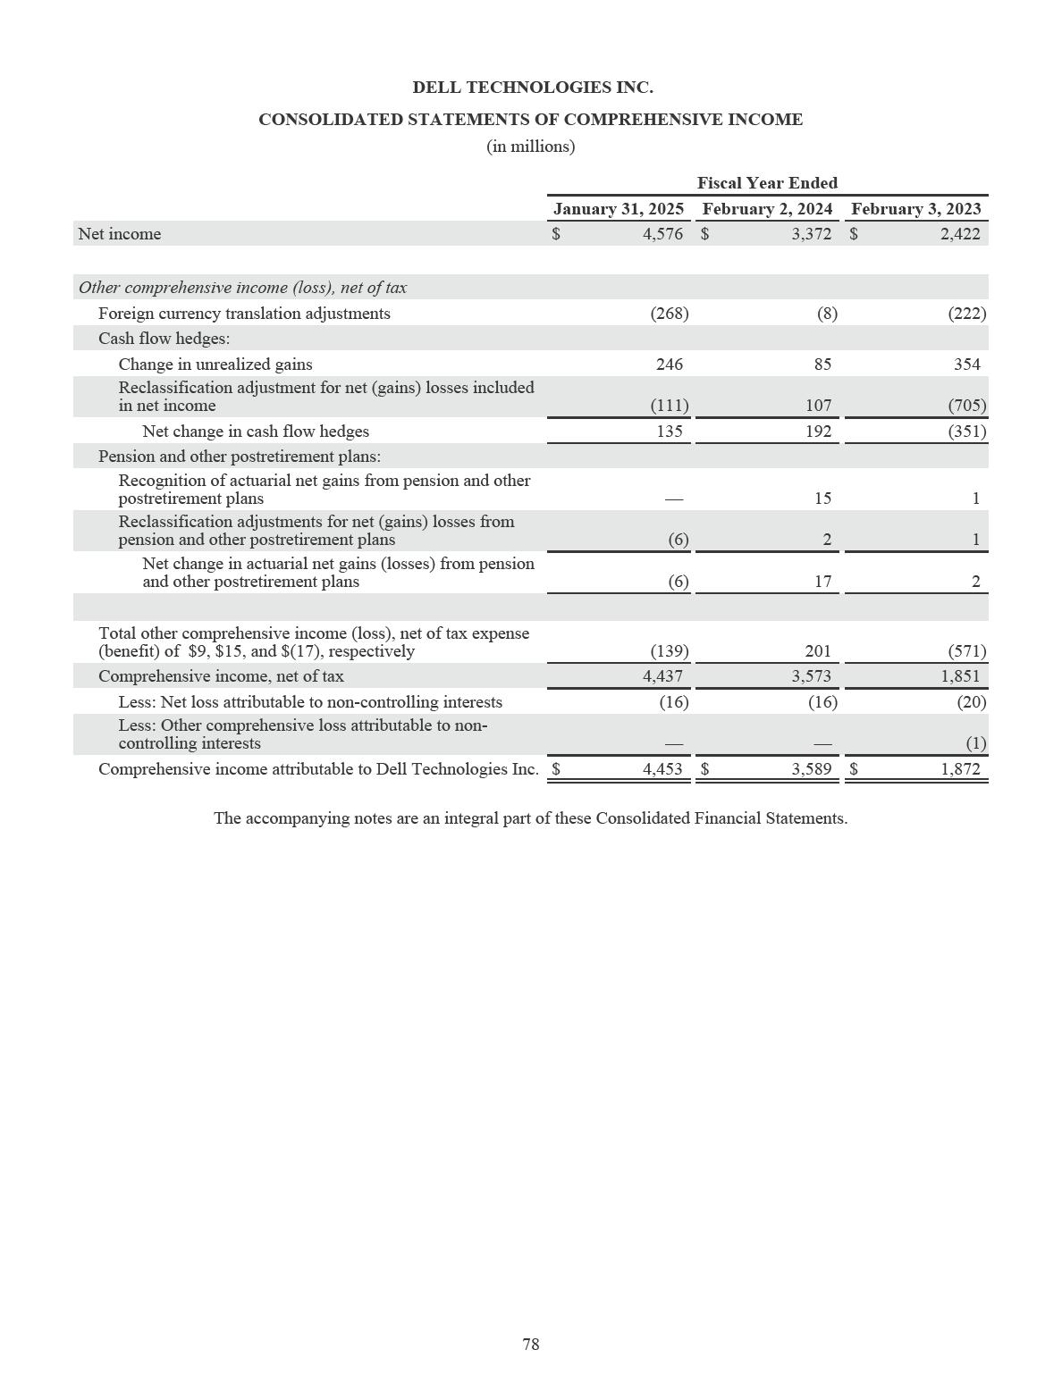

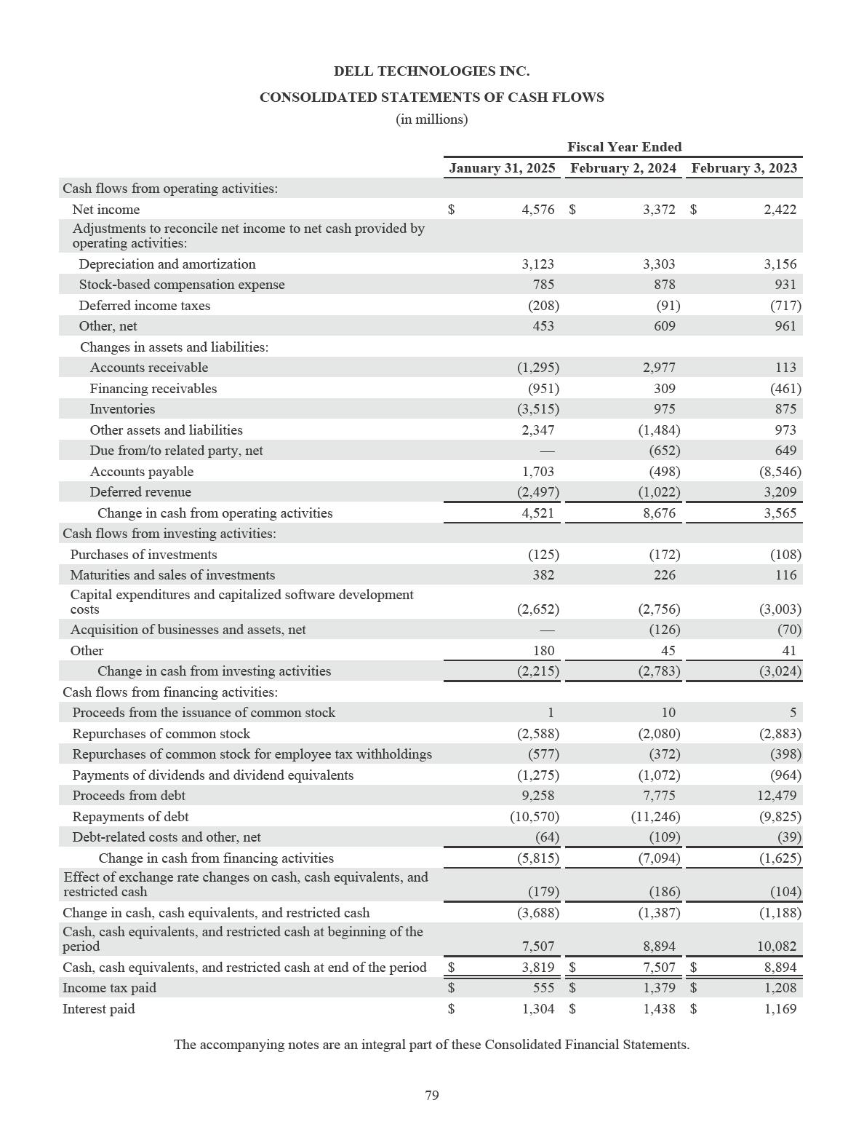

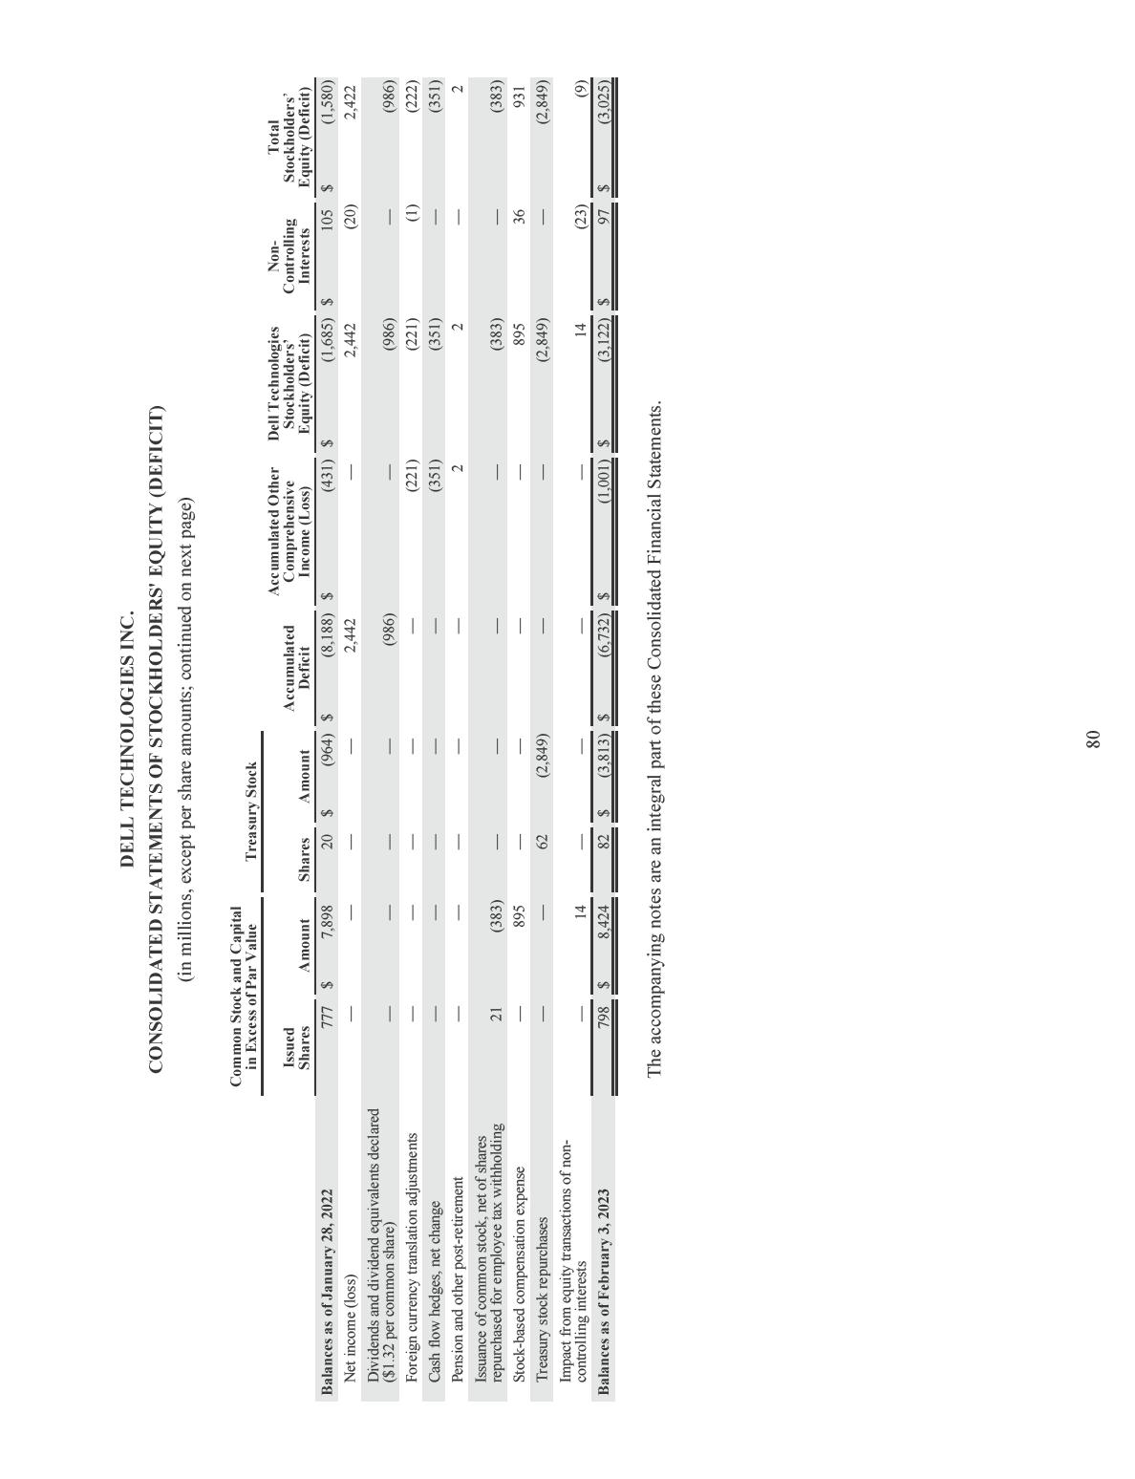

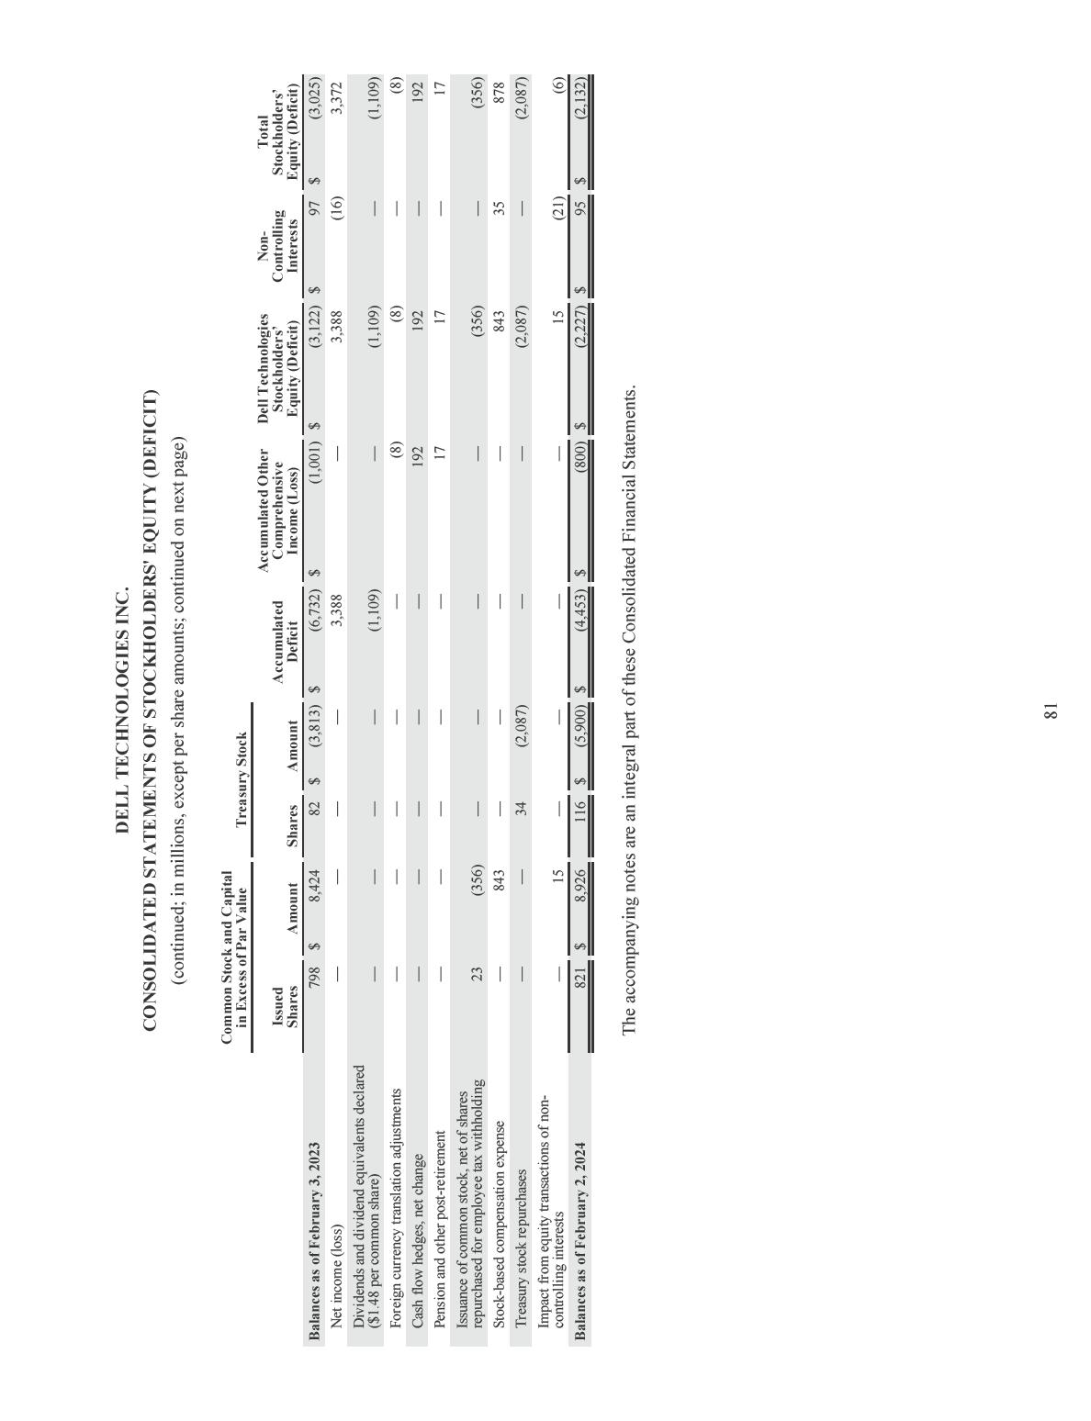

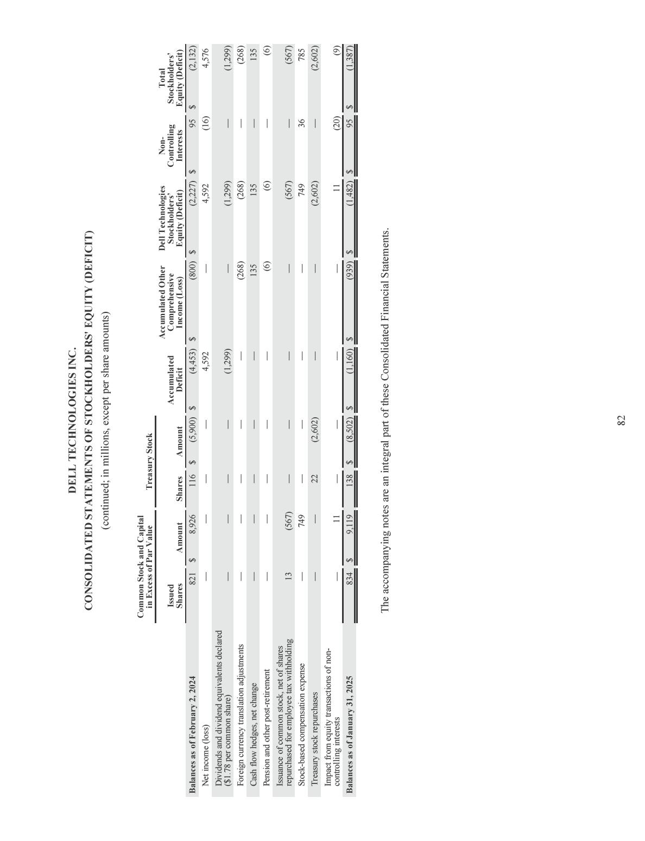

DELL TECHNOLOGIES INC.

NOTES TO THE CONSOLIDATED FINANCIAL STATEMENTS

NOTE 1 — OVERVIEW AND BASIS OF PRESENTATION

Dell Technologies is a leader in the global technology industry that designs, develops, manufactures, markets, sells, and supports a wide range of comprehensive and integrated solutions, products, and services. Dell Technologies offerings include servers and networking, storage, cloud solutions, desktops, notebooks, services, software, branded peripherals, and third-party software and peripherals. References in these Notes to the Consolidated Financial Statements to the “Company” or “Dell Technologies” mean Dell Technologies Inc. individually and together with its consolidated subsidiaries.

Basis of Presentation — These Consolidated Financial Statements have been prepared in accordance with accounting principles generally accepted in the United States of America (“GAAP”).

The Company’s fiscal year is the 52- or 53-week period ending on the Friday nearest January 31. The fiscal years ended January 31, 2025 and February 2, 2024 were 52-week periods. The fiscal year ended February 3, 2023 was a 53-week period.

Revision of Previously Issued Financial Statements — During the fiscal year ended January 31, 2025, the Company discovered accumulated credits from certain suppliers that were not recorded or not recorded in the correct period in its previously reported financial results. The Company initiated an investigation that indicated that the credits resulted from the actions of certain procurement employees that support a limited number of suppliers, which affected the Client Solutions Group (“CSG”) segment. The revision did not have an impact on the Company’s net revenue.

The Company determined that the impacts were not material, individually or in the aggregate, to its previously issued Consolidated Financial Statements and accompanying Notes to the Consolidated Financial Statements for any of the prior quarters or the annual period in which they occurred. However, in accordance with Staff Accounting Bulletin No. 108 of the Securities and Exchange Commission (“SEC”), the Company concluded that correcting the cumulative misstatement in the current period would be material to its results of operations for the fiscal year ended January 31, 2025.

Accordingly, the Company has revised its previously issued Consolidated Financial Statements, as applicable, as of and for the fiscal year ended February 2, 2024. A summary of the corrections to the impacted financial statement line items in these Consolidated Financial Statements is presented below.

Consolidated Statements of Financial Position
 |  |  |  |  | February 2, 2024
 |  |  | As Reported |  |  | Adjustment |  |  | As Revised
 |  |  |  |  |  | (in millions)
Current assets:
Other current assets |  | $ | 10,973 | $ |  | 37 | $ |  | 11,010
Total current assets |  | $ | 35,947 | $ |  | 37 | $ |  | 35,984
Total assets |  | $ | 82,089 | $ |  | 37 | $ |  | 82,126
Current liabilities:
Accounts payable |  | $ | 19,389 | $ |  | (163) | $ |  | 19,226
Accrued and other |  | $ | 6,805 | $ |  | 23 | $ |  | 6,828
Total current liabilities |  | $ | 48,494 | $ |  | (140) | $ |  | 48,354
Total liabilities |  | $ | 84,398 | $ |  | (140) | $ |  | 84,258
Stockholders' equity (deficit):
Accumulated deficit |  | $ | (4,630) | $ |  | 177 | $ |  | (4,453)
Total Dell Technologies Inc. stockholders' equity (deficit) |  | $ | (2,404) | $ |  | 177 | $ |  | (2,227)
Total stockholders' equity (deficit) |  | $ | (2,309) | $ |  | 177 | $ |  | (2,132)
Total liabilities and stockholders' equity |  | $ | 82,089 | $ |  | 37 | $ |  | 82,126

83

DELL TECHNOLOGIES INC.

NOTES TO THE CONSOLIDATED FINANCIAL STATEMENTS (continued)

Consolidated Statements of Income
 |  |  |  |  |  |  | Fiscal Year Ended
 |  |  |  |  |  |  | February 2, 2024
 |  |  |  |  | As Reported |  |  | Adjustment |  |  | As Revised
 |  |  |  |  | (in millions, except per share amounts)
Cost of net revenue:
Products |  |  |  | $ | 53,316 | $ |  | (200) | $ |  | 53,116
Total cost of net revenue |  |  |  | $ | 67,556 | $ |  | (200) | $ |  | 67,356
Gross margin |  |  |  | $ | 20,869 | $ |  | 200 | $ |  | 21,069
Operating income |  |  |  | $ | 5,211 | $ |  | 200 | $ |  | 5,411
Income before income taxes |  |  |  | $ | 3,887 | $ |  | 200 | $ |  | 4,087
Income tax expense |  |  |  | $ | 692 | $ |  | 23 | $ |  | 715
Net income |  |  |  | $ | 3,195 | $ |  | 177 | $ |  | 3,372
Net income attributable to Dell Technologies Inc. |  |  |  | $ | 3,211 | $ |  | 177 | $ |  | 3,388
Earnings per share attributable to Dell Technologies Inc.
Basic |  |  |  | $ | 4.46 | $ |  | 0.25 | $ |  | 4.71
Diluted |  |  |  | $ | 4.36 | $ |  | 0.24 | $ |  | 4.60
Consolidated Statements of Comprehensive Income
 |  |  |  |  |  |  | Fiscal Year Ended
 |  |  |  |  |  |  | February 2, 2024
 |  |  |  |  | As Reported |  |  | Adjustment |  |  | As Revised
 |  |  |  |  |  |  |  | (in millions)
Net income |  |  |  | $ | 3,195 | $ |  | 177 | $ |  | 3,372
Comprehensive income, net of tax |  |  |  | $ | 3,396 | $ |  | 177 | $ |  | 3,573
Comprehensive income attributable to Dell Technologies Inc. |  |  |  | $ | 3,412 | $ |  | 177 | $ |  | 3,589
Consolidated Statements of Cash Flows
 |  |  |  |  |  |  | Fiscal Year Ended
 |  |  |  |  |  |  | February 2, 2024
 |  |  |  |  | As Reported |  |  | Adjustment |  |  | As Revised
 |  |  |  |  |  |  |  | (in millions)
Cash flow from operations:
Net income |  |  |  | $ | 3,195 | $ |  | 177 | $ |  | 3,372
Adjustments to reconcile net income to net cash provided by
operating activities:
Other assets and liabilities |  |  |  | $ | (1,470) | $ |  | (14) | $ |  | (1,484)
Accounts payable |  |  |  | $ | (335) | $ |  | (163) | $ |  | (498)

The Company will also revise previously reported quarterly financial information for this misstatement based on the summary presented herein in its future filings with the SEC, as applicable. A summary of the corrections to the impacted financial statement line items to the Company’s previously issued Condensed Consolidated Financial Statements for each quarterly period is presented in Note 22 of the Notes to the Consolidated Financial Statements.

84

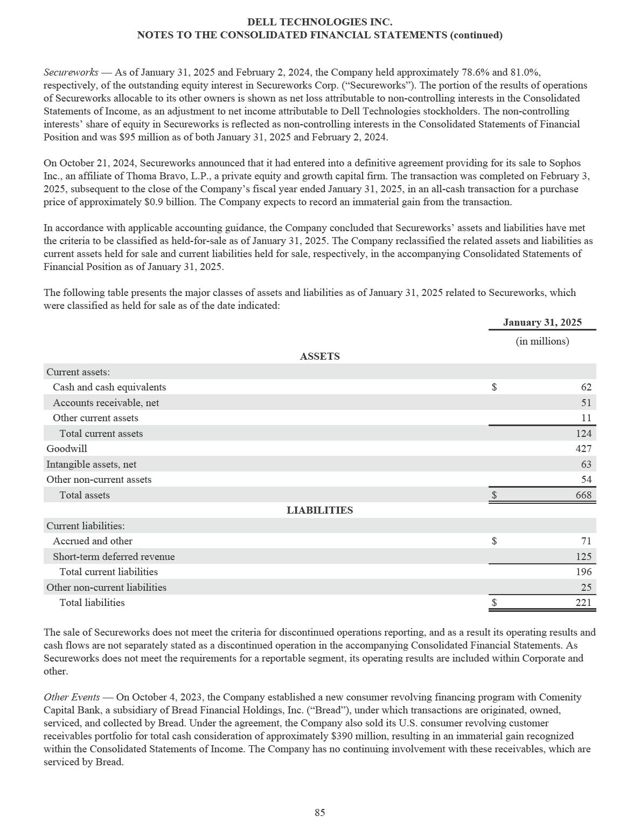

DELL TECHNOLOGIES INC.

NOTES TO THE CONSOLIDATED FINANCIAL STATEMENTS (continued)

NOTE 2 — SUMMARY OF SIGNIFICANT ACCOUNTING POLICIES

Principles of Consolidation — These Consolidated Financial Statements include the accounts of Dell Technologies and its wholly-owned subsidiaries, as well as the accounts of Secureworks, which, as indicated in Note 1 of the Notes to the Consolidated Financial Statements, was majority-owned by Dell Technologies as of January 31, 2025. All intercompany transactions have been eliminated.

The Company also consolidates Variable Interest Entities ("VIEs") where it has been determined that the Company is the primary beneficiary of the applicable entities’ operations. For each VIE, the primary beneficiary is the party that has both the power to direct the activities that most significantly impact the VIE's economic performance and the obligation to absorb losses or the right to receive benefits of the VIE that could potentially be significant to such VIE. In evaluating whether the Company is the primary beneficiary of each entity, the Company evaluates its power to direct the most significant activities of the VIE by considering the purpose and design of each entity and the risks each entity was designed to create and pass through to its respective variable interest holders. The Company also evaluates its economic interests in each of the VIEs. See Note 5 of the Notes to the Consolidated Financial Statements for more information regarding consolidated VIEs.

Use of Estimates — The preparation of financial statements in accordance with GAAP requires management to make estimates and assumptions that affect the amounts reported in the Consolidated Financial Statements and the accompanying Notes. Actual results could differ materially from those estimates.

Cash and Cash Equivalents — All highly liquid investments with original maturities of 90 days or less at date of purchase are reported at fair value and are considered to be cash equivalents. Credit card receivables are classified as either cash and cash equivalents or receivables depending on the nature of the payment terms.

Investments — The Company has strategic investments in equity and other securities as well as investments in fixed-income debt securities. All equity and other securities and long-term fixed income debt securities are recorded as long-term investments in the Consolidated Statements of Financial Position. Short-term fixed income debt securities are recorded as other current assets in the Consolidated Statements of Financial Position.

Strategic investments in marketable equity and other securities are recorded at fair value based on quoted prices in active markets. Strategic investments in non-marketable equity and other securities without readily determinable fair values are recorded at cost, less impairment, and are adjusted for observable price changes. In evaluating equity investments without readily determinable fair values for impairment or observable price changes, the Company uses inputs that include pre- and post-money valuations of recent financing events and the impact of those events on its fully diluted ownership percentages, as well as other available information regarding the issuer’s historical and forecasted performance. Fair value measurements and impairments for strategic investments are recognized in interest and other, net in the Consolidated Statements of Income.

Fixed-income debt securities are carried at amortized cost and approximate fair value. The Company intends to hold its fixed-income debt securities to maturity.

Allowance for Expected Credit Losses on Accounts Receivable — The Company recognizes an allowance for losses on accounts receivable in an amount equal to the current expected credit losses. The estimation of the allowance is based on an analysis of historical loss experience, current receivables aging, and management’s assessment of current conditions and reasonable and supportable expectation of future conditions, as well as an assessment of specific identifiable customer accounts considered at risk or uncollectible. The Company assesses collectibility by pooling receivables where similar characteristics exist and evaluates receivables individually when specific customer balances no longer share those risk characteristics and are considered at risk or uncollectible. The expense associated with the allowance for expected credit losses is recognized in selling, general, and administrative expenses in the Consolidated Statements of Income.

86

DELL TECHNOLOGIES INC.

NOTES TO THE CONSOLIDATED FINANCIAL STATEMENTS (continued)

Accounting for Operating Leases as a Lessee — In its ordinary course of business, the Company enters into leases as a lessee for office buildings, warehouses, employee vehicles, and equipment. The Company determines if an arrangement is a lease or contains a lease at inception. The Company’s leases are generally classified as operating leases. The Company does not have any material finance leases. Operating leases result in the recognition of right of use (“ROU”) assets and lease liabilities on the Consolidated Statements of Financial Position. ROU assets represent the right to use an underlying asset for the lease term, and lease liabilities represent the obligation to make lease payments arising from the lease, measured on a discounted basis. At lease commencement, the lease liability is measured at the present value of the lease payments over the lease term. The operating lease ROU asset equals the lease liability adjusted for any initial direct costs, prepaid or deferred rent, and lease incentives. The Company uses the implicit rate when readily determinable. As most of the leases do not provide an implicit rate, the Company uses its incremental borrowing rate based on the information available at the commencement date to determine the present value of lease payments.

The lease term may include options to extend or to terminate the lease that the Company is reasonably certain to exercise. The Company has elected not to record leases with an initial term of 12 months or less on the Consolidated Statements of Financial Position. Lease expense is recognized on a straight-line basis over the lease term in most instances. The Company does not generate material sublease income and has no material related party leases. The Company’s lease agreements do not contain any material residual value guarantees or material restrictive covenants.

The Company’s office building agreements contain costs such as common area maintenance and other executory costs that may be either fixed or variable in nature. Variable lease costs are expensed as incurred. The Company combines lease and non-lease components, including fixed common area and other maintenance costs, in calculating the ROU assets and lease liabilities for its office buildings and employee vehicles. Under certain service agreements with third-party logistics providers, the Company directs the use of the inventory within the warehouses and, therefore, controls the assets. The warehouses and some of the equipment used are considered embedded leases. The Company accounts for the lease and non-lease components separately for its warehouses and equipment. The lease components consist of the warehouses and some of the equipment, such as conveyor belts. The non-lease components consist of services and other shared equipment, such as material handling and transportation. The Company allocates the consideration to the lease and non-lease components using their relative standalone values. See Note 6 of the Notes to the Consolidated Financial Statements for additional information.

Accounting for Leases as a Lessor — The Company’s wholly-owned subsidiary Dell Financial Services and its affiliates (“DFS”) act as a lessor to provide equipment financing to customers through a variety of lease arrangements (“DFS leases”). The Company’s leases are classified as sales-type leases, direct financing leases, or operating leases. Direct financing leases are immaterial.

The Company also offers alternative payment structures and as-a-Service offerings that are assessed to determine whether an embedded lease arrangement exists. The Company accounts for those contracts as a lease arrangement if it is determined that the contract contains an identified asset and that control of that asset has transferred to the customer.

When a contract includes lease and non-lease components, the Company allocates consideration under the contract to each component based on relative standalone selling price and subsequently assesses lease classification for each lease component within a contract. DFS provides lessees with the option to extend the lease or purchase the underlying asset at the end of the lease term, which is considered when evaluating lease classification. In general, DFS lease arrangements do not have variable payment terms and are typically non-cancelable.

On commencement of sales-type leases, the Company recognizes profit up-front, and amounts due from the customer under the lease contract are recognized as financing receivables on the Consolidated Statements of Financial Position. Interest income is recognized as net product revenue over the term of the lease based on the effective interest method. The Company has elected not to include sales and other taxes collected from the lessee as part of lease revenue.

87

DELL TECHNOLOGIES INC.

NOTES TO THE CONSOLIDATED FINANCIAL STATEMENTS (continued)

All other leases that do not meet the definition of a sales-type lease or direct financing lease are classified as operating leases. The underlying asset in an operating lease arrangement is carried at depreciated cost as “Assets in a customer contract” within Property, plant, and equipment, net on the Consolidated Statements of Financial Position. Depreciation is calculated using the straight-line method over the term of the underlying lease contract and is recognized as cost of net revenue. The depreciable basis is the original cost of the equipment less the estimated residual value of the equipment at the end of the lease term. The residual value is based upon estimates of the value of the equipment at the end of the lease term using historical studies, industry data, and future value-at-risk demand valuation methods. The Company recognizes operating lease income to product revenue generally on a straight-line basis over the lease term and expenses deferred initial direct costs on the same basis. The Company recognizes variable lease income to product revenue generally as earned. Impairment of assets in a customer contract is assessed on the same basis as other long-lived assets.

Financing Receivables — Financing receivables are presented net of allowance for losses and consist of customer receivables and residual interest. Gross customer receivables include amounts due from customers under revolving loans, fixed-term loans, fixed-term sales-type or direct financing leases, and accrued interest. The Company has two portfolios, consisting of (i) fixed-term leases and loans and (ii) revolving loans, and assesses risk at the portfolio level to determine the appropriate allowance levels. The portfolio segments are further segregated into classes based on products, customer type, and credit risk evaluation. Fixed-term leases and loans are offered to qualified small and medium-sized businesses, large commercial accounts, governmental organizations, and educational entities. Fixed-term loans are also offered to qualified individual consumers. Revolving loans were primarily offered to small and medium-sized business customers, with the remaining offerings discontinued during the fiscal year ended January 31, 2025.

The Company retains a residual interest in equipment leased under its fixed-term lease programs. The amount of the residual interest is established at the inception of the lease based upon estimates of the value of the equipment at the end of the lease term using historical studies, industry data, and future value-at-risk demand valuation methods.

Allowance for Financing Receivable Losses — The Company recognizes an allowance for financing receivable losses, including both the lease receivable and unguaranteed residual, in an amount equal to the expected losses net of recoveries. The allowance for financing receivable losses on the lease receivable is determined based on various factors, including lifetime expected losses determined using macroeconomic forecast assumptions and management judgments applicable to and through the expected life of the portfolios as well as past due receivables, receivable type, and customer risk profile.

Generally, expected credit losses as a result of residual value risk on equipment under lease are not considered to be significant primarily because of the existence of a secondary market with respect to the equipment. The Company’s lease agreements also generally define applicable return conditions and remedies for non-compliance to ensure that the leased equipment will be in good operating condition upon return. Model changes and updates, as well as market strength and product acceptance, are monitored and adjustments are made to residual values in accordance with the significance of any such changes.

When an account is deemed to be uncollectible, customer account principal and interest are charged off to the allowance for losses. While the Company does not generally place financing receivables on non-accrual status during the delinquency period, accrued interest is included in the allowance for loss calculation and, therefore, the Company is adequately reserved in the event of charge off. Recoveries on receivables previously charged off as uncollectible are recorded to the allowance for financing receivable losses. The expense associated with the allowance for financing receivable losses is recognized as cost of net revenue.

Asset Securitization — The Company transfers certain U.S. and European customer lease and loan payments and associated equipment to Special Purpose Entities (“SPEs”) that meet the definition of a Variable Interest Entity (“VIE”) and are consolidated into the Consolidated Financial Statements. These SPEs are bankruptcy-remote legal entities with separate assets and liabilities. The purpose of the SPEs is to facilitate the funding of customer lease and loan payments and associated equipment in the capital markets. Some of these SPEs have entered into financing arrangements with multi-seller conduits that, in turn, issue asset-backed debt securities in the capital markets. The asset securitizations in the SPEs are accounted for as secured borrowings.

Inventories — The Company generally records inventory on the Consolidated Statements of Financial Position when legal title and risk of loss have passed to the Company for items that are held for sale in the ordinary course of business, that are in process of production for sale, or that will be consumed in the production of goods or services that will be held for sale.

88

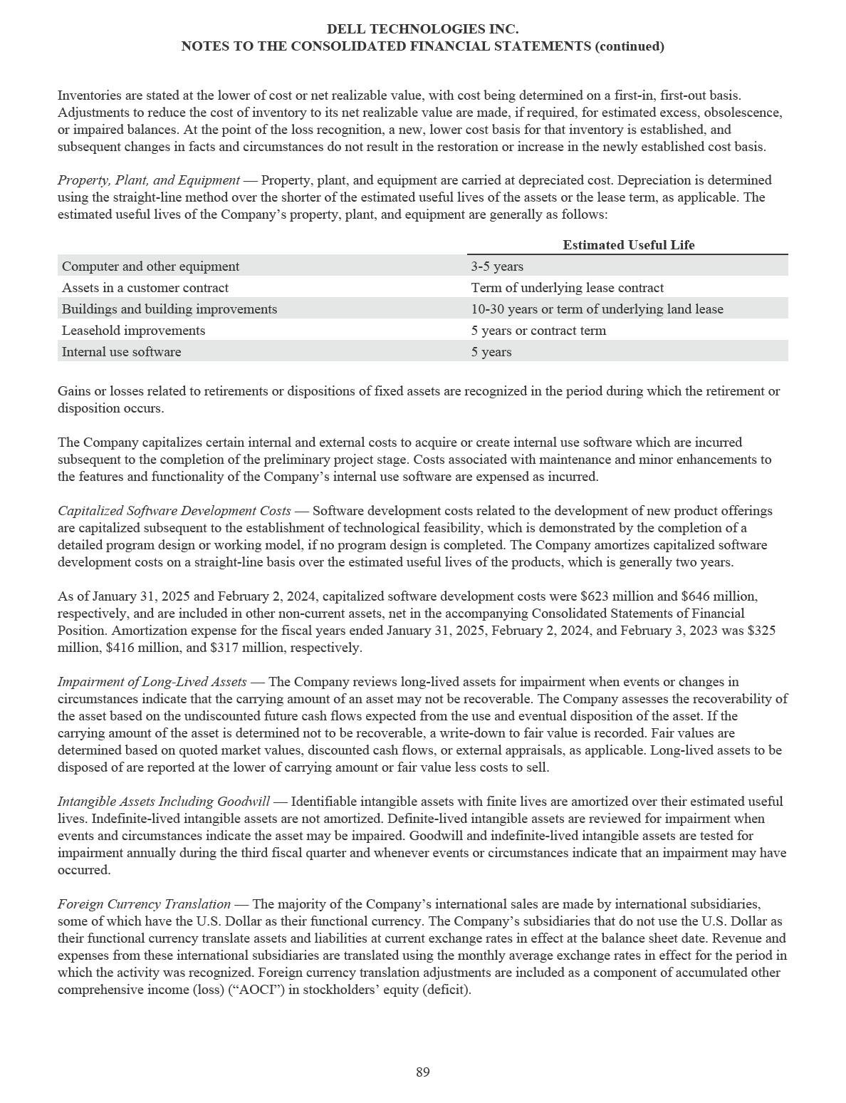

DELL TECHNOLOGIES INC.

NOTES TO THE CONSOLIDATED FINANCIAL STATEMENTS (continued)

Local currency transactions of international subsidiaries that have the U.S. Dollar as their functional currency are remeasured into U.S. Dollars using the current rates of exchange for monetary assets and liabilities and historical rates of exchange for nonmonetary assets and liabilities. Gains and losses from remeasurement of monetary assets and liabilities are included in interest and other, net on the Consolidated Statements of Income. See Note 20 of the Notes to the Consolidated Financial Statements for amounts recognized from remeasurement during the periods presented.

Hedging Instruments — The Company uses derivative financial instruments, primarily forward contracts, options, and swaps, to hedge certain foreign currency and interest rate exposures. The relationships between hedging instruments and hedged items, as well as the risk management objectives and strategies for undertaking hedge transactions, are formally documented. The Company does not use derivatives for speculative purposes. All derivative instruments are recognized as either assets or liabilities in the Consolidated Statements of Financial Position and are measured at fair value. The Company’s hedge portfolio includes non-designated derivatives and derivatives designated as cash flow hedges and, from time to time, fair value hedges.

For derivative instruments designated as a cash flow hedge, the Company assesses hedge effectiveness at the onset of the hedge, then performs qualitative assessments at regular intervals throughout the life of the derivative. The gain or loss on the hedge is recorded in AOCI, as a separate component of stockholders’ equity (deficit), and reclassified into earnings in the period during which the hedged transaction is recognized in earnings. For derivatives that are designated as a fair value hedge, the Company evaluates the effectiveness of the qualifying fair value hedge using the shortcut method of accounting under which hedges are assumed to be perfectly effective. The change in fair value of the hedge exactly offsets the fair value of the hedged item and there is no net impact recognized in earnings from the fair value of the derivative. For derivatives that are not designated as hedges or do not qualify for hedge accounting treatment, the Company recognizes the change in the instrument’s fair value in earnings as a component of interest and other, net.

Cash flows from derivative instruments are presented in the same category on the Consolidated Statements of Cash Flows as the cash flows from the underlying hedged items. See Note 8 of the Notes to the Consolidated Financial Statements for a description of the Company’s derivative financial instrument activities.

Revenue Recognition — The Company sells a wide portfolio of products and services to its customers. The Company’s agreements have varying requirements depending on the goods and services being sold, the rights and obligations conveyed, and the legal jurisdiction of the arrangement. While most of our agreements have standard terms and conditions, more complex agreements may contain nonstandard terms and conditions that require significant judgments in interpreting agreements to determine the appropriate accounting.

Revenue is recognized for these arrangements based on the following five steps:

- Identify the contract with a customer. The Company evaluates facts and circumstances regarding sales transactions in order to identify contracts with its customers. An agreement must meet all of the following criteria to qualify as a contract eligible for revenue recognition under the model: (i) the contract must be approved by all parties who are committed to perform their respective obligations; (ii) each party’s rights regarding the goods and services to be transferred to the customer can be identified; (iii) the payment terms for the goods and services can be identified; (iv) the customer has the ability and intent to pay and it is probable that the Company will collect substantially all of the consideration to which it will be entitled; and (v) the contract must have commercial substance. Judgment is used in determining the customer’s ability and intent to pay, which is based upon various factors, including the customer’s historical payment experience or customer credit and financial information.

90

DELL TECHNOLOGIES INC.

NOTES TO THE CONSOLIDATED FINANCIAL STATEMENTS (continued)

- Identify the performance obligations in the contract. The Company’s contracts with customers often include the promise to transfer multiple goods and services to the customer. Distinct promises within a contract are referred to as “performance obligations” and are accounted for as separate units of account. The Company assesses whether each promised good or service is distinct for the purpose of identifying the performance obligations in the contract. This assessment involves subjective determinations and requires management to make judgments about the individual promised goods or services and whether such goods or services are separable from the other aspects of the contractual relationship. Promised goods and services are considered distinct provided that: (i) the customer can benefit from the good or service either on its own or together with other resources that are readily available to the customer (that is, the good or service is capable of being distinct); and (ii) the Company’s promise to transfer the good or service to the customer is separately identifiable from other promises in the contract (that is, the promise to transfer the good or service is distinct within the context of the contract). The Company’s performance obligations include various distinct goods and services such as hardware, software licenses, support and maintenance agreements, and other service offerings and solutions. Promised goods and services are explicitly identified in the Company’s contracts and may be sold on a standalone basis or bundled as part of a combined solution. In certain hardware solutions, the hardware is highly interdependent on, and interrelated with, the embedded software. In these offerings, the hardware and software licenses are accounted for as a single performance obligation.

- Determine the transaction price. The transaction price reflects the amount of consideration to which the Company expects to be entitled in exchange for transferring goods or services to the customer. If the consideration promised in a contract includes a variable amount, the Company estimates the amount to which it expects to be entitled using either the expected value or most likely amount method. Generally, volume discounts, rebates, and sales returns reduce the transaction price. In determining the transaction price, the Company only includes amounts that are not subject to significant future reversal.

- Allocate the transaction price to performance obligations in the contract. When a contract includes multiple performance obligations, the transaction price is allocated to each performance obligation in an amount that depicts the consideration to which the Company expects to be entitled in exchange for transferring the promised goods or services. For contracts with multiple performance obligations, the transaction price is allocated in proportion to the standalone selling price (“SSP”) of each performance obligation.

The best evidence of SSP is the observable price of a good or service when the Company sells that good or service separately in similar circumstances to similar customers. If a directly observable price is available, the Company will utilize that price for the SSP. If a directly observable price is not available, the SSP must be estimated. The Company estimates SSP by considering multiple factors, including, but not limited to, pricing practices, internal costs, and profit objectives as well as overall market conditions, which include geographic or regional specific factors, competitive positioning, and competitor actions.

- Recognize revenue when (or as) the performance obligation is satisfied. Revenue is recognized when obligations under the terms of the contract with the Company’s customer are satisfied. Revenue is recognized either over time or at a point in time, depending on when the underlying products or services are transferred to the customer. Revenue is recognized at a point in time for products upon transfer of control. Revenue is recognized over time for support and deployment services, software support, Software-as-a-Service (“SaaS”), and Infrastructure-as-a-Service (“IaaS”). Revenue is recognized either over time or at a point in time for professional services and training depending on the nature of the offering to the customer.

The Company reports revenue net of any revenue-based taxes assessed by governmental authorities that are imposed on and concurrently with specific revenue-producing transactions.

91

DELL TECHNOLOGIES INC.

NOTES TO THE CONSOLIDATED FINANCIAL STATEMENTS (continued)

The Company has elected the following practical expedients:

- The Company does not account for significant financing components if the period between revenue recognition and when the customer pays for the product or service will be one year or less.

- The Company recognizes revenue equal to the amount it has a right to invoice when the amount corresponds directly with the value to the customer of the Company’s performance to date.

- The Company does not account for shipping and handling activities as a separate performance obligation, but rather as an activity performed to transfer the promised good.

The following summarizes the nature of revenue recognized and the manner in which the Company accounts for sales transactions.

Products

Product revenue consists of revenue from sales of hardware products, including notebooks and desktop PCs, servers, storage hardware, and other hardware-related devices, as well as revenue from software license sales, including non-essential software applications and third-party software licenses.

Revenue from sales of hardware products is recognized when control has transferred to the customer, which typically occurs when the hardware has been shipped to the customer, risk of loss has transferred to the customer, the Company has a present right to payment, and customer acceptance has been satisfied. Customer acceptance is satisfied if acceptance is obtained from the customer, if all acceptance provisions lapse, or if the Company has evidence that all acceptance provisions will be, or have been, satisfied. Revenue from software license sales is generally recognized when control has transferred to the customer, which is typically upon shipment, electronic delivery, or when the software is available for download by the customer. For certain software arrangements in which the customer is granted a right to additional unspecified future software licenses, the Company’s promise to the customer is considered a stand-ready obligation in which the transfer of control and revenue recognition will occur over time.

Services

Services revenue consists of revenue from sales of support services, including hardware support that extends beyond the Company’s standard warranties, software maintenance, and installation; professional services; training; SaaS; and IaaS. Revenue associated with undelivered performance obligations is deferred and recognized when or as control is transferred to the customer. Revenue from fixed-price support or maintenance contracts sold for both hardware and software is recognized on a straight-line basis over the period of performance because the Company is required to provide services at any given time. Other services revenue is recognized when the Company performs the services and the customer receives and consumes the benefits.

Other

Revenue from leasing arrangements is not subject to the revenue standard for contracts with customers and remains separately accounted for under lease accounting guidance. The Company records operating lease rental revenue as product revenue on a straight-line basis over the lease term. The Company records revenue under sales-type leases as product revenue in an amount equal to the present value of minimum lease payments at the inception of the lease. Sales-type leases also produce financing income, which is included in product net revenue in the Consolidated Statements of Income and is recognized at effective rates of return over the lease term. The Company also offers qualified customers fixed-term loans as well as previously offered revolving lines of credit through DFS for the purchase of products and services offered by the Company. Financing income attributable to these loans is recognized in product net revenue on an accrual basis.

92

DELL TECHNOLOGIES INC.

NOTES TO THE CONSOLIDATED FINANCIAL STATEMENTS (continued)

Principal versus Agent — For transactions that involve a third party, the Company evaluates whether it is acting as the principal or the agent in the transaction. This determination requires significant judgment and impacts the amount and timing of revenue recognized. If the Company determines that it controls a good or service before it is transferred to the customer, the Company is acting as the principal and recognizes revenue at the gross amount of consideration it is entitled to from the customer. Indicators that the Company controls a good or service before transferring it to a customer include, but are not limited to, the Company being the primary obligor to the customer, establishing its own pricing, and having inventory and credit risks. Conversely, if the Company determines that it does not control the good or service before it is transferred to the customer, the Company is acting as an agent in the transaction. As an agent, the Company is arranging for the good or service to be provided by another party and recognizes revenue at the net amount of consideration retained.

Disaggregation of Revenue — The Company’s revenue is presented on a disaggregated basis on the Consolidated Statements of Income and in Note 18 of the Notes to the Consolidated Financial Statements based on an evaluation of disclosures outside of the financial statements, information regularly provided to and reviewed by the Company’s chief operating decision maker for evaluating the financial performance of operating segments, and other information that is used to evaluate the Company’s financial performance and make resource allocations. This information includes revenue from products and services, revenue from reportable segments, and revenue by major product categories within the segments.

Contract Assets — Contract assets are rights to consideration in exchange for goods or services that the Company has transferred to a customer when such a right is conditional on criteria other than the passage of time. Such amounts are immaterial as of January 31, 2025 and February 2, 2024.

Contract Liabilities — Contract liabilities primarily consist of deferred revenue. Deferred revenue is recorded when the Company has invoiced or payments have been received for undelivered products or services, or in situations where revenue recognition criteria have not been met. Deferred revenue primarily includes amounts received in advance for extended warranty services and software maintenance. Revenue is recognized on these items when the revenue recognition criteria are met, generally resulting in ratable recognition over the contract term. The Company also has deferred revenue related to undelivered hardware and professional services, consisting of installations and consulting engagements, which are recognized when the Company’s performance obligations under the contract are completed. See Note 10 of the Notes to the Consolidated Financial Statements for additional information about deferred revenue.

Deferred Costs — Deferred costs primarily consist of costs incurred to fulfill or obtain a contract and are included within other current assets and other non-current assets on the Consolidated Statements of Financial Position, based on when the expense is expected to be recognized.

Costs incurred to fulfill revenue-generating contracts are mainly associated with third-party software support and maintenance offerings and VMware Resale offerings discussed in Note 18 and Note 19 of the Notes to the Consolidated Financial Statements. The Company defers and subsequently amortizes these charges on a straight-line basis over the life of the contract or the average contract duration. Amortization expense is included in cost of net revenue in the Consolidated Statements of Income. Deferred costs to fulfill revenue-generating contracts as of January 31, 2025 and February 2, 2024 were $4.8 billion and $7.7 billion, respectively. Amortization of deferred costs to fulfill revenue-generating contracts during the fiscal years ended January 31, 2025, February 2, 2024, and February 3, 2023 was $7.6 billion, $8.0 billion, and $7.3 billion, respectively.

The Company capitalizes incremental direct costs to obtain a contract, primarily sales commissions and employer taxes related to commission payments, if the costs are deemed to be recoverable. The Company has elected, as a practical expedient, to expense as incurred costs to obtain a contract equal to or less than one year in duration. Capitalized costs are deferred and amortized over the period of contract performance or the estimated life of the customer relationship, if renewals are expected, and are typically amortized over an average period of one to five years. Amortization expense is recognized on a straight-line basis and included in selling, general, and administrative expenses in the Consolidated Statements of Income. Deferred costs to obtain a contract as of January 31, 2025 and February 2, 2024 were $540 million and $674 million, respectively. Amortization of costs to obtain a contract during the fiscal years ended January 31, 2025, February 2, 2024, and February 3, 2023 was $346 million, $383 million, and $390 million, respectively.

93

DELL TECHNOLOGIES INC.

NOTES TO THE CONSOLIDATED FINANCIAL STATEMENTS (continued)

The Company periodically reviews these deferred costs to determine whether events or changes in circumstances have occurred that could impact the carrying value or period of benefit of the costs to fulfill or costs to obtain a contract. There were no material impairment losses for deferred costs during the fiscal years ended January 31, 2025, February 2, 2024, and February 3, 2023.

Standard Warranty Liabilities — The Company records warranty liabilities for estimated costs of fulfilling its obligations under standard limited hardware and software warranties at the time of sale. The liabilities for standard warranties are included in accrued and other and in other non-current liabilities in the Consolidated Statements of Financial Position. The specific warranty terms and conditions vary depending upon the product sold and the country in which the Company does business, but generally include technical support, parts, and labor over a period ranging from one to three years. Factors that affect the Company’s warranty liabilities include the number of installed units currently under warranty, historical and anticipated rates of warranty claims on those units, and cost per claim to satisfy the Company’s warranty obligation. The anticipated rate of warranty claims is the primary estimate used in determining the warranty liability and is relatively predictable using historical experience of failure rates. The average remaining aggregate warranty period of the covered installed base is approximately 17 months, repair parts are generally already in stock or available at pre-determined prices, and labor rates are generally arranged at preestablished amounts with service providers. If actual results differ from the estimates, the Company revises its estimated warranty liability. Each quarter, the Company reevaluates its estimates to assess the adequacy of its recorded warranty liabilities and adjusts the amounts as necessary. See Note 20 of the Notes to the Consolidated Financial Statements for additional information about standard warranty liabilities.

Consideration Received from Vendors — The Company may receive consideration from vendors in the normal course of business. Certain of these funds received as consideration are rebates of purchase price paid and others are related to reimbursement of costs incurred by the Company to sell the vendor’s products. The Company recognizes a reduction to cost of net revenue if the funds are determined to be a reduction of the price of the vendor’s products. If the consideration is a reimbursement of costs incurred by the Company to sell or develop the vendor’s products, the consideration is classified as a reduction of such costs, most often operating expenses, in the Consolidated Statements of Income. In order to be recognized as a reduction of operating expenses, the reimbursement must be for a specific, incremental, and identifiable cost incurred by the Company in selling the vendor’s products or services.

Loss Contingencies — The Company is subject to the possibility of various losses arising in the ordinary course of business. In determining loss contingencies, the Company considers the likelihood of loss or impairment of an asset or the incurrence of a liability, as well as the Company’s ability to reasonably estimate the amount of loss. An estimated loss contingency is accrued when it is probable that an asset has been impaired or a liability has been incurred and the amount of loss can be reasonably estimated. The Company regularly evaluates current information available to determine whether such accruals should be adjusted and whether new accruals are required.

Shipping Costs — The Company’s shipping and handling costs are included in cost of net revenue in the Consolidated Statements of Income.

Selling, General, and Administrative — Selling expenses include items such as sales salaries and commissions, marketing and advertising costs, and contractor services. Advertising costs are generally expensed as incurred in selling, general, and administrative expenses in the Consolidated Statements of Income. For the fiscal years ended January 31, 2025, February 2, 2024, and February 3, 2023, advertising expenses were $0.8 billion, $0.9 billion, and $1.1 billion, respectively. General and administrative expenses include items for the Company’s administrative functions, such as finance, legal, human resources, and information technology support. These functions include costs for items such as salaries and benefits and other personnel-related costs, maintenance and supplies, outside services, intangible asset amortization, and depreciation expense.

Research and Development — Research and development (“R&D”) costs are primarily expensed as incurred. As noted in Capitalized Software Development Costs in this Note, qualifying software development costs are capitalized and amortized over time. R&D costs include salaries and benefits and other personnel-related costs associated with product development. Also included in R&D expenses are infrastructure costs, which consist of equipment and material costs, facilities-related costs, and depreciation expense.

94

DELL TECHNOLOGIES INC.

NOTES TO THE CONSOLIDATED FINANCIAL STATEMENTS (continued)

Income Taxes — The Company calculates a provision for income taxes using the asset and liability method, under which deferred tax assets and liabilities are recognized by identifying the temporary differences arising from the different treatment of items for tax and accounting purposes. Deferred tax assets and liabilities are recorded using enacted tax rates in effect for the year in which the differences are expected to reverse. The Company accounts for the tax impact of including Global Intangible Low-Taxed Income (GILTI) in U.S. taxable income as a period cost. The Company provides valuation allowances for deferred tax assets, where appropriate. In assessing the need for a valuation allowance, the Company considers all available evidence for each jurisdiction, including past operating results, estimates of future taxable income, and the feasibility of ongoing tax planning strategies. In the event the Company determines that all or part of the net deferred tax assets are not realizable in the future, the Company will make an adjustment to the valuation allowance that will be charged to earnings in the period in which such a determination is made.

The accounting guidance for uncertainties in income tax prescribes a comprehensive model for the financial statement recognition, measurement, presentation, and disclosure of uncertain tax positions taken or expected to be taken in income tax returns. The Company recognizes a tax benefit from an uncertain tax position in the financial statements only when it is more likely than not that the position will be sustained upon examination, including resolution of any related appeals or litigation processes, based on the technical merits and a consideration of the relevant taxing authority’s administrative practices and precedents.

Stock-Based Compensation — The Company measures stock-based compensation expense for all share-based awards granted based on the estimated fair value of those awards at grant date. To estimate the fair value of performance-based awards containing a market condition, the Company uses the Monte Carlo valuation model. The fair value of other share-based awards is generally based on the closing price of the Class C Common Stock as reported on the New York Stock Exchange (“NYSE”) on the date of grant.

The compensation cost of service-based stock options, restricted stock, and restricted stock units is recognized net of any estimated forfeitures on a straight-line basis over the employee requisite service period. Compensation cost for performance-based awards is recognized on a graded accelerated basis net of estimated forfeitures over the requisite service period. Forfeiture rates are estimated at grant date based on historical experience and adjusted in subsequent periods for differences in actual forfeitures from those estimates.

Recently Issued Accounting Pronouncements

Expense Disaggregation Disclosures — In November 2024, the Financial Accounting Standards Board (“FASB”) issued guidance to improve disclosures about a public entity’s expenses by requiring disclosure of additional information about the types of expenses commonly presented in the financial statement on an annual and interim basis. Public entities must adopt the new guidance for fiscal years beginning after December 15, 2026, with early adoption permitted. Upon adoption, the guidance can be applied prospectively or retrospectively. Adoption of this new guidance will result in increased disclosures in the Notes to the Consolidated Financial Statements.

Income Taxes — In December 2023, the FASB issued guidance which requires companies to provide disaggregated income tax disclosures within the income tax rate reconciliation and income taxes paid. Public entities must adopt the new guidance for fiscal years beginning after December 15, 2024, with early adoption permitted. The Company will adopt the guidance prospectively. Adoption of this new guidance will result in increased disclosures in the Notes to the Consolidated Financial Statements.

Recently Adopted Accounting Pronouncements

Segment Reporting — In November 2023, the FASB issued guidance to improve disclosures about a public entity’s reportable segments by requiring disclosure of additional information about a reportable segment’s expenses on an annual and interim basis. The Company adopted this standard as of January 31, 2025 on a retrospective basis. Adoption of this new guidance resulted in increased disclosures on reportable segments in Note 18 of the Notes to the Consolidated Financial Statements.

95

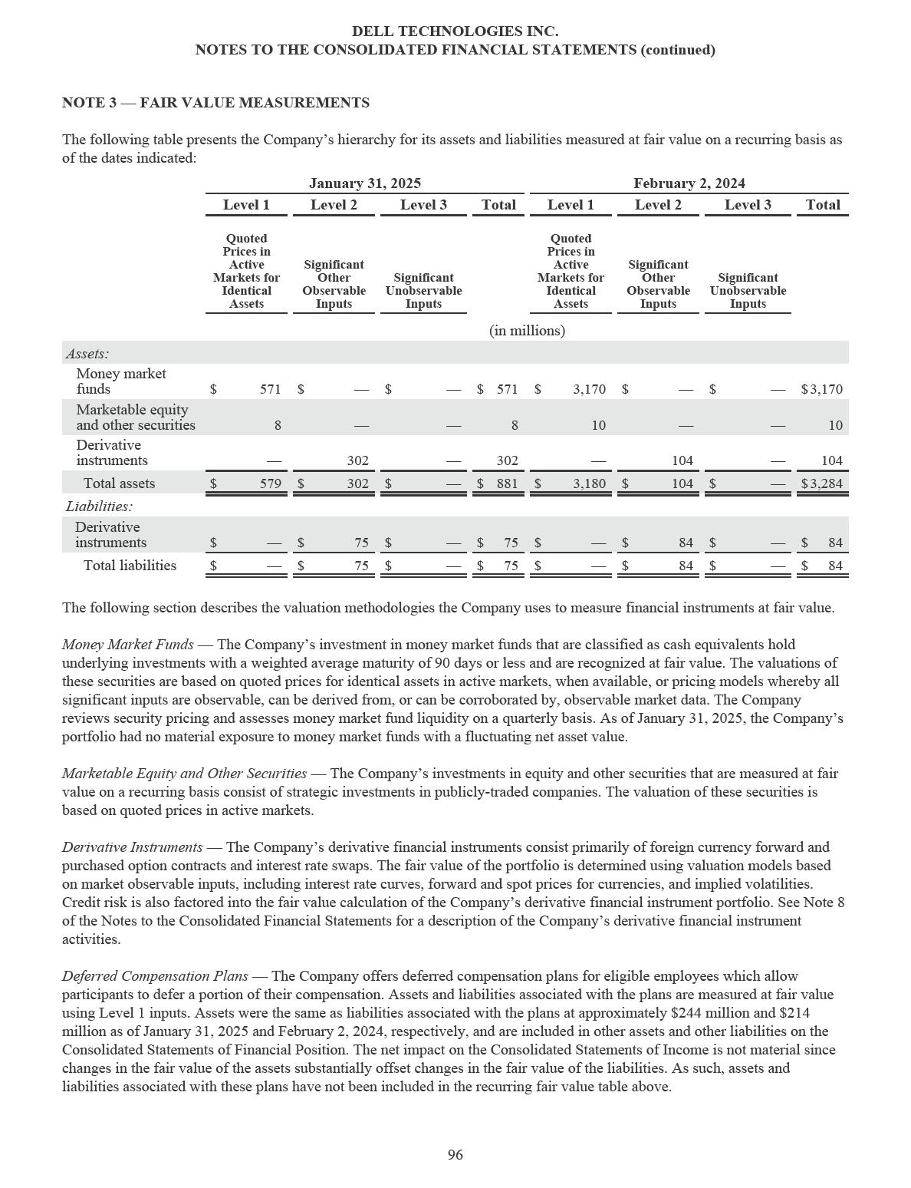

DELL TECHNOLOGIES INC.

NOTES TO THE CONSOLIDATED FINANCIAL STATEMENTS (continued)

Assets and Liabilities Measured at Fair Value on a Nonrecurring Basis — Certain assets are measured at fair value on a nonrecurring basis and therefore are not included in the recurring fair value table above. These assets consist primarily of financial assets such as the Company’s fixed income debt securities and strategic investments in non-marketable equity and other securities and non-financial assets such as goodwill and intangible assets.

Fixed income debt securities are recorded at amortized cost and approximate fair value. The fair value of fixed income debt securities is determined based on observable market prices in a less active market or based on valuation methodologies using observable inputs. If measured at fair value in the Consolidated Statements of Financial Position, these securities would generally be classified as Level 2 in the fair value hierarchy. See Note 4 of the Notes to the Consolidated Financial Statements for additional information about the Company’s fixed income debt securities.

Strategic investments in non-marketable equity and other securities and certain non-financial assets such as goodwill and intangibles are measured at fair value only if they are deemed to be impaired or when there is an adjustment from observable price changes in the current period. If measured at fair value in the Consolidated Statements of Financial Position, these securities would generally be classified as Level 3 in the fair value hierarchy. See Note 4 and Note 9 of the Notes to the Consolidated Financial Statements for additional information about the Company’s investments and goodwill and intangible assets, respectively.

Carrying Value and Estimated Fair Value of Outstanding Debt — The following table presents the carrying value and estimated fair value of the Company’s outstanding debt as described in Note 7 of the Notes to the Consolidated Financial Statements, including the current portion, as of the dates indicated:

 |  | January 31, 2025 |  |  |  |  |  | February 2, 2024
 | Carrying Value |  |  |  | Fair Value |  | Carrying Value |  |  |  | Fair Value
 |  |  |  |  | (in billions)
Senior Notes | $ | 15.0 | $ |  | 15.0 | $ |  | 15.5 | $ |  | 15.8
Legacy Notes | $ | 0.9 | $ |  | 1.0 | $ |  | 0.9 | $ |  | 1.0
DFS Debt | $ | 8.7 | $ |  | 8.5 | $ |  | 9.5 | $ |  | 9.1

The fair values of the outstanding debt shown in the table above were determined based on observable market prices in a less active market or based on valuation methodologies using observable inputs and were categorized as Level 2 in the fair value hierarchy.

97

DELL TECHNOLOGIES INC.

NOTES TO THE CONSOLIDATED FINANCIAL STATEMENTS (continued)

NOTE 4 — INVESTMENTS

The Company has strategic investments in equity and other securities as well as investments in fixed income debt securities. All equity and other securities as well as long-term fixed income debt securities are recorded as long-term investments while short-term fixed income debt securities are recorded as other current assets in the Consolidated Statements of Financial Position.

As of January 31, 2025 and February 2, 2024, total investments were $1.5 billion and $1.6 billion, respectively. Equity and Other Securities

Equity and other securities include strategic investments in marketable and non-marketable securities. Investments in marketable securities are measured at fair value on a recurring basis. Investments in non-marketable equity and other securities represent primarily early-stage companies without readily determinable fair values. The Company has elected to apply the measurement alternative for non-marketable securities. Under the alternative, the Company measures investments without readily determinable fair values at cost, less impairment, adjusted for observable price changes. The Company makes a separate election to use the alternative for each eligible investment and is required to reassess at each reporting period whether an investment qualifies for the alternative. In evaluating these investments for impairment or observable price changes, the Company uses inputs including pre- and post-money valuations of recent financing events and the impact of those events on its fully diluted ownership percentages, as well as other available information regarding the issuer’s historical and forecasted performance.

Carrying Value of Equity and Other Securities

The following table presents the cost, cumulative unrealized gain, cumulative unrealized loss, and carrying value of the

Company's strategic investments in marketable and non-marketable equity and other securities as of the dates indicated:

 |  |  |  |  | January 31, 2025 |  |  |  |  |  |  |  |  |  |  |  | February 2, 2024
 |  | Cost |  | Unrealized |  |  | Unrealized |  |  | Carrying |  |  |  | Cost |  | Unrealized |  |  | Unrealized |  |  | Carrying
 |  | Cost |  |  | Gain |  |  | Loss |  |  | Value |  |  | Cost |  |  | Gain |  |  | Loss |  |  | Value
 |  |  |  |  |  |  |  |  |  |  | (in millions)
Marketable | $ | 11 | $ |  | 24 | $ |  | (27) | $ |  | 8 | $ |  | 12 | $ |  | 24 | $ |  | (26) | $ |  | 10
Non-marketable |  | 739 |  |  | 1,009 |  |  | (261) |  |  | 1,487 |  |  | 732 |  |  | 1,015 |  |  | (454) |  |  | 1,293
Total equity and | $ | 750 | $ |  | 1,033 | $ |  | (288) | $ |  | 1,495 | $ |  | 744 | $ |  | 1,039 | $ |  | (480) | $ |  | 1,303
other securities

98

DELL TECHNOLOGIES INC.

NOTES TO THE CONSOLIDATED FINANCIAL STATEMENTS (continued)

Gains and Losses on Equity and Other Securities

The following table presents unrealized gains and losses on marketable and non-marketable equity and other securities for the periods indicated:

 |  |  |  | Fiscal Year Ended
 | January 31, 2025 |  |  | February 2, 2024 |  |  | February 3, 2023
 |  |  |  |  | (in millions)
Marketable securities:
Unrealized gain | $ | 5 | $ |  | 6 | $ |  | 57
Unrealized loss |  | (6) |  |  | (24) |  |  | (47)
Net unrealized gain (loss) |  | (1) |  |  | (18) |  |  | 10
Non-marketable securities:
Unrealized gain |  | 154 |  |  | 84 |  |  | 90
Unrealized loss |  | (32) |  |  | (49) |  |  | (349)
Net unrealized gain (loss) (a) (b) |  | 122 |  |  | 35 |  |  | (259)
Net unrealized gain (loss) on equity and other securities | $ | 121 | $ |  | 17 | $ |  | (249)
____________________
- For the fiscal year ended January 31, 2025 and February 2, 2024, net unrealized gains on non-marketable securities were due to upward adjustments for observable price changes offset by losses primarily attributable to downward adjustments for observable price changes and impairments.

- For the fiscal year ended February 3, 2023, net unrealized losses on non-marketable securities were primarily attributable to the recognition of impairments which were generally in line with extended public equity market declines.

Fixed Income Debt Securities

As of January 31, 2025 and February 2, 2024, the Company held fixed income debt securities of $27 million and $301 million, respectively, which it intends to hold to maturity. These investments are recorded at amortized cost and approximate fair value. As of January 31, 2025, the Company held $26 million in fixed income debt securities which will mature within one year and $1 million in fixed income debt securities which will mature within five years.

99

DELL TECHNOLOGIES INC.

NOTES TO THE CONSOLIDATED FINANCIAL STATEMENTS (continued)

NOTE 5 — FINANCIAL SERVICES

The Company offers or arranges a portfolio of payment and consumption solutions and services for its customers globally, including as-a-Service, subscription, utility, leases, and loans designed to match customers' consumption and financing preferences, and provide operational and financial flexibility.

To support financing solutions and services as part of the portfolio, DFS originates, collects, and services customer financing arrangements primarily related to the purchase and use of Dell Technologies products and services. In some cases, the Company also offers financing for the purchase of third-party technology products that complement the Dell Technologies portfolio of products and services. New financing originations were $8.4 billion for the fiscal years ended January 31, 2025 and February 2, 2024 and $9.7 billion for the fiscal year ended February 3, 2023.

The Company’s financing arrangements with customers are aggregated primarily into the following categories:

Fixed-term leases and loans — The Company enters into financing arrangements with customers who seek lease financing for equipment. Leases are generally classified as sales-type leases or operating leases. Additionally, utility, subscription, and as-a-Service flexible consumption models may result in identification of embedded lease arrangements that lead to the recognition of sales-type leases or operating leases. Leases with business customers have fixed terms of generally two to four years.

The Company also offers fixed-term loans to qualified small businesses, large commercial accounts, governmental organizations, educational entities, and certain individual consumer customers. These loans are repaid in equal payments including interest and have defined terms of generally three to five years. The fair value of the fixed-term loan portfolio is determined using market observable inputs. The carrying value of these loans approximates fair value.

Revolving loans — The Company primarily offered revolving loans to small and medium-sized commercial customers. Revolving loans provide qualified customers with a revolving credit line for the purchase of products and services offered by Dell Technologies. Revolving loans in the United States bear interest at a variable annual percentage rate that is tied to the prime rate. Based on historical payment patterns, revolving loan transactions are typically repaid within twelve months on average. Due to the short-term nature of the revolving loan portfolio, the carrying value of the portfolio approximates fair value.

Prior to the sale of the U.S. consumer revolving customer receivables portfolio on October 4, 2023 described in Note 1 of the Notes to the Consolidated Financial Statements, the Company offered private label credit financing under the Dell Preferred Account (“DPA”) program. The DPA product was primarily offered to individual consumer customers. During the fiscal year ended January 31, 2025, the Company discontinued remaining offerings under the revolving loan portfolio. The Company will support existing customer arrangements as well as transition these customers to fixed-term offerings.

100

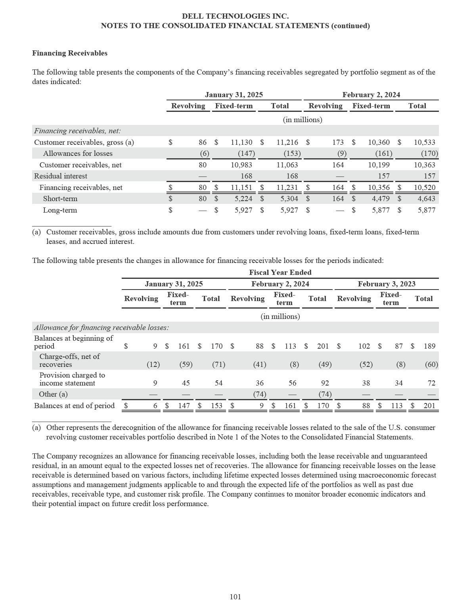

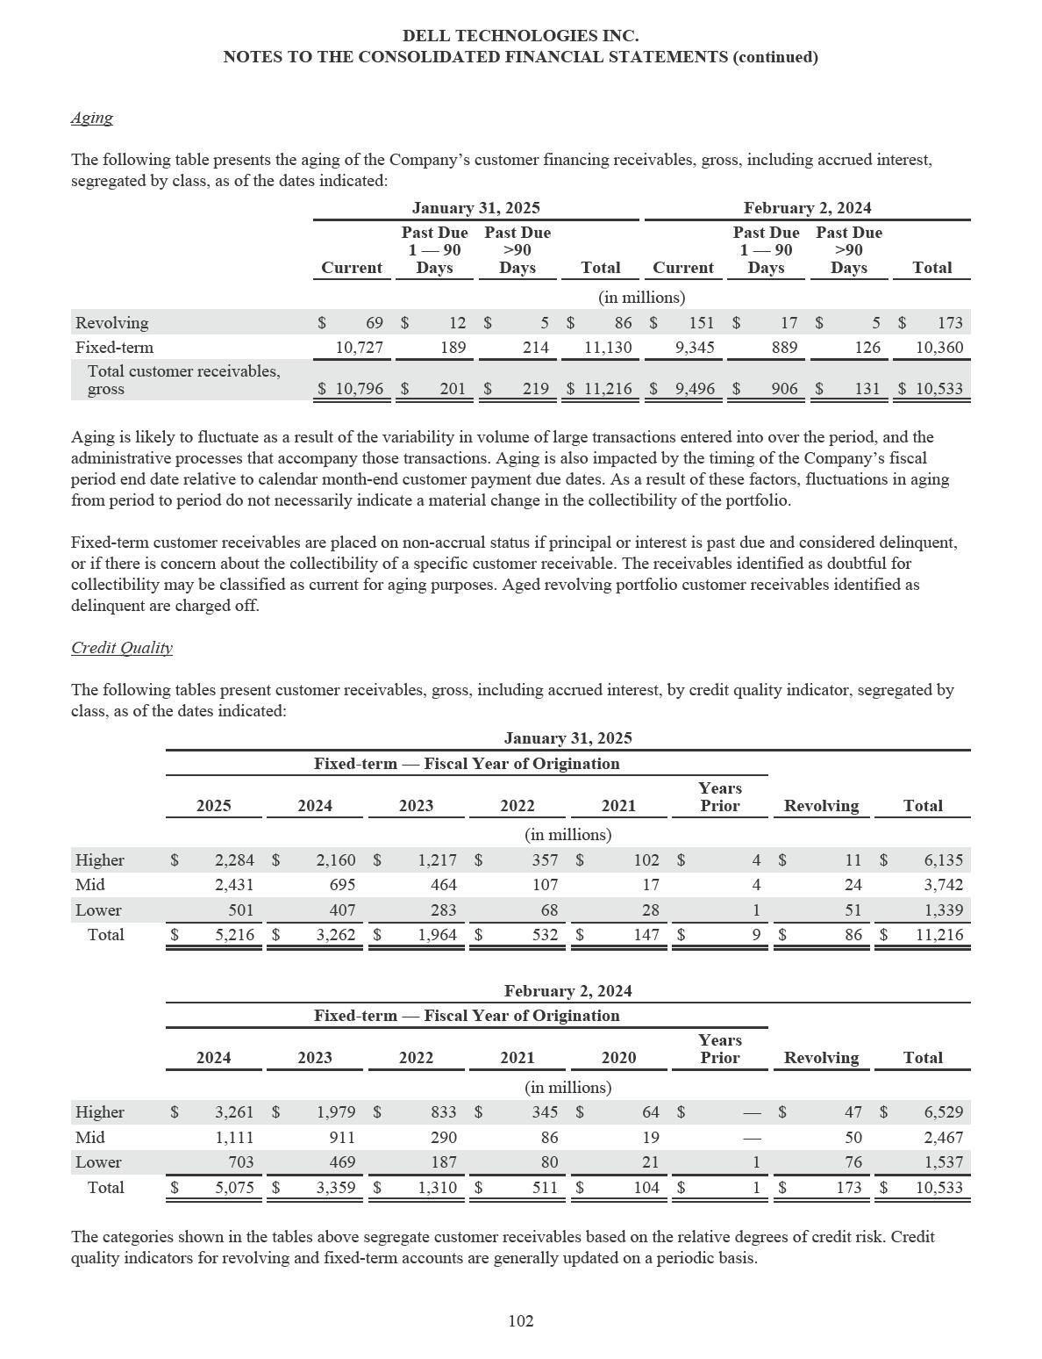

DELL TECHNOLOGIES INC.

NOTES TO THE CONSOLIDATED FINANCIAL STATEMENTS (continued)

An internal grading system is utilized that assigns a credit level score based on a number of considerations, including liquidity, operating performance, and industry outlook. The grading criteria and classifications for the fixed-term products differ from those for the revolving products as loss experience varies between these product and customer groups. The credit quality categories cannot be compared between the different classes as loss experience varies substantially between the classes.

Leases

The following table presents amounts included in the Consolidated Statements of Income related to sales-type lease activity for the periods indicated:

 |  |  |  | Fiscal Year Ended
 | January 31, 2025 |  |  | February 2, 2024 |  |  | February 3, 2023
 |  |  |  |  | (in millions)
Interest income — products | $ | 305 | $ |  | 175 | $ |  | 161
Net revenue — products | $ | 1,992 | $ |  | 1,140 | $ |  | 851
Cost of net revenue — products |  | 1,703 |  |  | 854 |  |  | 727
Gross margin — products | $ | 289 | $ |  | 286 | $ |  | 124

The following table presents the future maturity of the Company’s fixed-term customer leases and associated financing payments, and reconciles the undiscounted cash flows to the customer receivables, gross recognized on the Consolidated Statements of Financial Position as of the date indicated:

 |  | January 31, 2025
 |  | (in millions)
Fiscal 2026 | $ | 3,327
Fiscal 2027 |  | 2,296
Fiscal 2028 |  | 998
Fiscal 2029 |  | 477
Fiscal 2030 and thereafter |  | 218
Total undiscounted cash flows |  | 7,316
Fixed-term loans |  | 4,914
Revolving loans |  | 86
Less: Unearned income |  | (1,100)
Total customer receivables, gross | $ | 11,216

Operating Leases

The Company’s operating leases primarily consist of fixed-term leases and contractually committed embedded leases identified within flexible consumption arrangements.

The following table presents the components of the Company’s operating lease portfolio included in property, plant, and equipment, net as of the dates indicated:

 |  | January 31, 2025 |  |  | February 2, 2024
 |  | (in millions)
Equipment under operating lease, gross | $ | 4,180 | $ |  | 4,002
Less: Accumulated depreciation |  | (1,995) |  |  | (1,800)
Equipment under operating lease, net | $ | 2,185 | $ |  | 2,202

103

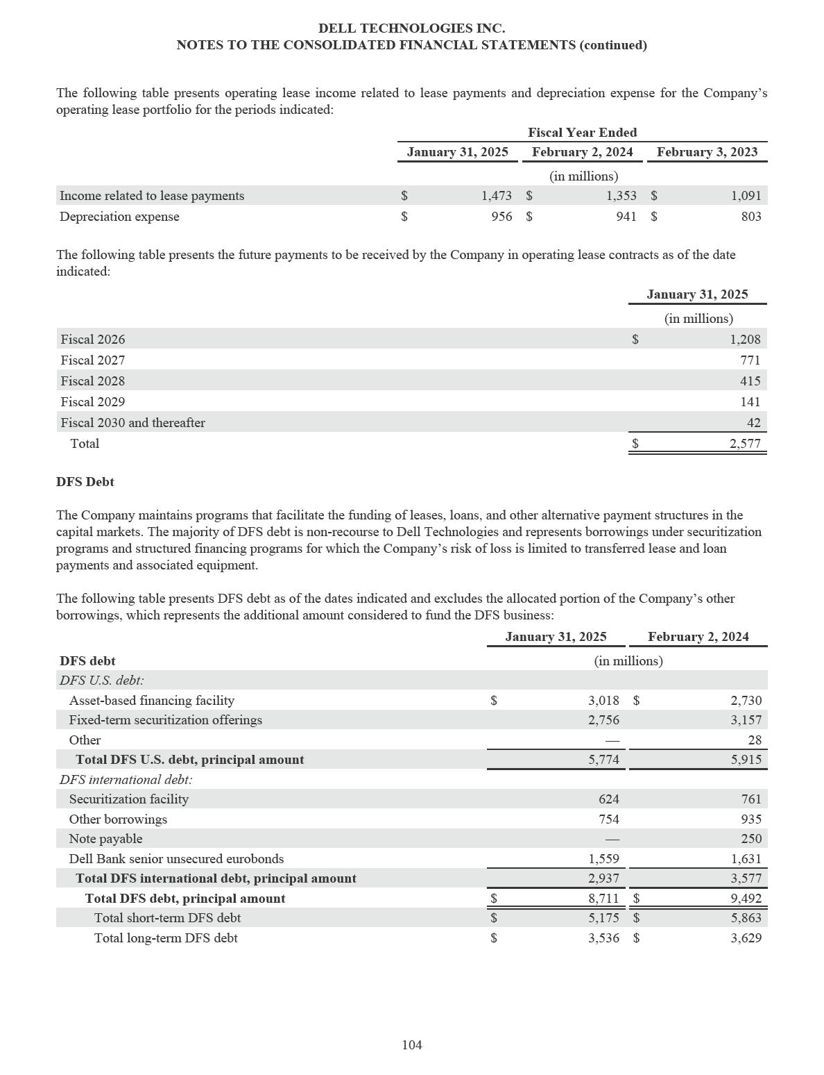

DELL TECHNOLOGIES INC.

NOTES TO THE CONSOLIDATED FINANCIAL STATEMENTS (continued)

DFS U.S. Debt

Asset-Based Financing Facility — The Company maintains an asset-based financing facility in the United States, which is a revolving facility for fixed-term leases and loans. This debt is collateralized solely by the U.S. lease and loan payments and associated equipment in the facility. The asset-based financing facility consists of two tranches, with effective dates through July 7, 2025 and July 7, 2026, respectively. As of January 31, 2025, the total debt capacity related to the asset-based financing facility was $5.0 billion. The debt has a variable interest rate, and the duration of the debt is based on the terms of the underlying lease and loan payment streams. The Company enters into interest rate swap agreements to economically convert a portion of this debt from a floating rate to a fixed rate. See Note 8 of the Notes to the Consolidated Financial Statements for additional information about the Company’s interest rate swaps.

The asset-based financing facility contains standard structural features related to the performance of the funded receivables, which include defined credit losses, delinquencies, average credit scores, and minimum collection requirements. In the event one or more of these criteria are not met and the Company is unable to restructure the facility, no further funding of receivables will be permitted and the timing of the Company’s expected cash flows from over-collateralization will be delayed. As of January 31, 2025, these criteria were met.

Fixed-Term Securitization Offerings — The Company periodically issues asset-backed debt securities under fixed-term securitization programs to private investors. The asset-backed debt securities are collateralized solely by the U.S. fixed-term lease and loan payments and associated equipment, which are held by Special Purpose Entities (“SPEs”), as discussed below. The interest rate on these securities is fixed and ranges from 4.14% to 6.80% per annum as of January 31, 2025, and the duration of these securities is based on the terms of the underlying lease and loan payment streams.

DFS International Debt

Securitization Facility — The Company maintains a securitization facility in Europe for fixed-term leases and loans. The debt under this facility has a variable interest rate, and the duration of the debt is based on the terms of the underlying lease and loan payment streams. This facility is effective through December 22, 2026 and had a total debt capacity of $831 million as of January 31, 2025.

The securitization facility contains standard structural features related to the performance of the securitized receivables, which include defined credit losses, delinquencies, average credit scores, and minimum collection requirements. In the event one or more of these criteria are not met and the Company is unable to restructure the program, no further funding of receivables will be permitted and the timing of the Company’s expected cash flows from over-collateralization will be delayed. As of January 31, 2025, these criteria were met.

Other Borrowings — In connection with the Company’s international financing operations, the Company has entered into revolving structured financing debt programs related to its fixed-term lease and loan products sold in Canada, Europe, Australia, New Zealand, the Middle East, and Singapore. The debt under these programs has a variable interest rate.

The duration of the debt in Canada, Europe, Australia, New Zealand, and the Middle East is based on the terms of the underlying lease and loan payment streams. These facilities are collateralized solely by the lease and loan payments and associated equipment in their respective region or country. The Canadian facility had a total debt capacity of $242 million as of January 31, 2025 and is effective through January 15, 2028. The European facility had a total debt capacity of $520 million as of January 31, 2025 and is effective through December 14, 2026. The Australia and New Zealand facility had a total debt capacity of $279 million as of January 31, 2025 and is effective through April 20, 2025. The Middle East facility had a total debt capacity of $150 million as of January 31, 2025 and was effective through March 24, 2025. Subsequent to the close of the fiscal year ended January 31, 2025, the Company extended the term of the Middle East facility to be effective through March 14, 2027.

The Company also has two unsecured Singapore facilities with a total debt capacity of $244 million as of January 31, 2025 that are effective through July 3, 2026 and July 3, 2027, respectively.

105

DELL TECHNOLOGIES INC.

NOTES TO THE CONSOLIDATED FINANCIAL STATEMENTS (continued)

Note Payable — On May 25, 2022, the Company entered into an unsecured credit agreement which had an aggregate principal amount of $250 million to fund receivables in Mexico. The note bore interest at an annual rate of 4.24% and was paid in full on May 31, 2024.

Dell Bank Senior Unsecured Eurobonds — On October 27, 2021, Dell Bank issued 500 million Euro of 0.5% senior unsecured five year eurobonds due October 2026. On October 18, 2022, Dell Bank issued 500 million Euro of 4.5% senior unsecured five year eurobonds due October 2027. On June 13, 2024, Dell Bank issued 500 million Euro of 3.6% senior unsecured five year eurobonds due June 2029. The issuances of the senior unsecured eurobonds support the expansion of the financing operations in Europe.

Variable Interest Entities

In connection with the asset-based financing facility, securitization facility, and fixed-term securitization offerings discussed above, the Company transfers certain U.S. and European lease and loan payments and associated equipment to SPEs that meet the definition of a VIE and are consolidated, along with the associated debt described above, into the Consolidated Financial Statements, as the Company is the primary beneficiary of the VIEs. The SPEs are bankruptcy-remote legal entities with separate assets and liabilities. The purpose of the SPEs is to facilitate the funding of customer lease and loan payments and associated equipment in the capital markets.

Some of the SPEs have entered into financing arrangements with multi-seller conduits that, in turn, issue asset-backed debt securities in the capital markets. DFS debt outstanding held by the consolidated VIEs is collateralized by the lease and loan payments and associated equipment. The Company’s risk of loss related to securitized receivables is limited to the amount by which the Company’s right to receive collections for assets securitized exceeds the amount required to pay interest, principal, and fees and expenses related to the asset-backed securities. The Company provides credit enhancement to the securitization in the form of over-collateralization.

The following table presents the assets and liabilities held by the consolidated VIEs as of the dates indicated, which are included in the Consolidated Statements of Financial Position:

 |  | January 31, 2025 |  |  | February 2, 2024
 |  | (in millions)
Assets held by consolidated VIEs
Other current assets | $ | 123 | $ |  | 136
Financing receivables, net of allowance
Short-term | $ | 3,262 | $ |  | 3,314
Long-term | $ | 2,725 | $ |  | 2,747
Property, plant, and equipment, net | $ | 984 | $ |  | 1,081
Liabilities held by consolidated VIEs
Debt, net of unamortized debt issuance costs
Short-term | $ | 4,598 | $ |  | 4,450
Long-term | $ | 1,788 | $ |  | 2,184

Lease and loan payments and associated equipment transferred via securitization through SPEs were $3.6 billion and $4.6 billion for the fiscal years ended January 31, 2025 and February 2, 2024, respectively.

Customer Receivables Sales

To manage certain concentrations of customer credit exposure, the Company may sell selected fixed-term customer receivables to unrelated third parties on a periodic basis, without recourse. The amount of customer receivables sold for this purpose was $79 million, $222 million, and $680 million for the fiscal years ended January 31, 2025, February 2, 2024, and February 3, 2023, respectively. The Company’s continuing involvement in these customer receivables is primarily limited to servicing arrangements.

106

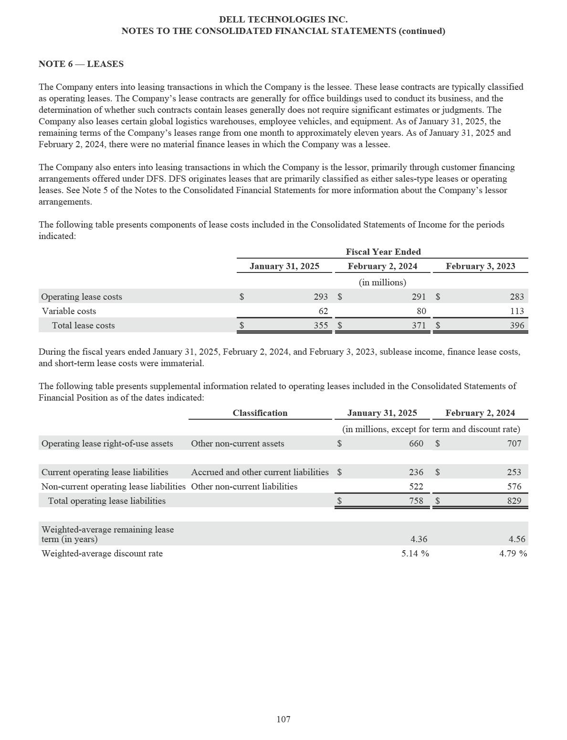

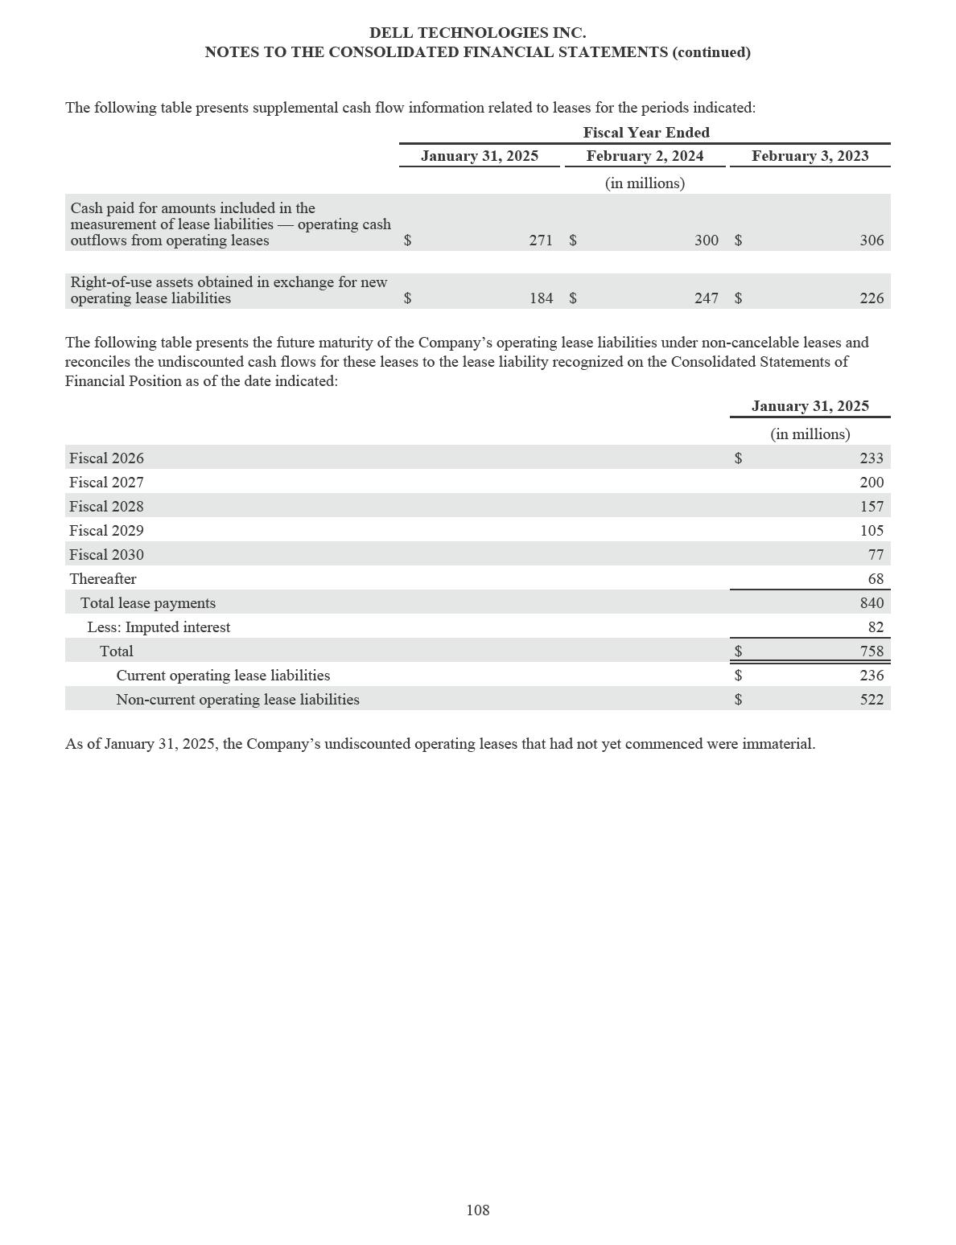

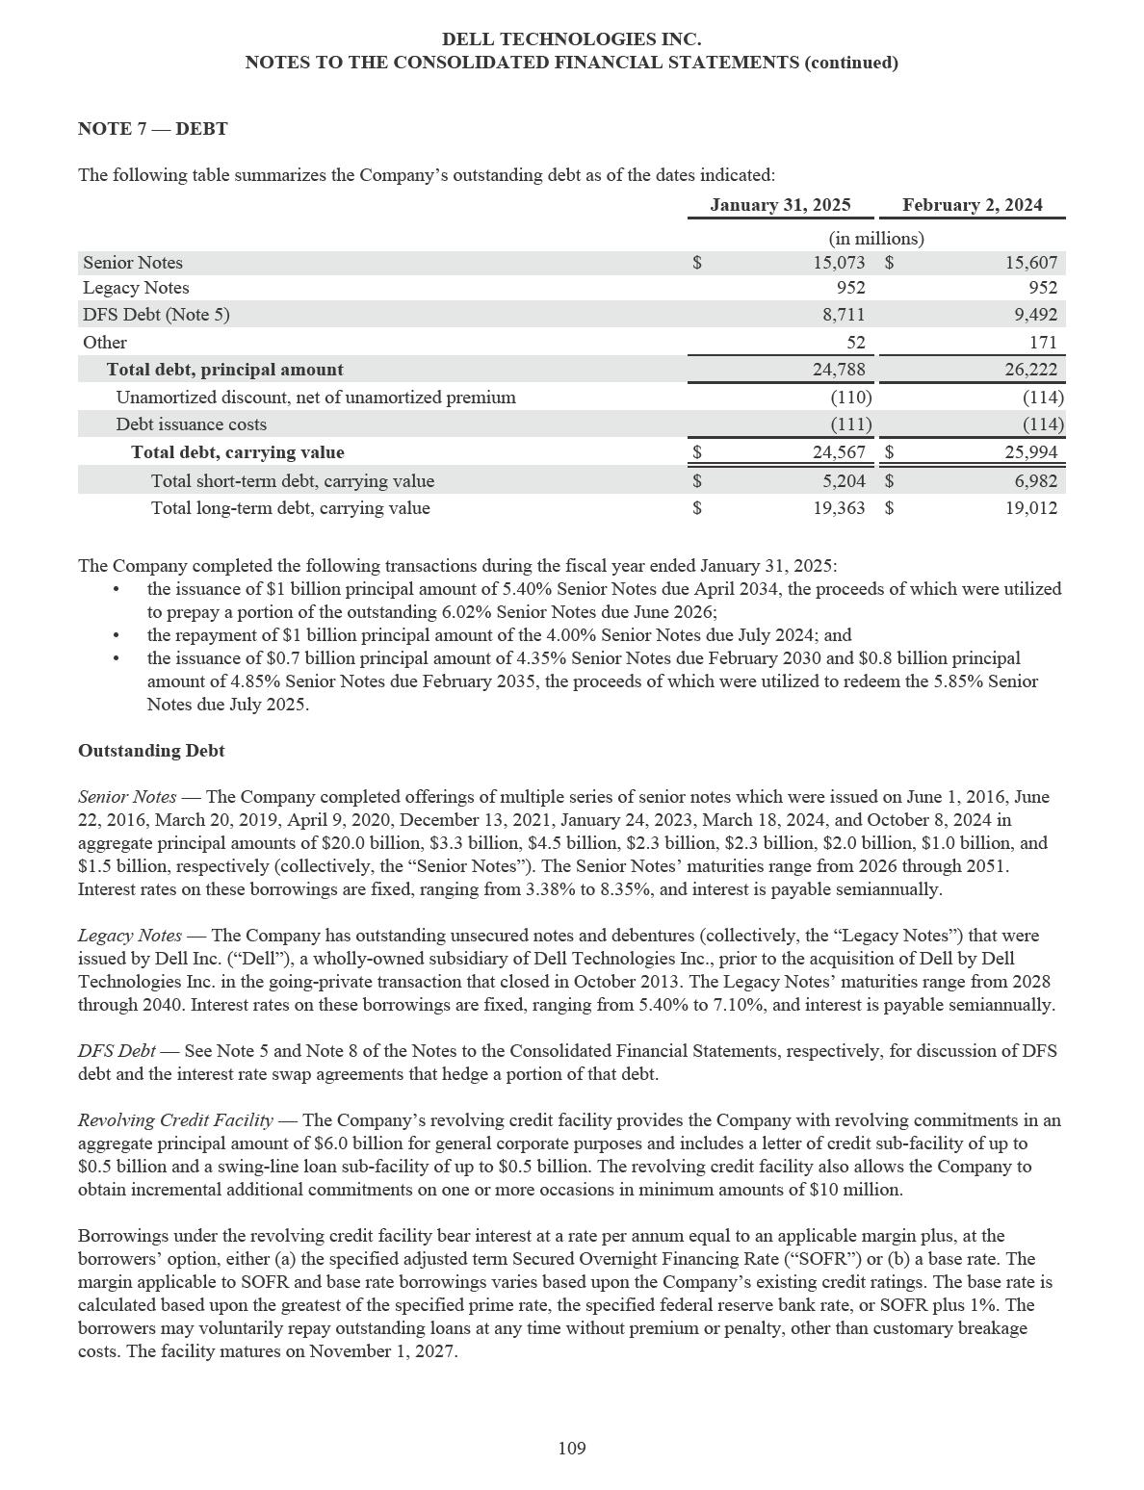

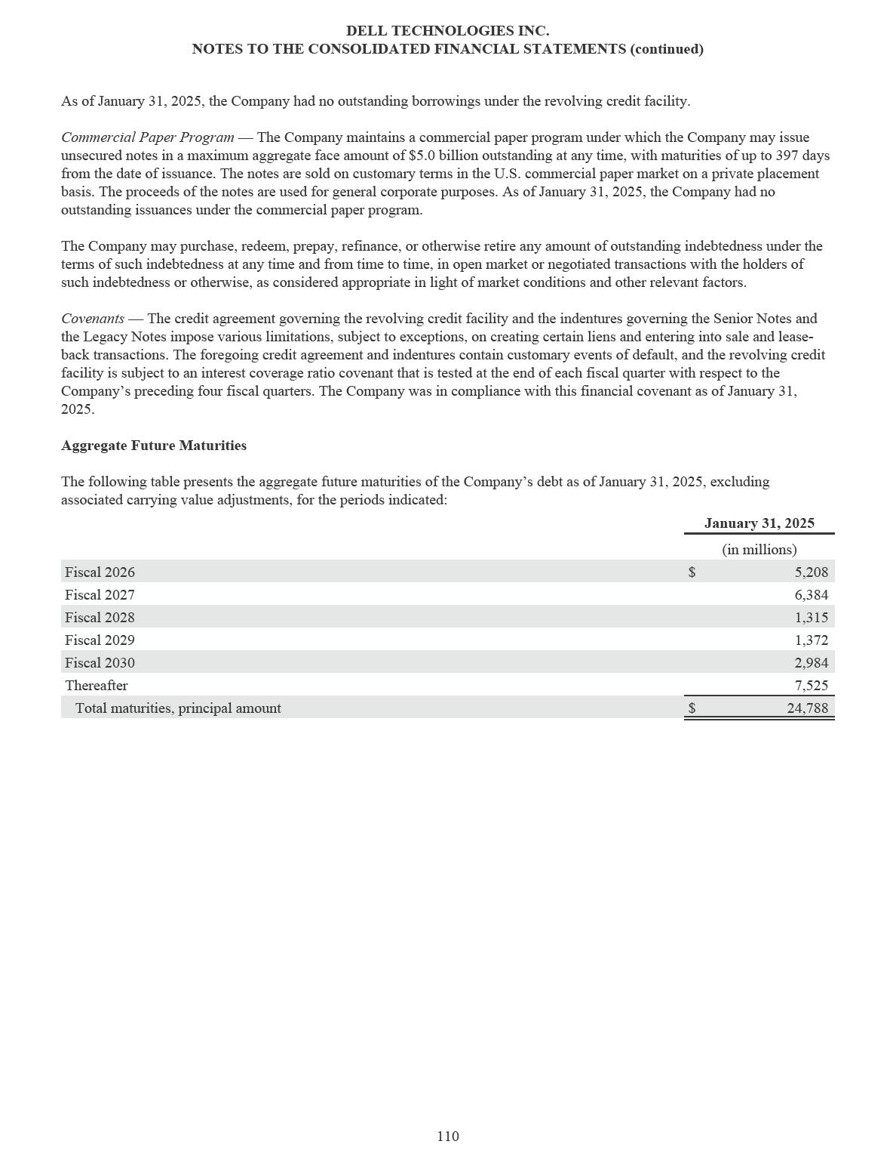

DELL TECHNOLOGIES INC.

NOTES TO THE CONSOLIDATED FINANCIAL STATEMENTS (continued)

NOTE 8 — DERIVATIVE INSTRUMENTS AND HEDGING ACTIVITIES

As part of its risk management strategy, the Company uses derivative instruments, primarily foreign currency forward and option contracts and interest rate swaps, to hedge certain foreign currency and interest rate exposures, respectively.

The Company’s objective is to offset gains and losses resulting from these exposures with gains and losses on the derivative contracts used to hedge the exposures, thereby reducing volatility of earnings and protecting the fair values of assets and liabilities. The earnings effects of the derivative instruments are presented in the same line items on the Consolidated Statements of Income as the earnings effects of the hedged items. For derivatives designated as cash flow hedges, the Company assesses hedge effectiveness both at the onset of the hedge and at regular intervals throughout the life of the instruments. For derivatives designated as fair value hedges, the Company assesses hedge effectiveness on qualifying instruments using the shortcut method whereby the hedges are considered perfectly effective at the onset of the hedge and over the life of the hedging relationship.

Foreign Exchange Risk

The Company uses foreign currency forward and option contracts designated as cash flow hedges to protect against the foreign currency exchange rate risks inherent in its forecasted transactions denominated in currencies other than the U.S. Dollar. Hedge accounting is applied based upon the criteria established by accounting guidance for derivative instruments and hedging activities. The risk of loss associated with purchased options is limited to premium amounts paid for the option contracts. The risk of loss associated with forward contracts is equal to the exchange rate differential from the time the contract is entered into until the time it is settled. The majority of these contracts typically expire in twelve months or less.

During the fiscal years ended January 31, 2025, February 2, 2024, and February 3, 2023, the Company did not discontinue any cash flow hedges related to foreign exchange contracts that had a material impact on the Company’s results of operations due to the probability that the forecasted cash flows would not occur.

The Company uses forward contracts to hedge monetary assets and liabilities denominated in a foreign currency. These contracts generally expire in three months or less, are considered economic hedges, and are not designated for hedge accounting. The change in the fair value of these instruments represents a natural hedge as their gains and losses offset the changes in the underlying fair value of the monetary assets and liabilities due to movements in currency exchange rates.

In connection with DFS operations in Europe, forward contracts are used to hedge financing receivables denominated in foreign currencies other than Euro. These contracts are not designated for hedge accounting and most expire within three years or less.

Interest Rate Risk

The Company uses interest rate swaps to hedge the variability in cash flows related to the interest rate payments on structured financing debt. The interest rate swaps economically convert the variable rate on the structured financing debt to a fixed interest rate to match the underlying fixed rate being received on fixed-term customer leases and loans. These contracts are not designated for hedge accounting and most expire within four years or less.

Interest rate swaps are utilized to manage the interest rate risk, at a portfolio level, associated with DFS operations in Europe. The interest rate swaps economically convert the fixed rate on financing receivables to a one-month or three-month Euribor floating rate in order to match the floating rate nature of the banks’ funding pool. The Company also uses interest rate swaps to manage the cash flows related to interest payments on senior unsecured eurobonds. The interest rate swaps economically convert the fixed rate on the Company’s bonds to a floating rate to match the underlying lease repayments profile. These contracts are not designated for hedge accounting and most expire within five years or less. See Note 5 of the Notes to the Consolidated Financial Statements for more information about the Dell Bank senior unsecured eurobonds.

111

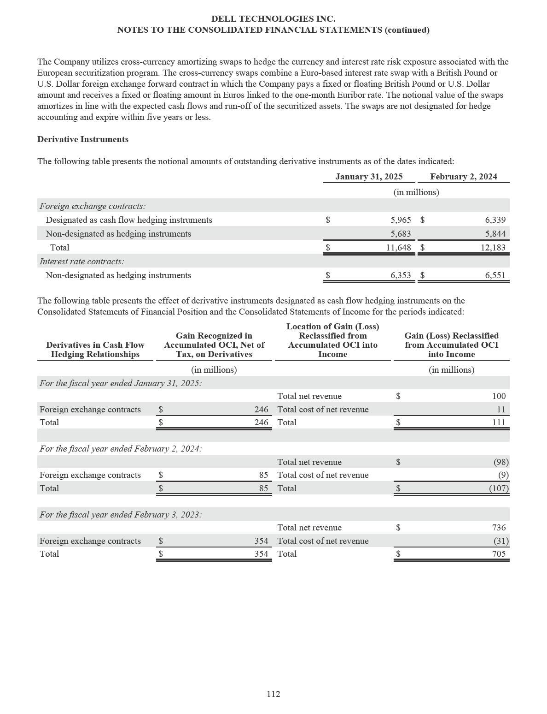

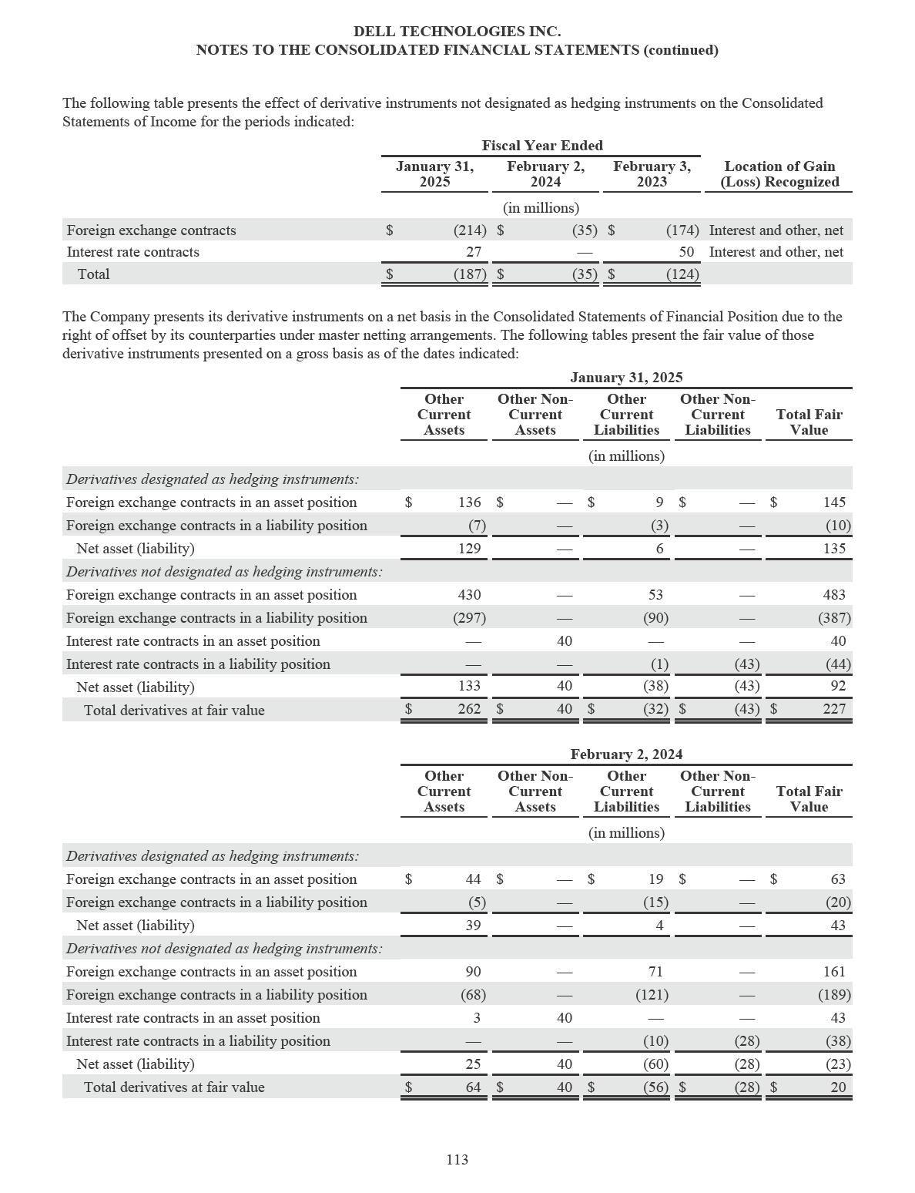

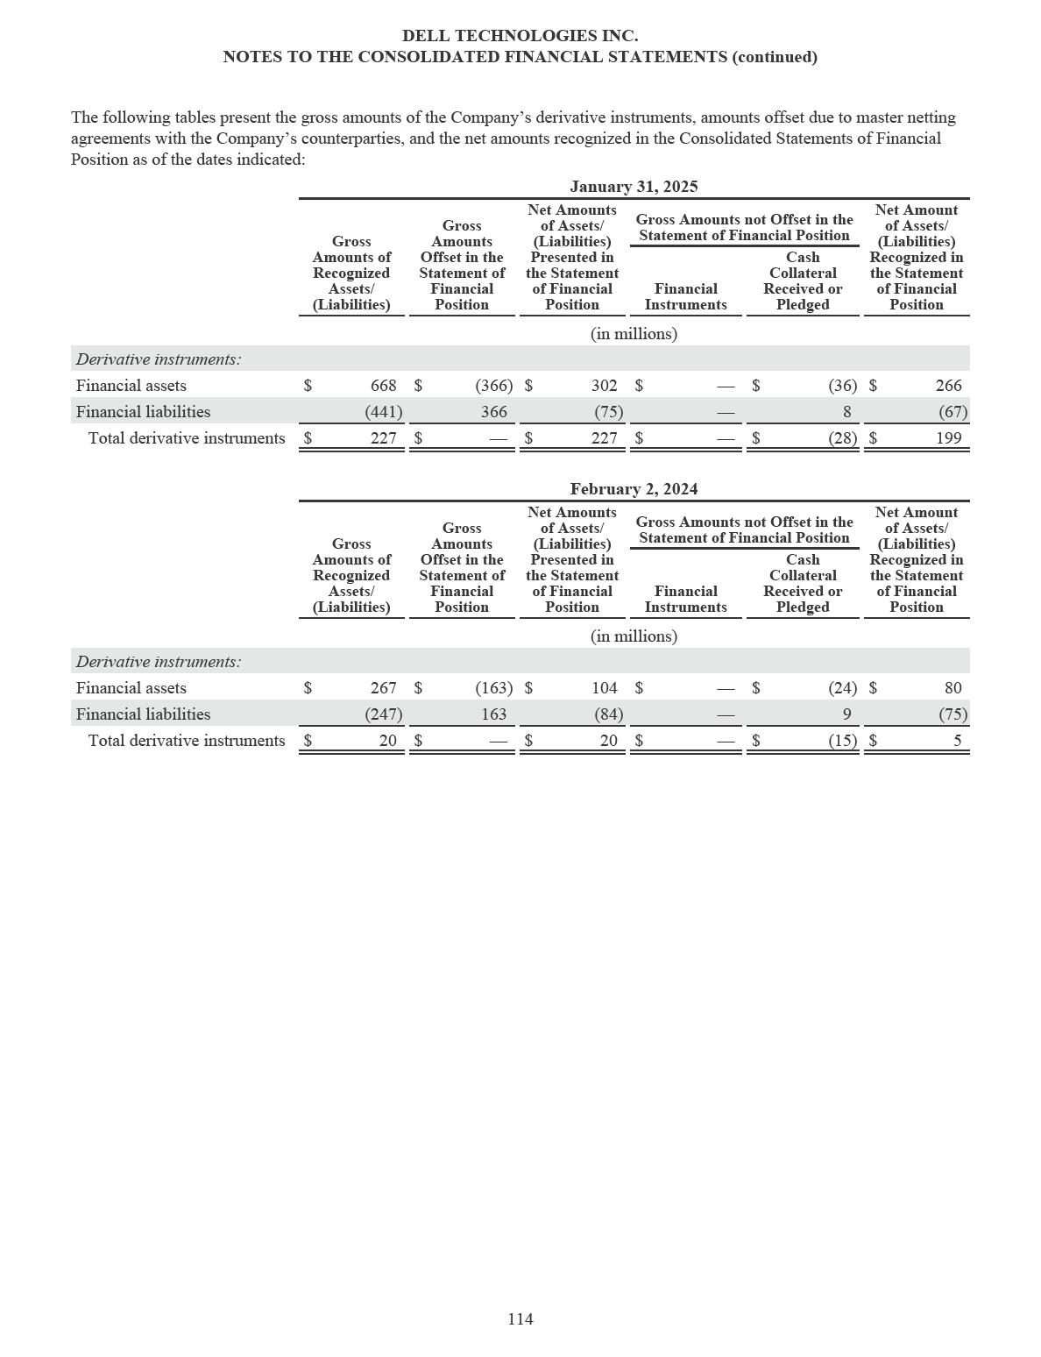

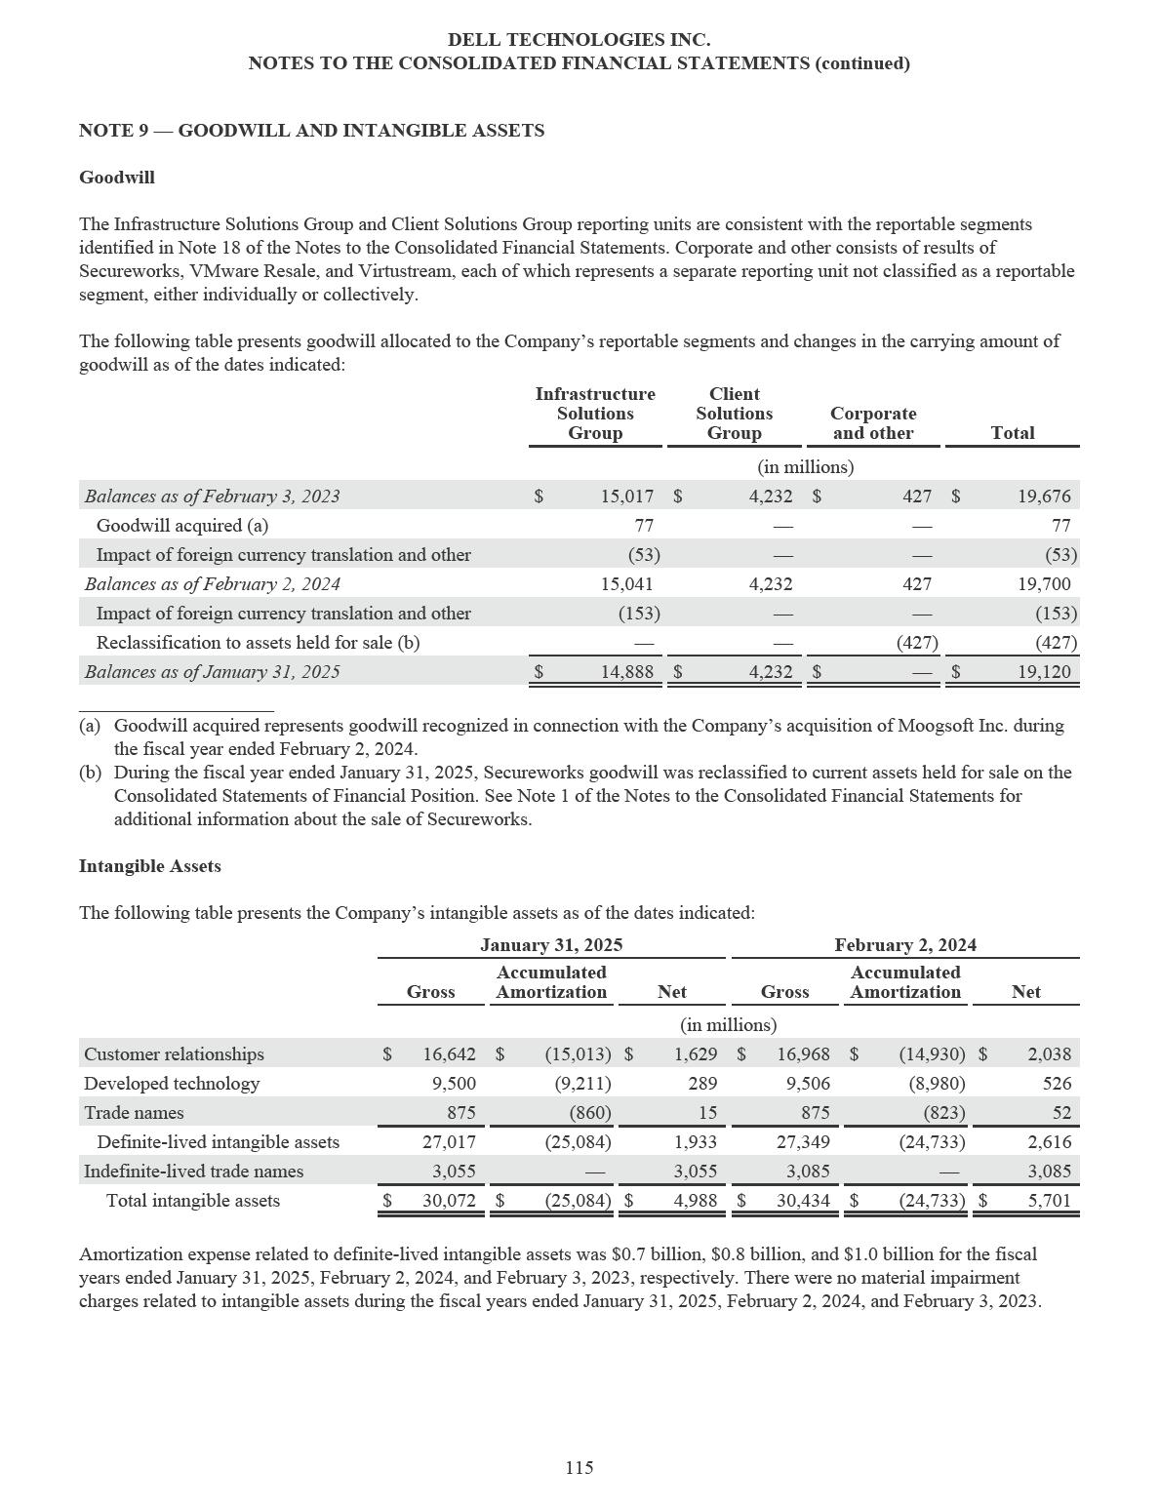

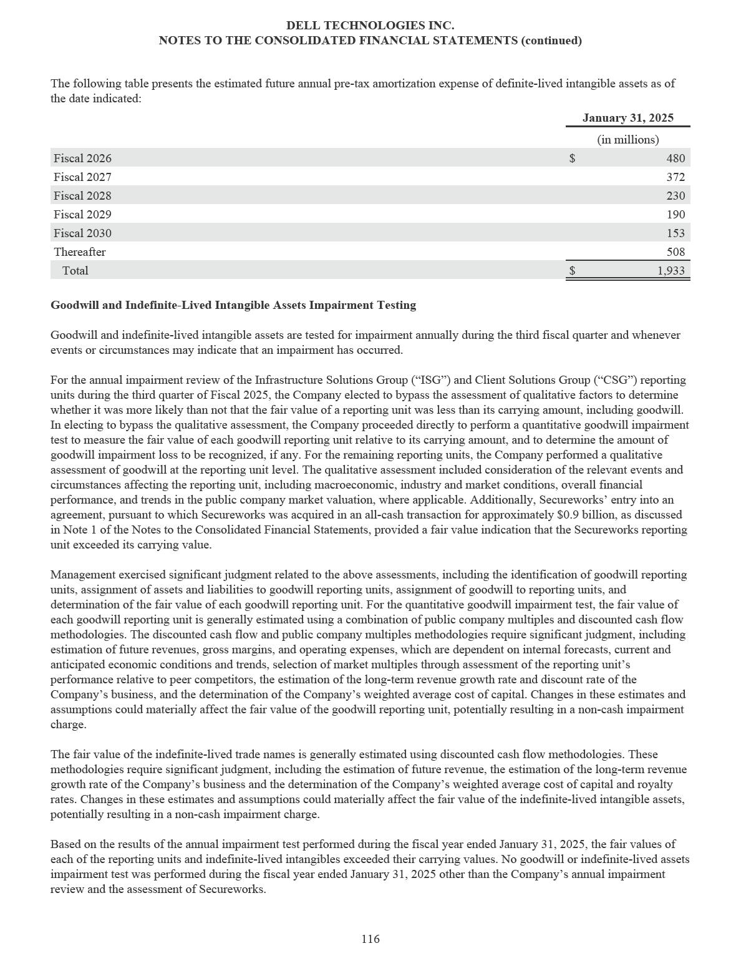

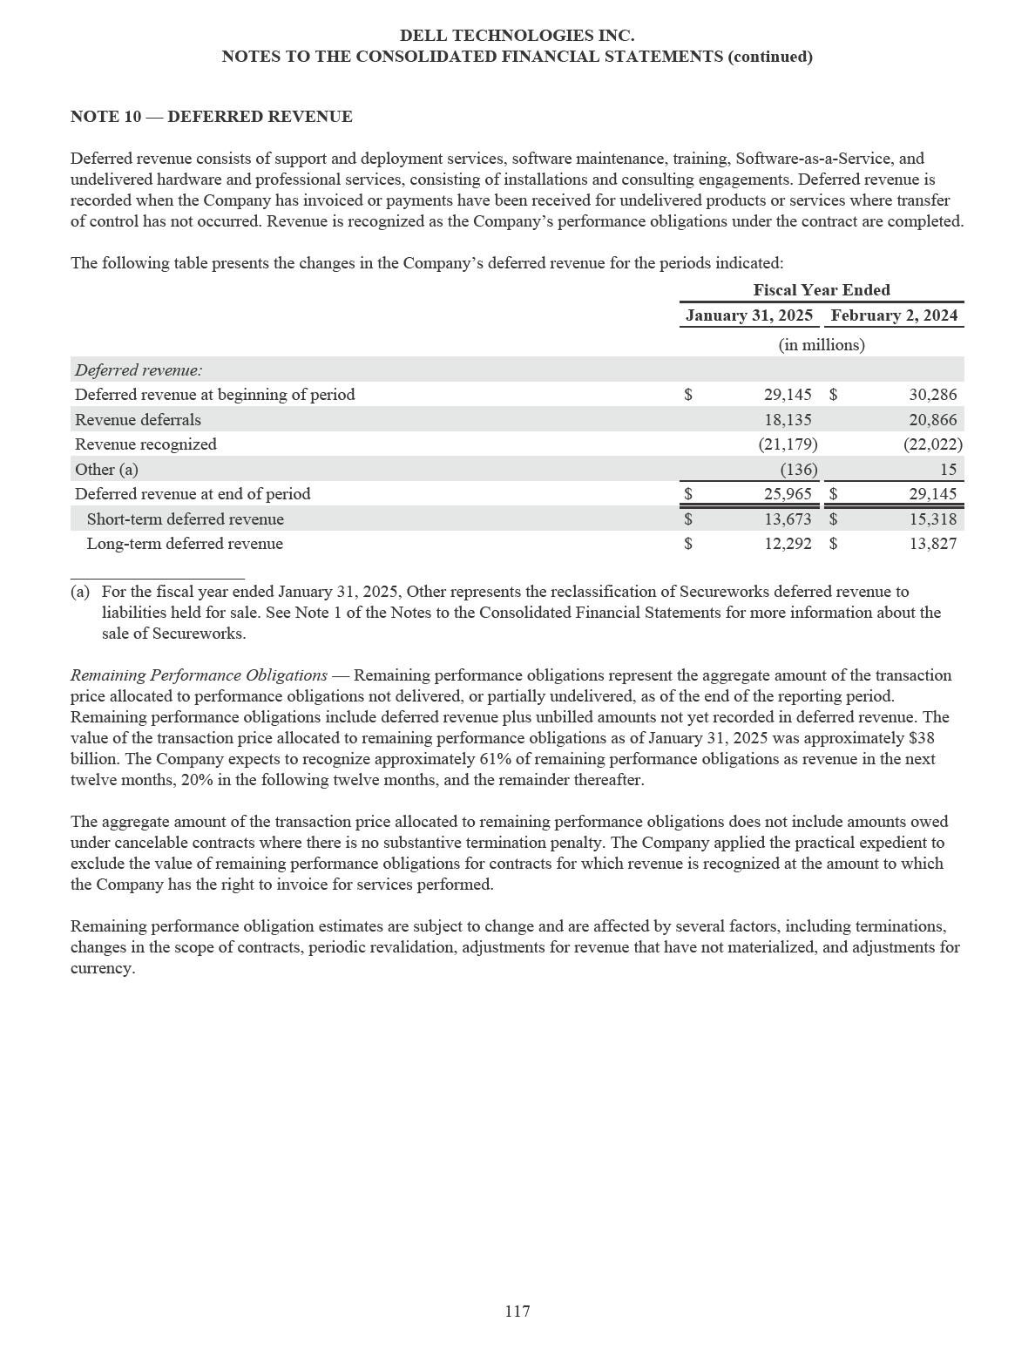

DELL TECHNOLOGIES INC.

NOTES TO THE CONSOLIDATED FINANCIAL STATEMENTS (continued)

NOTE 11 — COMMITMENTS AND CONTINGENCIES

Purchase Obligations

The Company has contractual obligations to purchase goods or services, which specify significant terms (including fixed or minimum quantities to be purchased), fixed, minimum, or variable price provisions, and the approximate timing of the transaction. Purchase obligations are primarily related to commitments with suppliers and software maintenance and support services. As of January 31, 2025, such purchase obligations were $5.0 billion for Fiscal 2026, $0.6 billion for Fiscal 2027, and $0.9 billion for Fiscal 2028 and thereafter.

Legal Matters

The Company is involved in various claims, suits, assessments, investigations, and legal proceedings that arise from time to time in the ordinary course of its business, including those identified below, consisting of matters involving consumer, antitrust, tax, intellectual property, and other issues on a global basis.

The Company accrues a liability when it believes that it is both probable that a liability has been incurred and that it can reasonably estimate the amount of the loss. The Company reviews these accruals at least quarterly and adjusts them to reflect ongoing negotiations, settlements, rulings, advice of legal counsel, and other relevant information. To the extent new information is obtained and the Company’s views on the probable outcomes of claims, suits, assessments, investigations, or legal proceedings change, changes in the Company’s accrued liabilities are recorded in the period in which such a determination is made. For some matters, the incurrence of a liability is not probable or the amount cannot be reasonably estimated and therefore accruals have not been made.

The following is a discussion of the Company’s significant legal matters and other proceedings:

Class Actions Related to the Class V Transaction — On December 28, 2018, the Company completed a transaction (the “Class V transaction”) in which it paid $14.0 billion in cash and issued 149,387,617 shares of its Class C Common Stock to holders of its Class V Common Stock in exchange for all outstanding shares of Class V Common Stock. As a result of the Class V transaction, the tracking stock feature of the Company’s capital structure associated with the Class V Common Stock was terminated. Certain stockholders of the Company subsequently brought class action complaints arising out of the Class V transaction in which they named as defendants (collectively, the “defendants”) Michael S. Dell and certain other directors serving on the Company’s board of directors at the time of the Class V transaction (collectively, the “director defendants”), certain stockholders of the Company, consisting of Mr. Dell and Silver Lake Group, L.L.C. and certain of its affiliated funds (collectively, the “stockholder defendants”), and Goldman Sachs & Co. LLC, which served as financial advisor to the Company in connection with the transaction. The plaintiffs generally alleged that the director defendants and the stockholder defendants breached their fiduciary duties under Delaware law to the former holders of the Class V Common Stock in connection with the Class V transaction by offering a transaction value that was allegedly billions of dollars below fair value.

As previously reported, during the fourth quarter of the fiscal year ended February 3, 2023, the plaintiffs and the defendants entered into an agreement to settle the lawsuit. Under the terms of the settlement, the plaintiffs agreed to the dismissal of all claims upon payment of a total of $1.0 billion (the “settlement amount”), which included all costs, expenses and fees of the plaintiff class relating to the action and its resolution. On May 16, 2023, during the fiscal year ended February 2, 2024, the Company paid the settlement amount following approval of the settlement by the Delaware Court of Chancery. This matter is no longer material to the Company.

118

DELL TECHNOLOGIES INC.

NOTES TO THE CONSOLIDATED FINANCIAL STATEMENTS (continued)

R2 Semiconductor Patent Litigation — In November 2022, R2 Semiconductor, Inc. (“R2”) filed a lawsuit in the Dusseldorf Regional Court in Germany against Intel Deutschland GmbH, Dell GmbH, and certain other customers of Intel Corporation. R2 asserted that one European patent is infringed by certain Intel processors and those of the Company’s products that incorporate those processors. R2 sought an injunction prohibiting the sale of the allegedly infringing products and damages for the alleged infringement. The court conducted a trial on December 7, 2023 and, on February 7, 2024, issued a decision in favor of R2 and imposed an injunction prohibiting the sale and use of such products in Germany by Dell GmbH, and requiring Dell GmbH to issue a communication to certain customers recalling the covered products sold since March 5, 2020. On February 8, 2024, the Company filed an appeal. In April and May 2024, R2 filed lawsuits in Paris, France and Milan, Italy, against affiliates of Intel Corporation (“Intel”) and of the Company, raising similar allegations. Intel agreed to defend the foregoing actions and indemnify the Company and its affiliates against certain losses incurred by the Company in connection with R2’s claims. On August 30, 2024, Intel and R2 publicly announced an agreement to dismiss all litigation between the two companies that would include dismissal of all litigation against all subsidiaries of Dell Technologies named in the foregoing actions. Pursuant to that agreement, the Italian lawsuit was dismissed on September 2, 2024, the German lawsuit was dismissed on September 4, 2024, and the French lawsuit was dismissed on September 6, 2024.

Other Litigation — Dell does not currently anticipate that any of the other legal proceedings it is involved in will have a material adverse effect on its business, financial condition, results of operations, or cash flows.

In accordance with the relevant accounting guidance, the Company provides disclosures of matters where it is at least reasonably possible that the Company could experience a material loss exceeding the amounts already accrued for these or other proceedings or matters. In addition, the Company also discloses matters based on its consideration of other matters and qualitative factors, including the experience of other companies in the industry, and investor, customer, and employee relations considerations. As of January 31, 2025, the Company does not believe there is a reasonable possibility that a material loss exceeding the amounts already accrued for these or other proceedings or matters has been incurred. However, since the ultimate resolution of any such proceedings and matters is inherently unpredictable, the Company’s business, financial condition, results of operations, or cash flows could be materially affected in any particular period by unfavorable outcomes in one or more of these proceedings or matters. Whether the outcome of any claim, suit, assessment, investigation, or legal proceeding, individually or collectively, could have a material adverse effect on the Company’s business, financial condition, results of operations, or cash flows will depend on a number of factors, including the nature, timing, and amount of any associated expenses, amounts paid in settlement, damages, or other remedies or consequences.

Indemnifications Obligations

In the ordinary course of business, the Company enters into various contracts under which it may agree to indemnify other parties for losses incurred from certain events as defined in the relevant contract, such as litigation, regulatory penalties, or claims relating to past performance. Such indemnification obligations may not be subject to maximum loss clauses. Historically, payments related to these indemnification obligations have not been material to the Company.

Under the Separation and Distribution Agreement entered into with VMware, Inc. upon completion of the spin-off of VMware, Inc. on November 1, 2021 (the “VMware Spin-off”), Dell Technologies agreed to indemnify VMware, Inc., each of its subsidiaries and each of their respective directors, officers, employees, as well as any successors and assigns of the foregoing, from and against all liabilities relating to, arising out of or resulting from, among other matters, the liabilities allocated to Dell Technologies as part of the separation of Dell Technologies and VMware, Inc. (currently operating under the name VMware LLC, and individually and together with its subsidiaries, “VMware”) and their respective businesses (the “Separation”). VMware similarly agreed to indemnify Dell Technologies Inc., each of its subsidiaries and each of their respective directors, officers, and employees from and against all liabilities relating to, arising out of or resulting from, among other matters, the liabilities allocated to VMware as part of the Separation. The amounts that VMware and Dell Technologies may be obligated to pay each other could vary depending on the outcome of certain unresolved tax matters, which may not be resolved for several years. Net income tax indemnification receivables from VMware were immaterial as of January 31, 2025 and February 2, 2024.

119

DELL TECHNOLOGIES INC.

NOTES TO THE CONSOLIDATED FINANCIAL STATEMENTS (continued)

Certain Concentrations

The Company maintains cash and cash equivalents, derivatives, and certain other financial instruments with various financial institutions that potentially subject it to concentration of credit risk. As part of its risk management processes, the Company performs periodic evaluations of the relative credit standing of these financial institutions. The Company has not sustained material credit losses from instruments held at these financial institutions. Further, the Company does not anticipate nonperformance by any of the counterparties.

The Company markets and sells its products and services to large corporate clients, governmental agencies, and health care and education accounts, as well as to small and medium-sized businesses and individuals. No single customer accounted for more than 10% of the Company’s consolidated net revenue during the fiscal years ended January 31, 2025, February 2, 2024, and February 3, 2023.

The Company utilizes a limited number of contract manufacturers that assemble a portion of its products. The Company purchases components from suppliers and sells those components to such contract manufacturers. The Company reflects the sale of such components by recognizing non-trade receivables from the contract manufacturers and a reduction in inventory when title and risk of loss pass to the manufacturer. Cash flows related to such transactions are recorded within cash flows from operating activities. The Company does not reflect the sale of the components in revenue and does not recognize any profit on the component sales until the related products are sold to a customer.

The agreements with the majority of the contract manufacturers permit the Company to offset its payables against the

receivables, thus mitigating the credit risk wholly or in part. Such receivables were $5.4 billion and $3.4 billion as of

January 31, 2025 and February 2, 2024, respectively, and primarily consisted of receivables from the Company’s three largest

contract manufacturers. The Company offset its corresponding payables against $4.7 billion and $2.7 billion of such receivables

as of January 31, 2025 and February 2, 2024, respectively. The portion of receivables not offset is included in other current

assets in the Consolidated Statements of Financial Position.

120

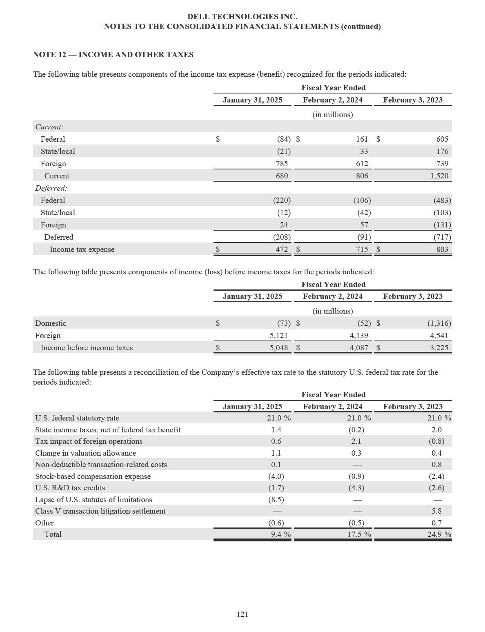

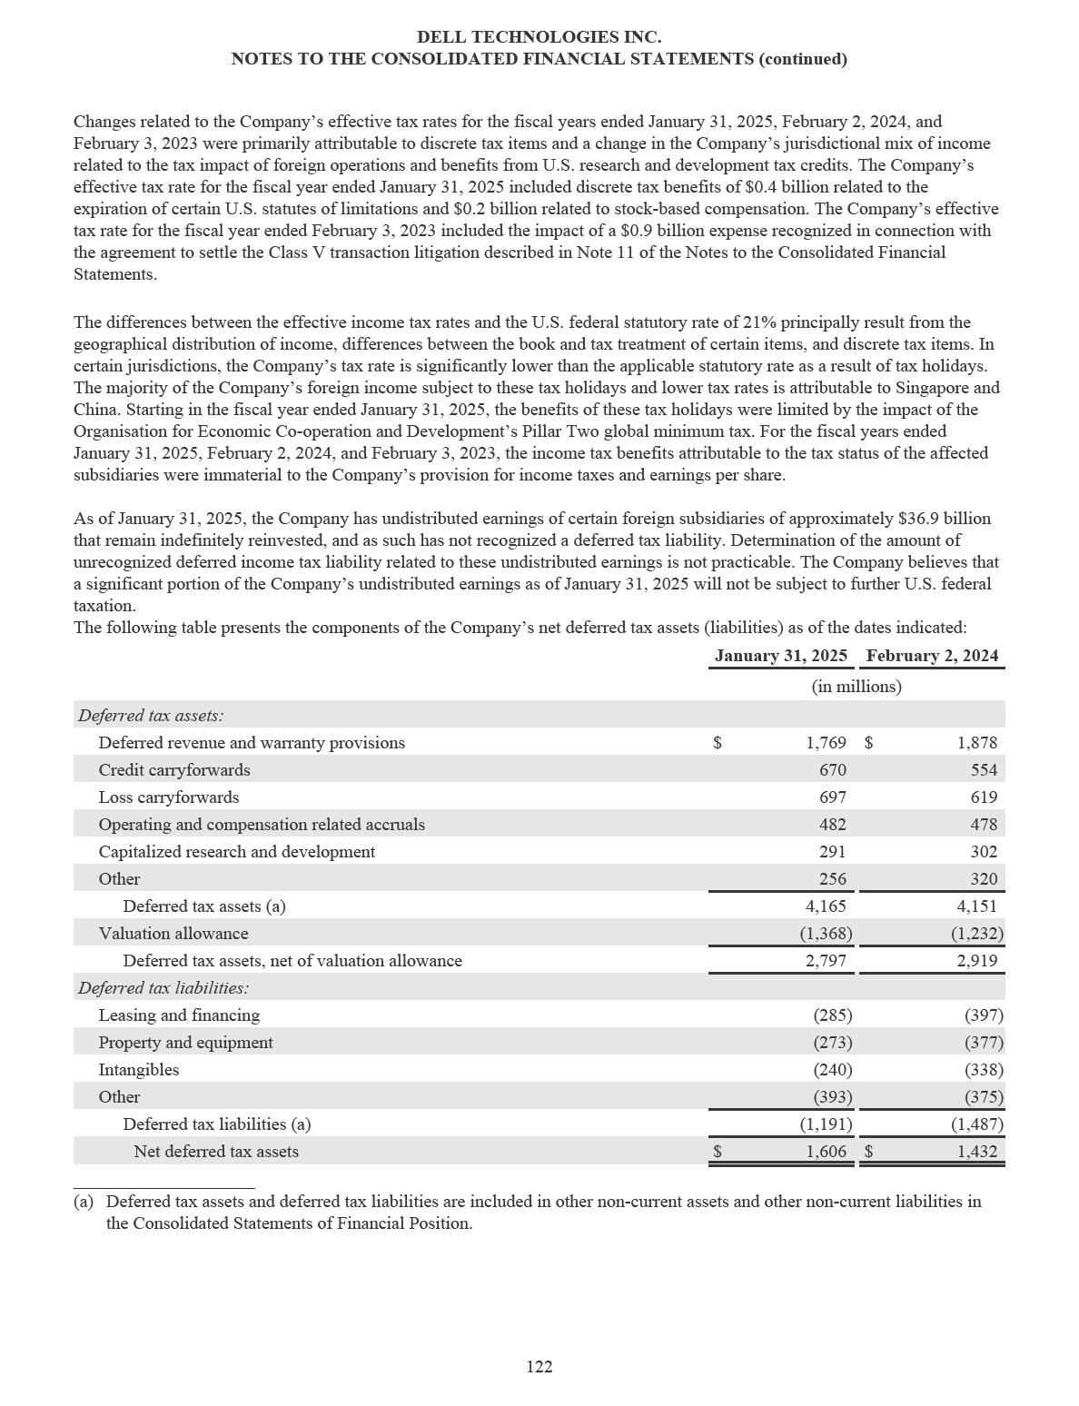

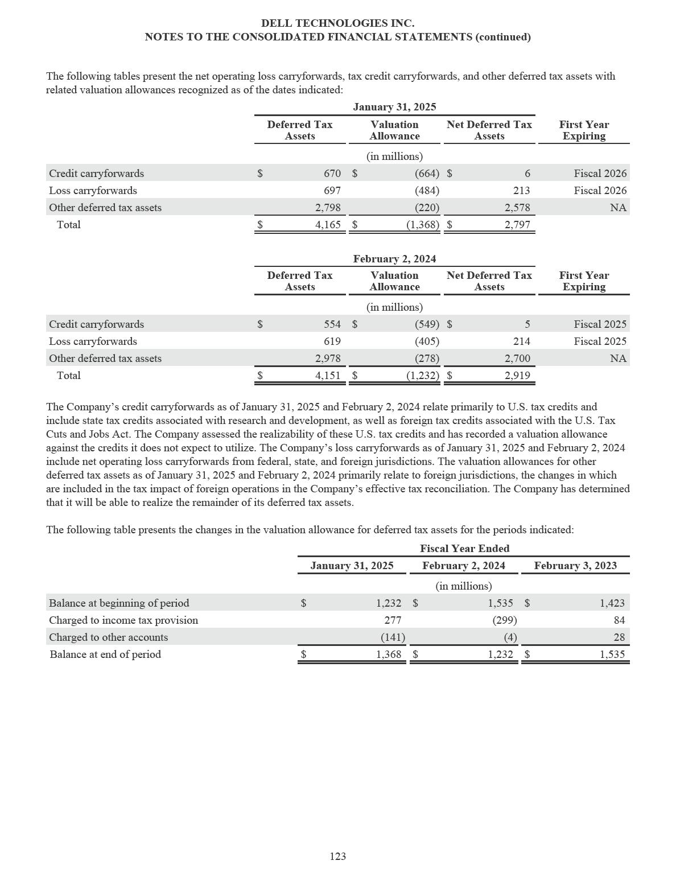

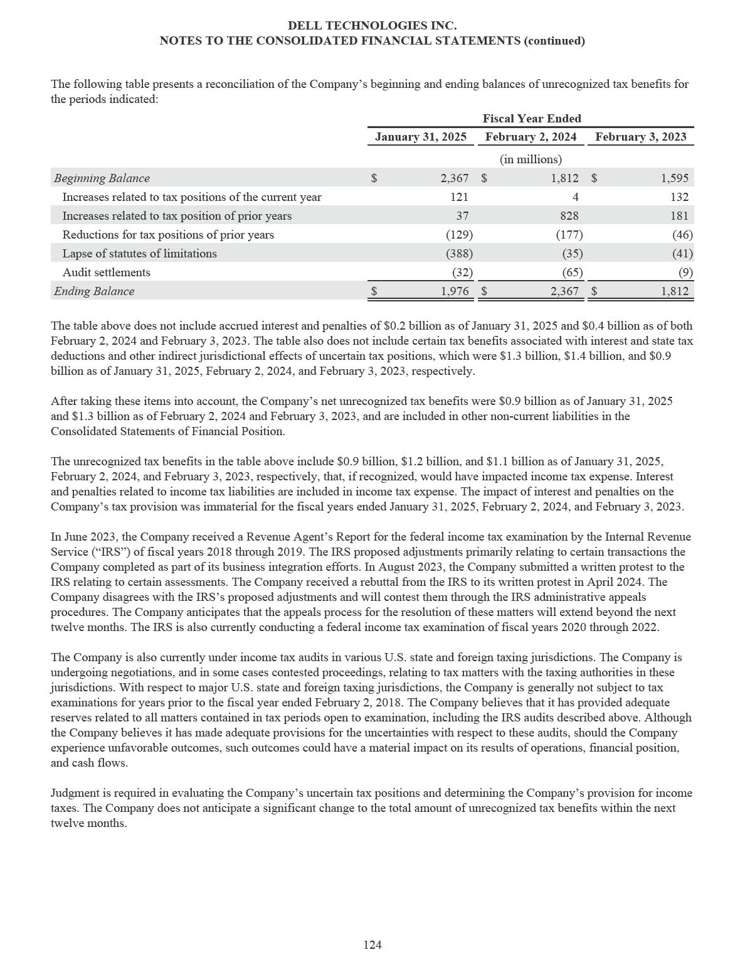

DELL TECHNOLOGIES INC.

NOTES TO THE CONSOLIDATED FINANCIAL STATEMENTS (continued)

The Company takes certain non-income tax positions in the jurisdictions in which it operates and has received certain non-income tax assessments from various jurisdictions. The Company believes that a material loss in these matters is not probable and that it is not reasonably possible that a material loss exceeding amounts already accrued has been incurred. The Company believes its positions in these non-income tax litigation matters are supportable and that it ultimately will prevail in the matters. In the normal course of business, the Company’s positions and conclusions related to its non-income taxes could be challenged and assessments may be made. To the extent new information is obtained and the Company’s views on its positions, probable outcomes of assessments, or litigation change, changes in estimates to the Company’s accrued liabilities would be recorded in the period in which such a determination is made. In the resolution process for income tax and non-income tax audits, the Company is required in certain situations to provide collateral guarantees or indemnification to regulators and tax authorities until the matter is resolved.

125

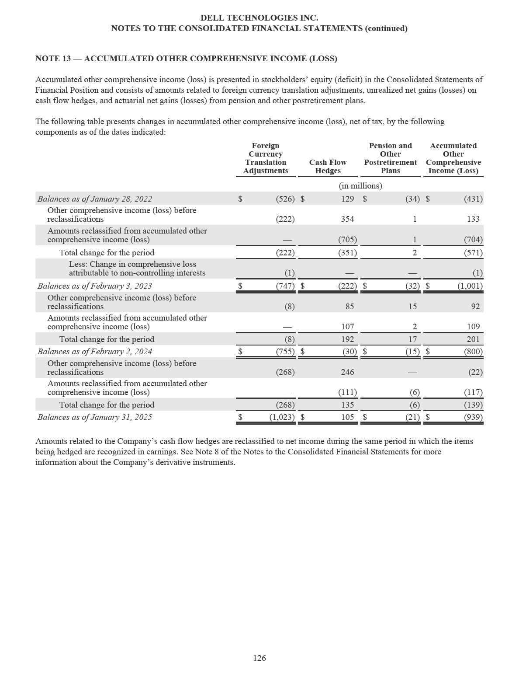

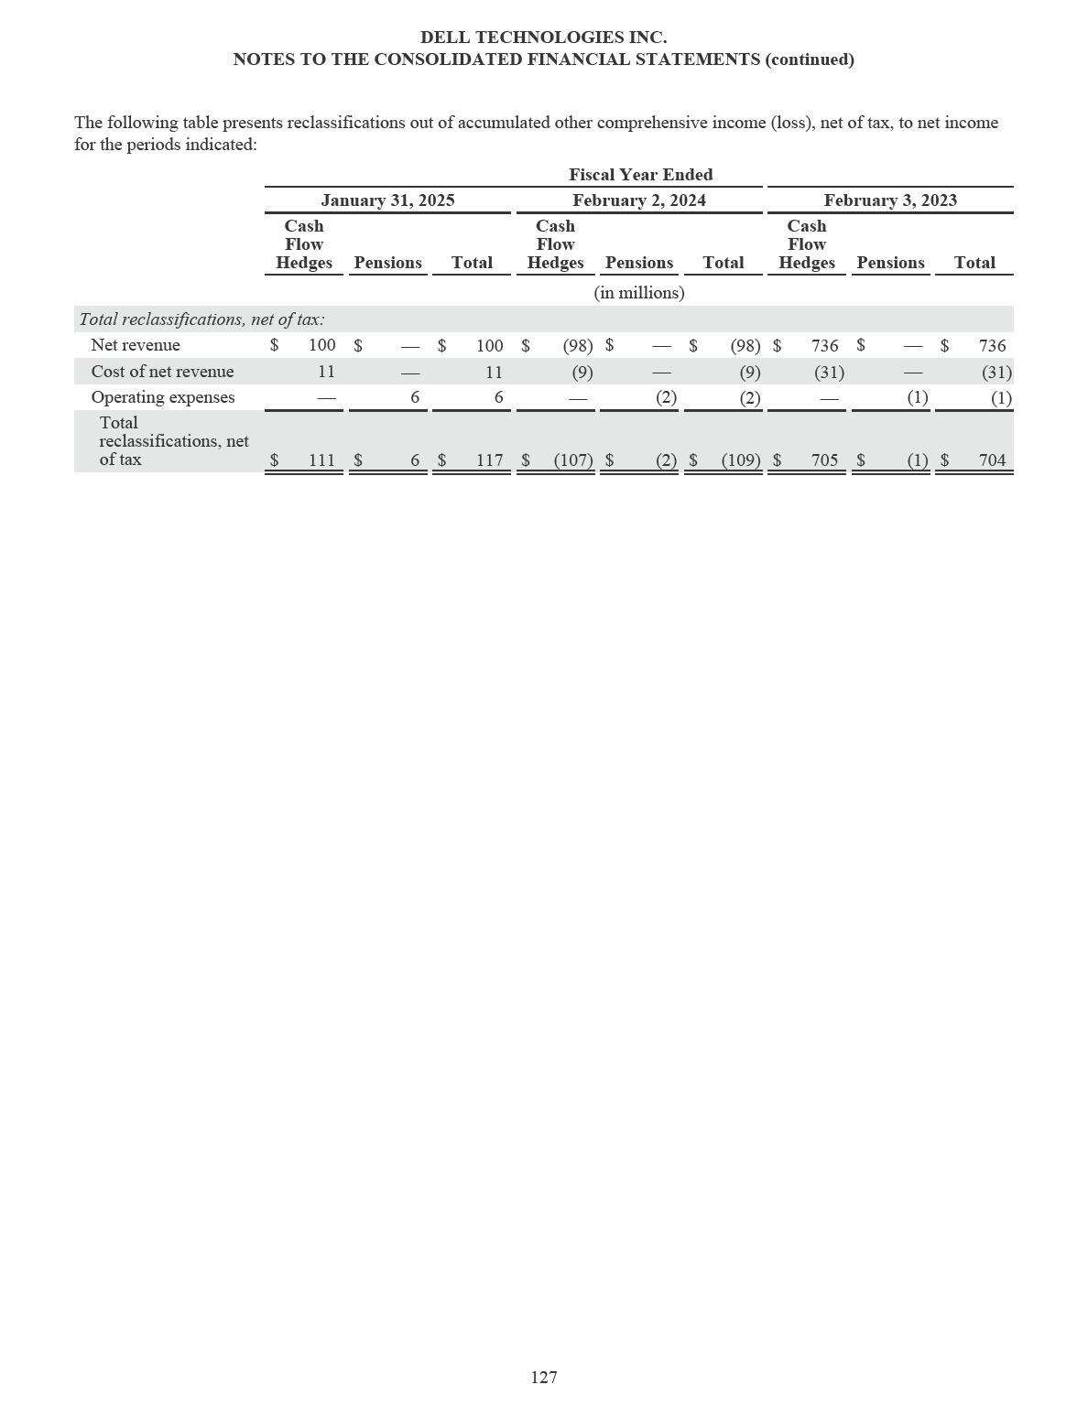

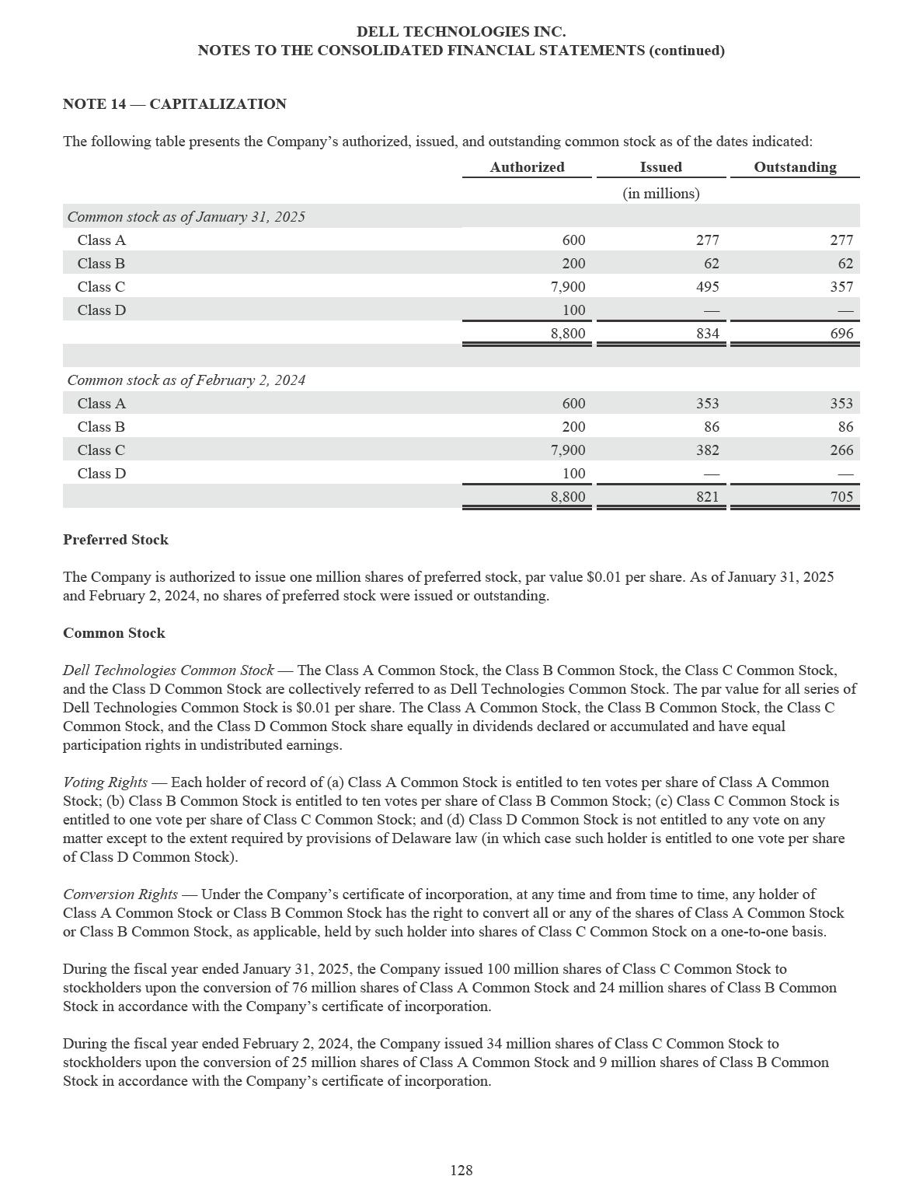

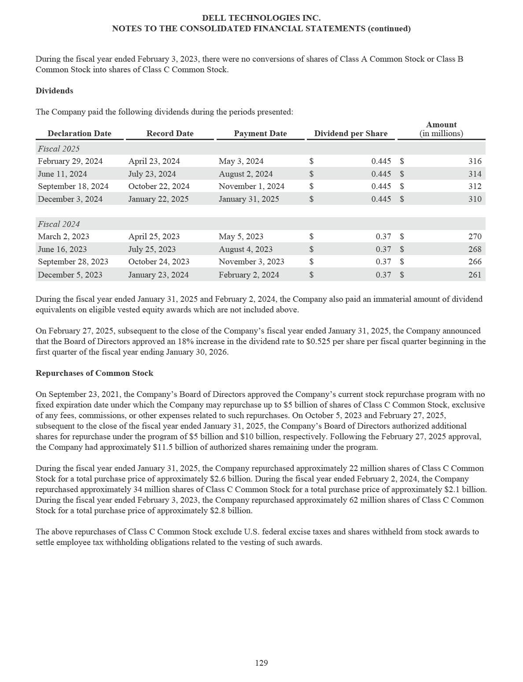

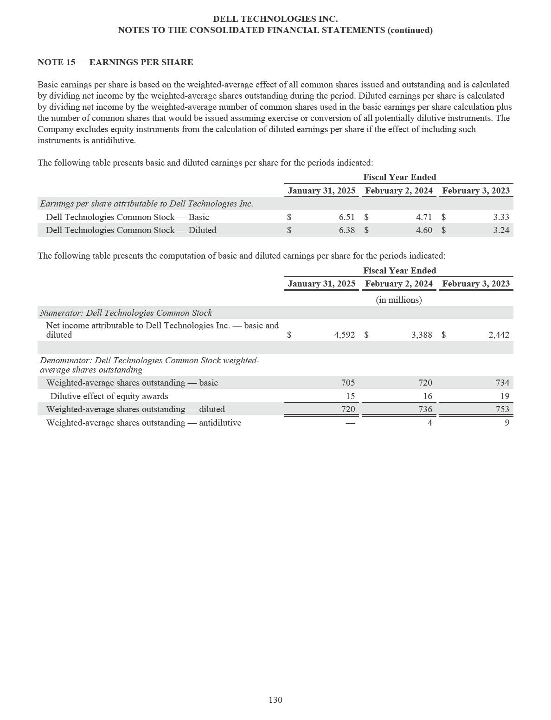

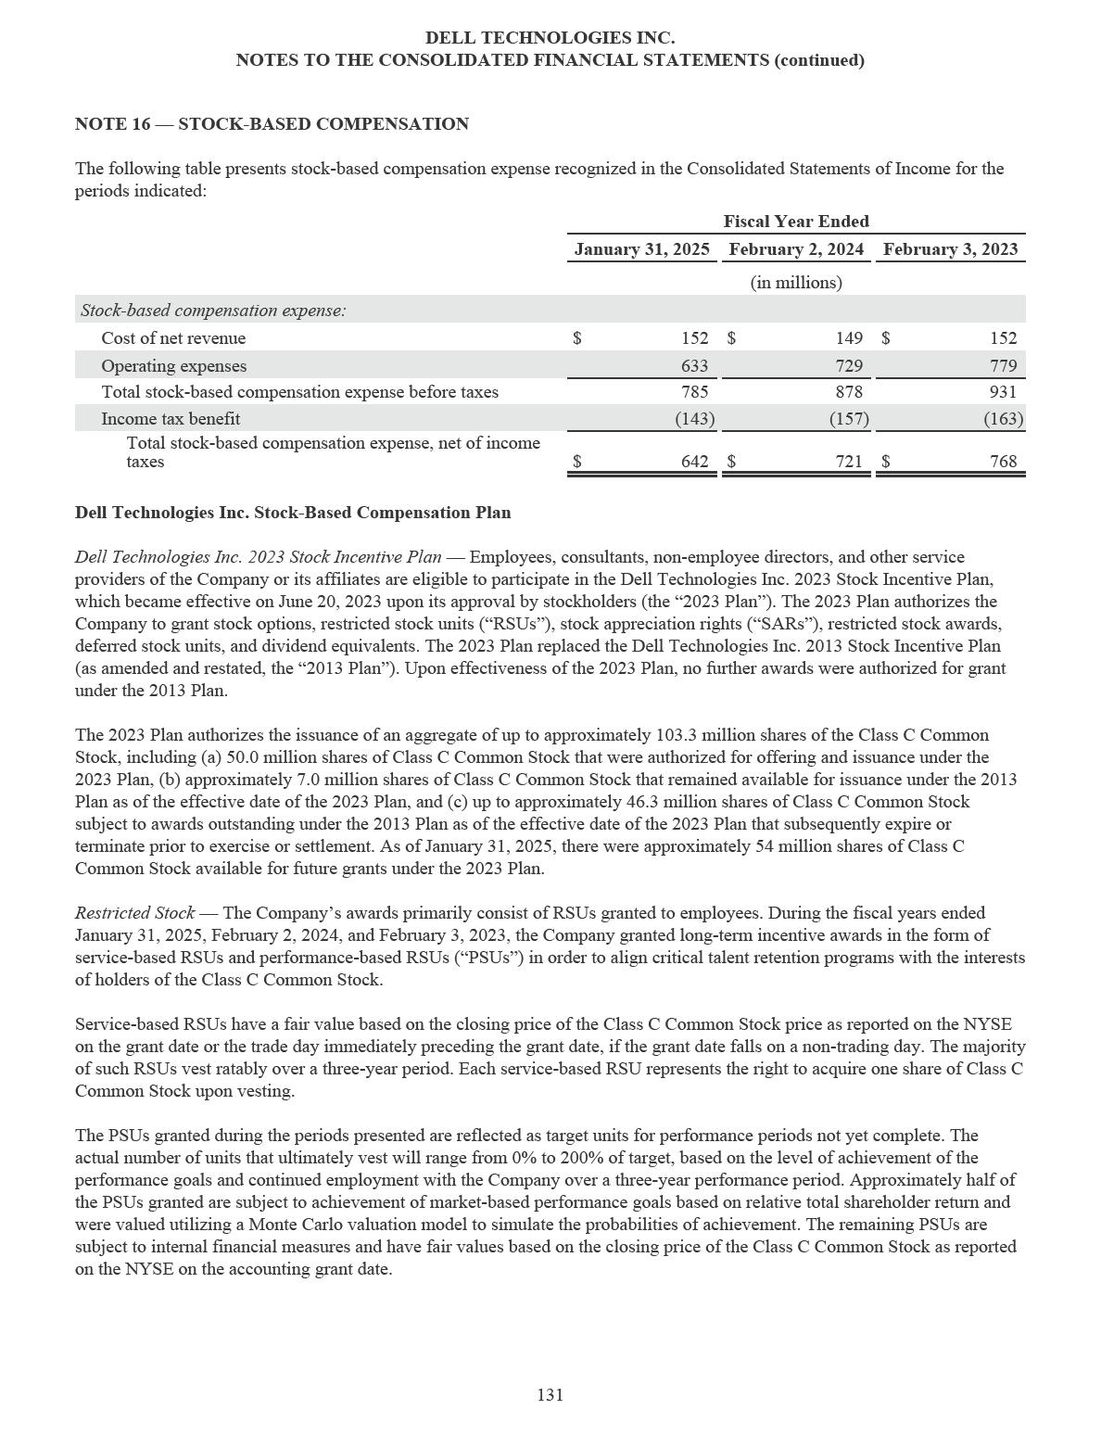

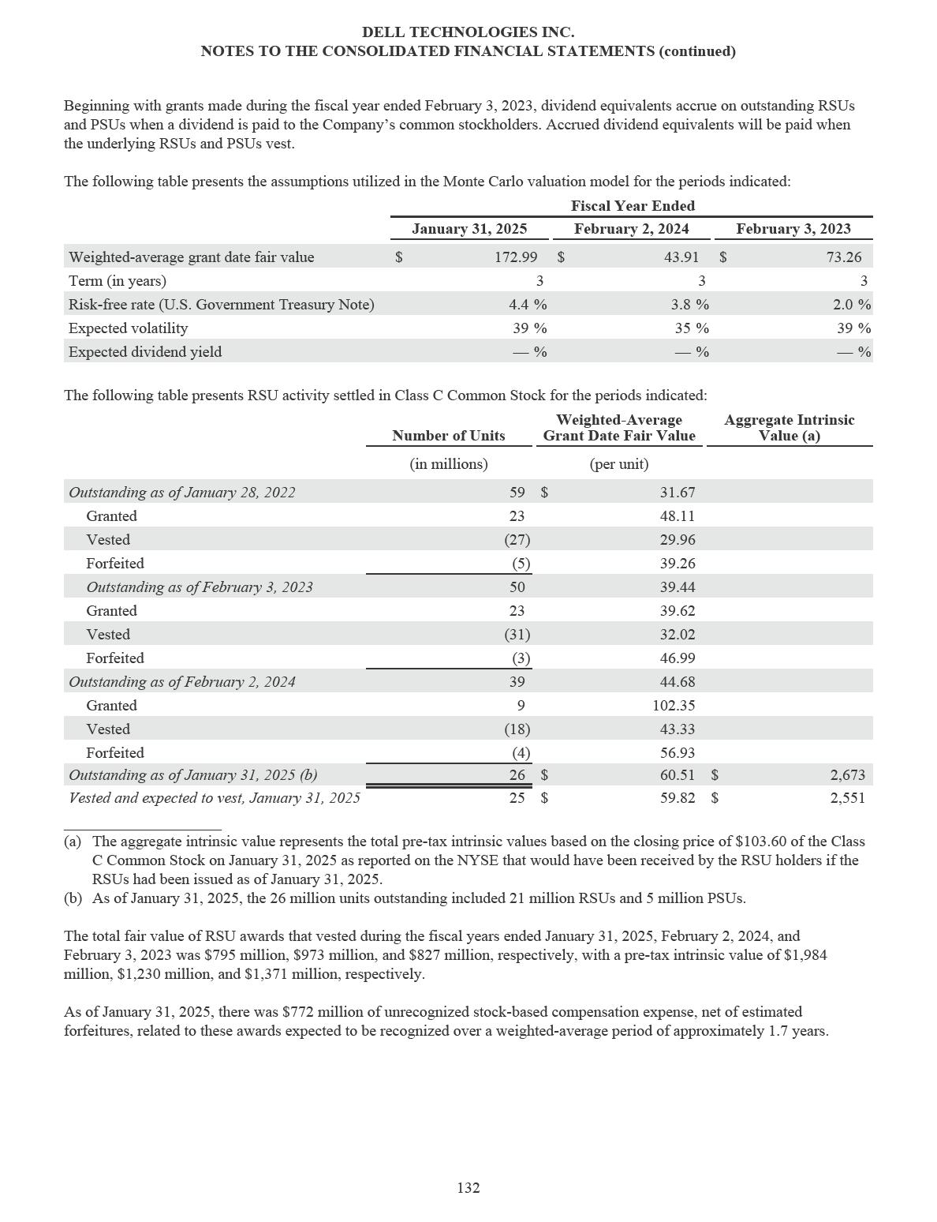

DELL TECHNOLOGIES INC.

NOTES TO THE CONSOLIDATED FINANCIAL STATEMENTS (continued)

Dell Technologies Shares Withheld for Taxes — Beginning in the fiscal year ended February 3, 2023, shares of Class C Common Stock are generally withheld from issuance to cover employee taxes for the vesting of restricted stock units. For the fiscal years ended January 31, 2025, February 2, 2024, and February 3, 2023, 5.0 million, 9.0 million, and 8.0 million shares, respectively, were withheld to cover $568 million, $366 million, and $388 million, respectively, of employees’ tax obligations. The value of the withheld shares was classified as a reduction to common stock and capital in excess of par value.

Stock Option Activity — In addition to RSU activity, the Company also had stock option activity which was not material during the fiscal years ended January 31, 2025, February 2, 2024, and February 3, 2023. Stock options are granted with option exercise prices equal to the fair market value of the Company’s Class C Common Stock and expire ten years after the grant date.

Other Plans

In addition to the 2023 Plan described above, the Company’s consolidated subsidiary, Secureworks, maintains its own equity plan and issues equity grants settling in its Class A common stock. The stock option and restricted stock unit activity under this plan was not material to the Company during the fiscal years ended January 31, 2025, February 2, 2024, and February 3, 2023.

133

DELL TECHNOLOGIES INC.

NOTES TO THE CONSOLIDATED FINANCIAL STATEMENTS (continued)

NOTE 17 — RETIREMENT PLAN BENEFITS

Defined Benefit Retirement Plans

The Company sponsors retirement plans for certain employees, some of which meet the criteria of a defined benefit retirement plan. Benefits under defined benefit retirement plans guarantee a particular payment to the employee in retirement. The amount of retirement benefit is defined by the plan and is typically a function of the number of years of service rendered by the employee and the employee’s average salary or salary at retirement. The annual costs of the plans are determined using the projected unit credit actuarial cost method that includes actuarial assumptions and estimates which are subject to change.

U.S. Pension Plan — The Company sponsored a noncontributory defined benefit retirement plan in the United States (the “U.S. pension plan”), which was assumed in connection with the EMC merger transaction that was completed in September 2016. As of December 1999, the U.S. pension plan was frozen, so employees no longer accrue retirement benefits for future services.

On August 20, 2024, the Company’s Board of Directors approved an amendment to terminate the U.S. pension plan with an effective date of September 30, 2024. The Company is transitioning the U.S. pension plan to a qualified insurance company and expects settlement in 12 to 18 months from the termination effective date. The Company does not expect the settlement of the U.S. pension plan obligations to have a material impact on its Consolidated Financial Statements.

The measurement date for the U.S. pension plan is the end of the Company’s fiscal year. The Company did not make any material contributions to the U.S. pension plan for the fiscal years ended January 31, 2025, February 2, 2024, and February 3, 2023. Net periodic benefit costs related to the U.S. pension plan were immaterial for the fiscal years ended January 31, 2025, February 2, 2024, and February 3, 2023.

The following table presents attributes of the U.S. pension plan as of the dates indicated:

 |  | January 31, 2025 |  |  | February 2, 2024
 |  | (in millions)
Plan assets at fair value (a) | $ | 423 | $ |  | 440
Benefit obligations |  | (437) |  |  | (457)
Underfunded position (b) | $ | (14) | $ |  | (17)

____________________

- Plan assets are managed by outside investment managers. Assets are recognized at fair value and are primarily classified within Level 2 of the fair value hierarchy.
- The underfunded position of the U.S. pension plan is recognized in other non-current liabilities in the Consolidated Statements of Financial Position.

As of January 31, 2025, future benefit payments for the U.S. pension plan are expected to be paid as follows: $38 million in Fiscal 2026; $39 million in Fiscal 2027; $39 million in Fiscal 2028; $39 million in Fiscal 2029; $38 million in Fiscal 2030; and $176 million from Fiscal 2031 through Fiscal 2035.

134

DELL TECHNOLOGIES INC.

NOTES TO THE CONSOLIDATED FINANCIAL STATEMENTS (continued)

International Pension Plans — The Company also sponsors retirement plans outside of the United States that qualify as defined benefit plans. The following table presents attributes of the international pension plans as of the dates indicated:

 |  | January 31, 2025 |  |  | February 2, 2024
 |  | (in millions)
Plan assets at fair value (a) | $ | 228 | $ |  | 224
Benefit obligations |  | (438) |  |  | (420)
Underfunded position (b) | $ | (210) | $ |  | (196)
____________________
- Plan assets are managed by outside investment managers. The Company’s investment strategy with respect to plan assets is to achieve a long-term growth of capital, consistent with an appropriate level of risk. Assets are recognized at fair value and are primarily classified within Level 2 of the fair value hierarchy for the fiscal year ended January 31, 2025 and were primarily classified within Level 1 of the fair value hierarchy for the fiscal year ended February 2, 2024.

- The underfunded position is recognized in other non-current liabilities in the Consolidated Statements of Financial Position.

Defined Contribution Retirement Plans

Dell 401(k) Plan — The Company maintains a defined contribution retirement plan (the “Dell 401(k) Plan”) that complies with Section 401(k) of the Internal Revenue Code. Only U.S. employees and employees of certain subsidiaries, except those who are covered by a collective bargaining agreement, classified as a leased employee or a nonresident alien, or are covered under a separate plan, are eligible to participate in the Dell 401(k) Plan. Participation in the Dell 401(k) Plan is at the election of the employee. As of January 31, 2025, the Company matched 100% of each participant’s voluntary contributions (the “Dell 401(k) employer match”), subject to a maximum contribution of 6% of the participant’s eligible compensation, up to an annual limit of $7,500. Participants vest immediately in all contributions to the Dell 401(k) Plan. The Company’s matching contributions as well as participants’ voluntary contributions are invested according to each participant’s elections in the investment options provided under the Dell 401(k) Plan. The Company’s contributions during the fiscal years ended January 31, 2025, February 2, 2024, and February 3, 2023 were $218 million, $238 million, and $263 million, respectively.

135

DELL TECHNOLOGIES INC.

NOTES TO THE CONSOLIDATED FINANCIAL STATEMENTS (continued)

NOTE 18 — SEGMENT INFORMATION

The Company reports its financial results through two reportable segments which are based on the following business units: Infrastructure Solutions Group (“ISG”) and Client Solutions Group (“CSG”). The Company organizes its reportable segments based on the manner in which management evaluates the performance of the Company.

The Company’s Chief Executive Officer is the Chief Operating Decision Maker (“CODM”). The CODM is regularly provided and reviews segment revenue and segment operating income to assess the performance of each segment and allocate resources to the segments in the annual planning process. The Company’s measure of segment revenue and segment operating income for management reporting purposes excludes Corporate and other, amortization of intangible assets, stock-based compensation expense, and other corporate expenses, as applicable, which are not used in evaluating the results of, or in allocating resources to, the segments. The Company does not allocate assets to the above reportable segments for internal reporting purposes. Additionally, the accounting policies of the segments are the same as those described in Note 2 of the Notes to the Consolidated Financial Statements.

ISG includes the Company’s servers and networking offerings and storage offerings. The Company’s server portfolio includes high-performance general-purpose and AI-optimized servers. The Company’s networking portfolio includes wide area network infrastructure, data center and edge networking switches, and cables and optics. The Company’s comprehensive storage portfolio includes modern and traditional storage solutions, including all-flash arrays, scale-out file, object platforms, hyper-converged infrastructure, and software-defined storage. ISG also offers software, peripherals, and services, including consulting and support and deployment.

CSG includes the Company’s commercial offerings and consumer offerings. The Company’s CSG portfolio includes branded PCs, including notebooks, desktops, and workstations and branded peripherals that include displays, docking stations, keyboards, mice, and webcam and audio devices, as well as third-party software and peripherals. CSG also includes services offerings, such as configuration, support and deployment, and extended warranties.

Following its acquisition by Broadcom on November 22, 2023, VMware announced changes to its go-to-market approach for VMware offerings that impacted the Company’s commercial relationship with VMware. On March 25, 2024, the Company terminated the Commercial Framework Agreement with VMware, which provided the framework pursuant to which the Company and VMware continued the commercial relationship following the VMware Spin-off described in Note 11 of the Notes to the Consolidated Financial Statements and under which Dell Technologies acted as a distributor of Broadcom’s VMware stand-alone products and services and purchased such products and services for resale to end-user customers (“VMware Resale”). Dell Technologies no longer acts as a distributor of VMware’s standalone products and services, although the Company will continue to support customers that have purchased resale offerings sold in prior periods. The results of VMware Resale transactions are reflected in Corporate and other. The Company continues to integrate and embed certain VMware products and services with select Dell Technologies’ offerings to end-users. The results of such offerings are reflected within CSG or ISG, depending upon the nature of the underlying offering sold.

136

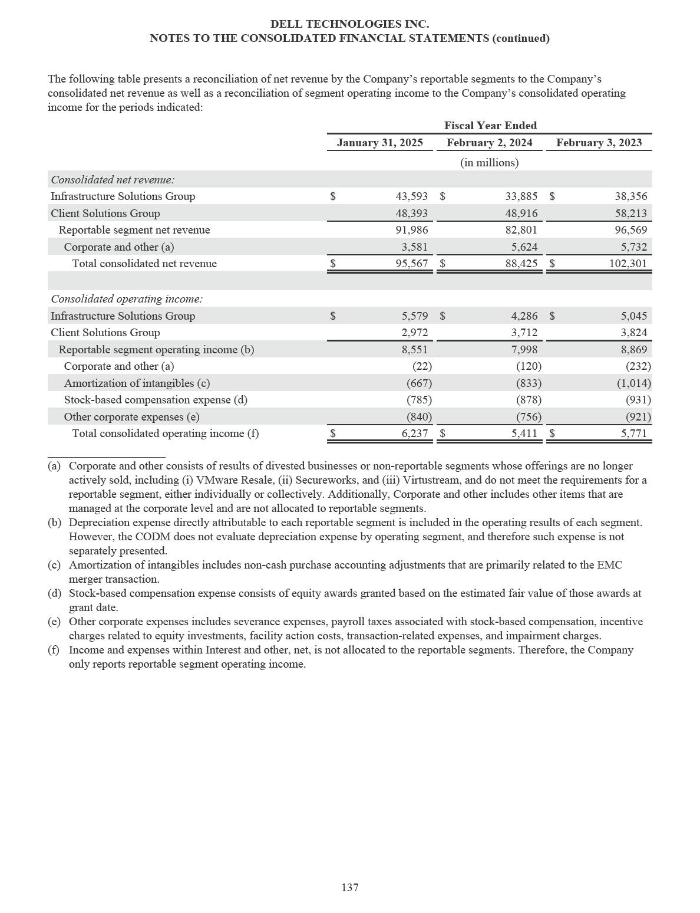

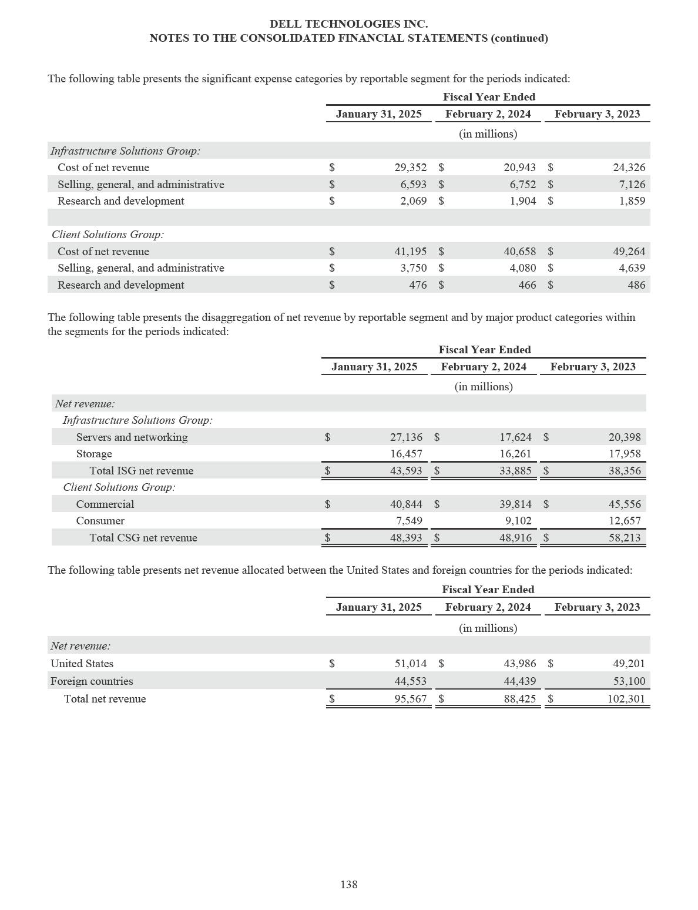

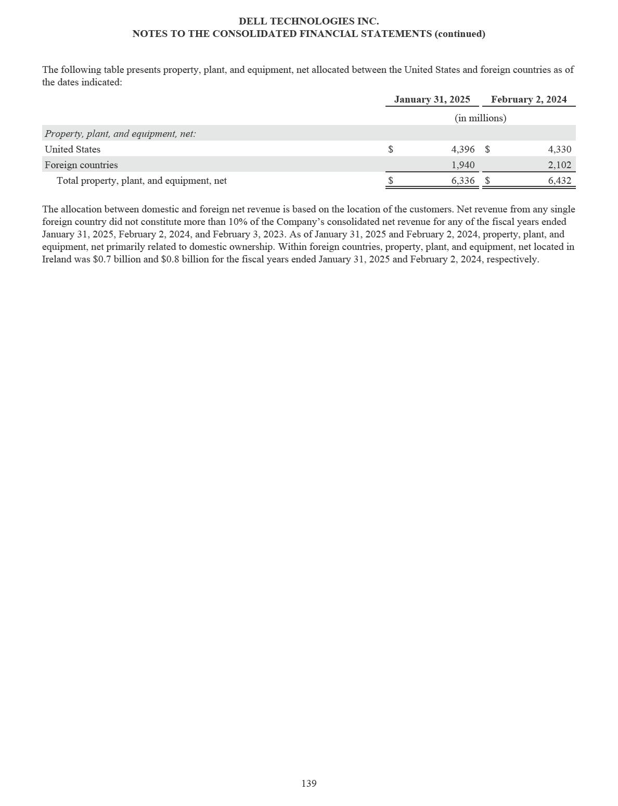

DELL TECHNOLOGIES INC.

NOTES TO THE CONSOLIDATED FINANCIAL STATEMENTS (continued)

NOTE 19 — RELATED PARTY TRANSACTIONS

Prior to the acquisition on November 22, 2023 of VMware LLC (previously VMware, Inc. and individually and together with its consolidated subsidiaries, “VMware”) by Broadcom Inc. (“Broadcom”), VMware was considered a related party of the Company. Upon Broadcom’s acquisition of VMware, Michael Dell’s ownership interest in VMware and his position as Chairman of the Board of VMware terminated, and the Company determined no related party relationship exists with Broadcom or VMware effective as of November 22, 2023. The Company continues to engage in select transactions with VMware following the completion of Broadcom’s acquisition and the termination of the related party relationship. See Note 18 of the Notes to the Consolidated Financial Statements for additional information.

Related Party Transactions with VMware

The information provided below includes a summary of related party transactions with VMware for the periods presented within this report. Such transactions were considered related party transactions only through November 21, 2023, the day immediately preceding Broadcom’s acquisition of VMware.

- Dell Technologies integrated or bundled select VMware products and services with Dell Technologies’ products and sold them to end-users. Dell Technologies also acted as a distributor, purchasing VMware’s standalone products and services for resale to end-user customers. Where applicable, costs under these arrangements were presented net of rebates received by Dell Technologies.

- DFS provided financing to certain VMware end-users, which resulted in the recognition of amounts due to related parties on the Consolidated Statements of Financial Position. Associated financing fees were recorded to product net revenue on the Consolidated Statements of Income and were reflected within sales and leases of products to VMware in the table below.

- Dell Technologies procured products and services from VMware for its internal use. For the fiscal years ended February 2, 2024 and February 3, 2023, costs incurred associated with products and services purchased from VMware for internal use were immaterial.

- Dell Technologies sold and leased products and sold services to VMware. For the fiscal years ended February 2, 2024 and February 3, 2023, revenue recognized from sales of services to VMware was immaterial.

- Dell Technologies and VMware entered into joint marketing, sales, and branding arrangements, for which both parties incurred costs. For the fiscal years ended February 2, 2024 and February 3, 2023, consideration received from VMware for joint marketing, sales, and branding arrangements was immaterial.

- Dell Technologies and VMware entered into a transition services agreement in connection with the VMware Spin-off to provide various support services, including investment advisory services, certain support services from Dell Technologies personnel, and other transitional services. Costs incurred associated with this agreement were immaterial for the fiscal year ended February 3, 2023. Activities under the agreement concluded during Fiscal 2023.

The following table presents information about the impact of Dell Technologies’ related party transactions with VMware on the

Consolidated Statements of Income for the periods presented:

 |  |  |  | Fiscal Year Ended
 | Classification |  | February 2, 2024 (a) |  |  |  | February 3, 2023
 |  |  |  | (in millions)
Sales and leases of products to VMware | Net revenue — products |  | $ | 103 | $ |  | 154
Purchase of VMware products for resale | Cost of net revenue — products |  | $ | 1,010 | $ |  | 1,634
Purchase of VMware services for resale | Cost of net revenue — services |  | $ | 2,810 | $ |  | 3,065
____________________
- For the fiscal year ended February 2, 2024, amounts are reported only through November 21, 2023, the day immediately preceding the acquisition of VMware by Broadcom.

140

DELL TECHNOLOGIES INC.

NOTES TO THE CONSOLIDATED FINANCIAL STATEMENTS (continued)

In connection with the completion of the VMware Spin-off described in Note 11 of the Notes to the Consolidated Financial Statements, Dell Technologies and VMware entered into a Tax Matters Agreement effective as of April 14, 2021 (the “Tax Matters Agreement”), which governs the respective rights and obligations of Dell Technologies and VMware regarding income and other taxes as well as related matters, including tax liabilities and benefits, attributes, and returns for periods both preceding and following the VMware Spin-off.

Pursuant to the Tax Matters Agreement, net receipts from VMware during the fiscal year ended February 2, 2024 were

$286 million, a portion of which was received subsequent to the completion of Broadcom’s acquisition of VMware, and were immaterial during the fiscal year ended February 3, 2023. Such receipts were primarily related to VMware’s portion of the mandatory one-time transition tax on accumulated earnings of foreign subsidiaries and federal income taxes on Dell Technologies’ consolidated income tax return.

Other Related Parties

Transactions with other related parties during the periods presented were immaterial, individually and in aggregate.

141

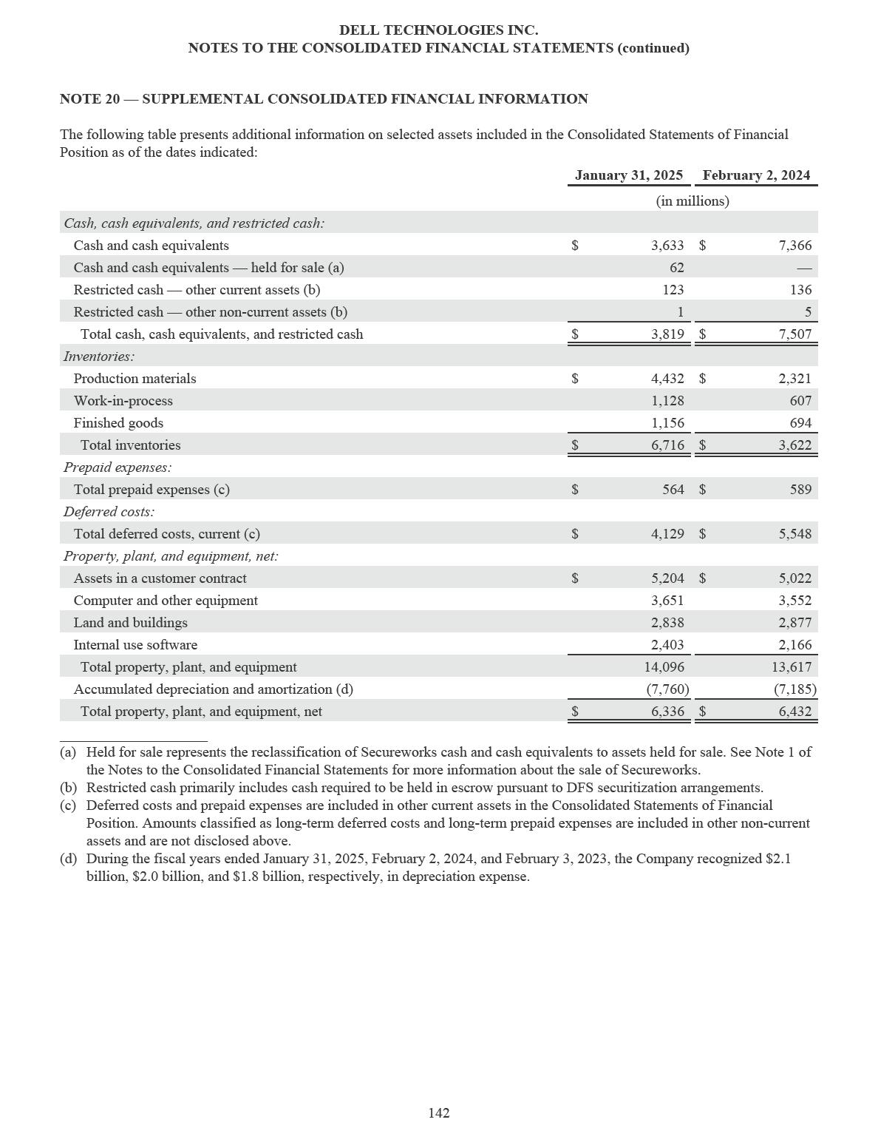

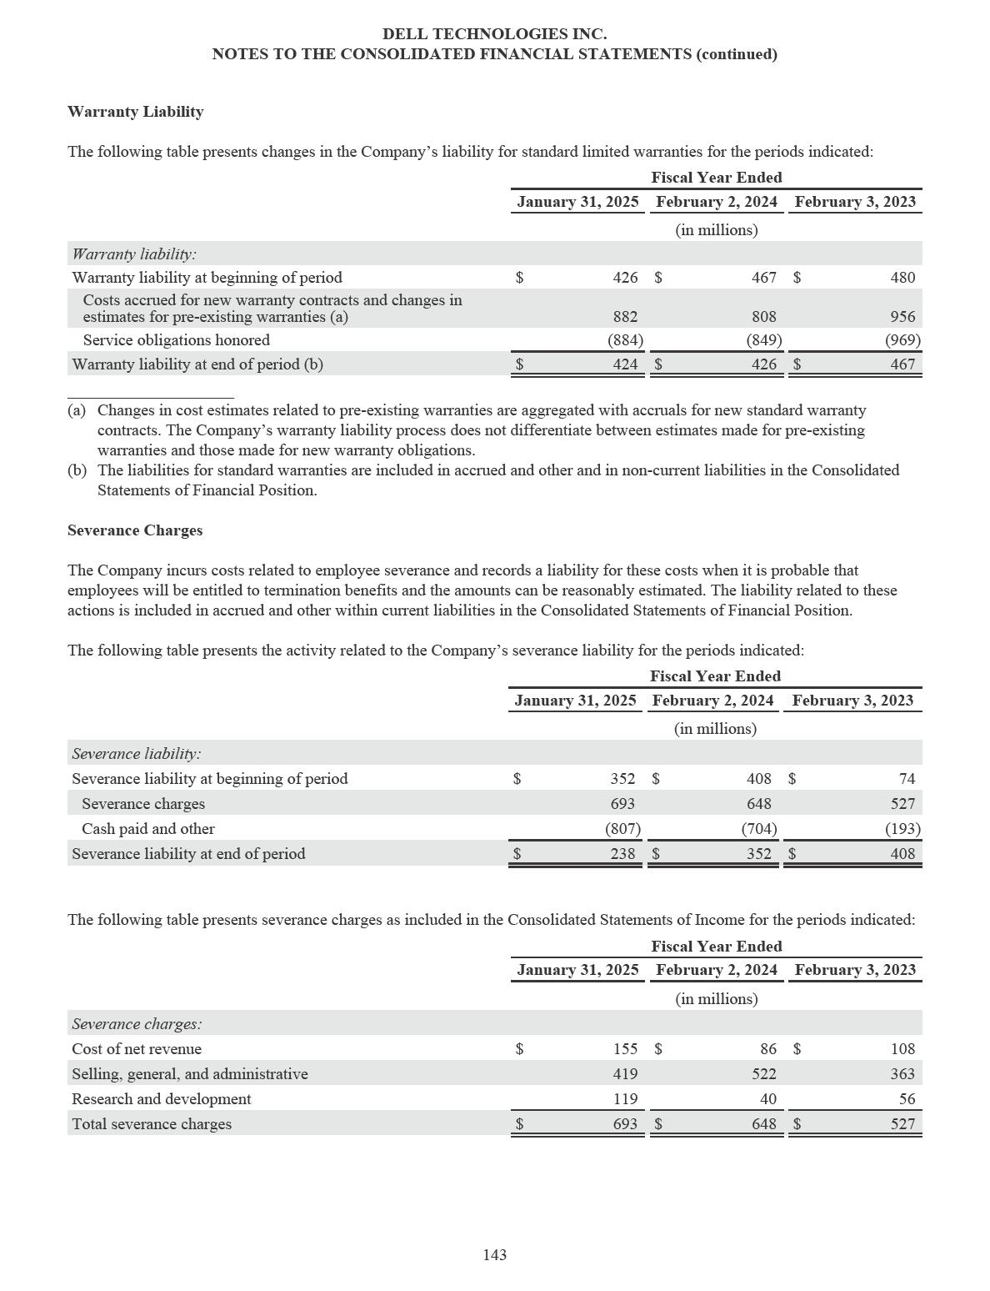

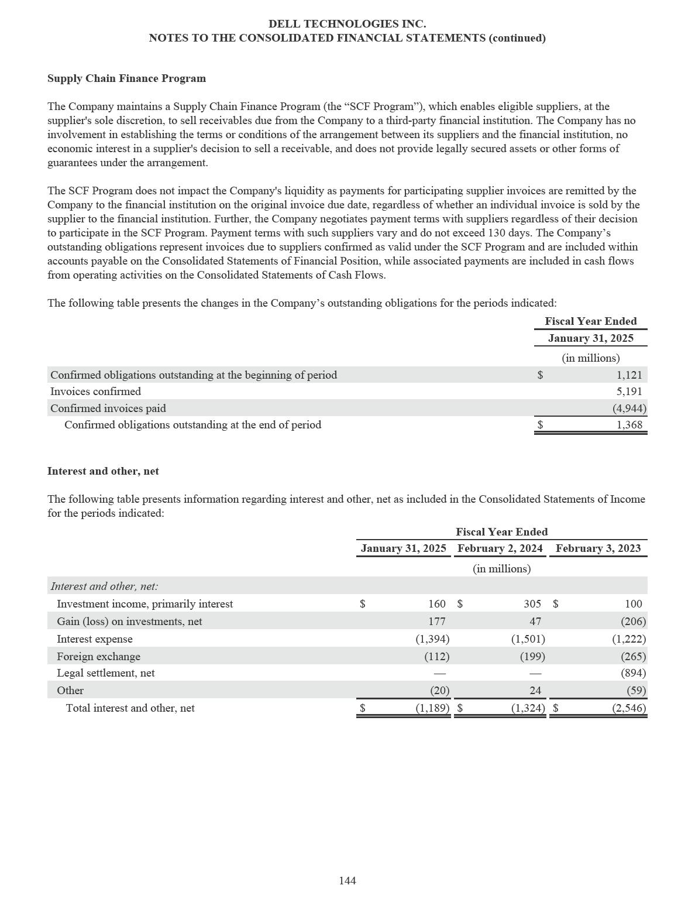

DELL TECHNOLOGIES INC.

NOTES TO THE CONSOLIDATED FINANCIAL STATEMENTS (continued)

NOTE 21 — GOVERNMENT ASSISTANCE

The Company receives government assistance in the form of grants and incentives which vary in size, duration, and conditions from various domestic and international governing bodies and related entities which are primarily structured as cash grants and non-income tax incentives. For government assistance in which no specific US GAAP applies, the Company accounts for such transactions as a gain contingency and by analogy to a grant model. Under such model, the Company recognizes the impact of the government assistance on the Consolidated Statements of Income upon reaching reasonable assurance that the Company will comply with the conditions of the assistance and that the grant will be received. The Company classifies the impact of government assistance on the Consolidated Statements of Income based on the underlying nature and purpose of the assistance.

During the fiscal years ended January 31, 2025, February 2, 2024, and February 3, 2023, government assistance received primarily consisted of the following:

The Company received assistance from foreign governmental entities designed, in part, to promote competitive pricing by providing companies with an offset to local sales taxes incurred on the sales of products to customers. The assistance received is broadly available to companies. To qualify for this assistance, companies are required to invest a portion of local revenue, derived from goods manufactured locally, into research and development activities. The incentives in place are currently set to expire at various dates through 2029. Such expirations could be impacted by future legislation. During the fiscal years ended January 31, 2025, February 2, 2024, and February 3, 2023, the Company recognized $279 million, $288 million, and $297 million, respectively, within net revenue on the Consolidated Statements of Income related to such assistance.

The Company received incentives from foreign governmental entities to provide reimbursement for various costs incurred that are directly tied to the production or delivery of offerings sold to customers. The agreements governing such assistance require that the Company comply with certain conditions including, but not limited to, the achievement of future operational targets.

These agreements currently expire at various dates through 2029. During the fiscal years ended January 31, 2025, February 2, 2024, and February 3, 2023, the Company recognized a benefit of $45 million, $166 million, and $318 million, respectively, to cost of net revenue on the Consolidated Statements of Income related to such assistance.

145

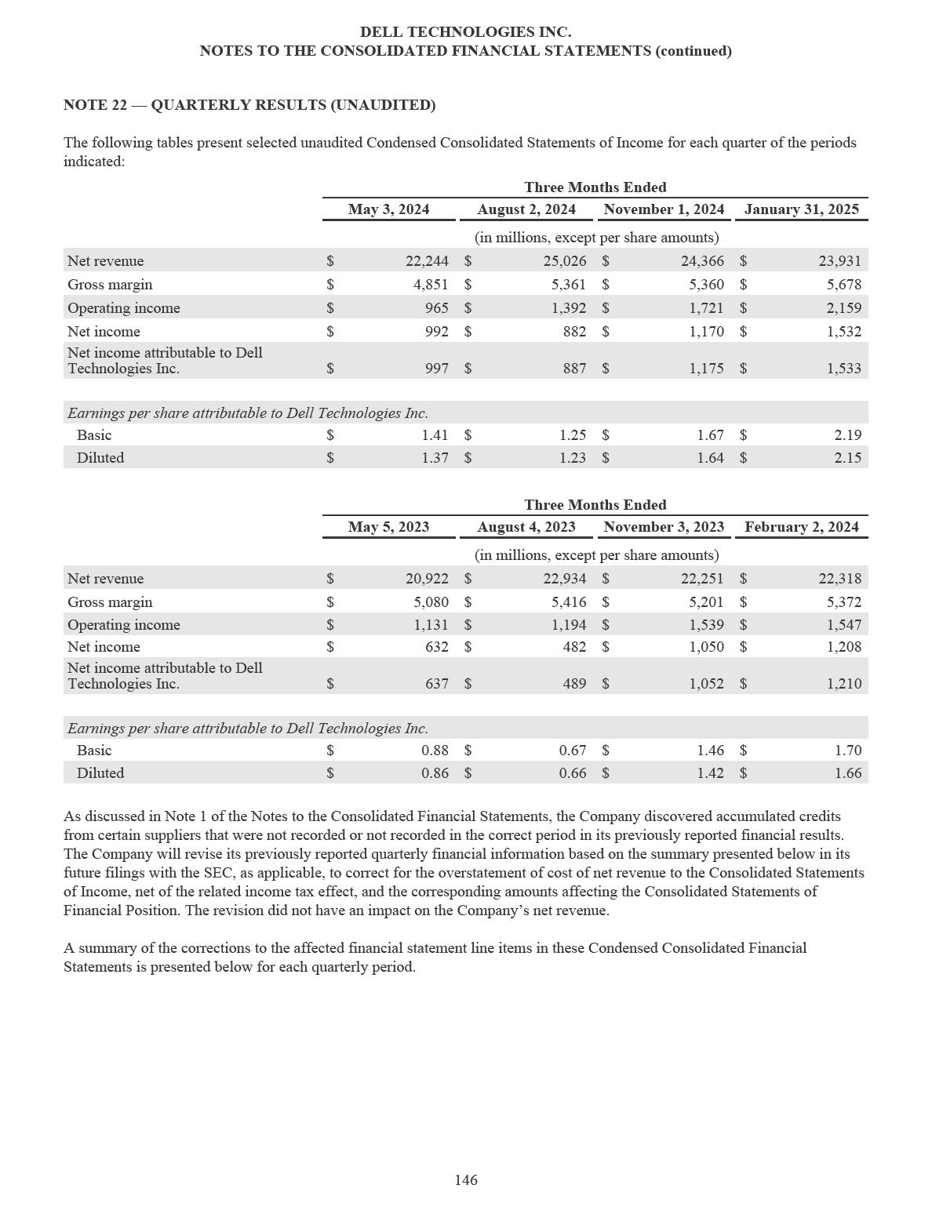

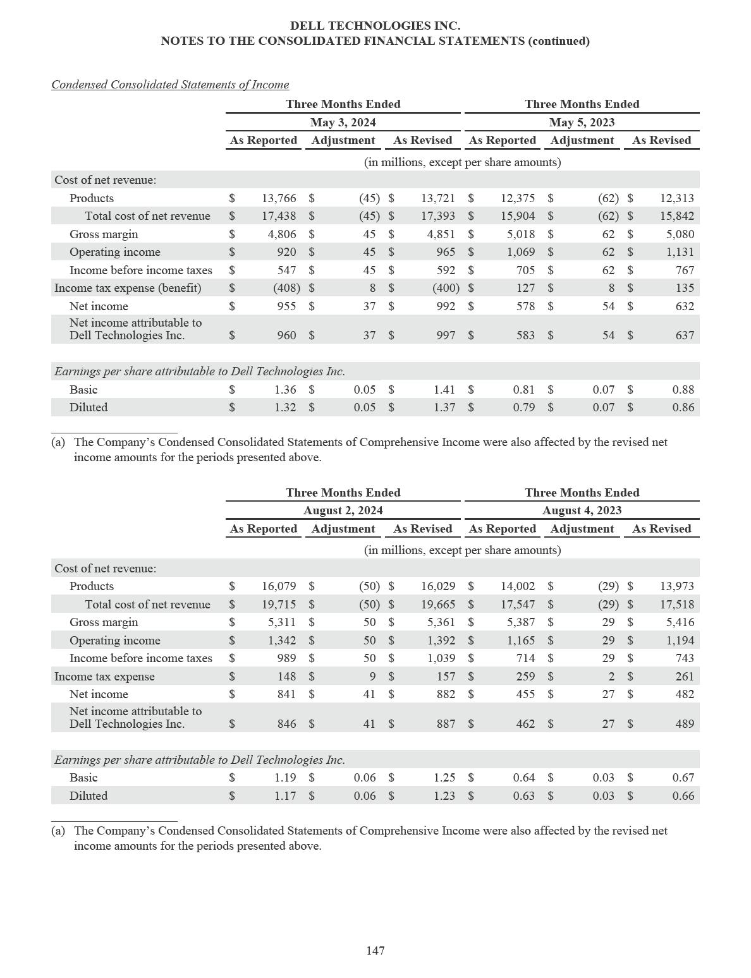

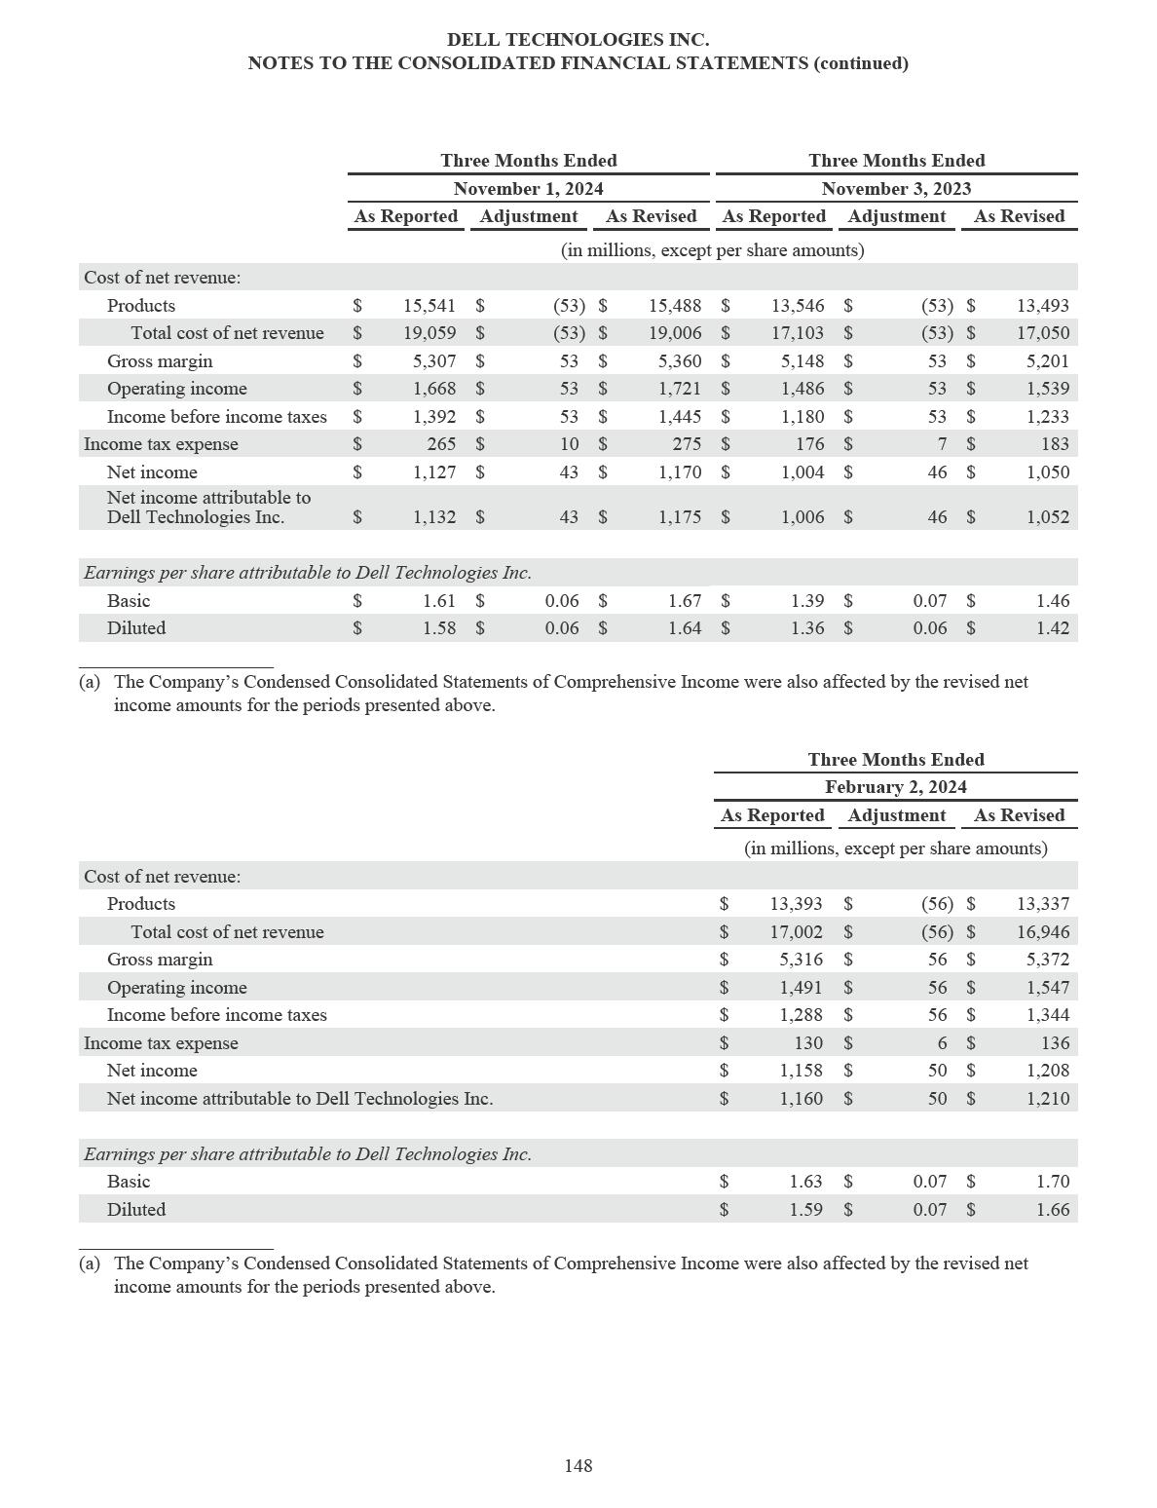

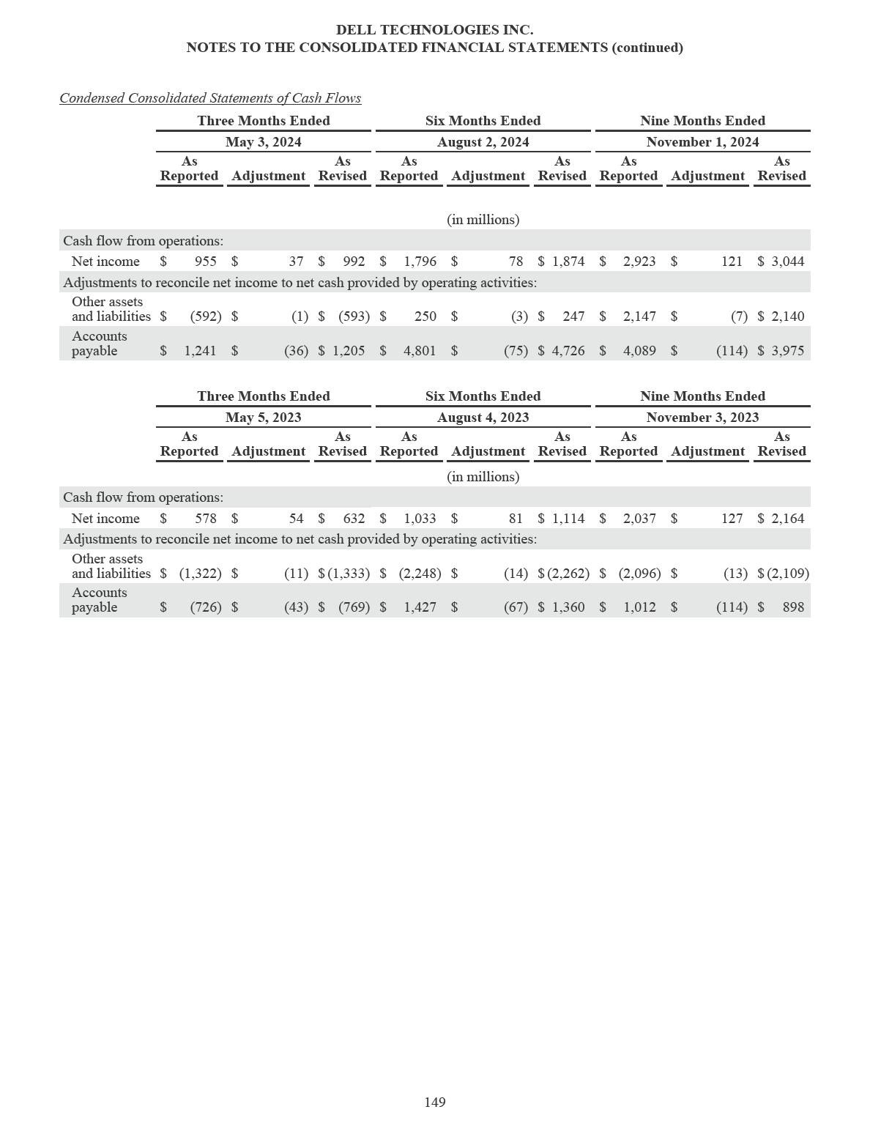

DELL TECHNOLOGIES INC.

NOTES TO THE CONSOLIDATED FINANCIAL STATEMENTS (continued)

NOTE 23 — SUBSEQUENT EVENTS

There were no known events occurring after January 31, 2025, and up until the date of issuance of this report that would materially affect the information presented herein.

150

ITEM 9 — CHANGES IN AND DISAGREEMENTS WITH ACCOUNTANTS ON ACCOUNTING AND FINANCIAL DISCLOSURE

None.

ITEM 9A — CONTROLS AND PROCEDURES

This report includes the certifications of our Chief Executive Officer and Chief Financial Officer required by Rule 13a-14 under the Securities Exchange Act of 1934 (the “Exchange Act”). See Exhibits 31.1 and 31.2 filed with this report. This Item 9A includes information concerning the controls and control evaluations referred to in those certifications.

Evaluation of Disclosure Controls and Procedures

Disclosure controls and procedures (as defined in Rules 13a-15(e) and 15d-15(e) under the Exchange Act) are designed to provide reasonable assurance that information required to be disclosed in reports filed or submitted under the Exchange Act is recorded, processed, summarized, and reported within the time periods specified in SEC rules and forms and that such information is accumulated and communicated to management, including the Chief Executive Officer and the Chief Financial Officer, as appropriate to allow timely decisions regarding required disclosures.

In connection with the preparation of this report, our management, under the supervision and with the participation of our Chief Executive Officer and Chief Financial Officer, conducted an evaluation of the effectiveness of the design and operation of our disclosure controls and procedures as of January 31, 2025. Based on that evaluation, our Chief Executive Officer and Chief Financial Officer have concluded that as of January 31, 2025, the Company’s disclosure controls and procedures were not effective to accomplish their objectives at the reasonable assurance level due to the material weakness in internal control over financial reporting as described below.

Management’s Annual Report on Internal Control Over Financial Reporting

Management, under the supervision of the Chief Executive Officer and the Chief Financial Officer, is responsible for establishing and maintaining adequate internal control over financial reporting. Internal control over financial reporting (as defined in Rules 13a-15(f) and 15d(f) under the Exchange Act) is a process designed to provide reasonable assurance regarding the reliability of financial reporting and the preparation of financial statements for external purposes in accordance with generally accepted accounting principles. Internal control over financial reporting includes those policies and procedures which

- pertain to the maintenance of records that, in reasonable detail, accurately and fairly reflect the transactions and dispositions of assets, (b) provide reasonable assurance that transactions are recorded as necessary to permit preparation of financial statements in accordance with generally accepted accounting principles and that receipts and expenditures of the issuer are being made only in accordance with appropriate authorization of management and the directors of the issuer, and (c) provide reasonable assurance regarding prevention or timely detection of unauthorized acquisition, use, or disposition of assets that could have a material effect on the financial statements.

A material weakness is a deficiency, or a combination of deficiencies, in internal control over financial reporting, such that there is a reasonable possibility that a material misstatement of our annual or interim financial statements will not be prevented or detected on a timely basis.

During the preparation of the Company’s financial statements for the fiscal year ended January 31, 2025, management identified a material weakness in its internal control over financial reporting as the Company did not design and maintain effective controls over non-recurring credits from certain suppliers that related to cost of net revenue. This material weakness resulted in the revision of the Company’s annual Consolidated Financial Statements previously issued for the fiscal year ended February 2, 2024 and the unaudited interim Condensed Consolidated Financial Statements previously issued for Fiscal 2025 and Fiscal 2024 interim periods. While the impacts were not material, individually or in the aggregate, to the Company’s previously issued Consolidated Financial Statements, the material weakness related to non-recurring credits from certain suppliers could result in a material misstatement to the annual or interim Consolidated Financial Statements that would not be prevented or detected until such material weakness is remediated.

151

In connection with the preparation of this report, our management, under the supervision and with the participation of our Chief Executive Officer and Chief Financial Officer, conducted an evaluation of the effectiveness of our internal control over financial reporting as of January 31, 2025, based on the criteria established in Internal Control — Integrated Framework (2013) issued by the Committee of Sponsoring Organizations of the Treadway Commission (COSO). As a result of the material weakness described above, management has concluded that our internal control over financial reporting was not effective as of January 31, 2025.

The effectiveness of our internal control over financial reporting as of January 31, 2025 has been audited by PricewaterhouseCoopers LLP, our independent registered public accounting firm, as stated in their report, which is included in “Item 8 — Financial Statements and Supplementary Data.”

Remediation of Material Weakness

The Company is committed to addressing the material weakness described above and has begun to implement changes in processes designed to improve its internal control over financial reporting. To remediate the material weakness, we are designing and implementing a new control over non-recurring credits from certain suppliers.

As the Company evaluates and enhances its internal control over financial reporting, it may take additional measures to modify, or add to, the remediation measures described above. Remediation will not occur until the plans are implemented and there has been appropriate time to conclude through testing that the controls operate effectively.

Changes in Internal Control Over Financial Reporting

We are in the process of an ongoing business modernization initiative to advance our capabilities, leverage new technology, and optimize business processes to change the way we work and make decisions, improve business outcomes, and reduce costs. As part of this initiative, we are modernizing accounting and finance systems. We have modified and will continue to modify the design and implementation of certain internal control processes to accommodate changes to our business processes and finance procedures, as our business modernization initiative continues.

There were no other changes in our internal control over financial reporting during the fiscal quarter ended January 31, 2025 that have materially affected, or are reasonably likely to materially affect, our internal control over financial reporting.

Limitations on the Effectiveness of Controls

Our system of controls is designed to provide reasonable, not absolute, assurance regarding the reliability and integrity of accounting and financial reporting. Management does not expect that our disclosure controls and procedures or our internal control over financial reporting will prevent or detect all errors and all fraud. A control system, no matter how well designed and operated, can provide only reasonable, not absolute, assurance that the objectives of the control system will be met. These inherent limitations include the following:

- Judgments in decision-making can be faulty, and control and process breakdowns can occur because of simple errors or mistakes.

- Controls can be circumvented by individuals, acting alone or in collusion with each other, or by management override.

- The design of any system of controls is based in part on certain assumptions about the likelihood of future events, and there can be no assurance that any design will succeed in achieving its stated goals under all potential future conditions.

- Over time, controls may become inadequate because of changes in conditions or deterioration in the degree of compliance with associated policies or procedures.

- The design of a control system must reflect the fact that resources are constrained, and the benefits of controls must be considered relative to their costs.

152

ITEM 9B — OTHER INFORMATION

Trading Arrangements

On January 13, 2025, William Green, one of the Company’s directors, adopted a written plan for the sale of up to 272,736 shares of the Company’s Class C Common Stock that is intended to satisfy the affirmative defense conditions of Rule 10b5-1(c) under the Exchange Act. The plan will expire on December 31, 2025, or on any earlier date on which all of the shares have been sold.

ITEM 9C — DISCLOSURE REGARDING FOREIGN JURISDICTIONS THAT PREVENT INSPECTIONS Not applicable.

PART III

ITEM 10 — DIRECTORS, EXECUTIVE OFFICERS AND CORPORATE GOVERNANCE

We have adopted a code of ethics applicable to our principal executive officer and our other senior financial officers. The code of ethics, which we refer to as our Code of Ethics for Senior Financial Officers, is available on the Investor Relations page of our website at www.delltechnologies.com. To the extent required by SEC rules, we intend to disclose any amendments to this code and any waiver of a provision of the code for the benefit of any senior financial officers on our website within any period that may be required under SEC rules from time to time.

See “Part I — Item 1 — Business — Information about our Executive Officers” for more information about our executive officers, which is incorporated by reference in this Item 10. Other information required by this Item 10 is incorporated herein by reference to our definitive proxy statement for our 2025 annual meeting of stockholders, referred to as the “2025 proxy statement,” which we will file with the SEC on or before 120 days after our 2025 fiscal year-end, and which will appear in the 2025 proxy statement under the captions “Proposal 1 — Election of Directors,” “Compensation Discussion and Analysis” and “Additional Information — Delinquent Section 16(a) Reports,” if applicable.

The following information about the members of our Board of Directors and the principal occupation or employment of each director is provided as of the date of this report.

Michael S. Dell | David Grain
Chairman and Chief Executive Officer | Founder and CEO
Dell Technologies Inc. | Grain Management
Dell Technologies Inc. | (private equity)
David W. Dorman | Egon Durban
Founding Partner | Co-CEO
Centerview Capital Technology | Silver Lake
(investments) | (private equity)
Ellen J. Kullman | Steve M. Mollenkopf
Public Company Director | Public Company Director
William D. Green | Lynn Vojvodich Radakovich
Public Company Director | Public Company Director

153

ITEM 11 — EXECUTIVE COMPENSATION

As discussed in Note 1 and Note 22 of the Notes to the Consolidated Financial Statements included in this report, the Consolidated Financial Statements were revised for the fiscal year ended February 2, 2024 and the unaudited interim periods for Fiscal 2025 and Fiscal 2024 to correct for the overstatement of cost of net revenue to the Consolidated Statements of Income, net of the related income tax effect, and the corresponding amounts affecting the Consolidated Statements of Financial Position. The revision required a recovery analysis of incentive-based executive compensation under the Dell Technologies Inc. Incentive-Based Compensation Recovery Policy filed as Exhibit 97 to this report. The Company determined that the revision had no recovery impact with respect to such incentive-based compensation.

Information required by this Item 11 is incorporated herein by reference to the 2025 proxy statement, including the information in the 2025 proxy statement appearing under the captions “Proposal 1 — Election of Directors — Director Compensation,” “Compensation Discussion and Analysis” and “Compensation of Executive Officers.”

ITEM 12 — SECURITY OWNERSHIP OF CERTAIN BENEFICIAL OWNERS AND MANAGEMENT AND RELATED STOCKHOLDER MATTERS

Information required by this Item 12 is incorporated herein by reference to the 2025 proxy statement, including the information in the 2025 proxy statement appearing under the captions “Equity Compensation Plan Information” and “Security Ownership of Certain Beneficial Owners and Management.”

ITEM 13 — CERTAIN RELATIONSHIPS AND RELATED TRANSACTIONS, AND DIRECTOR INDEPENDENCE

Information required by this Item 13 is incorporated herein by reference to the 2025 proxy statement, including the information in the 2025 proxy statement appearing under the captions “Proposal 1 — Elections of Directors” and “Transactions with Related Persons.”

ITEM 14 — PRINCIPAL ACCOUNTANT FEES AND SERVICES

Information required by this Item 14 is incorporated herein by reference to the 2025 proxy statement, including the information in the 2025 proxy statement appearing under the caption “Proposal 2 — Ratification of Appointment of Independent Registered Public Accounting Firm.”

154

PART IV

ITEM 15 — EXHIBITS AND FINANCIAL STATEMENT SCHEDULES

The following documents are filed as part of this Annual Report on Form 10-K:

- Financial Statements: The following financial statements are filed as part of this report under “Part II — Item 8 — Financial Statements and Supplementary Data”:

Consolidated Financial Statements:
Report of Independent Registered Public Accounting Firm
Consolidated Statements of Financial Position at January 31, 2025 and February 2, 2024
Consolidated Statements of Income for the fiscal years ended January 31, 2025, February 2, 2024, and February 3, 2023

Consolidated Statements of Comprehensive Income for the fiscal years ended January 31, 2025, February 2, 2024, and February 3, 2023

Consolidated Statements of Cash Flows for the fiscal years ended January 31, 2025, February 2, 2024, and February 3, 2023

Consolidated Statements of Stockholders’ Equity (Deficit) for the fiscal years ended January 31, 2025, February 2, 2024, and February 3, 2023

Notes to Consolidated Financial Statements

- Financial Statement Schedules:

All schedules have been omitted because they are not applicable or the required information is otherwise included in the Consolidated Financial Statements or Notes thereto.

Exhibits:
Exhibit |  | Description
Number |  | Description
2.1 |  | Separation and Distribution Agreement, dated as of April 14, 2021, by and between Dell Technologies Inc. and
 |  | VMware, Inc. (incorporated by reference to Exhibit 2.1 to the Current Report on Form 8-K of Dell Technologies
 |  | Inc. (the “Company”) filed with the Securities and Exchange Commission (the “Commission”) on April 14,
 |  | 2021) (Commission File No. 001-37867).
2.2 |  | Letter Agreement, dated as of October 7, 2021, by and between Dell Technologies Inc. and VMware, Inc.
 |  | (incorporated by reference to Exhibit 99.1 to the Company’s Current Report on Form 8-K filed with the
 |  | Commission on October 7, 2021) (Commission File No. 001-37867).
2.3 |  | Letter Agreement, dated as of November 1, 2021, by and between Dell Technologies Inc. and VMware, Inc.
 |  | (incorporated by reference to Exhibit 99.2 to the Company’s Current Report on Form 8-K filed with the
 |  | Commission on November 1, 2021) (Commission File No. 001-37867).
3.1 |  | Sixth Amended and Restated Certificate of Incorporation of Dell Technologies Inc. (incorporated by reference to
 |  | Exhibit 3.1 to the Company’s Current Report on Form 8-K filed with the Commission on June 29, 2022)
 |  | (Commission File No. 001-37867).
3.2 |  | Third Amended and Restated Bylaws of Dell Technologies Inc. (incorporated by reference to Exhibit 3.2 to the
 |  | Company’s Current Report on Form 8-K filed with the Commission on June 29, 2022) (Commission File No.
 | 001-37867).
4.1 |  | Indenture, dated as of April 27, 1998, between Dell Computer Corporation and Chase Bank of Texas, National
 |  | Association, as trustee (incorporated by reference to Exhibit 99.2 to Dell Inc.’s Current Report on Form 8-K filed
 |  | with the Commission on April 28, 1998) (Commission File No. 000-17017).
4.2 |  | Indenture, dated as of April 17, 2008, between Dell Inc. and The Bank of New York Mellon Trust Company,
 |  | N.A. (formerly The Bank of New York Trust Company, N.A.), as trustee (including the form of notes)
 |  | (incorporated by reference to Exhibit 4.1 to Dell Inc.’s Current Report on Form 8-K filed with the Commission
 |  | on April 17, 2008) (Commission File No. 000-17017).

155

4.3 Indenture, dated as of April 6, 2009, between Dell Inc. and The Bank of New York Mellon Trust Company, N.A., as trustee (incorporated by reference to Exhibit 4.1 to Dell Inc.’s Current Report on Form 8-K filed with the Commission on April 6, 2009) (Commission File No. 000-17017).

4.4 Third Supplemental Indenture, dated September 10, 2010, between Dell Inc. and The Bank of New York Mellon Trust Company, N.A., as trustee (incorporated by reference to Exhibit 4.1 to Dell Inc.’s Current Report on Form 8-K filed with the Commission on September 10, 2010) (Commission File No. 000-17017).

4.5 Base Indenture, dated as of June 1, 2016, among Diamond 1 Finance Corporation and Diamond 2 Finance Corporation, as issuers, and The Bank of New York Mellon Trust Company, N.A., as trustee and collateral agent (incorporated by reference to Exhibit 4.14 to Amendment No. 6 to the Company’s Registration Statement on Form S-4 (the “2016 Form S-4”) filed with the Commission on June 3, 2016) (Registration No. 333-208524).

4.6 2026 Notes Supplemental Indenture No. 1, dated June 1, 2016, among Diamond 1 Finance Corporation, Diamond 2 Finance Corporation and The Bank of New York Mellon Trust Company, N.A., as trustee and collateral agent (incorporated by reference to Exhibit 4.21 to Amendment No. 6 to the Company’s 2016 Form S-4 filed with the Commission on June 3, 2016) (Registration No. 333-208524).

4.7 2036 Notes Supplemental Indenture No. 1, dated June 1, 2016, among Diamond 1 Finance Corporation, Diamond 2 Finance Corporation and The Bank of New York Mellon Trust Company, N.A., as trustee and collateral agent (incorporated by reference to Exhibit 4.23 to Amendment No. 6 to the Company’s 2016 Form S-4 filed with the Commission on June 3, 2016) (Registration No. 333-208524).

4.8 2046 Notes Supplemental Indenture No. 1, dated June 1, 2016, among Diamond 1 Finance Corporation, Diamond 2 Finance Corporation and The Bank of New York Mellon Trust Company, N.A., as trustee and collateral agent (incorporated by reference to Exhibit 4.25 to Amendment No. 6 to the Company’s 2016 Form S-4 filed with the Commission on June 3, 2016) (Registration No. 333-208524).

4.9 First Supplemental Indenture, dated as of September 6, 2016, by and among Diamond 1 Finance Corporation, Diamond 2 Finance Corporation and The Bank of New York Mellon Trust Company, N.A., as trustee and collateral agent (incorporated by reference to Exhibit 4.1 to the Company’s Current Report on Form 8-K filed with the Commission on September 9, 2016) (Commission File No. 001-37867).

4.10 2019 Notes Supplemental Indenture No. 2, 2021 Notes Supplemental Indenture No. 2, 2023 Notes Supplemental Indenture No. 2, 2026 Notes Supplemental Indenture No. 2, 2036 Notes Supplemental Indenture No. 2 and 2046 Notes Supplemental Indenture No. 2, dated as of September 7, 2016, by and among Dell International L.L.C., EMC Corporation, New Dell International LLC and The Bank of New York Mellon Trust Company, N.A., as trustee and collateral agent (incorporated by reference to Exhibit 4.2 to the Company’s Current Report on Form 8-K filed with the Commission on September 9, 2016) (Commission File No. 001-37867).

4.11 2019 Notes Supplemental Indenture No. 3, 2021 Notes Supplemental Indenture No. 3, 2023 Notes Supplemental Indenture No. 3, 2026 Notes Supplemental Indenture No. 3, 2036 Notes Supplemental Indenture No. 3 and 2046 Notes Supplemental Indenture No. 3, dated as of September 7, 2016, by and among Dell International L.L.C., EMC Corporation, Dell Technologies Inc., Denali Intermediate Inc., Dell Inc., the other guarantors named therein and The Bank of New York Mellon Trust Company, N.A., as trustee and collateral agent (incorporated by reference to Exhibit 4.3 to the Company’s Current Report on Form 8-K filed with the Commission on September 9, 2016) (Commission File No. 001-37867).

4.12 2019 Notes Supplemental Indenture No. 4, 2021 Notes Supplemental Indenture No. 4, 2023 Notes Supplemental Indenture No. 4, 2026 Notes Supplemental Indenture No. 4, 2036 Notes Supplemental Indenture No. 4 and 2046 Notes Supplemental Indenture No. 4, dated as of May 23, 2017, by and among Dell International L.L.C., EMC Corporation, Dell Global Holdings XIII L.L.C., QTZ L.L.C. and The Bank of New York Mellon Trust Company, N.A., as Trustee and Collateral Agent (incorporated by reference to Exhibit 4.32 to the Company’s Annual Report on Form 10-K for the fiscal year ended February 1, 2019) (Commission File No. 001-37867).

4.13 Supplemental Indenture No. 5, dated as of March 20, 2019, among Dell International L.L.C., EMC Corporation, the guarantors party thereto and The Bank of New York Mellon Trust Company, N.A., as Trustee and Notes Collateral Agent (incorporated by reference to Exhibit 4.11 to the Company’s Current Report on Form 8-K filed with the Commission on March 21, 2019) (Commission File No. 001-37867).

4.14 Base Indenture, dated as of March 20, 2019, among Dell International L.L.C., EMC Corporation, the guarantors party thereto and The Bank of New York Mellon Trust Company, N.A., as Trustee and Notes Collateral Agent (incorporated by reference to Exhibit 4.1 to the Company’s Current Report on Form 8-K filed with the Commission on March 21, 2019) (Commission File No. 001-37867).

4.15 2026 Notes Supplemental Indenture No. 1, dated as of March 20, 2019, among Dell International L.L.C., EMC Corporation, the guarantors party thereto and The Bank of New York Mellon Trust Company, N.A., as Trustee and Notes Collateral Agent (incorporated by reference to Exhibit 4.3 to the Company’s Current Report on Form 8-K filed with the Commission on March 21, 2019) (Commission File No. 001-37867).

4.16 2029 Notes Supplemental Indenture No. 1, dated as of March 20, 2019, among Dell International L.L.C., EMC Corporation, the guarantors party thereto and The Bank of New York Mellon Trust Company, N.A., as Trustee and Notes Collateral Agent (incorporated by reference to Exhibit 4.4 to the Company’s Current Report on Form 8-K filed with the Commission on March 21, 2019) (Commission File No. 001-37867).

156

4.17 Base Indenture, dated as of April 9, 2020, among Dell International L.L.C., EMC Corporation, the guarantors party thereto and The Bank of New York Mellon Trust Company, N.A., as Trustee and Notes Collateral Agent (incorporated by reference to Exhibit 4.1 to the Company’s Current Report on Form 8-K filed with the Commission on April 9, 2020) (Commission File No. 001-37867).

4.18 2027 Notes Supplemental Indenture No. 1, dated as of April 9, 2020, among Dell International L.L.C., EMC Corporation, the guarantors party thereto and The Bank of New York Mellon Trust Company, N.A., as Trustee and Notes Collateral Agent (incorporated by reference to Exhibit 4.3 to the Company’s Current Report on Form 8-K filed with the Commission on April 9, 2020) (Commission File No. 001-37867).

4.19 2030 Notes Supplemental Indenture No. 1, dated as of April 9, 2020, among Dell International L.L.C., EMC Corporation, the guarantors party thereto and The Bank of New York Mellon Trust Company, N.A., as Trustee and Notes Collateral Agent (incorporated by reference to Exhibit 4.4 to the Company’s Current Report on Form 8-K filed with the Commission on April 9, 2020) (Commission File No. 001-37867).

4.20 Base Indenture, dated as of December 13, 2021, among Dell International L.L.C., EMC Corporation, the guarantors party thereto and The Bank of New York Mellon Trust Company, N.A., as Trustee (incorporated by reference to Exhibit 4.1 to the Company’s Current Report on Form 8-K filed with the Commission on December 15, 2021) (Commission File No. 001-37867).

4.21 2041 Notes Supplemental Indenture No. 1, dated as of December 13, 2021, among Dell International L.L.C., EMC Corporation, the guarantors party thereto and The Bank of New York Mellon Trust Company, N.A., as Trustee (incorporated by reference to Exhibit 4.2 to the Company’s Current Report on Form 8-K filed with the Commission on December 15, 2021) (Commission File No. 001-37867).

4.22 2051 Notes Supplemental Indenture No. 1, dated as of December 13, 2021, among Dell International L.L.C., EMC Corporation, the guarantors party thereto and The Bank of New York Mellon Trust Company, N.A., as Trustee (incorporated by reference to Exhibit 4.3 to the Company’s Current Report on Form 8-K filed with the Commission on December 15, 2021) (Commission File No. 001-37867).

4.23 Registration Rights Agreement, dated as of December 13, 2021, among Dell International L.L.C., EMC Corporation, the guarantors party thereto and BofA Securities, Inc., Barclays Capital Inc., Citigroup Global Markets Inc., Credit Suisse Securities (USA) LLC, J.P. Morgan Securities LLC and Wells Fargo Securities LLC, as the representatives for the initial purchasers (incorporated by reference to Exhibit 4.4 to the Company’s Current Report on Form 8-K filed with the Commission on December 15, 2021) (Commission File No.

001-37867).

4.24 Form of Global Note for 3.375% Senior Notes due 2041 (included in Exhibit 4.21).

4.25 Form of Global Note for 3.450% Senior Notes due 2051 (included in Exhibit 4.22).

4.26 Second Amended and Restated Registration Rights Agreement, dated as of December 25, 2018, by and among Dell Technologies Inc., Michael S. Dell, Susan Lieberman Dell Separate Property Trust, MSDC Denali Investors, L.P., MSDC Denali EIV, LLC, Silver Lake Partners III, L.P., Silver Lake Technology Investors III, L.P., Silver Lake Partners IV, L.P., Silver Lake Technology Investors IV, L.P., SLP Denali Co-Invest, L.P., Venezio Investments Pte. Ltd. and the Management Stockholders party thereto (incorporated by reference to Exhibit 10.4 to the Company’s Current Report on Form 8-K filed with the Commission on December 28, 2018) (Commission File No. 001-37867).

4.27 Amendment No. 1 to the Second Amended and Restated Registration Rights Agreement, dated as of May 27, 2019, among Dell Technologies Inc., Michael S. Dell, Susan Lieberman Dell Separate Property Trust, MSDC Denali Investors, L.P., MSDC Denali EIV, LLC, SL SPV-2, L.P., Silver Lake Partners IV, L.P., Silver Lake Technology Investors IV, L.P., Silver Lake Partners V DE (AIV), L.P., Silver Lake Technology Investors V, L.P., SLP Denali Co-Invest, L.P. and Venezio Investments Pte. Ltd. (incorporated by reference to Exhibit 4.40 to the Company’s Annual Report on Form 10-K for the fiscal year ended January 31, 2020) (Commission File No. 001-37867).

4.28 Amendment No. 2 to the Second Amended and Restated Registration Rights Agreement, dated as of April 15, 2020, among Dell Technologies Inc., Michael S. Dell and Susan Lieberman Dell Separate Property Trust, SL SPV-2 L.P., Silver Lake Partners IV, L.P., Silver Lake Technology Investors IV, L.P., Silver Lake Partners V DE (AIV), L.P., Silver Lake Technology Investors V, L.P. and Venezio Investments Pte. Ltd. (incorporated by reference to Exhibit 4.9 to the Company’s Quarterly Report on Form 10-Q for the quarterly period ended May 1, 2020) (Commission File No. 001-37867).

4.29 Amendment No. 3 to the Second Amended and Restated Registration Rights Agreement, dated as of September 15, 2020, among Dell Technologies Inc., Michael S. Dell and Susan Lieberman Dell Separate Property Trust, SL SPV-2 L.P., Silver Lake Partners IV, L.P., Silver Lake Technology Investors IV, L.P., Silver Lake Partners V DE (AIV), L.P., Silver Lake Technology Investors V, L.P. and Venezio Investments Pte. Ltd. (incorporated by reference to Exhibit 4.1 to the Company’s Quarterly Report on Form 10-Q for the quarterly period ended October 30, 2020) (Commission File No. 001-37867).

157

4.30 Consent to the Extension of Registration Rights Under the Second Amended and Restated Registration Rights Agreement, dated December 13, 2023, among Dell Technologies Inc. and SL SPV-2 L.P., Silver Lake Partners IV, L.P., Silver Lake Technology Investors IV, L.P., Silver Lake Partners V DE (AIV), L.P., Silver Lake Technology Investors V, L.P. (incorporated by reference to Exhibit 4.36 to the Company’s Annual Report on Form 10-K for the fiscal year ended February 2, 2024) (Commission File No. 001-37867).

4.31 Consent to the Extension of Registration Rights Under the Second Amended and Restated Registration Rights Agreement, dated March 25, 2024, among Dell Technologies Inc. and SL SPV-2 L.P., Silver Lake Partners IV, L.P., Silver Lake Technology Investors IV, L.P., Silver Lake Partners V DE (AIV), L.P., Silver Lake Technology Investors V, L.P. (incorporated by reference to Exhibit 4.1 to the Company’s Quarterly Report on Form 10-Q for the quarterly period ended May 3, 2024) (Commission File No. 001-37867).

4.32† Consent to the Extension of Registration Rights Under the Second Amended and Restated Registration Rights Agreement, dated May 20, 2024, among Dell Technologies Inc. and SL SPV-2 L.P., Silver Lake Partners IV, L.P., Silver Lake Technology Investors IV, L.P., Silver Lake Partners V DE (AIV), L.P., Silver Lake Technology Investors V, L.P.

4.33 Consent to the Extension of Registration Rights Under the Second Amended and Restated Registration Rights Agreement, dated June 24, 2024, among Dell Technologies Inc. and SL SPV-2 L.P., Silver Lake Partners IV, L.P., Silver Lake Technology Investors IV, L.P., Silver Lake Partners V DE (AIV), L.P., Silver Lake Technology Investors V, L.P. (incorporated by reference to Exhibit 4.1 to the Company’s Quarterly Report on Form 10-Q for the quarterly period ended August 2, 2024) (Commission File No. 001-37867).

4.34 Consent to the Extension of Registration Rights Under the Second Amended and Restated Registration Rights Agreement, dated September 12, 2024, among Dell Technologies Inc. and SL SPV-2 L.P., Silver Lake Partners IV, L.P., Silver Lake Technology Investors IV, L.P., Silver Lake Partners V DE (AIV), L.P., Silver Lake Technology Investors V, L.P. (incorporated by reference to Exhibit 4.1 to the Company’s Quarterly Report on Form 10-Q for the quarterly period ended November 1, 2024) (Commission File No. 001-37867).

4.35† Consent to the Extension of Registration Rights Under the Second Amended and Restated Registration Rights Agreement, dated December 5, 2024, among Dell Technologies Inc. and SL SPV-2 L.P., Silver Lake Partners IV, L.P., Silver Lake Technology Investors IV, L.P., Silver Lake Partners V DE (AIV), L.P., Silver Lake Technology Investors V, L.P.

4.36 Base Indenture, dated as of January 24, 2023, among Dell International L.L.C., EMC Corporation, the guarantors party thereto and The Bank of New York Mellon Trust Company, N.A., as Trustee (incorporated by reference to Exhibit 4.1 to the Company’s Current Report on Form 8-K filed with the Commission on January 24, 2023)

(Commission File No. 001-37867).

4.37 2028 Notes Supplemental Indenture No. 1, dated as of January 24, 2023, among Dell International L.L.C., EMC Corporation, the guarantors party thereto and The Bank of New York Mellon Trust Company, N.A., as Trustee (incorporated by reference to Exhibit 4.2 to the Company’s Current Report on Form 8-K filed with the Commission on January 24, 2023) (Commission File No. 001-37867).

4.38 2033 Notes Supplemental Indenture No. 1, dated as of January 24, 2023, among Dell International L.L.C., EMC Corporation, the guarantors party thereto and The Bank of New York Mellon Trust Company, N.A., as Trustee (incorporated by reference to Exhibit 4.3 to the Company’s Current Report on Form 8-K filed with the Commission on January 24, 2023) (Commission File No. 001-37867).

4.39 2034 Notes Supplemental Indenture No. 1, dated as of March 18, 2024, among Dell International L.L.C., EMC Corporation, the guarantors party thereto and The Bank of New York Mellon Trust Company, N.A., as Trustee (incorporated by reference to Exhibit 4.1 to the Company’s Current Report on Form 8-K filed with the Commission on March 18, 2024) (Commission File No. 001-37867).

4.40 2030 Notes Supplemental Indenture No. 1, dated as of October 8, 2024, among Dell International L.L.C., EMC Corporation, the guarantors party thereto and The Bank of New York Mellon Trust Company, N.A., as Trustee (incorporated by reference to Exhibit 4.1 to the Company’s Current Report on Form 8-K filed with the Commission on October 8, 2024) (Commission File No. 001-37867).

4.41 2035 Notes Supplemental Indenture No. 1, dated as of October 8, 2024, among Dell International L.L.C., EMC Corporation, the guarantors party thereto and The Bank of New York Mellon Trust Company, N.A., as Trustee (incorporated by reference to Exhibit 4.2 to the Company’s Current Report on Form 8-K filed with the Commission on October 8, 2024) (Commission File No. 001-37867).

4.42 Form of Global Note for 5.250% Senior Notes due 2028 (included in Exhibit 4.37).

4.43 Form of Global Note for 5.750% Senior Notes due 2033 (included in Exhibit 4.38).

4.44 Form of Global Note for 5.400% Senior Notes due 2034 (included in Exhibit 4.39).

4.45 Form of Global Note for 4.350% Senior Notes due 2030 (included in Exhibit 4.40).

4.46 Form of Global Note for 4.850% Senior Notes due 2035 (included in Exhibit 4.41).

4.47 Amended and Restated Description of Common Stock (incorporated by reference to Exhibit 4.42 to the Company’s Annual Report on Form 10-K for the fiscal year ended February 3, 2023) (Commission File No.

001-37867).

158

10.1* Dell Technologies Inc. 2012 Long-Term Incentive Plan (formerly known as Dell Inc. 2012 Long-Term Incentive Plan) as amended and restated as of October 6, 2017 (incorporated by reference to Exhibit 10.4 to the Company’s Quarterly Report on Form 10-Q for the quarterly period ended November 3, 2017) (Commission File No.

001-37867).

10.2* Dell Inc. Annual Bonus Plan (incorporated by reference to Exhibit 10.1 to the Company’s Quarterly Report on Form 10-Q for the quarterly period ended May 1, 2020) (Commission File No. 001-37867).

10.3* Employment Agreement, dated October 29, 2013, by and among Dell Inc., Denali Holding, Inc. and Michael S. Dell (incorporated by reference to Exhibit 10.7 to Amendment No. 3 to the Company’s 2016 Form S-4 filed with the Commission on April 11, 2016) (Registration No. 333-208524).

10.4* Dell Inc. Severance Pay Plan for Executive Employees (incorporated by reference to Exhibit 10.14 to the Company’s Annual Report on Form 10-K for the fiscal year ended February 3, 2017) (Commission File No.

001-37867).

10.5* Form of Protection of Sensitive Information, Noncompetition and Nonsolicitation Agreement (incorporated by reference to Exhibit 10.16 to Amendment No. 3 to the Company’s 2016 Form S-4 filed with the Commission on April 11, 2016) (Registration No. 333-208524).

10.6* Form of Dell Technologies Inc. Deferred Cash Award Agreement (incorporated by reference to Exhibit 10.26 to the Company’s Annual Report on Form 10-K for the fiscal year ended February 3, 2017) (Commission File No. 001-37867).

10.7* Form of Indemnification Agreement between Dell Technologies Inc. and certain members of its Board of Directors (incorporated by reference to Exhibit 10.1 to the Company’s Quarterly Report on Form 10-Q for the quarterly period ended October 28, 2022) (Commission File No. 001-37867).

10.8* Form of Indemnification Agreement between Dell Technologies Inc. and certain of its executive officers (incorporated by reference to Exhibit 10.40 to the Company’s Annual Report on Form 10-K for the fiscal year ended February 3, 2017) (Commission File No. 001-37867).

10.9* Form of EMC Corporation Deferred Compensation Retirement Plan, as amended and restated, effective as of January 1, 2016 (incorporated by reference to Exhibit 10.41 to the Company’s Annual Report on Form 10-K for the fiscal year ended February 3, 2017) (Commission File No. 001-37867).

10.10* Form of Dell Deferred Compensation Plan, effective as of January 1, 2017 (incorporated by reference to Exhibit 10.42 to the Company’s Annual Report on Form 10-K for the fiscal year ended February 3, 2017) (Commission File No. 001-37867).

10.11* Form of Protection of Sensitive Information, Noncompetition and Nonsolicitation Agreement between Dell Inc. and each of Howard D. Elias and William F. Scannell (incorporated by reference to Exhibit 10.47 to the Company’s Annual Report on Form 10-K for the fiscal year ended February 2, 2018) (Commission File No.

001-37867).

10.12* Offer Letter to William F. Scannell, dated August 12, 2016 (incorporated by reference to Exhibit 10.51 to the Company’s Annual Report on Form 10-K for the fiscal year ended February 2, 2018) (Commission File No.

001-37867).

10.13* Form of Amended and Restated Stock Option Agreement-Performance Vesting Option for grants to executive officers under the Dell Technologies Inc. 2013 Stock Incentive Plan (incorporated by reference to Exhibit 10.10 to Amendment No. 2 to the Company’s Registration Statement on Form S-4 (the “2018 Form S-4”) filed with the Commission on October 4, 2018) (Registration No. 333-226618).

10.14* Form of Amended and Restated Stock Option Agreement-Performance Vesting Option for grants to employees under the Dell Technologies Inc. 2013 Stock Incentive Plan (incorporated by reference to Exhibit 10.11 to Amendment No. 2 to the Company’s 2018 Form S-4 filed with the Commission on October 4, 2018) (Registration No. 333-226618).

10.15* Form of Amended and Restated Stock Option Agreement-Time Vesting Option for grants to executive officers under the Dell Technologies Inc. 2013 Stock Incentive Plan (incorporated by reference to Exhibit 10.12 to Amendment No. 2 to the Company’s 2018 Form S-4 filed with the Commission on October 4, 2018) (Registration No. 333-226618).

10.16* Form of Amended and Restated Stock Option Agreement-Time Vesting Option for grants to employees under the Dell Technologies Inc. 2013 Stock Incentive Plan (incorporated by reference to Exhibit 10.13 to Amendment No. 2 to the Company’s 2018 Form S-4 filed with the Commission on October 4, 2018) (Registration No.

333-226618).

10.17* Form of Amended and Restated Dell Performance Award Agreement for grants to executive officers under the Dell Technologies Inc. 2013 Stock Incentive Plan (incorporated by reference to Exhibit 10.14 to Amendment No. 2 to the Company’s 2018 Form S-4 filed with the Commission on October 4, 2018) (Registration No.

333-226618).

10.18* Form of Amended and Restated Dell Performance Award Agreement for grants to employees under the Dell Technologies Inc. 2013 Stock Incentive Plan (incorporated by reference to Exhibit 10.15 to Amendment No. 2 to the Company’s 2018 Form S-4 filed with the Commission on October 4, 2018) (Registration No. 333-226618).

159

10.19* Form of Amended and Restated Dell Time Award Agreement for grants to executive officers under the Dell Technologies Inc. 2013 Stock Incentive Plan (incorporated by reference to Exhibit 10.16 to Amendment No. 2 to the Company’s 2018 Form S-4 filed with the Commission on October 4, 2018) (Registration No. 333-226618).

10.20* Form of Amended and Restated Dell Time Award Agreement for grants to employees under the Dell Technologies Inc. 2013 Stock Incentive Plan (incorporated by reference to Exhibit 10.17 to Amendment No. 2 to the Company’s 2018 Form S-4 filed with the Commission on October 4, 2018) (Registration No. 333-226618).

10.21* Form of Amended and Restated Dell Deferred Time Award Agreement for Non-Employee Directors under the Dell Technologies Inc. 2013 Stock Incentive Plan (incorporated by reference to Exhibit 10.18 to Amendment No. 2 to the Company’s 2018 Form S-4 filed with the Commission on October 4, 2018) (Registration No.

333-226618).

10.22* Form of Amended and Restated Stock Option Agreement for Non-Employee Directors (Annual Grant) under the Dell Technologies Inc. 2013 Stock Incentive Plan (incorporated by reference to Exhibit 10.19 to Amendment No. 2 to the Company’s 2018 Form S-4 filed with the Commission on October 4, 2018) (Registration No.

333-226618).

10.23* Form of Stock Option Agreement for Non-Employee Directors (Sign-On Grant) under the Dell Technologies Inc.
2013 Stock Incentive Plan (incorporated by reference to Exhibit 10.20 to Amendment No. 2 to the Company’s

2018 Form S-4 filed with the Commission on October 4, 2018) (Registration No. 333-226618).

10.24* Form of Amended and Restated Stock Option Agreement for grants to executive officers (Rollover Option) under the Dell Technologies Inc. 2013 Stock Incentive Plan (incorporated by reference to Exhibit 10.21 to Amendment No. 2 to the Company’s 2018 Form S-4 filed with the Commission on October 4, 2018)

(Registration No. 333-226618).

10.25* Dell Technologies Inc. 2013 Stock Incentive Plan (as amended and restated as of July 9, 2019) (incorporated by reference to Exhibit 10.1 to the Company’s Current Report on Form 8-K filed with the Commission on July 11, 2019) (Commission File No. 001-37867).

10.26* Amended and Restated Compensation Program for Independent Non-Employee Directors (incorporated by reference to Exhibit 10.3 to the Company’s Quarterly Report on Form 10-Q for the quarterly period ended August 4, 2023) (Commission File No. 001-37867).

10.27 MD Stockholders Agreement, dated as of December 25, 2018, by and among Dell Technologies Inc., Denali Intermediate Inc., Dell Inc., EMC Corporation, Denali Finance Corp., Dell International L.L.C., Michael S. Dell and the Susan Lieberman Dell Separate Property Trust (incorporated by reference to Exhibit 10.1 to the Company’s Current Report on Form 8-K filed with the Commission on December 28, 2018) (Commission File No. 001-37867).

10.28 SLP Stockholders Agreement, dated as of December 25, 2018, by and among Dell Technologies Inc., Denali Intermediate Inc., Dell Inc., EMC Corporation, Denali Finance Corp., Dell International L.L.C., Silver Lake Partners III, L.P., Silver Lake Technology Investors III, L.P., Silver Lake Partners IV, L.P., Silver Lake Technology Investors IV, L.P. and SLP Denali Co-Invest, L.P. and the other stockholders named therein (incorporated by reference to Exhibit 10.2 to the Company’s Current Report on Form 8-K filed with the Commission on December 28, 2018) (Commission File No. 001-37867).

10.29 Second Amended and Restated Management Stockholders Agreement, dated as of December 25, 2018, by and among Dell Technologies Inc., Michael S. Dell, Susan Lieberman Dell Separate Property Trust, Silver Lake Partners III, L.P., Silver Lake Technology Investors III, L.P., Silver Lake Partners IV, L.P., Silver Lake Technology Investors IV, L.P., SLP Denali Co-Invest, L.P. and the Management Stockholders (as defined therein) (incorporated by reference to Exhibit 10.5 to the Company’s Current Report on Form 8-K filed with the Commission on December 28, 2018) (Commission File No. 001-37867).

10.30 Amended and Restated Class C Stockholders Agreement, dated as of December 25, 2018, by and among Dell Technologies Inc., Michael S. Dell, Susan Lieberman Dell Separate Property Trust, Silver Lake Partners III, L.P., Silver Lake Partners IV, L.P., Silver Lake Technology Investors III, L.P., Silver Lake Technology Investors IV, L.P., SLP Denali Co-Invest, L.P. and Venezio Investments Pte. Ltd. (incorporated by reference to Exhibit 10.6 to the Company’s Current Report on Form 8-K filed with the Commission on December 28, 2018) (Commission File No. 001-37867).

10.31 Second Amended and Restated Class A Stockholders Agreement, dated as of December 25, 2018, by and among Dell Technologies Inc., Michael S. Dell, Susan Lieberman Dell Separate Property Trust, Silver Lake Partners III, L.P., Silver Lake Partners IV, L.P., Silver Lake Technology Investors III, L.P., Silver Lake Technology Investors IV, L.P., SLP Denali Co-Invest, L.P. and the New Class A Stockholders party thereto (incorporated by reference to Exhibit 10.7 to the Company’s Current Report on Form 8-K filed with the Commission on December 28, 2018) (Commission File No. 001-37867).

10.32* Form of Restricted Stock Unit Agreement under the Dell Technologies Inc. 2013 Stock Incentive Plan (incorporated by reference to Exhibit 10.1 to the Company’s Current Report on Form 8-K filed with the Commission on March 19, 2019) (Commission File No. 001-37867).

10.33* Form of Performance-Based Restricted Stock Unit Agreement under the Dell Technologies Inc. 2013 Stock Incentive Plan (incorporated by reference to Exhibit 10.2 to the Company’s Current Report on Form 8-K filed with the Commission on March 19, 2019) (Commission File No. 001-37867).

160

10.34 Commercial Framework Agreement, dated as of November 1, 2021, by and between Dell Technologies Inc. and VMware, Inc. (incorporated by reference to Exhibit 10.1 to the Company’s Current Report on Form 8-K filed with the Commission on November 1, 2021) (Commission File No. 001-37867).

10.35* Dell Technologies Inc. Restricted Stock Unit Agreement with Anthony Charles Whitten (incorporated by reference to Exhibit 10.45 to the Company’s Annual Report on Form 10-K for the fiscal year ended February 3, 2023) (Commission File No. 001-37867).

10.36 Credit Agreement, dated as of November 1, 2021, among Dell Technologies Inc., Denali Intermediate Inc., Dell Inc., Dell International L.L.C., as a borrower, EMC Corporation, as a borrower, JPMorgan Chase Bank, N.A., as administrative agent, and each of the lenders and other parties from time to time party thereto (incorporated by reference to Exhibit 10.2 to the Company’s Current Report on Form 8-K filed with the Commission on November 1, 2021) (Commission File No. 001-37867).

10.37 First Amendment to the Credit Agreement, dated as of February 8, 2022, among Dell Technologies Inc., Denali Intermediate Inc., Dell Inc., Dell International L.L.C., as a borrower, EMC Corporation, as a borrower, JPMorgan Chase Bank, N.A., as administrative agent, and each of the lenders and other parties from time to time party thereto (incorporated by reference to Exhibit 10.47 to the Company’s Annual Report on Form 10-K for the fiscal year ended February 3, 2023) (Commission File No. 001-37867).

10.38 Second Amendment to the Credit Agreement, dated as of November 10, 2022, among Dell Technologies Inc., Denali Intermediate Inc., Dell Inc., Dell International L.L.C., as a borrower, EMC Corporation, as a borrower, JPMorgan Chase Bank, N.A., as administrative agent, and each of the lenders and other parties from time to time party thereto (incorporated by reference to Exhibit 10.48 to the Company’s Annual Report on Form 10-K for the fiscal year ended February 3, 2023) (Commission File No. 001-37867).

10.39* Dell Technologies Inc. 2023 Stock Incentive Plan (incorporated by reference to Exhibit 10.1 to the Company’s Current Report on Form 8-K filed with the Commission on June 22, 2023) (Commission File No. 001-37867).

10.40* Form of Time-Based Restricted Stock Unit Agreement under the Dell Technologies Inc. 2023 Stock Incentive Plan (incorporated by reference to Exhibit 10.44 to the Company’s Annual Report on Form 10-K for the fiscal year ended February 2, 2024) (Commission File No. 001-37867).

10.41* Form of Performance-Based Restricted Stock Unit Agreement under the Dell Technologies Inc. 2023 Stock Incentive Plan (incorporated by reference to Exhibit 10.45 to the Company’s Annual Report on Form 10-K for the fiscal year ended February 2, 2024) (Commission File No. 001-37867).

10.42* Form of Deferred Stock Unit Agreement under the Dell Technologies Inc. 2023 Stock Incentive Plan (incorporated by reference to Exhibit 10.6 to the Company’s Quarterly Report on Form 10-Q for the quarterly period ended August 4, 2023) (Commission File No. 001-37867).

10.43* Separation Agreement and Release, dated July 27, 2023, between Dell Technologies Inc. and Anthony Charles Whitten (incorporated by reference to Exhibit 10.2 to the Company’s Quarterly Report on Form 10-Q for the quarterly period ended August 4, 2023) (Commission File No. 001-37867).

19† Dell Technologies Inc. Securities Trading Policy.

21.1† Subsidiaries of Dell Technologies Inc.

22.1† List of Guarantor Subsidiaries and Issuers of Guaranteed Securities

23.1† Consent of PricewaterhouseCoopers LLP, independent registered public accounting firm of Dell Technologies Inc.

31.1† Certification of Michael S. Dell, Chairman and Chief Executive Officer, pursuant to Rule 13a-14(a) or Rule 15d-14(a) under the Securities Exchange Act of 1934, as adopted pursuant to Section 302 of the Sarbanes-Oxley Act of 2002.

31.2† Certification of Yvonne McGill, Executive Vice President and Chief Financial Officer, pursuant to Rule 13a-14(a) or Rule 15d-14(a) under the Securities Exchange Act of 1934, as adopted pursuant to Section 302 of the Sarbanes-Oxley Act of 2002.

32.1†† Certifications of Michael S. Dell, Chairman and Chief Executive Officer, and Yvonne McGill, Executive Vice President and Chief Financial Officer, pursuant to Rule 13a-14(b) or Rule 15d-14(b) under the Securities Exchange Act of 1934 and 18 U.S.C. Section 1350, as adopted pursuant to Section 906 of the Sarbanes-Oxley Act of 2002.

- Dell Technologies Inc. Incentive-Based Compensation Recovery Policy effective September 28, 2023 (incorporated by reference to Exhibit 97 to the Company’s Annual Report on Form 10-K for the fiscal year ended February 2, 2024) (Commission File No. 001-37867).
101 .INS† | XBRL Instance Document - the instance document does not appear in the Interactive Data File because its XBRL
 | tags are embedded within the Inline XBRL document.
101 .SCH† | Inline XBRL Taxonomy Extension Schema Document.
101 .CAL†† Inline XBRL Taxonomy Extension Calculation Linkbase Document.
101 .DEF† | Inline XBRL Taxonomy Extension Definition Linkbase Document.

161

- .LAB†

101 .PRE†

104

*

†

††

Inline XBRL Taxonomy Extension Label Linkbase Document.

Inline XBRL Taxonomy Extension Presentation Linkbase Document.

Cover Page Interactive Data File - the cover page XBRL tags are embedded within the Inline XBRL document (included in Exhibit 101).

Management contracts or compensation plans or arrangements in which directors or executive officers participate.

Filed with this report.

Furnished with this report.

Pursuant to Item 601(b)(4)(iii) of Regulation S-K, copies of certain instruments defining the rights of holders of certain long-term debt of the Company and its subsidiaries are not filed. The Company agrees to furnish to the Securities and Exchange Commission, upon request, a copy of each instrument with respect to issuances of such long-term debt.

ITEM 16 — FORM 10-K SUMMARY

None.

162

SIGNATURES

Pursuant to the requirements of Section 13 or 15(d) of the Securities Exchange Act of 1934, the registrant has duly caused this report to be signed on its behalf by the undersigned, thereunto duly authorized.

DELL TECHNOLOGIES INC.

By: /s/ MICHAEL S. DELL

Michael S. Dell

Chairman and Chief Executive Officer

(Duly Authorized Officer)

Date: March 25, 2025

163

Pursuant to the requirements of the Securities Exchange Act of 1934, this report has been signed below by the following persons on behalf of the registrant and in the capacities indicated as of March 25, 2025:

Signature | Title
/s/ MICHAEL S. DELL | Chairman and Chief Executive Officer
Michael S. Dell | (principal executive officer)
/s/ DAVID W. DORMAN | Director
David W. Dorman
/s/ EGON DURBAN | Director
Egon Durban
/s/ DAVID GRAIN | Director
David Grain
/s/ WILLIAM D. GREEN | Director
William D. Green
/s/ ELLEN J. KULLMAN | Director
Ellen J. Kullman
/s/ STEVE M. MOLLENKOPF | Director
Steve M. Mollenkopf
/s/ LYNN VOJVODICH RADAKOVICH | Director
Lynn Vojvodich Radakovich
/s/ YVONNE MCGILL | Executive Vice President and Chief Financial Officer
Yvonne McGill | (principal financial officer)
/s/ BRUNILDA RIOS | Senior Vice President, Corporate Finance and
Brunilda Rios | Chief Accounting Officer
 | (principal accounting officer)

164

